RetailPulse - AI-Powered Customer Analytics & Demand Forecasting
Transforming Retail Intelligence with AI-Driven Insights

Zidio Internship Project
Developed By:
GULAFSHA
Project Duration: July 2026 – August 2026 (1 Month)
Project Overview
RetailPulse is an AI-powered retail analytics platform designed to help businesses understand customer behavior, forecast product demand, and optimize inventory management using Machine Learning and MLOps practices. The project focuses on improving business intelligence through predictive analytics and real-time visual dashboards.

Vision & Objectives:
• Predict future product demand using AI forecasting models.
• Analyze customer purchasing behavior.
• Identify churn-prone customers.
• Improve inventory planning and reduce overstocking.

Target Users / Use Cases:
• Retail store managers
• E-commerce businesses
• Supply chain teams
• Business analysts and decision-makers

Business Value Delivered:
• Better forecasting accuracy
• Reduced inventory wastage
• Improved customer retention
• Data-driven decision making

Non-functional Goals:
• Scalable ML pipeline
• Low latency dashboard visualization
• Reliable model tracking and monitoring
• Maintainable and modular architecture

Architecture & MLOps Workflow
RetailPulse follows an end-to-end AI and MLOps workflow:

Raw Sales Data → Data Cleaning → Feature Engineering → Customer Segmentation & Churn Prediction → Forecasting Models (Prophet + LSTM + Hybrid Forecasting) → Inventory Optimization → Streamlit Dashboard → MLflow Tracking & Monitoring.

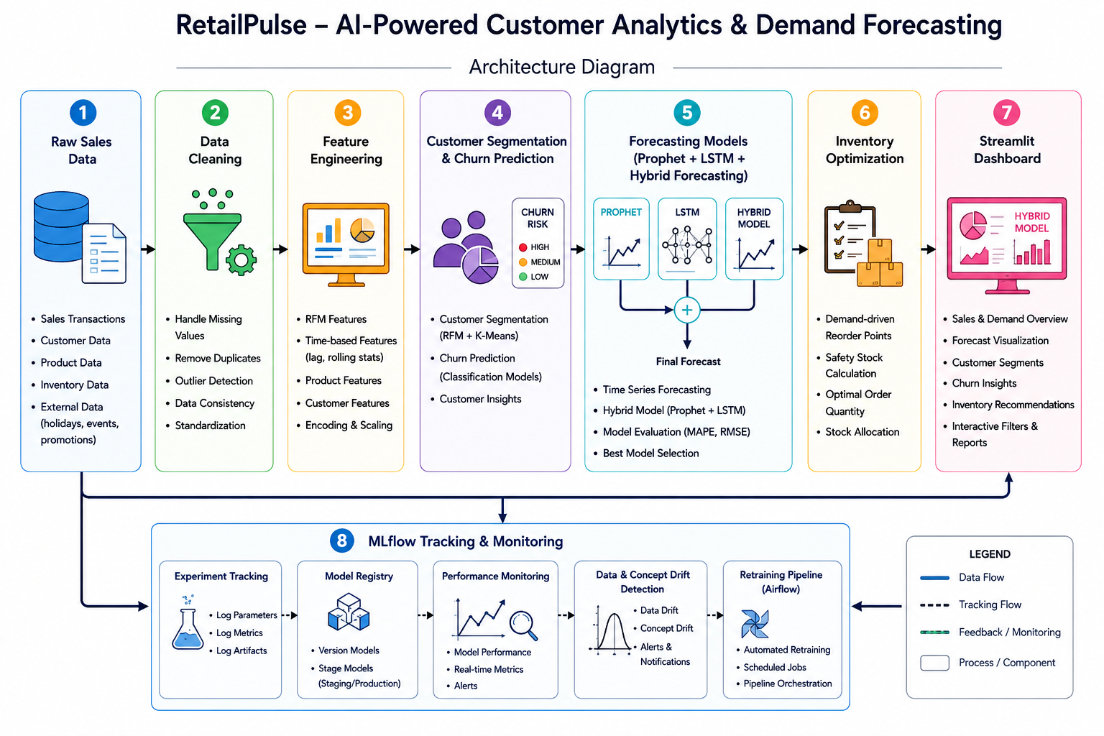

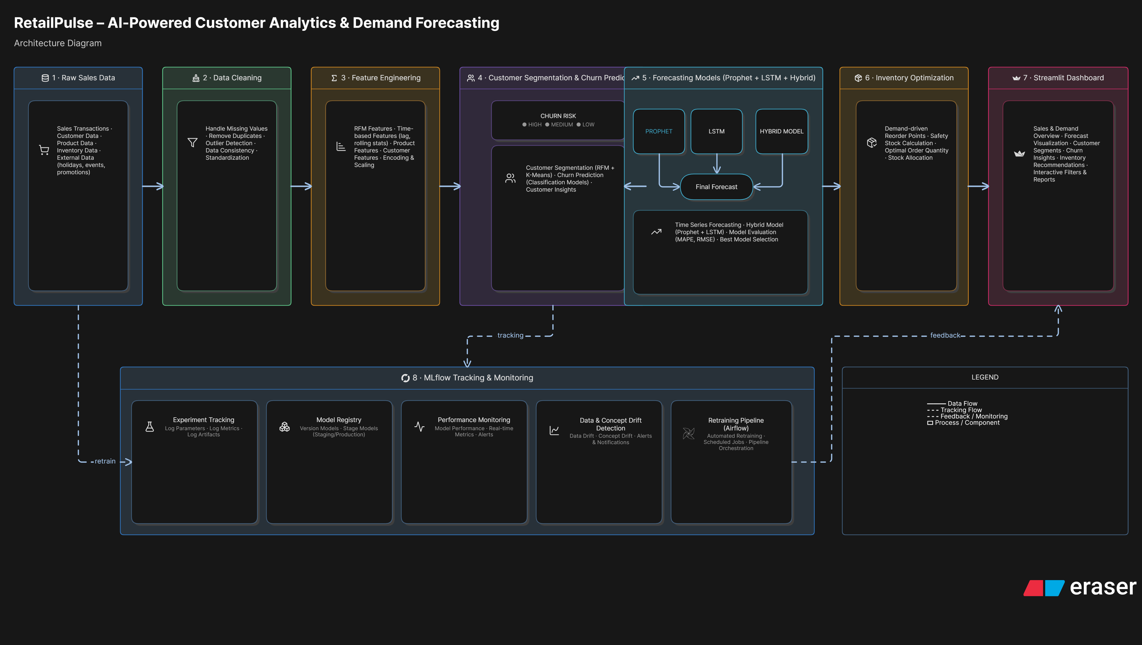
Execution Timeline
Week 1 (15 July - 17 July 2026):
- Requirement gathering.
- Dataset collection, preprocessing.
- Exploratory Data Analysis (EDA)

Week 2 (18 July - 25 July 2026):
- Feature engineering
- Customer segmentation using RFM analysis
- Churn prediction implementation

Week 3 (25 July - 03 Aug 2026):
- Demand forecasting using Prophet and LSTM
- Hybrid model integration
- Inventory optimization

Week 4 (04 Aug - 07 Aug 2026):
- Streamlit dashboard development
- Docker containerization
- Deployment testing
- Final report preparation

Key Features Summary
Feature ID | Feature Name | Description | Acceptance Criteria
F1 | Customer Segmentation | Groups customers based on behavior | Customers categorized successfully
F2 | Churn Prediction | Predicts at-risk customers | Accurate churn insights generated
F3 | Demand Forecasting | Predicts future demand | Reliable forecast trends shown
F4 | Hybrid Forecasting | Combines multiple models | Improved prediction quality
F5 | Inventory Optimization | Optimizes stock levels | Reduced overstocking risk
F6 | Dashboard Analytics | Interactive visualization | Real-time insights accessible
F7 | Drift Detection | Detects data changes | Alerts for model degradation
F8 | MLflow Tracking | Tracks experiments | Performance history maintained

Technology Stack
Category | Technology | Rationale / Alternatives
Programming | Python | Primary language for ML and analytics
Frontend | Streamlit | Interactive dashboard development
Machine Learning | Scikit-learn, TensorFlow | Model training and prediction
Forecasting | Prophet, LSTM | Time-series forecasting
MLOps | MLflow, Optuna, Airflow | Experiment tracking and orchestration
Containerization | Docker | Portable deployment
Version Control | Git & GitHub | Collaboration and code management

Personal Reflection & Conclusion
Overview: This project provided practical exposure to real-world Machine Learning and MLOps concepts. During development, we learned how to design scalable data pipelines, build predictive models, and deploy applications professionally.
• Hands-on experience with ML workflows.
• End-to-end deployment process using Docker and Streamlit Cloud.
• Practical implementation of time-series forecasting and churn analysis.

