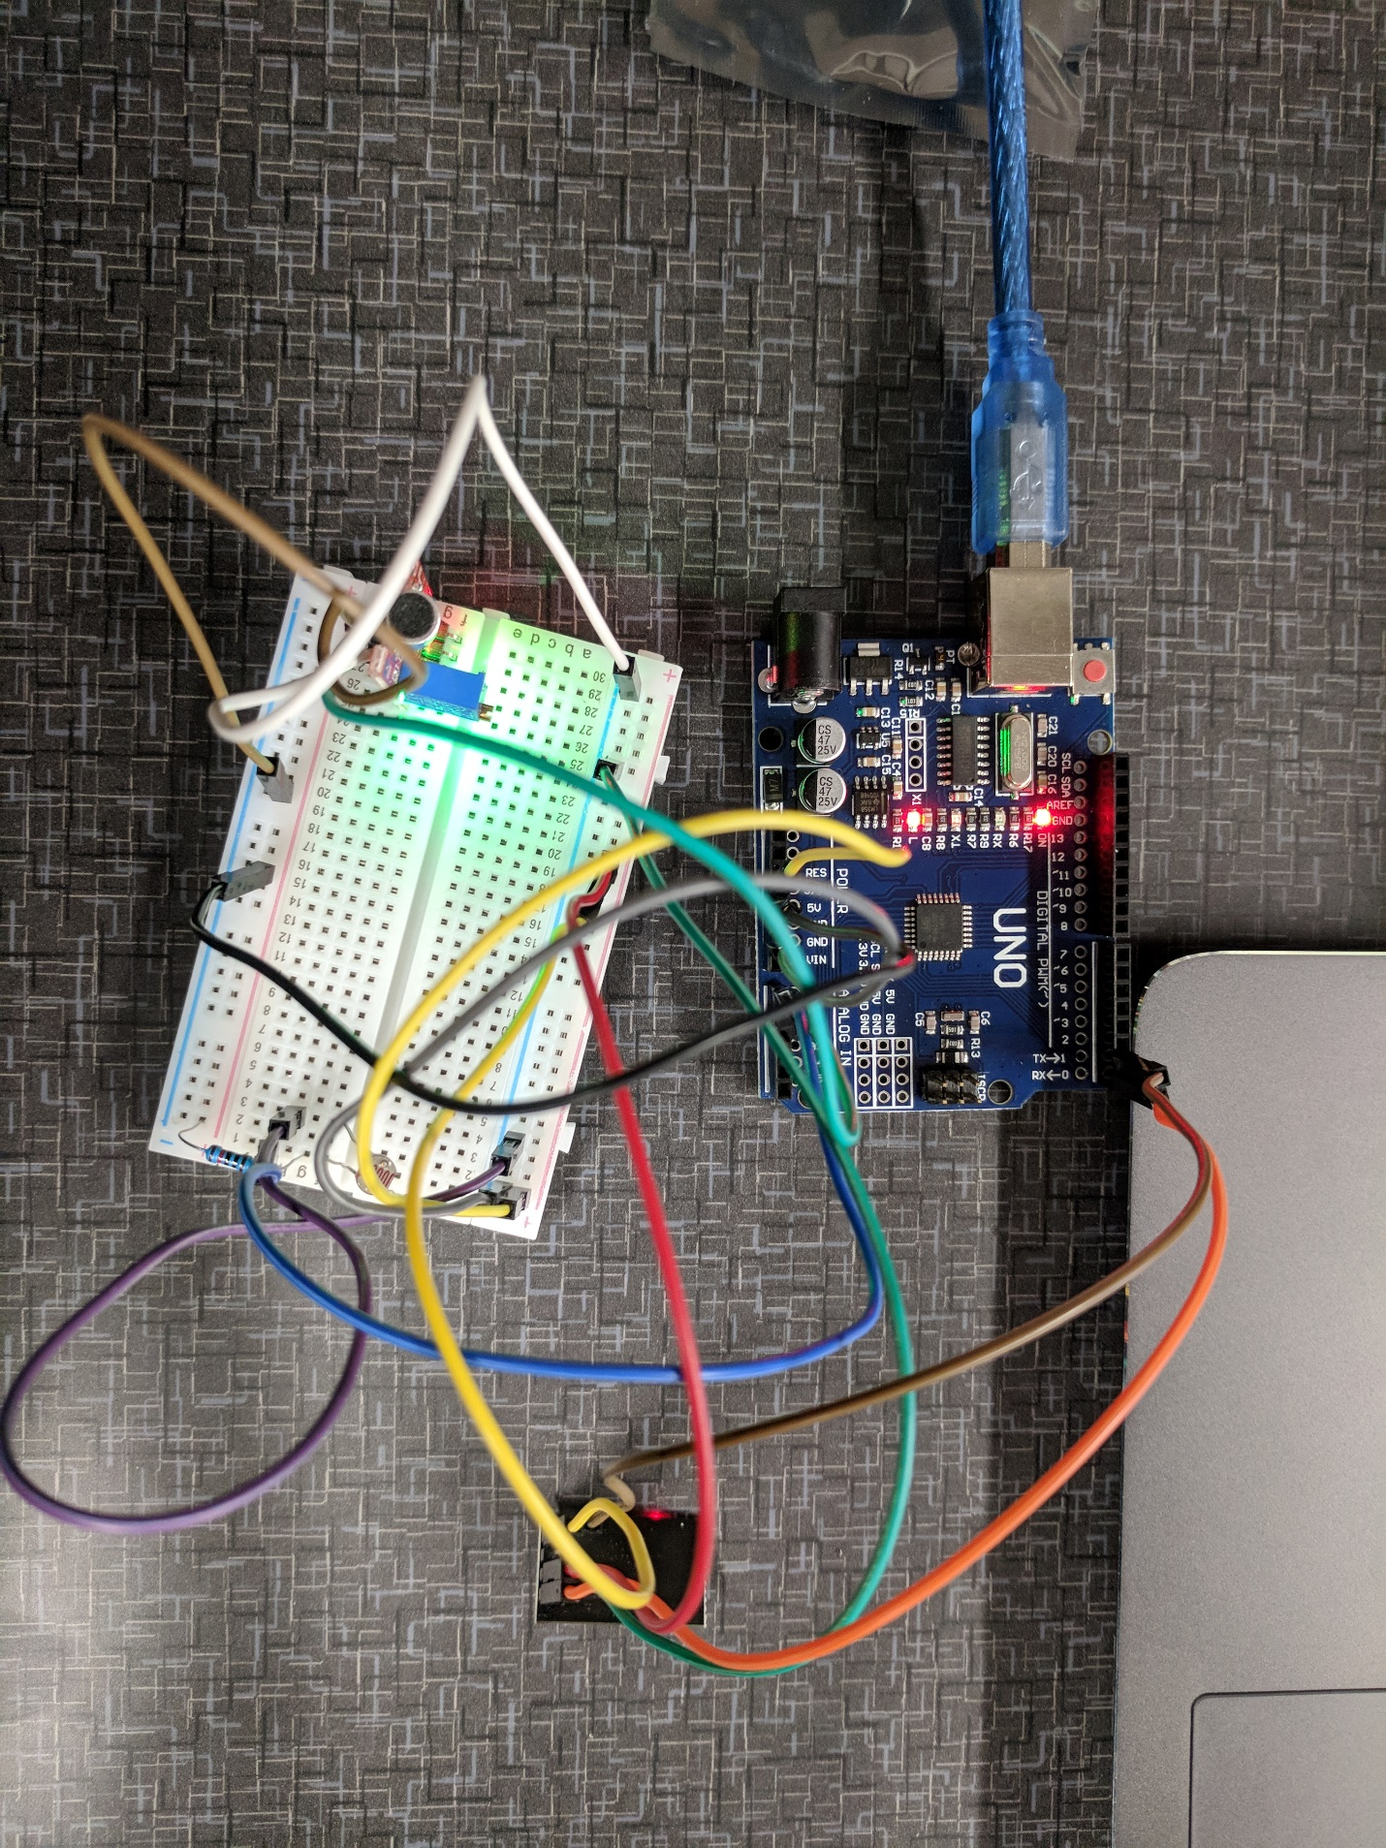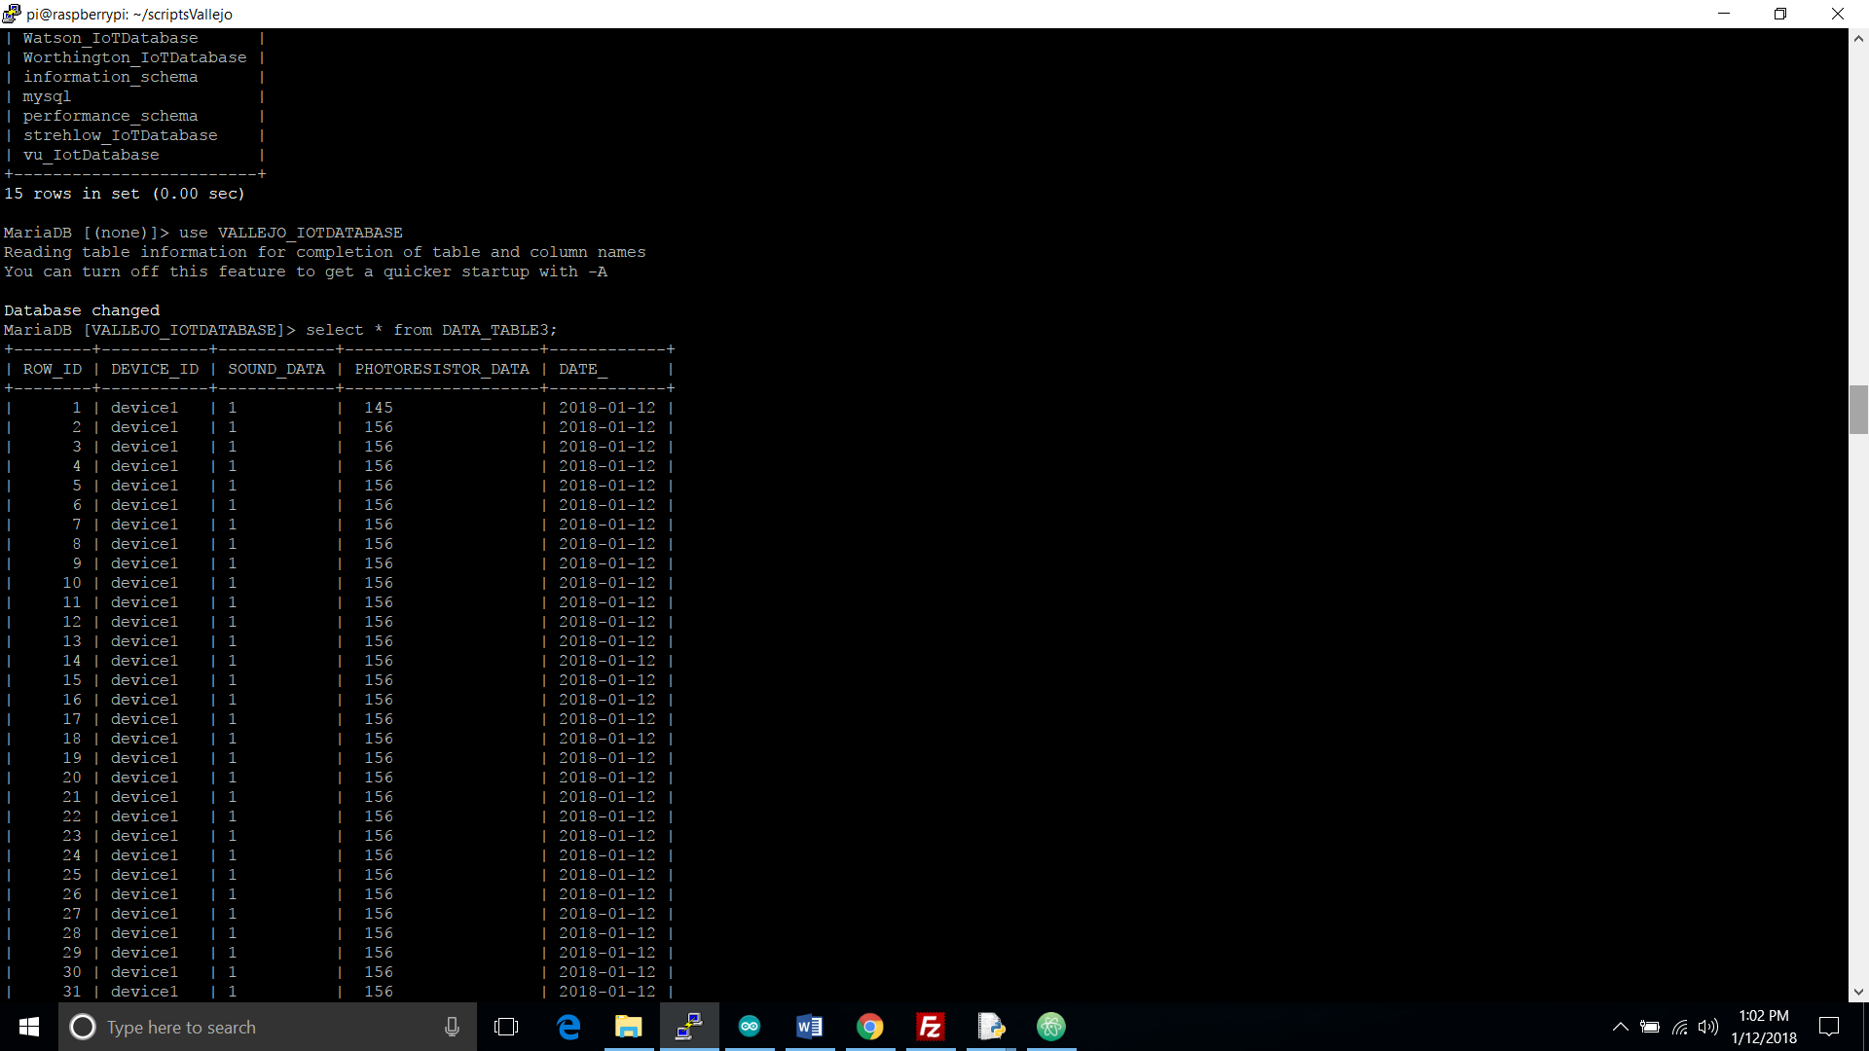

|  |  |  |
| --- | --- | --- |
| Column Name | Data Type | Description |
| ROW_ID | Integer | Primary Key, not null and should auto increment by 1 |
| DEVICE_ID | Varchar 25 | Unique device id |
| SOUND_DATA | Varchar 25 | Records the value of the small sound sensor |
| PHOTORESISTOR_DATA | Varchar 25 | Records the value of the light sensitivity. |
| DATE_ | Date Time | Time stamp of the data |
|  |  |  |