1. **cd to your file**
2. **composer create-project laravel/laravel .**
3. **create your db and put its name to file .env in DB_CONNECTION instead of mysql**
4. **create some migrations, seeders, controllers and models**

migrations:

php artisan make:migration create_users_table

php artisan make:migration create_roles_table

php artisan make:migration create_products_table

php artisan make:migration create_orders_table

seeders:

php artisan make:seeder UserSeeder

php artisan make:seeder RoleSeeder

php artisan make:seeder ProductSeeder

models:

php artisan make:model User

php artisan make:model Role

php artisan make:model Product

php artisan make:model Order

controllers:

php artisan make:controller AuthController

php artisan make:controller ProductController

php artisan make:controller OrderController

for fast creating:

php artisan make:model User –mcr

1. **fill in migrations , after «php artisan migrate»**

User

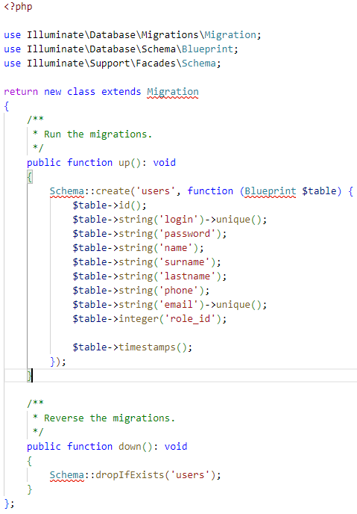

Product

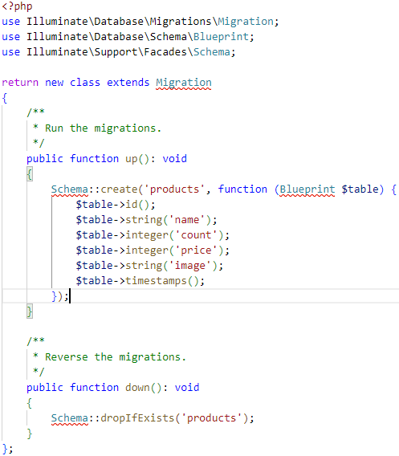

Role

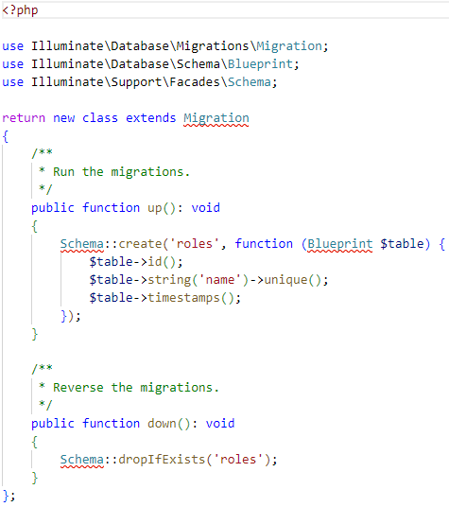

Order

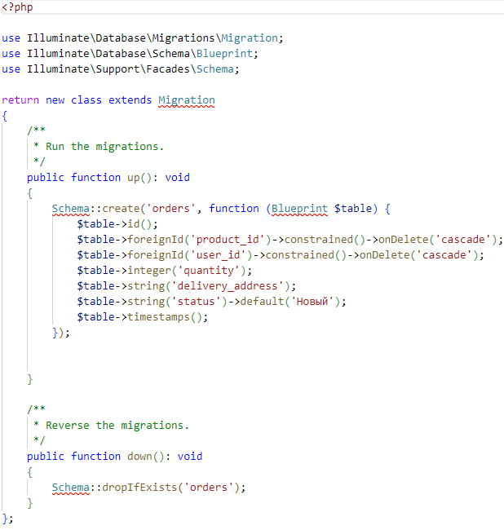

1. **fill in seeders, after «php artisan db:seed»**

DatabaseSeeder

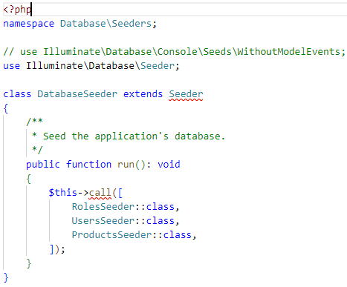

User

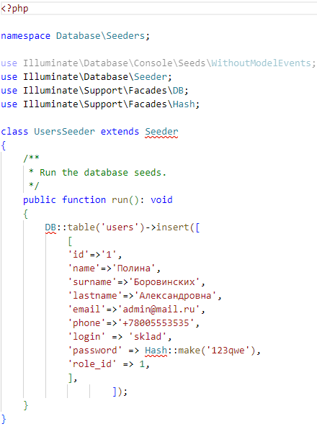

Role

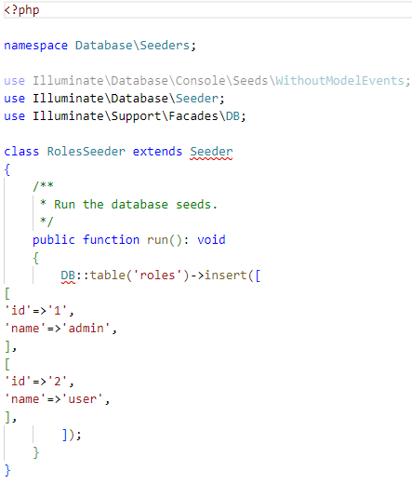

Product

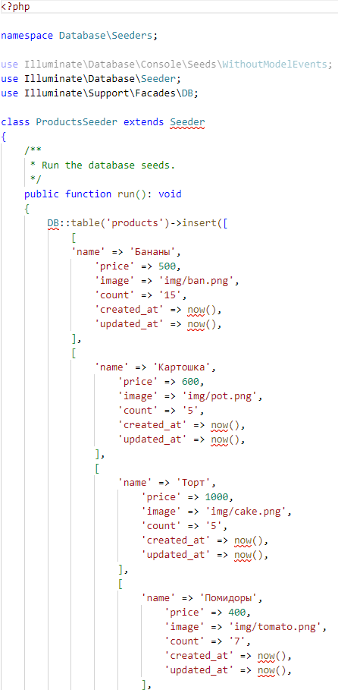

1. **put your bootstrap styles, jquery in folder «public» and also in separate folder called «img» put your images**
2. **in folder «resources» сreate folders like css(app.css), js(app.js, bootstrap.js) and views with your blades(pages)**

* welcome.blade.php or index.blade.php
* header.blade.php
* footer.blade.php
* registr.blade.php
* login.blade.php
* admin.blade.php
* adminOrder.blade.php
* create.blade.php
* orders.blade.php

1. **write your routes in folder «routes» in file web.php**

for the first write your controllers at the start of file

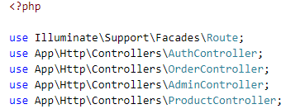

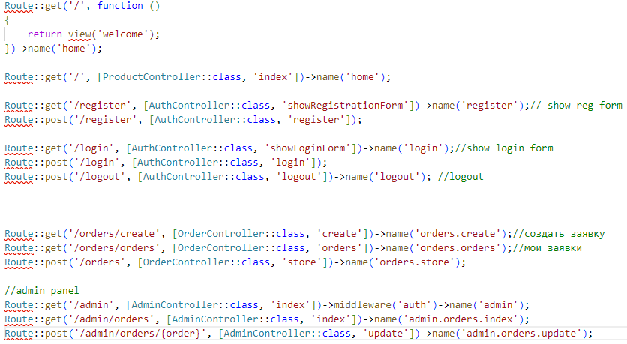

1. **fill in header and footer blades**

Header

<!DOCTYPE html>

<html lang="en">

<head>

<meta charset="UTF-8">

<meta name="viewport" content="width=device-width, initial-scale=1.0">

<title>Document</title>

<link rel="stylesheet" href="./bootstrap-4.6.1-dist/css/bootstrap.min.css">

</head>

<body>

<div class="container">

<nav class="navbar navbar-expand-lg navbar-light bg-light">

<a class="navbar-brand" href="{{ route('home') }}">Авоська</a>

<button class="navbar-toggler" type="button" data-toggle="collapse" data-target="#navbarSupportedContent" aria-controls="navbarSupportedContent" aria-expanded="false" aria-label="Toggle navigation">

<span class="navbar-toggler-icon"></span>

</button>

<div class="collapse navbar-collapse" id="navbarSupportedContent">

<ul class="navbar-nav mr-auto">

<li class="nav-item active">

<a class="nav-link" href="{{ route('home') }}">Главная <span class="sr-only"></span></a>

</li>

@if (Auth::check())

@if (Auth::user()->role_id == 2)

<li class="nav-item">

<a class="nav-link" href="{{ route('orders.create') }}">Оформить заказ</a>

</li>

<li class="nav-item">

<a class="nav-link" href="{{ route('orders.orders') }}">Мои заказы</a>

</li>

<form action="{{ route('logout') }}" method="POST">

@csrf

<button class="btn btn-primary" type="submit">Выйти</button>

</form>

@elseif (Auth::user()->role_id == 1)

<li class="nav-item"><a href="{{ route('admin.orders.index') }}" class="nav-link">Управление заказами</a></li>

</ul>

</div>

<div class="d-flex">

<form action="{{ route('logout') }}" method="POST">

@csrf

<button class="btn btn-primary" type="submit">Выйти</button>

</form>

@endif

@else

<a class="btn btn-primary" href="{{ route('login') }}">Войти</a>

<a class="btn btn-light" href="{{ route('register') }}">Регистрация</a>

@endif

</div>

</nav>

</div>

<script src="./jquery-3.7.1.js"></script>

<script src="./bootstrap-4.6.1-dist/js/bootstrap.min.js"></script>

</body>

</html>

1. **fil in your welcome page**

@include('header')

<div class="container">

<h1> «Авоська» </h1>

<p>Добро пожаловать в интернет-магазин "Авоська"! Удобный сервис по заказу продуктов под рукой.</p>

<p>Для заказа необходимо зарегестрироваться или авторизоваться.</p>

<div id="carouselExampleControls" class="carousel slide" data-ride="carousel">

<div class="carousel-inner">

<div class="carousel-item active">

<img src="./img/1.jpg" class="d-block w-100" alt="...">

</div>

<div class="carousel-item">

<img src="./img/7.jpg" class="d-block w-100" alt="...">

</div>

<div class="carousel-item">

<img src="./img/5.jpg" class="d-block w-100" alt="...">

</div>

</div>

<button class="carousel-control-prev" type="button" data-target="#carouselExampleControls" data-slide="prev">

<span class="carousel-control-prev-icon" aria-hidden="true"></span>

<span class="sr-only">Previous</span>

</button>

<button class="carousel-control-next" type="button" data-target="#carouselExampleControls" data-slide="next">

<span class="carousel-control-next-icon" aria-hidden="true"></span>

<span class="sr-only">Next</span>

</button>

</div>

<!-- card product -->

<div class="container mt-5">

<h1>Каталог товаров</h1>

<div class="row">

@foreach ($products as $product)

<div class="col-md-4 mb-4">

<div class="card">

<img src="{{ $product->image}}" class="card-img-top" alt="{{ $product->name }}">

<div class="card-body">

<h5 class="card-title">{{ $product->name }}</h5>

<p class="card-text">Цена: {{ $product->price }} ₽</p>

<p class="card-text">

@if ($product->count > 0)

<span class="text-success">В наличии</span>

@else

<span class="text-danger">Нет в наличии</span>

@endif

</p>

@if ($product->count > 0)

@if (Auth::check())

@if (Auth::user()->role_id == 2)

<a href="{{ route('orders.create') }}" class="btn btn-primary">Заказать</a>

@endif

@else

<a href="{{ route('login') }}" class="btn btn-primary">Заказать</a>

@endif

@else

<button class="btn btn-secondary" disabled>Нет в наличии</button>

@endif

</div>

</div>

</div>

@endforeach

</div>

</div>

</div>

<script src="./bootstrap-4.6.1-dist/js/bootstrap.min.js"></script>

<script src="./jquery-3.7.1.js"></script>

</body>

</html>

1. **fill in AuthController.php**

<?php

namespace App\Http\Controllers;

use Illuminate\Support\Facades\Auth;

use Illuminate\Http\Request;

use App\Models\User;

use Illuminate\Support\Facades\Hash;

use Illuminate\Support\Facades\Validator;

class AuthController extends Controller

{

public function showRegistrationForm()

{

return view('register');

}

public function register(Request $request)

{

$validator = Validator::make($request->all(), [

'phone'=>"required|string|regex:/^\+7\d{3}-\d{3}-\d{2}-\d{2}$/i",

'name'=>"required|string|regex:/^[А-Яа-яЁё]+$/u",

'surname'=>"required|string|regex:/^[А-Яа-яЁё]+$/u",

'lastname'=>"required|string|regex:/^[А-Яа-яЁё]+$/u",

'password' => ['required', 'string', 'min:4', 'confirmed'],

]);

if ($validator->fails()) {

return redirect()->back()->withErrors($validator)->withInput();

}

$user = User::create([

'name' => $request->input('name'),

'surname' => $request->input('surname'),

'phone' => $request->input('phone'),

'email' => $request->input('email'),

'login' => $request->input('login'),

'lastname' => $request->input('lastname'),

'password' => Hash::make($request->input('password')),

'role_id' => 2

]);

Auth::login($user);

return redirect()->route('home')->with('success', 'Вы успешно зарегистрировались!');

}

protected function showLoginForm()

{

return view('login');

}

public function login(Request $request)

{

$credentials = $request->validate([

'login' => ['required'],

'password' => ['required'],

]);

if (!Auth::attempt($credentials)) {

return redirect()->back()->withErrors(['login' => 'Неверный логин или пароль']);

}

$user = Auth::user();

$request->session()->regenerate();

if ($user->role_id === 1) {

return redirect()->route('admin')->with('success', 'Добро пожаловать в админ-панель!');

}

return redirect('/');

}

public function logout(Request $request)

{

Auth::logout();

$request->session()->invalidate();

$request->session()->regenerateToken();

return redirect('/');

}

}

1. **fill in registr.blade.php**

<!DOCTYPE html>

<html lang="ru">

<head>

<meta charset="UTF-8">

<meta name="viewport" content="width=device-width, initial-scale=1.0">

@include('header')

<link rel="stylesheet" href="./bootstrap-4.6.1-dist/css/bootstrap.min.css">

<style>

body {

font-family: Arial, sans-serif;

line-height: 1.6;

color: #333;

}

</style>

</head>

<div class="container">

<body class="d-flex flex-column min-vh-100 bg-light">

<main class="container mx-auto px-4 py-8">

<div class="row justify-content-center">

<div class="col-md-10 col-lg-6">

<div class="card bg-white shadow-lg rounded-lg overflow-hidden">

<div class="card-header bg-gray-100 p-4">

<h2 class="text-center mb-0">Регистрация</h2>

</div>

<div class="card-body p-5">

<form method="POST" action="{{ route('register') }}">

@csrf

<div class="mb-3">

<label for="surname" class="form-label">Фамилия</label>

<input id="surname" type="text" class="form-control @error('surname') is-invalid @enderror" name="surname" value="{{ old('surname') }}" required autocomplete="surname">

@error('surname')

<span class="invalid-feedback" role="alert">

<strong>{{ $message }}</strong>

</span>

@enderror

</div>

<div class="mb-3">

<label for="name" class="form-label">Имя</label>

<input id="name" type="text" class="form-control @error('name') is-invalid @enderror" name="name" value="{{ old('name') }}" required autocomplete="name" autofocus>

@error('name')

<span class="invalid-feedback" role="alert">

<strong>{{ $message }}</strong>

</span>

@enderror

</div>

<div class="mb-3">

<label for="lastname" class="form-label">Отчество</label>

<input id="lastname" type="text" class="form-control @error('lastname') is-invalid @enderror" name="lastname" value="{{ old('lastname') }}" required autocomplete="lastname">

@error('lastname')

<span class="invalid-feedback" role="alert">

<strong>{{ $message }}</strong>

</span>

@enderror

</div>

<div class="mb-3">

<label for="login" class="form-label">Логин</label>

<input id="login" type="text" class="form-control @error('login') is-invalid @enderror" name="login" value="{{ old('login') }}" required autocomplete="login">

@error('login')

<span class="invalid-feedback" role="alert">

<strong>{{ $message }}</strong>

</span>

@enderror

</div>

<div class="mb-3">

<label for="email" class="form-label">Электронная почта</label>

<input id="email" type="email" class="form-control @error('email') is-invalid @enderror" name="email" value="{{ old('email') }}" required autocomplete="email">

@error('email')

<span class="invalid-feedback" role="alert">

<strong>{{ $message }}</strong>

</span>

@enderror

</div>

<div class="mb-3">

<label for="phone" class="form-label">Телефон</label>

<input id="phone" type="text" class="form-control @error('phone') is-invalid @enderror" name="phone" placeholder='+7XXX-XXX-XX-XX ' value="{{ old('phone') }}" required >

@error('phone')

<span class="invalid-feedback" role="alert">

<strong>{{ $message }}</strong>

</span>

@enderror

</div>

<div class="mb-3">

<label for="password" class="form-label">Пароль</label>

<input id="password" type="password" class="form-control @error('password') is-invalid @enderror" name="password" required autocomplete="new-password">

@error('password')

<span class="invalid-feedback" role="alert">

<strong>{{ $message }}</strong>

</span>

@enderror

</div>

<div class="mb-3">

<label for="password-confirm" class="form-label">Подтвердите пароль</label>

<input id="password-confirm" type="password" class="form-control" name="password_confirmation" required autocomplete="new-password">

</div>

<button type="submit" class="btn btn-primary w-100 mt-3">Зарегистрироваться</button>

</form>

<a href="{{ route('login') }}" class="btn btn-link mt-2">Уже зарегестрированы? Войти</a>

</div>

</div>

</div>

</div>

</main>

</div>

<script src="./bootstrap-4.6.1-dist/js/bootstrap.min.js"></script>

<script src="./jquery-3.7.1.js"></script>

</body>

</html>

1. **fill in login.blade.php**

@include('header')

<div class="container">

<div class="container mt-5">

<div class="row justify-content-center">

<div class="col-md-6 col-lg-4">

<div class="card bg-white shadow-lg rounded-lg overflow-hidden">

<div class="card-header bg-gray-100 p-4">

<h2 class="text-center">Авторизация</h2>

</div>

<div class="card-body p-5">

<form method="POST" action="{{ route('login') }}">

@csrf

<div class="mb-3">

<label for="login" class="form-label">Логин</label>

<input type="login" name="login" id="login" class="form-control" required>

</div>

<div class="mb-3">

<label for="password" class="form-label">Пароль</label>

<input type="password" name="password" id="password" class="form-control" required>

</div>

<button type="submit" class="btn btn-primary w-100 mt-3">Войти</button>

<a href="{{ route('register') }}" class="btn btn-link mt-2">Нет аккаунта? Регистрация</a>

</form>

</div>

</div>

</div>

</div>

</div>

@if ($errors->any())

<div class="alert alert-danger mt-4">

<ul>

@foreach ($errors->all() as $error)

<li>{{ $error }}</li>

@endforeach

</ul>

</div>

@endif

</div>

<script src="./bootstrap-4.6.1-dist/js/bootstrap.min.js"></script>

<script src="./jquery-3.7.1.js"></script>

1. **fill in ProductController.php**

<?php

namespace App\Http\Controllers;

use Illuminate\Support\Facades\Auth;

use Illuminate\Http\Request;

use App\Models\User;

use App\Models\Product;

use Illuminate\Support\Facades\Hash;

use Illuminate\Support\Facades\Validator;

class ProductController extends Controller

{

public function index()

{

$products= Product::all();

return view('welcome', compact('products'));

}

}

1. **fill in admin.blade.php**

@include'(header')

<h1>Hello, админ!</h1>

1. **fill in adminOrder.php**

<!DOCTYPE html>

<html lang="en">

<head>

<meta charset="UTF-8">

<meta http-equiv="X-UA-Compatible" content="IE=edge">

<meta name="viewport" content="width=device-width, initial-scale=1.0">

<link href="/bootstrap-5.0.2-dist/css/bootstrap.min.css" rel="stylesheet">

<link rel="stylesheet" href="{{ asset('/css/style.css') }}">

<title>Управление заказами</title>

</head>

<body>

@include('header')

<div class="container">

<h1 class="my-4">Заказы</h1>

@if (session('success'))

<div class="alert alert-success">{{ session('success') }}</div>

@endif

@if ($errors->any())

<div class="alert alert-danger">

<ul>

@foreach ($errors->all() as $error)

<li>{{ $error }}</li>

@endforeach

</ul>

</div>

@endif

<form method="GET" action="{{ route('admin.orders.index') }}" class="mb-4">

<div class="form-group">

<label for="status">Фильтр по статусу:</label>

<select name="status" id="status" class="form-control">

<option value="">Все</option>

<option value="Новый" {{ $status == 'Новый' ? 'selected' : '' }}>Новый</option>

<option value="Подтвержден" {{ $status == 'Подтвержден' ? 'selected' : '' }}>Подтвержден</option>

<option value="Отменен" {{ $status == 'Отменен' ? 'selected' : '' }}>Отменен</option>

</select>

</div>

<button type="submit" class="btn btn-primary mt-2">Применить</button>

</form>

<table class="table table-bordered">

<thead class="thead-light">

<tr>

<th>Имя пользователя</th>

<th>Фамилия</th>

<th>Отчество</th>

<th>Email</th>

<th>Наименование товара</th>

<th>Количество</th>

<th>Статус</th>

<th>Действия</th>

</tr>

</thead>

<tbody>

@foreach ($orders as $order)

<tr>

<td>{{ $order->user->name }}</td>

<td>{{ $order->user->surname }}</td>

<td>{{ $order->user->lastname }}</td>

<td>{{ $order->user->email }}</td>

<td>{{ $order->product->name }}</td>

<td>{{ $order->quantity }}</td>

<td>{{ $order->status }}</td>

<td>

@if ($order->status === 'Новый')

<form action="{{ route('admin.orders.update', $order) }}" method="POST" class="d-inline">

@csrf

<select name="status" class="form-control d-inline-block" style="width: auto;">

<option value="Подтвержден">Подтвержден</option>

<option value="Отменен">Отменен</option>

</select>

<button type="submit" class="btn btn-primary btn-sm">Изменить статус</button>

</form>

@else

<span class="text-muted">Статус не может быть изменен</span>

@endif

</td>

</tr>

@endforeach

</tbody>

</table>

</div>

</body>

<script src="/bootstrap-5.0.2-dist/js/bootstrap.min.js"></script>

</html>

1. **fill in AdminController.php**

<?php

namespace App\Http\Controllers;

use Illuminate\Support\Facades\Auth;

use Illuminate\Http\Request;

use App\Models\User;

use Illuminate\Support\Facades\Hash;

use Illuminate\Support\Facades\Validator;

use App\Models\Order;

class AdminController extends Controller

{

public function index(Request $request)

{

// Получаем статус из запроса (если он есть)

$status = $request->input('status');

// Получаем все заказы с загруженными пользователями и продуктами

$orders = Order::with(['user', 'product']);

// Если статус выбран, фильтруем заказы по статусу

if ($status) {

$orders->where('status', $status);

}

// Получаем заказы

$orders = $orders->get();

return view('adminOrder', compact('orders', 'status'));

}

public function update(Request $request, Order $order)

{

if ($order->status !== 'Новый') {

return redirect()->back()->withErrors(['status' => 'Статус заказа можно изменить только для новых заказов.']);

}

$request->validate([

'status' => 'required|string|in: Новый,Подтвержден,Отменен',

]);

// Обновляем статус заказа

$order->status = $request->status;

$order->save();

return redirect()->route('admin.orders.index')->with('success', 'Статус заказа успешно обновлен.');

}

}

1. **fill in OrderController.php**

<?php

namespace App\Http\Controllers;

use Illuminate\Support\Facades\Auth;

use Illuminate\Http\Request;

use App\Models\User;

use App\Models\Product;

use App\Models\Order;

use Illuminate\Support\Facades\Hash;

use Illuminate\Support\Facades\Validator;

class OrderController extends Controller

{

//заказы текущего юзера

public function orders()

{

$orders = Order::with('product')->where('user_id', auth()->id())->get();

return view('orders', compact('orders'));

}

public function create(){

$products = Product::all();

return view('create', compact('products'));

}

public function store(Request $request)

{

$request->validate([

'product_id' => 'required|exists:products,id',

'quantity' => 'required|integer|min:1',

'delivery_address' => 'required|string|max:255',

]);

// Получаем продукт из базы данных

$product = Product::find($request->product_id);

// Проверяем, достаточно ли товара на складе

if ($request->quantity > $product->count) {

return redirect()->back()->withErrors(['quantity' => 'Недостаточно товара на складе. Доступно: ' . $product->count]);

}

// Создаем заказ, добавляя user_id

$order = Order::create([

'product_id' => $request->product_id,

'user_id' => auth()->id(),

'quantity' => $request->quantity,

'delivery_address' => $request->delivery_address,

'status' => 'Новый',

]);

// Уменьшаем количество товара на складе

$product->count -= $request->quantity;

$product->save();

return redirect()->route('orders.create')->with('success', 'Заказ успешно создан!');

}

}

1. **fill in orders.blade.php**

<!DOCTYPE html>

<html lang="en">

<head>

<meta charset="UTF-8">

<meta http-equiv="X-UA-Compatible" content="IE=edge">

<meta name="viewport" content="width=device-width, initial-scale=1.0">

<link href="/bootstrap-5.0.2-dist/css/bootstrap.min.css" rel="stylesheet">

<link rel="stylesheet" href="{{ asset('/css/style.css') }}">

<title>Мои заказы</title>

</head>

<body>

@include('header')

<div class="container">

<h1>Мои Заказы</h1>

<a href="{{ route('orders.create') }}" class="btn btn-primary mb-3">Создать новый заказ</a>

@if ($orders->isEmpty())

<div class="alert alert-info">У вас нет заказов.</div>

@else

<table class="table table-striped">

<thead>

<tr>

<th>№</th>

<th>Продукт</th>

<th>Количество</th>

<th>Статус</th>

<th>Дата создания</th>

</tr>

</thead>

<tbody>

@foreach ($orders as $order)

<tr>

<td>{{ $order->id }}</td>

<td>{{ $order->product->name }}</td>

<td>{{ $order->quantity }}</td>

<td>{{ $order->status }}</td>

<td>{{ $order->created_at->format('d-m-Y H:i') }}</td>

</tr>

@endforeach

</tbody>

</table>

@endif

</div>

</body>

<script src="./jquery-3.7.1.js"></script>

<script src="./bootstrap-4.6.1-dist/js/bootstrap.min.js"></script>

<script src="/bootstrap-5.0.2-dist/js/bootstrap.min.js"></script>

</html>

1. **fill in create.blade.php**

<!DOCTYPE html>

<html lang="en">

<head>

<meta charset="UTF-8">

<meta http-equiv="X-UA-Compatible" content="IE=edge">

<meta name="viewport" content="width=device-width, initial-scale=1.0">

<link href="/bootstrap-5.0.2-dist/css/bootstrap.min.css" rel="stylesheet">

<link rel="stylesheet" href="{{ asset('/css/style.css') }}">

<title>Формирование заказа</title>

</head>

<body>

@include('header')

<div class="container mt-5">

<h1 class="mb-4">Формирование заказа</h1>

@if(session('success'))

<div class="alert alert-success">{{ session('success') }}</div>

@endif

<form action="{{ route('orders.store') }}" method="POST">

@csrf

<div class="form-group">

<label for="product_id">Товар:</label>

<select name="product_id" id="product_id" class="form-control" required>

<option value="">Выберите товар</option>

@foreach($products as $product)

<option value="{{ $product->id }}">{{ $product->name }}</option>

@endforeach

</select>

</div><br>

<div class="form-group">

<label for="quantity">Количество:</label>

<input type="number" name="quantity" id="quantity" class="form-control" required min="1">

</div><br>

<div class="form-group">

<label for="delivery_address">Адрес доставки:</label>

<input type="text" name="delivery_address" id="delivery_address" class="form-control" required>

</div><br>

<button type="submit" class="btn btn-primary">Создать заказ</button>

@if ($errors->any())

<div>

@foreach ($errors->all() as $error)

<p>{{ $error }}</p>

@endforeach

</div>

@endif

</form>

</div>

</body>

<script src="./jquery-3.7.1.js"></script>

<script src="./bootstrap-4.6.1-dist/js/bootstrap.min.js"></script>

<script src="/bootstrap-5.0.2-dist/js/bootstrap.min.js"></script>

</html>

1. also you have to fill in models and make some connections

User

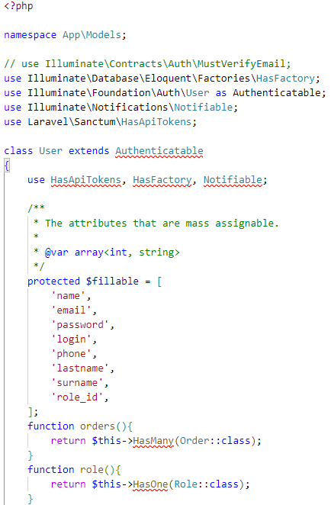

Role

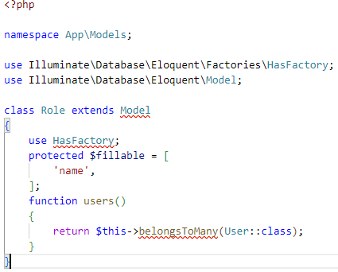

Product

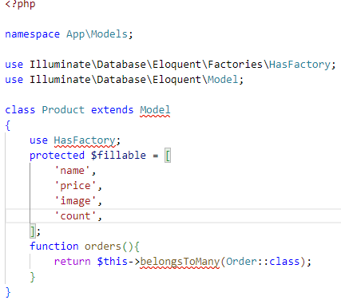

Order

