**What is your team’s name?**

Team Rally

**What is your project about?**

We will be creating an application where users can search for group events and simultaneously check the weather for the physical location at the same time to help plan their schedules.

**Provide attached files or links to files showing a mockup of your intended application user interface:**

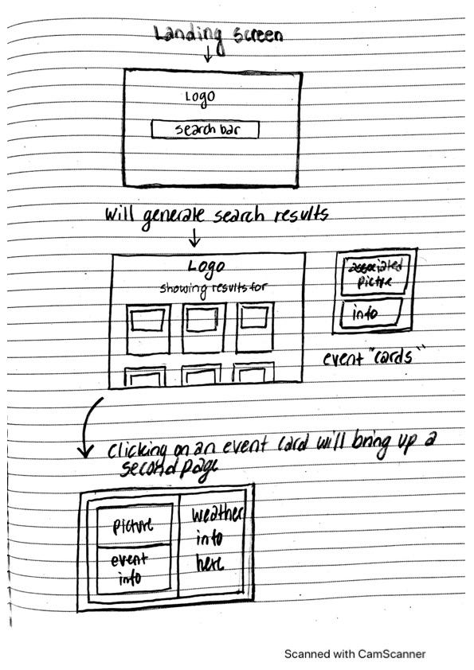

**What role(s) will everyone on the team hold:**

**Maddie - CSS/ Bulma**

**Kenny - JS/ Focus on API’s**

**Andrea - JS**

**How often will you have meetings?**

We will have meetings outside of class as frequently as our schedules allow.

**How will you keep track of tasks?**

GitHub, Slack, and Jira software.

**What if someone misses a deadline?**

We will try to communicate with each other to prevent this and also be able to jump in and help pick up slack with one another.

**What happens if someone misses a meeting? What is their responsibility? The team’s responsibility?**

We delegate a task for the team member that missed a meeting.

**How does each team member like to receive feedback?**

Maddie: Realistic and honest, preferably with a feasible suggestion for improvement.

Kenny: Straight to the point and have if someones idea works better than mine, then I’d like to know how it works.

Andrea: Being open to each other’s ideas if someone feels they have a better approach to a result.

**What if there is friction between members? How will you address it?**

Open and frank communication so that the issue can be resolved, either by talking or helping with work.

**Other Group Agreements:**

We are all in agreement with helping each other and that we’d all participate in each other’s tasks. We all want to learn and understand how to each group members roles work in the grand scheme of things.