**Final Project Analysis**

My revised EDUC240 final project is an action campaign called Culture In Class. Culture In Class directly focuses on the issue of the lack of diverse ethnic cultures being celebrated within schools in North America. The main goal of Culture In Class is to encourage a multicultural community to all audiences, as everyone plays an important goal in recognizing diversity. This project originated out of my own experiences as an ethnic student growing up in Canada, as throughout elementary and secondary school I was always encouraged to fit into North American culture rather than express or learn about my own ethnic diversity. Superficially, teachers and students may have demonstrated acknowledgement and appreciation of other cultures, but rarely did we express the actual values and relationships that truly defined a culture. Not only is it important to understand the importance of other cultures for the sake of ethnic students similar to me but doing so actively promotes an anti-racist environment. It is common for ethnic groups to be separated into their own miniature communities by the time they reach secondary school, socially segregated from the non-colored and even other ethic students. Culture In Class hopes to minimize the social borders between students by integrating ethic studies and cultures into the classroom while acknowledging the realities of a multicultural society.

A related piece of reading we were assigned was, Taking Multicultural, Anti-Racist Education Seriously: An Interview with Enid Lee. In this reading, Enid Lee explains her perspectives of multicultural education and is adamant to point out that there is "no neutral ground" between monocultural and racist education. She encourages to look objectively at the specific advantages and disadvantages that ethic groups have and to challenge the perspective of "white is normal." This reading has a significant connection to my project as Enid Lee’s ideas on multiculturalism defined the connection between social injustice and a monocultural society. Another impactful reading that is connected to my project is, Diversity vs. White Privilege An Interview with Christine Sleeter. In this reading, Christine American explains that in history, European people generally assumed power within a land, and this may lead to white students having a preconceived notion that their culture is superior to others. Similar to Enid Lee’s article, Christine advocates against the superficial celebration of urban cultures, but to look into the backgrounds of students and ethnic groups.

The main social mechanism that is linked to my final project is recognition. It is important that students should feel recognized for who they are when they arrival at school and not only at home. As such, students should be acknowledged for who they are as an individual which includes the culture they belong in. A personal example is when I first entered elementary school at the age of 6, teachers and other students had a difficult time pronouncing my name. Without fail, my teachers would try to pronounce my name and ask if I had an alternative English name. Eventually, other students started calling me JJ and would even answer tell the teacher in my behalf, that I preferred to be called JJ. Interestingly enough, I never asked to be called JJ in the first place, and it seemed like the name was given to me by my classmates. Eventually, I had to switch schools in secondary school, and my mother read that students with English names fared better in finding jobs within North America. She decided that I should take this opportunity to use a common English name, and as such, I went by Noah during my grade 11 and 12 years. Essentially, I went through two separate name changes in the span of 10 years in my education. During each transition, I remember that had I a difficult time being recognized when someone called me by my new alias. I had such a difficult time with my second transition, that I stopped going by Noah and went back to JJ after a few years (but even today, friends from my newer high school still call me Noah). In either case, I felt that I altered a part of my identity when my I received my new name and had to balance being Jong Joon at home and JJ or Noah at school. Therefore, I believe that teachers and other students should support the use of using a student’s official name, as it is a key part of recognizing the identity and familiarity of the student. Another aspect of recognition in my project, is that certain ethnic groups simply do not receive the appropriate amount of recognition in school. This may stem from the fact that the traditional demographic group that these ethnic students belong to have parents that were not treated recognized enough in school and have ultimately learned to accept the social imbalance. In conjunction, these parents proportionally have a higher likelihood of both parents working full time, while in the Caucasian demographic, there is a higher probability that one parent is able to stay at home and supervise the studies of their students.

Another important social mechanism that relates to my project is reproduction. Centrifugally, it is important that children learn from a young age, the importance of celebrating diversity and other cultures. These ideas will spread into their adult lives and effect the community that they live upon. This will cause a future chain reaction, as future students will also learn about their environment in a centripetal manner. For example, if a student is raised up in a mono-culturalist community, then they will likely bring mono-cultural ideas into the classroom. The information learned at school is vital, as at this age and location, children are most susceptible to their environment, and combined with the scale at which school’s churn out students, slight changes in ideas

taught here can make large changes in society.

For my project, I wanted to accomplish a complete package of what a modern action campaign may consist of. The main project itself consists of a website and three separate social media accounts (Facebook page, Twitter, and Instagram) dedicated to Culture in Class. There is also a FAQ page in which I try to answer potential questions people may have. In the future, potential goals would be to actually share my campaign to the world, and hopefully reach at least a small audience and to actually create and upload a full-scale professional plan that is a realistic guide on how to integrate ethic studies into class. The main challenge of this project was creating a campaign that was personal to my experiences while being related to our class materials and addresses a significant issue that has not been getting proper recognition. Overall, I believe that Culture In Class is a well-suited subject that has merit in its relevance to social issues.

Other thoughts and personal notes:

I worked on the logo of Culture in Class with my friend and graphics designer, MJ Kim. We shared ideas of what could work as a logo, and we came up with three potential logos (as seen below). I had a difficult time in deciding which logo to use, but I ended up using the logo with children's hands as I felt this symbolized the concept more accurately than the others. However, a qualm I had with this logo is mainly categorizing cultures into skin colors and using skin color as a form of identity. This is one issue that I recognize as a potential problem as society is trying to turn into a more colorblind society. My current justification for using it is because I believe that skin color is a universal visual representation of races and that censorship of this idea is in itself, a form of monoculturalism. Personally, I am still debating whether or not to change the logo, but at the moment I think that it might be slightly ignorant to change it at this point (or would it be the opposite?).

We Can BC, was also a great source of inspiration in my project. Although they seem to have shut down a few years ago, going through their old Facebook and Twitter pages gave me a better idea of what an action campaign may look like on social media. The “An Unschooled Prof” Facebook page was another source of reference and inspiration, as I even tweeted one of the articles that Prof. Bingham had posted on the page (the article “Canada’s race problem? It’s even worse than America’s”).

|  |  |
| --- | --- |
| |  | | --- | |  | |

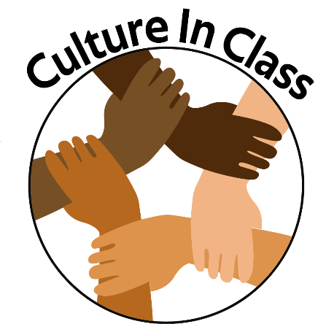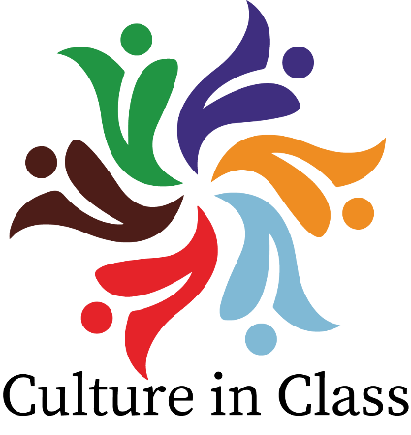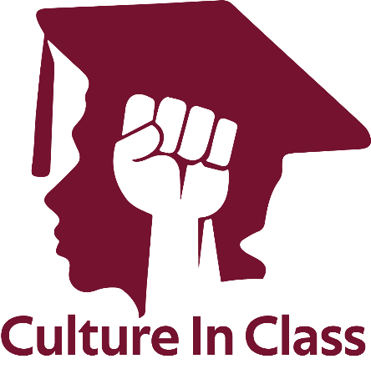

(Logos created for Culture In Class)

Bibliography:

Chapters 1 and 4 of Rethinking Multicultural Education. Both helped tremendously in ideas for teachers in the classroom, and overall references:

E. L. (2018). *Rethinking multicultural education: Teaching for racial and cultural justice*. Burnaby, B.C.: Simon Fraser University Library.

C. S. (2018). *Rethinking multicultural education: Teaching for racial and cultural justice*. Burnaby, B.C.: Simon Fraser University Library.

Clip Art used for website:

[Digital image]. (n.d.). Retrieved from https://www.kisspng.com/png-multiculturalism-free-content-diversity-clip-art-c-169194/preview.html

[Digital image]. (n.d.). Retrieved from https://www.kissclipart.com/dusk-clipart-clip-art-ovplxa/

Facebook pages for references and ideas for what an action campaign looks like:

<https://www.facebook.com/WeCanBC/>

<https://www.facebook.com/An-Unschooled-Prof-360953690587893/>

Github for allowing to upload and host my website:

Build software better, together. (n.d.). Retrieved from <https://github.com/>

Legislative Services Branch. (2019, June 26). Consolidated federal laws of canada, Canadian Multiculturalism Act. Retrieved from https://laws-lois.justice.gc.ca/eng/acts/c-18.7/

MJ Kim for help with the logos.

Professor Charles Bingham for the information on social mechanisms and overall social issues to be aware about.

The Greyscale Bootstrap Template for help with the Web Design:

Bootstrap. (n.d.). Grayscale - Free One Page Bootstrap Theme. Retrieved from https://startbootstrap.com/themes/grayscale/