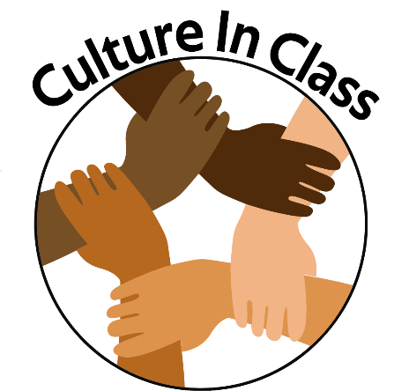

**Frequently Asked Questions**

**What is Culture In Class?**

Culture in Class is an action campaign meant to help break down the borders of ethnic segregation in class. Throughout North America, socially segregated classrooms and the lack of proper cultural recognition can be seen in different classrooms. Culture In Class wishes to expand upon the values and relationships that truly define a culture so that all children can grow up appreciating one another.

**Aren’t we supposed to be in a color-blind society? Wouldn’t this sort of this thinking be detrimental?**

The notion of a “color-blind society” was likely made with good intentions but lacks the considerations of the complicated issues when considering race. A “color-blind society” promotes the lack of considering or appreciating an individual’s culture and to automatically assume that the individual will feel a default sense of belonging. The reality of a color-blind society is that it promotes racism by undercutting the discussion of race and discrimination, which encourages a mono-cultural society.

**Does this mean Caucasian individuals are to blame and should be held the most responsibility in promoting a multicultural society in North America?**

Culture in Class promotes the equality of all races within the classroom. We believe that both Caucasian and non-Caucasian students and teachers alike should share in the discussion. We understand that in most classrooms there is an abundance of history in frame of the European perspective, and how the cultural differences of certain races led to this type of situation. We hope that classrooms can teach the realities of the hardships other ethnic groups have faced, and the truths of the tensions between cultures.

However, we also acknowledge the fact that certain ethic groups and individuals are unwilling to learn and accept North American culture and traditions in conjunction with their own. In either case, our goal is that all sides of the discussion will communicate and work together to create a unified, understanding community.

**I thought Canada was known for its multiculturalism. How is this campaign different?**

Canada is proud to be the first North American country to adopt multicultural policies in the federal level when the *Canadian Multiculturalism Act* was adopted in 1988. This act states that all individuals, regardless of race, nationality, ethnic origin, color, religion, sex, age or disability, receive equal treatment under the law without discrimination.

However, the social issues of multiculturalism do not end here. This act cannot fix the social implications that are being taught in classrooms, or the preconceived assumptions and stereotypes that other races have against each other. For the sake of our community, we must learn to accept, and understand each other in a human-to-human perspective and not only due to legalities or policy.

**How can I help?**

If you are a current student, parent of a student or part of an educational faculty, there are numerous ways in which you can help promote the celebration of cultures.

Students and parents should ask their respective teachers how the ways in which their classrooms celebrate multiculturalism. Let them know that you have an interest in learning about other cultures, and that you would appreciate it if the class can learn more about multiculturalism. Students should try to ask questions and learn to challenge the status quo. For instance, if you are being taught about the history of the United States, ask about the perspectives of the aboriginal and native people, and how the experiences were like from their point of view.

For instructors and faculty members, integrating multiculturalism in the class is usually done in a series of steps. Teachers must remember to go beyond the superficial level of understanding, and to truly consider the past experiences of people that seem to be neglected out of the curriculum. On the surface level, teachers can first add posters such as welcome signs in different language and have in class festivals and group activities with ethnic foods and music. Teachers should also make actual study units where they can learn about the histories of neglected ethnic groups. If possible, it would be ideal if these study units can be integrated into the regular curriculum. Eventually, teachers can help promote active social changes within the community, by volunteering or community outreach to places such as the local newspaper. Teachers should also be cautious not to oversaturate ethnic studies either, as this will inherently cause a lack of interest in the subject. There is no simple solution to integrate multicultural studies in the class. It will take multiple attempts to find activities and study plans that are well suited to a classroom environment and though it may be difficult, it is vital in creating a truly multicultural classroom.

You can also connect with us on social media at:

<https://www.instagram.com/cultureinclass/>

<https://twitter.com/CultureinClass>

<https://www.facebook.com/cultureinclass>