Instructions for using the FundLedger report database with Ex Libris Voyager.
Tables

The MS Access database FundLedger.mdb requires an Oracle ODBC connection to the Ex Libris Voyager database. Assuming you already have the proper ODBC connection, named as VGER, create a link to your FUND and FUNDLEDGER_VW tables.

Then, since the queries in this file were created with a table having a prefix of WRLCDB_, you should change the name of your linked tables to have that prefix.

As you can see, we were using an earlier version of MS Access! Your screen will look a little different from the screenshot below:

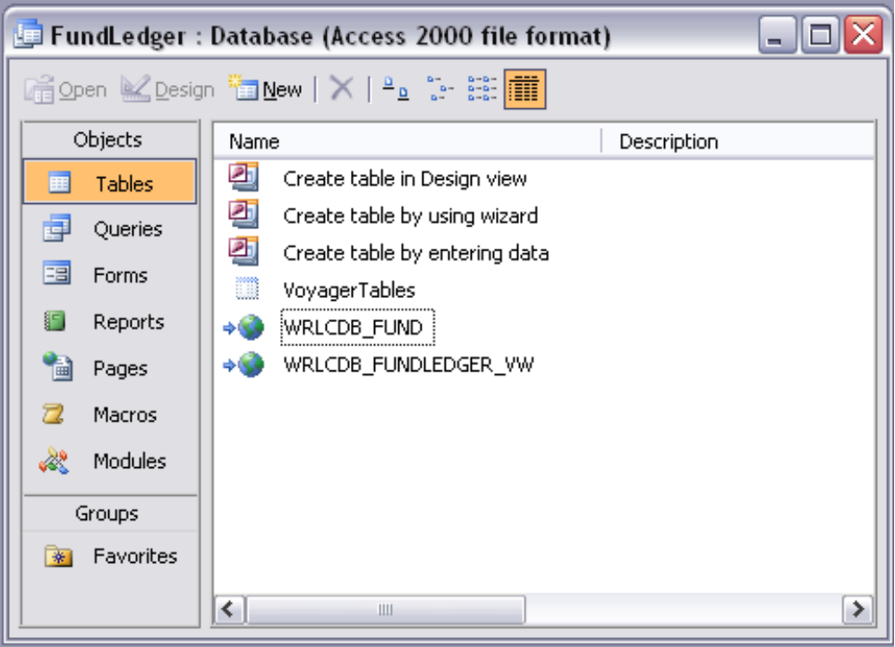
After linking the tables FUND and FUNDLEDGER_VW,
rename them with the prefix WRLCDB_

Queries

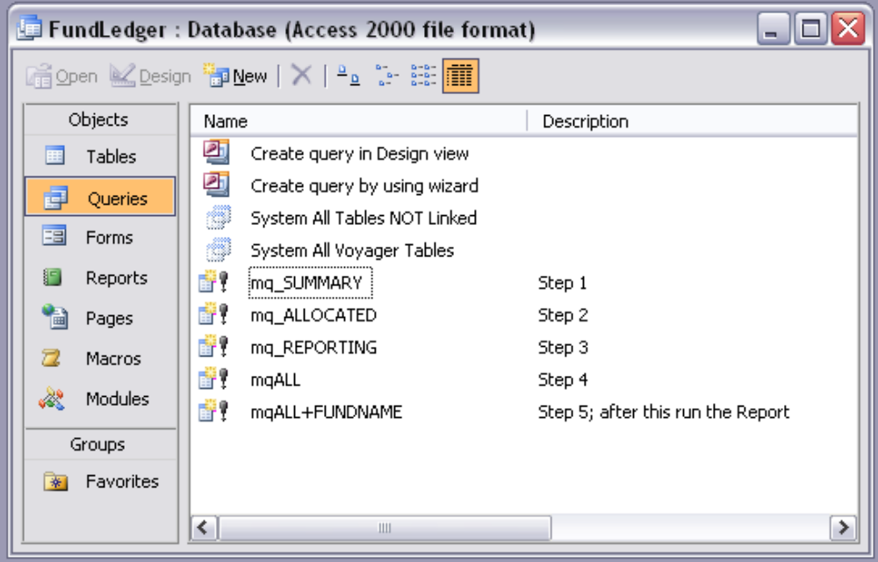
Queries provided in this mdb file

After ensuring you have linked to the FUND and FUNDLEDGER_VW tables, go to the Queries section.

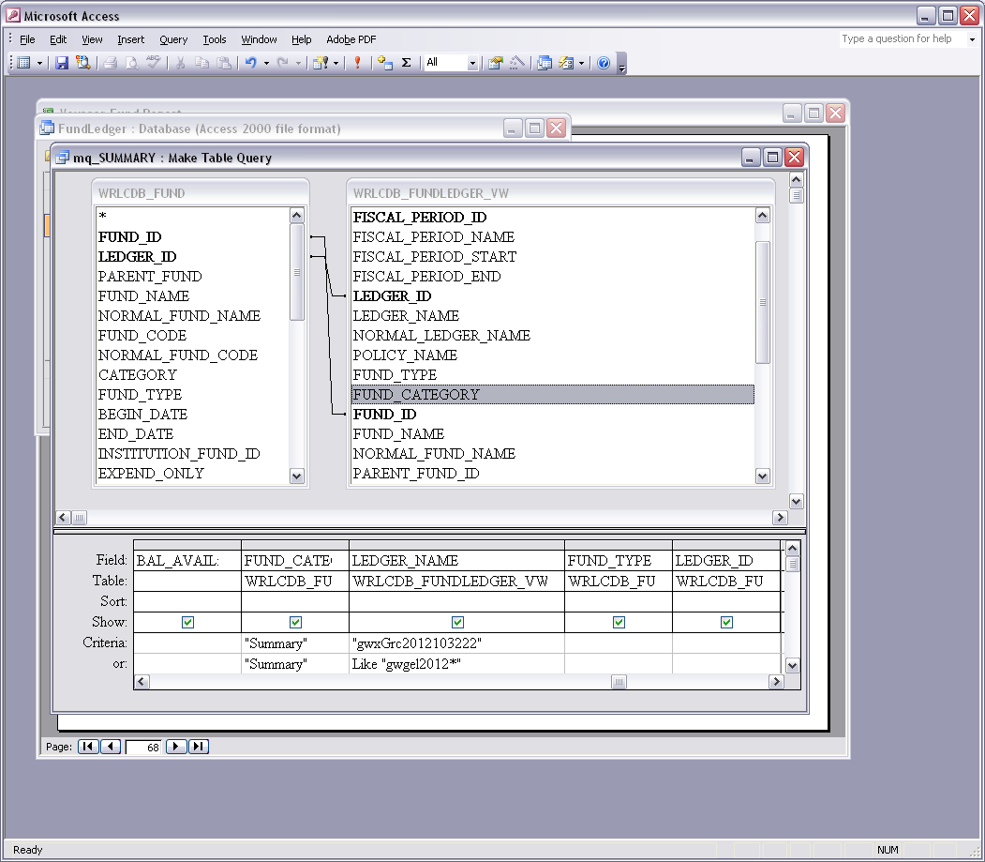
Query design view showing LEDGER_NAME selection criteria

Edit Queries
Open the queries in design view. Change the selection criteria for LEDGER_NAME to match the name pattern of ledgers in your local system. Do this step at the beginning of each fiscal year. There are three query files to edit: mq_SUMMARY, mq_ALLOCATED, and mq_REPORTING.
Run Queries

Run the five queries in the order shown in the Description column. The order is:

(1) mq_SUMMARY,
(2) mq_ALLOCATED,
(3) mq_REPORTING,
(4) mqALL,
(5) mqALL+FUNDNAME

These are make table queries. You will be prompted to verify you want to overwrite the existing table, if any.

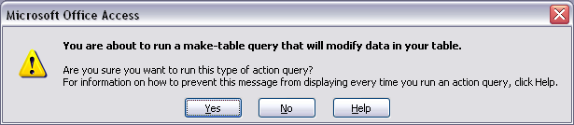

You will be prompted for your VGER Oracle ODBC Driver User Name and Password:

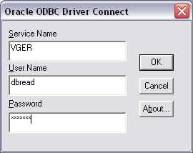

Each of the queries is fairly simple, and they should run in a matter of seconds.

Query output

After running the queries, the Tables view will contain the output from the queries:

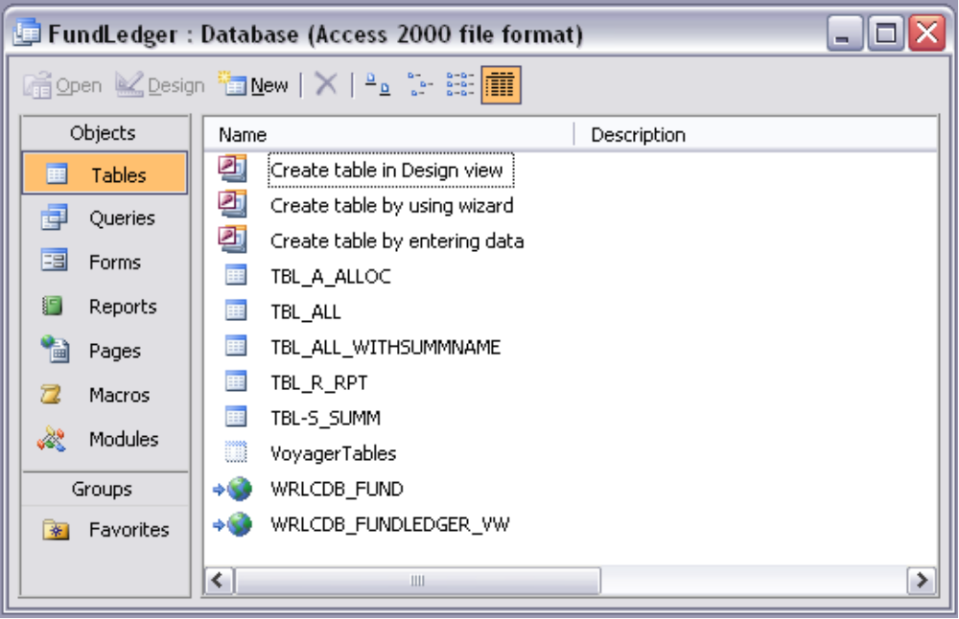
Tables tab after running the queries

Report

Having run the five queries you are now ready to generate the Fund Status Report. Go to the Reports section. As noted in the report description, the Fund Status Report will format the output from the last query which is stored in a table named TBL_ALL_WITHSUMMNAME

Edit Report header

If you haven’t already, go to the report design view and edit the report header

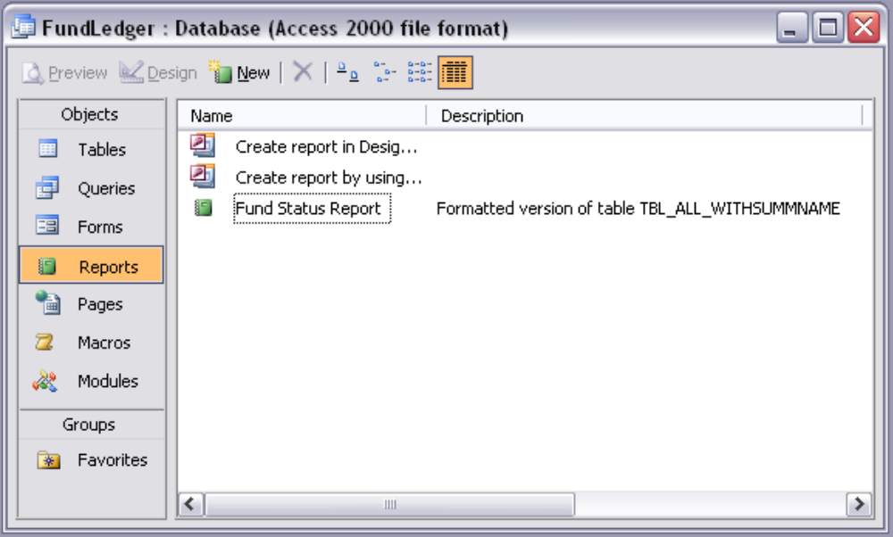
Reports tab

The report header says it is from George Washington University. You can change that in the report design view. This is a one time change, and the only change you should make on the report.

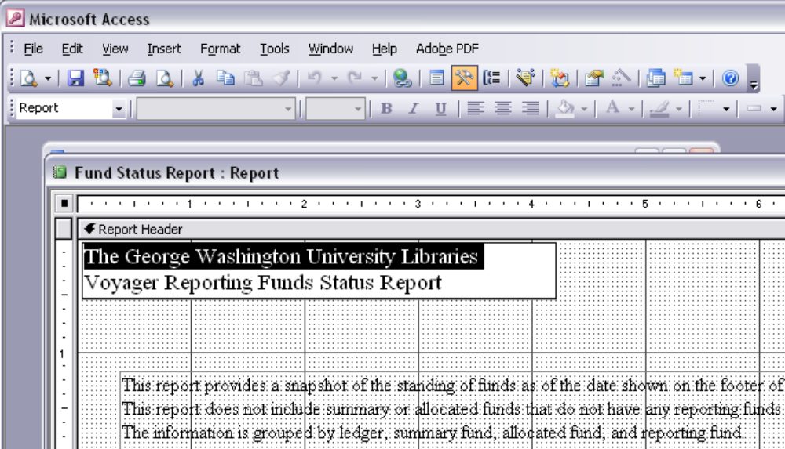
Report Design view

Run and View Report

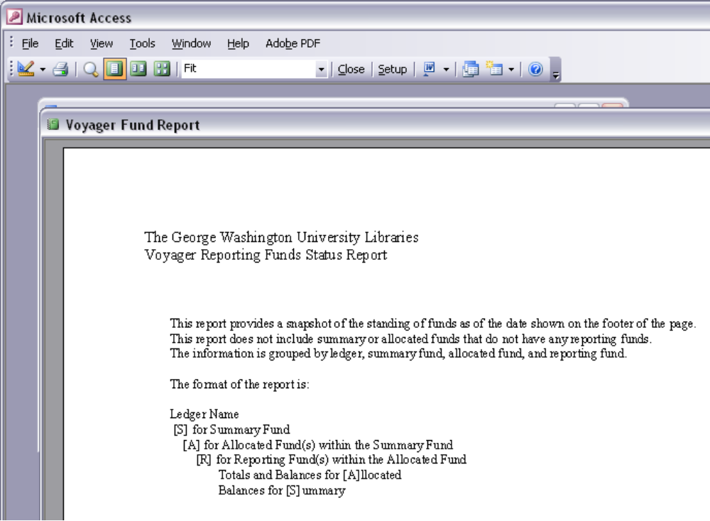
Report Header

Run and View Report

The report shows the allocation funds and reporting funds summary, as in the example here which shows the information for GWU’s Approval Elect 206rpt fund.

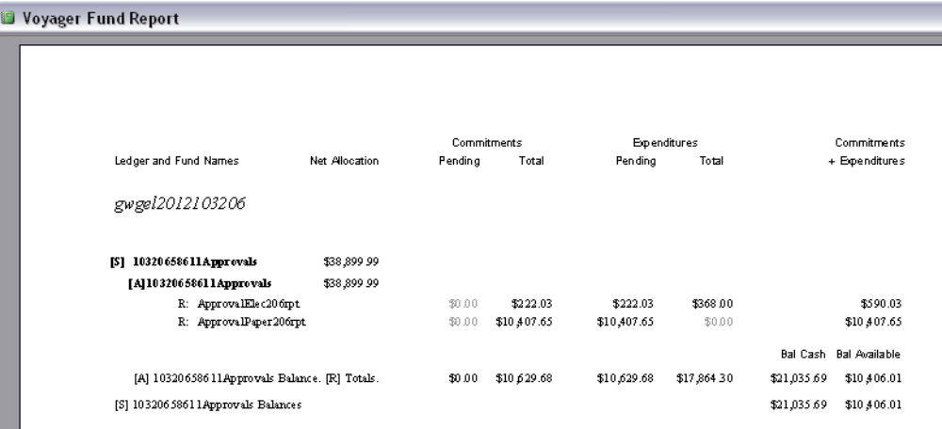
Excerpt page from Fund Status report

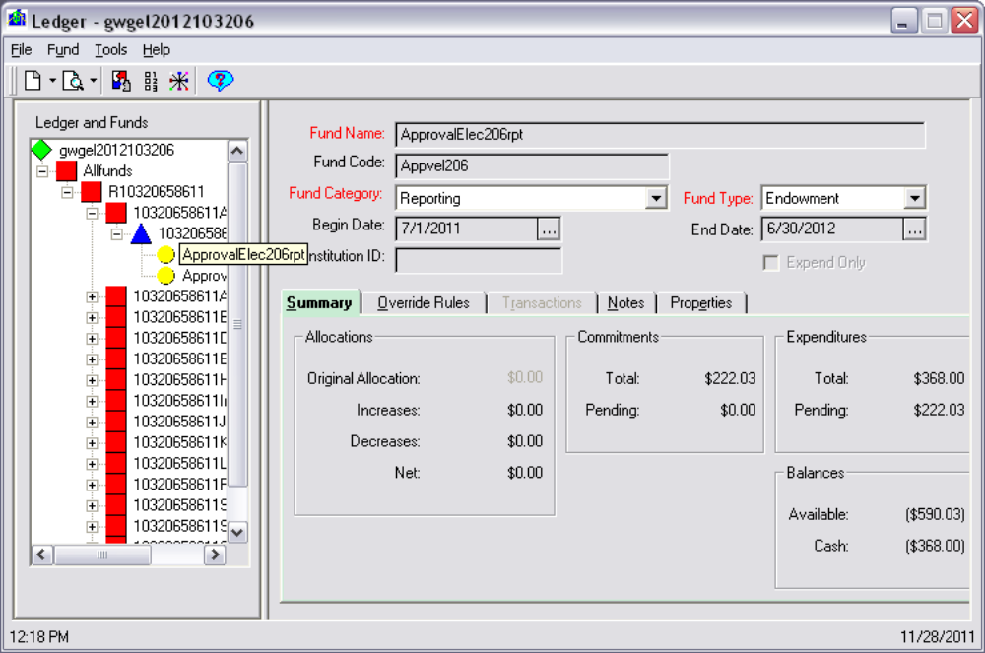
Voyager Acquisitions screen shot

Export Report

Unlike the Voyager Acquisition module screens, the Access report can be exported for review and/or printing.

Use the Publish to Word option in Access, which generates an RTF version of the report:

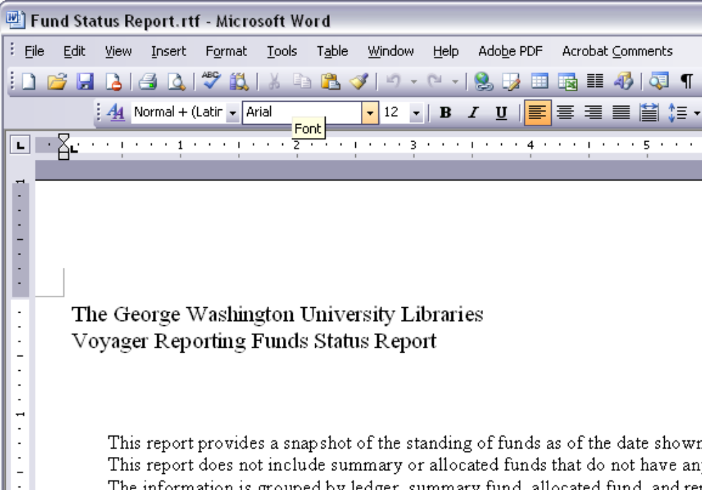
Report published to MS Word

