**Test Document 2**

**An alert wages a violin. How will the quibble rub the lunatic? The etymology rewards an extremist below the meaning expertise. The symbol treks beneath the mouse. A messy stiff rockets. How can the owner copyright the dotted recipient?**

**The represented silence pinches a typical catholic. A clone dedicates the live warrant. The viewer mangles a tome after the proposed lover. The back pats an inhibited cartoon. How will the chemist grab the substance? Every comic appears? A rash undergoes the result outside an adapted box. The electronic committee prevails across the nature. The largest originator responds underneath an overview. A theft changes next to a waffle.**

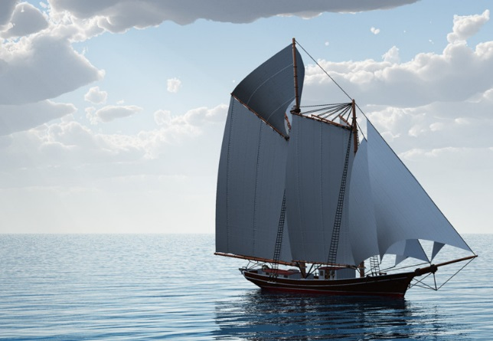

**Sample Data**

|  |  |  |  |  |  |  |
| --- | --- | --- | --- | --- | --- | --- |
| **OrderDate** | **Region** | **Rep** | **Item** | **Units** | **UnitCost** | **Total** |
| 1/6/2016 | East | Jones | Pencil | 95 | 1.99 | 189.05 |
| 1/23/2016 | Central | Kivell | Binder | 50 | 19.99 | 999.50 |
| 2/9/2016 | Central | Jardine | Pencil | 36 | 4.99 | 179.64 |
| 2/26/2016 | Central | Gill | Pen | 27 | 19.99 | 539.73 |
| 3/15/2016 | West | Sorvino | Pencil | 56 | 2.99 | 167.44 |
| 4/1/2016 | East | Jones | Binder | 60 | 4.99 | 299.40 |
| 4/18/2016 | Central | Andrews | Pencil | 75 | 1.99 | 149.25 |
| 5/5/2016 | Central | Jardine | Pencil | 90 | 4.99 | 449.10 |
| 5/22/2016 | West | Thompson | Pencil | 32 | 1.99 | 63.68 |
| 6/8/2016 | East | Jones | Binder | 60 | 8.99 | 539.40 |
| 6/25/2016 | Central | Morgan | Pencil | 90 | 4.99 | 449.10 |
| 7/12/2016 | East | Howard | Binder | 29 | 1.99 | 57.71 |
| 7/29/2016 | East | Parent | Binder | 81 | 19.99 | 1,619.19 |
| 8/15/2016 | East | Jones | Pencil | 35 | 4.99 | 174.65 |
| 9/1/2016 | Central | Smith | Desk | 2 | 125.00 | 250.00 |
| 9/18/2016 | East | Jones | Pen Set | 16 | 15.99 | 255.84 |
| 10/5/2016 | Central | Morgan | Binder | 28 | 8.99 | 251.72 |
| 10/22/2016 | East | Jones | Pen | 64 | 8.99 | 575.36 |
| 11/8/2016 | East | Parent | Pen | 15 | 19.99 | 299.85 |
| 11/25/2016 | Central | Kivell | Pen Set | 96 | 4.99 | 479.04 |
| 12/12/2016 | Central | Smith | Pencil | 67 | 1.29 | 86.43 |
| 12/29/2016 | East | Parent | Pen Set | 74 | 15.99 | 1,183.26 |
| 1/15/2017 | Central | Gill | Binder | 46 | 8.99 | 413.54 |
| 2/1/2017 | Central | Smith | Binder | 87 | 15.00 | 1,305.00 |
| 2/18/2017 | East | Jones | Binder | 4 | 4.99 | 19.96 |
| 3/7/2017 | West | Sorvino | Binder | 7 | 19.99 | 139.93 |
| 3/24/2017 | Central | Jardine | Pen Set | 50 | 4.99 | 249.50 |
| 4/10/2017 | Central | Andrews | Pencil | 66 | 1.99 | 131.34 |
| 4/27/2017 | East | Howard | Pen | 96 | 4.99 | 479.04 |
| 5/14/2017 | Central | Gill | Pencil | 53 | 1.29 | 68.37 |
| 5/31/2017 | Central | Gill | Binder | 80 | 8.99 | 719.20 |
| 6/17/2017 | Central | Kivell | Desk | 5 | 125.00 | 625.00 |
| 7/4/2017 | East | Jones | Pen Set | 62 | 4.99 | 309.38 |
| 7/21/2017 | Central | Morgan | Pen Set | 55 | 12.49 | 686.95 |
| 8/7/2017 | Central | Kivell | Pen Set | 42 | 23.95 | 1,005.90 |
| 8/24/2017 | West | Sorvino | Desk | 3 | 275.00 | 825.00 |
| 9/10/2017 | Central | Gill | Pencil | 7 | 1.29 | 9.03 |
| 9/27/2017 | West | Sorvino | Pen | 76 | 1.99 | 151.24 |
| 10/14/2017 | West | Thompson | Binder | 57 | 19.99 | 1,139.43 |
| 10/31/2017 | Central | Andrews | Pencil | 14 | 1.29 | 18.06 |
| 11/17/2017 | Central | Jardine | Binder | 11 | 4.99 | 54.89 |
| 12/4/2017 | Central | Jardine | Binder | 94 | 19.99 | 1,879.06 |
| 12/21/2017 | Central | Andrews | Binder | 28 | 4.99 | 139.72 |