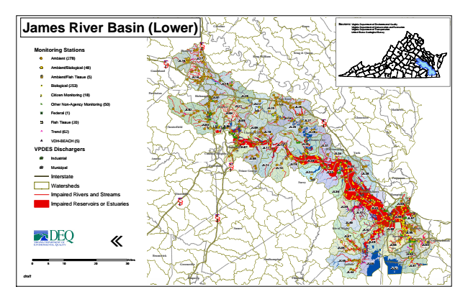

**James River Basin (Lower)**

**Monitoring Stations**

Ambient (278)

Ambient/Biological (48)

Ambient/Fish Tissue (5)

#* Biological (253)

kj Citizen Monitoring (18)

k Other Non-Agency Monitoring (50)

XW Federal (1)

Fish Tissue (20)

^ Trend (62)

!A VDH-BEACH (5)

**VPDES Dischargers**

A@ Industrial

A@ Municipal

Interstate

Watersheds

Impaired Rivers and Streams

Impaired Reservoirs or Estuaries

«

0 5

10 20 30 Sources: Virginia Department of Environmental Quality Virginia Department of Conservation and Recreation Virginia Department of Transportation United States Geological Survey

*draft*

Miles

**Northumberland Louisa**

**Caroline**

**Essex**

**Hanover**

**§ ̈¦ 95**

**Lancaster King & Queen § ̈¦ 64**

**JL16**

**JL17**

**King William**

**Goochland**

**Middlesex JL18**

**JL19**

**Powhatan**

**Richmond**

**JL01**

**JL20**

**New Kent**

**JL02**

**Henrico**

**JL21**

**JL22**

**JL23**

**JL26**

**Mathews JL04**

**JL05**

**Chesterfield**

**JL03**

**JL06**

**JL09**

**JL24**

**JL27**

**JL25**

**§ ̈¦ 64**

**James City**

**Amelia**

**Poquoson**

**Emporia**

**Franklin Gloucester Charles City**

**JL10**

**JL28**

**Hopewell**

**JL07**

**JL11**

**JL13**

**JL29**

**JL31**

**Williamsburg Colonial Heights**

**JL34**

**York**

**JL08**

**Petersburg**

**§ ̈¦ 295**

**JL12**

**Prince George**

**JL14**

**JL30 JL15**

**JL35**

**JL32**

**JL33**

**JL38**

**Surry**

**Dinwiddie**

**JL36**

**JL37**

**JL43 JL41**

**JL57 JL40**

**Sussex**

**JL42**

**JL50**

**Norfolk JL56 JL47**

**Portsmouth**

**JL49**

**Virginia Beach**

**JL46**

**JL55**

**Brunswick**

**JL53 Southampton**

**Greensville**

**Suffolk**

**JL48**

**Chesapeake**

**JL52**

**JL51**

**JL44**

**Newport News § ̈¦ 85**

**Hampton**

**JL39**

**JL58**

**§ ̈¦ 95**

**JL59**

**Isle of Wight**

**JL54**

**JL45**