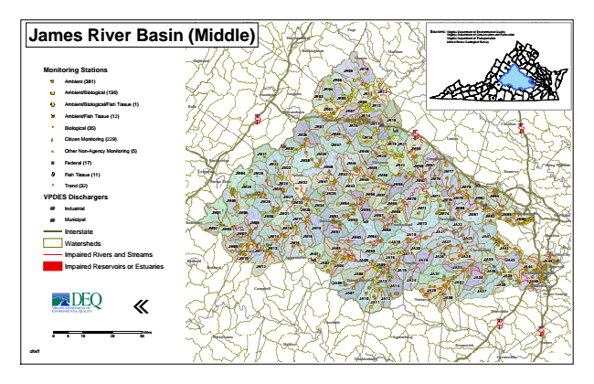

**James River Basin (Middle)**

**Monitoring Stations**

Ambient (381)

Ambient/Biological (136)

Ambient/Biological/Fish Tissue (1)

Ambient/Fish Tissue (12)

#* Biological (35)

kj Citizen Monitoring (229)

k Other Non-Agency Monitoring (5)

XW Federal (17)

Fish Tissue (11)

^ Trend (32)

**VPDES Dischargers**

A@ Industrial

A@ Municipal

Interstate

Watersheds

Impaired Rivers and Streams

Impaired Reservoirs or Estuaries

«

0 5 10 20 30 Sources: Virginia Virginia Department Department of of Environmental Conservation and Quality Recreation Virginia Department of Transportation United States Geological Survey

*draft*

Miles

**Page**

**Fauquier**

**King William**

**Lynchburg**

**Harrisonburg**

**Culpeper**

**Rockingham**

**Hopewell**

**Halifax**

**Madison**

**Henrico**

**Appomattox**

**Stafford**

**Highland**

**Greene**

**Powhatan**

**Brunswick**

**Fredericksburg**

**King George**

**JR09**

**JR10**

**JR06**

**Orange**

**Staunton**

**Augusta**

**JR03**

**JR04**

**JR11**

**JR12**

**Spotsylvania**

**JR05**

**JR08 Bath**

**JR13 § ̈¦ 81**

**Waynesboro**

**JR02**

**JR07**

**JR14 Albemarle**

**Charlottesville**

**JR18 JR01**

**JR15**

**JR17**

**JM36**

**JM46**

**JR16**

**§ ̈¦ 64**

**Louisa**

**Fluvanna**

**Buena Vista**

**JM71 JM68**

**JM09**

**JM10**

**Colonial Heights**

**JA40**

**JA10**

**Charlotte**

**Caroline**

**§ ̈¦ 95**

**JM21**

**JM37**

**JM39**

**JM47**

**JM48**

**JR19**

**JR21**

**JM59**

**JR20 Rockbridge**

**JM22**

**JM23**

**JM38**

**JM44**

**JM60**

**Goochland**

**Lexington**

**JM04**

**JM25**

**Nelson**

**JM40**

**JM42**

**JM49**

**JR22**

**JM61**

**JM28**

**JM26**

**JM24**

**JM32**

**JM41**

**JM43**

**JM45**

**JM50**

**JM58**

**JM62**

**JM76**

**JM77**

**Hanover**

**JM79**

**JM05**

**Amherst**

**JM29**

**JM27**

**JM33**

**JM34**

**JM35**

**JM54**

**JM56**

**JM57**

**JM69**

**JM70**

**JM72**

**JM75**

**JM78**

**JM82**

**JM84**

**JM01**

**JM06**

**JM31**

**JM17**

**JM20**

**JM52**

**JM53**

**JM55**

**JM67**

**JM74**

**JM81**

**JM02**

**JM03**

**JM08**

**Cumberland**

**JM73**

**JA22**

**JM14**

**JM18**

**JM63**

**JM64**

**JM66**

**JA19**

**JA21**

**JA23**

**JM11**

**JA03**

**JA17**

**JA20**

**Chesterfield**

**JA42**

**Bedford**

**Bedford**

**JM80**

**JM85**

**Richmond**

**JM15**

**JM12**

**JA05**

**JA09**

**JA15**

**JA25**

**JA26**

**JA28**

**JA35**

**JA33**

**JA44**

**JA45**

**JA08**

**Prince Edward**

**JA24**

**JA31**

**JA34**

**JA36**

**JA39**

**Campbell**

**JA07**

**JA29**

**JA11**

**JA12**

**JA30**

**Petersburg**

**Prince George**

**§ ̈¦ 85**

**§ ̈¦ 95**

**Greensville New Botetourt**

**JM30**

**Buckingham**

**JM83**

**JM86**

**Kent**

**JM07**

**JM13**

**JM19**

**JM51**

**Charles City**

**JA02**

**JA32**

**Mecklenburg**

**JA41 JM16**

**JA18**

**JA27**

**JA01**

**JA04**

**JM65**

**JA16**

**Amelia**

**JA43**

**JA06**

**JA13**

**JA14**

**JA38**

**JA37**

**Nottoway**

**Dinwiddie**

**Pittsylvania**

**Lunenburg Sussex**