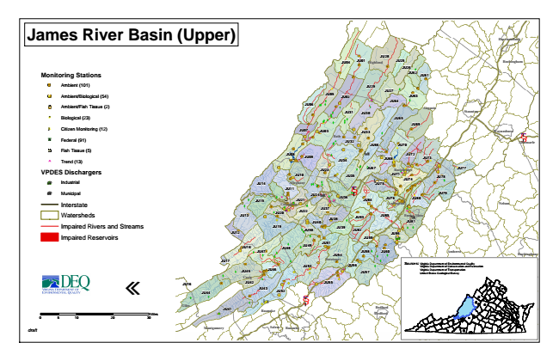

**James River Basin (Upper)**

**Monitoring Stations**

Ambient (101)

Ambient/Biological (54)

Ambient/Fish Tissue (2)

#* Biological (23)

kj Citizen Monitoring (12)

XW Federal (91)

Fish Tissue (5)

^ Trend (13)

**VPDES Dischargers**

A@ Industrial

A@ Municipal

Interstate

Watersheds

Impaired Rivers and Streams

Impaired Reservoirs

«

0 5

10 20 30 Sources: Virginia Department of Environmental Quality

Virginia Department of Conservation and Recreation Virginia Department of Transportation United States Geological Survey

*draft*

Miles

**Harrisonburg**

**JU28 JU01**

**JU29**

**Waynesboro**

**JU13**

**JU48**

**Bedford**

**JU25**

**JU12**

**JU17**

**JU16**

**JU04**

**Highland Rockingham**

**JU26**

**JU62**

**JU61**

**JU27 JU05**

**JU02**

**JU63**

**JU06**

**JU31**

**JU30**

**JU64**

**Augusta**

**Staunton**

**JU65**

**JU69**

**JU07**

**JU03**

**JU33 Bath**

**JU32**

**JU66**

**JU70**

**Albemarle § ̈¦ 64**

**JU08**

**JU09**

**JU34**

**JU68**

**JU72**

**JU73**

**JU23**

**JU67**

**Rockbridge**

**JU77**

**JU10**

**JU35**

**JU71**

**JU78**

**JU14**

**Alleghany JU11**

§ ̈¦ 64

**JU75**

**JU79**

**JU15**

**JU21**

**JU36**

**JU38**

**JU85**

**JU19**

**JU50**

**JU59**

**JU18**

**JU49**

**JU47**

**JU54**

**JU58**

**Buckingham**

**JU45**

**JU46**

**JU57**

**JU42**

**JU44**

**JU52**

**JU41**

**Bedford**

**Appomattox**

**Campbell JU74**

**JU60**

§ ̈¦ 81

**JU24**

**JU80**

**JU82**

**JU51**

**JU76**

**JU43**

**JU84**

**Lexington**

**JU53**

**JU55**

**Nelson**

**Craig**

**Covington**

**JU20**

**JU22**

**JU37**

**JU39**

**JU83**

**Buena Vista**

**JU40**

**JU81**

**JU86**

**JU56**

**Amherst**

**Botetourt**

**Lynchburg Giles**

**Roanoke**

**Montgomery Salem**

**Roanoke**