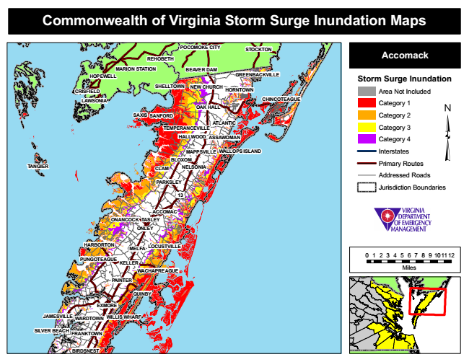

**Commonwealth of Virginia Storm Surge Inundation Maps**

**REHOBETH**

**POCOMOKE CITY**

**STOCKTON**

**Accomack**

**MARION STATION**

**BEAVER DAM**

**Storm Surge Inundation NEW CHURCH**

Area Not Included

**LAWSONIA**

Category 1

Category 2

Category 3

Category 4

**MAPPSVILLE**

**WALLOPS ISLAND**

Interstates

Primary Routes

Addressed Roads

Jurisdiction Boundaries

0 1 2 3 4 5 6 7 8 9 101112

Miles

**JAMESVILLE**

**HOPEWELL**

**GREENBACKVILLE**

**TEMPERANCEVILLE**

**13**

**WARDTOWN**

**SHELLTOWN CRISFIELD**

**HARBORTON**

**FRANKTOWN**

**BIRDSNEST**

**HORNTOWN**

**HALLWOOD**

**CHINCOTEAGUE**

**OAK HALL SAXIS**

**NELSONIA**

**ONLEY**

**MELFA**

**SANFORD**

**PAINTER**

**ATLANTIC**

**ASSAWOMAN**

**BLOXOM TANGIER**

**CLAM**

**PARKSLEY**

**ONANCOCK**

**ACCOMAC TASLEY**

**LOCUSTVILLE**

**PUNGOTEAGUE**

**KELLER**

**WACHAPREAGUE**

**QUINBY**

**EXMORE**

**WILLIS WHARF**

**SILVER BEACH**