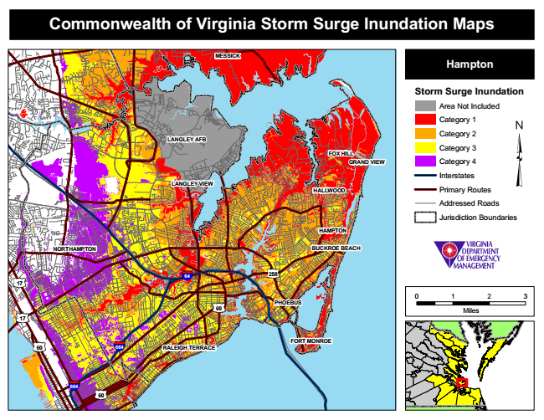

**Commonwealth of Virginia Storm Surge Inundation Maps**

**MESSICK**

**Hampton**

**Storm Surge Inundation**

Area Not Included

Category 1

**LANGLEY AFB**

Category 2

**FOX HILL**

Category 3

**GRAND VIEW**

Category 4

Interstates LANGLEY VIEW

Primary Routes

Addressed Roads

Jurisdiction Boundaries

**HAMPTON**

**NORTHAMPTON**

**BUCKROE BEACH**

0 1 2 3

Miles

**FORT MONROE RALEIGH TERRACE**

**HALLWOOD**

**258 17**

**60**

**64**

**664**

**664**

**60**

**PHOEBUS**

**17**

**60**