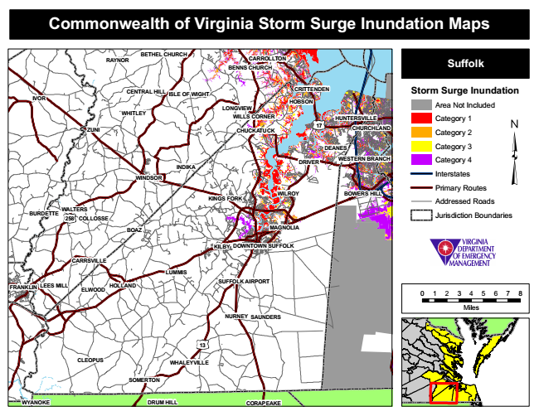

**Commonwealth of Virginia Storm Surge Inundation Maps**

**RAYNOR**

**BETHEL CHURCH**

**CARROLLTON BENNS CHURCH**

**Suffolk**

**IVOR**

**CENTRAL HILL**

**ISLE OF WIGHT**

**CRITTENDEN**

**Storm Surge Inundation**

Area Not Included

Category 1

**CHUCKATUCK**

**CHURCHLAND**

Category 2

Category 3

**WESTERN BRANCH**

Category 4

Interstates

Primary Routes

Addressed Roads

Jurisdiction Boundaries

**BOAZ**

**KILBY**

**CARRSVILLE**

**SUFFOLK AIRPORT**

0 1 2 3 4 5 6 7 8

**Miles NURNEY**

**WHALEYVILLE**

**HOBSON**

**ELWOOD**

**LONGVIEW**

**FRANKLIN**

**WHITLEY**

**WALTERS**

**HOLLAND**

**CLEOPUS**

**SOMERTON**

**WILLS CORNER HUNTERSVILLE**

**ZUNI**

**17**

**DEANES**

**WYANOKE**

**INDIKA**

**DRIVER**

**WINDSOR**

**KINGS FORK**

**WILROY**

**BOWERS HILL**

**BURDETTE**

**258**

**COLLOSSE**

**MAGNOLIA**

**DOWNTOWN SUFFOLK**

**LUMMIS**

**LEES MILL**

**SAUNDERS**

**13**

**DRUM HILL CORAPEAKE**