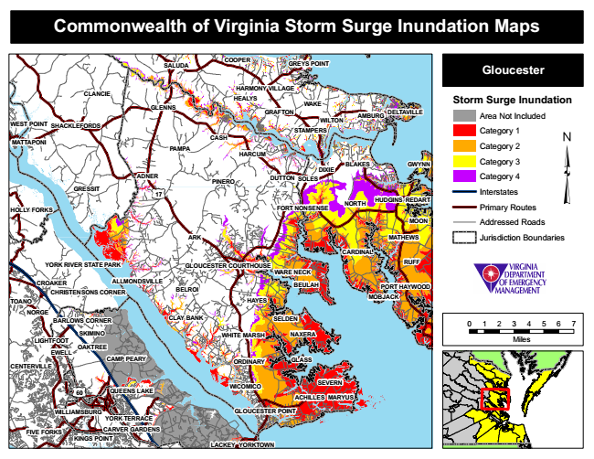

**Commonwealth of Virginia Storm Surge Inundation Maps**

**COOPER**

**GREYS POINT**

**Gloucester**

**Storm Surge Inundation**

Area Not Included

Category 1

Category 2

**BLAKES**

Category 3

Category 4

Interstates

Primary Routes

Addressed Roads

Jurisdiction Boundaries

**BELROI**

**BEULAH**

0 1 2 3 4 5 6 7

Miles

**CENTERVILLE**

**YORK TERRACE**

**SALUDA**

**CLANCIE**

**HARMONY VILLAGE HEALYS GLENNS**

**WEST POINT**

**SHACKLEFORDS**

**HARCUM**

**REDART**

**GLOUCESTER POINT**

**YORKTOWN**

**WAKE GRAFTON**

**WILTON**

**AMBURG**

**DELTAVILLE**

**STAMPERS**

**MATTAPONI**

**CASH**

**PAMPA**

**DUTTON**

**NORTH**

**RUFF**

**CROAKER**

**PORT HAYWOOD**

**TOANO**

**NORGE**

**SKIMINO LIGHTFOOT**

**OAKTREE**

**CAMP PEARY**

**ORDINARY**

**SEVERN**

**FIVE FORKS**

**GWYNN**

**GLASS**

**DIXIE ADNER**

**PINERO**

**SOLES GRESSIT**

**17**

**NAXERA**

**60**

**MARYUS**

**LACKEY**

**HUDGINS**

**HOLLY FORKS**

**FORT NONSENSE**

**ALLMONDSVILLE**

**CARVER GARDENS**

**MOON**

**ARK**

**MATHEWS**

**CARDINAL**

**YORK RIVER STATE PARK**

**GLOUCESTER COURTHOUSE**

**WARE NECK**

**CHRISTENSONS CORNER**

**HAYES**

**MOBJACK**

**BARLOWS CORNER**

**CLAY BANK**

**SELDEN**

**WHITE MARSH**

**EWELL**

**QUEENS LAKE**

**ACHILLES**

**KINGS POINT**

**WICOMICO**

**WILLIAMSBURG**