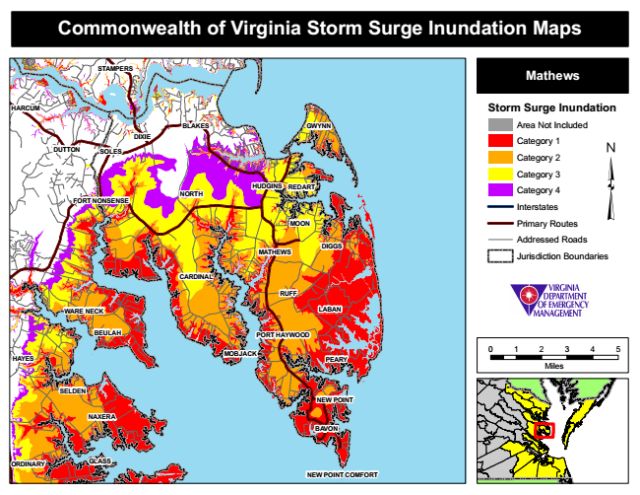

**Commonwealth of Virginia Storm Surge Inundation Maps**

**STAMPERS**

**Mathews**

**HARCUM**

**Storm Surge Inundation**

Area Not Included

Category 1 DUTTON

Category 2

Category 3

Category 4

Interstates

Primary Routes

Addressed Roads

Jurisdiction Boundaries

0 1 2 3 4 5

Miles

**ORDINARY**

**BLAKES**

**BEULAH**

**MOBJACK**

**GWYNN**

**GLASS**

**DIXIE**

**SOLES**

**HUDGINS**

**REDART**

**FORT NONSENSE**

**NORTH**

**MOON**

**MATHEWS**

**DIGGS**

**CARDINAL**

**RUFF**

**WARE NECK**

**LABAN**

**PORT HAYWOOD**

**HAYES**

**PEARY**

**SELDEN**

**NEW POINT**

**NAXERA**

**BAVON**

**NEW POINT COMFORT**