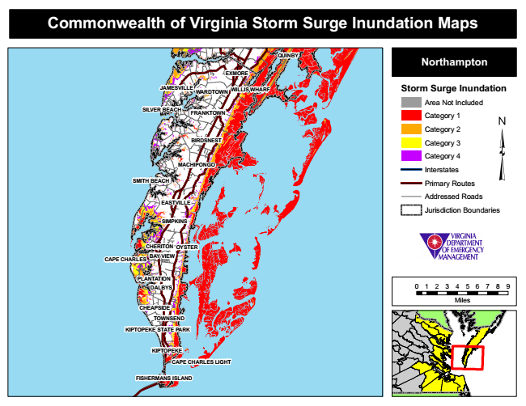

**Commonwealth of Virginia Storm Surge Inundation Maps**

**QUINBY**

**Northampton**

**EXMORE**

**JAMESVILLE**

**WILLIS WHARF**

**Storm Surge Inundation**

Area Not Included SILVER BEACH

Category 1

Category 2

Category 3

Category 4

Interstates

**SMITH BEACH**

Primary Routes

Addressed Roads

Jurisdiction Boundaries

**OYSTER**

**CAPE CHARLES**

**DALBYS**

0 1 2 3 4 5 6 7 8 9

Miles

**FISHERMANS ISLAND**

**WARDTOWN**

**TOWNSEND**

**FRANKTOWN**

**EASTVILLE**

**CHEAPSIDE**

**BIRDSNEST**

**PLANTATION**

**MACHIPONGO**

**SIMPKINS**

**CHERITON**

**BAY VIEW**

**KIPTOPEKE STATE PARK**

**KIPTOPEKE**

**CAPE CHARLES LIGHT**