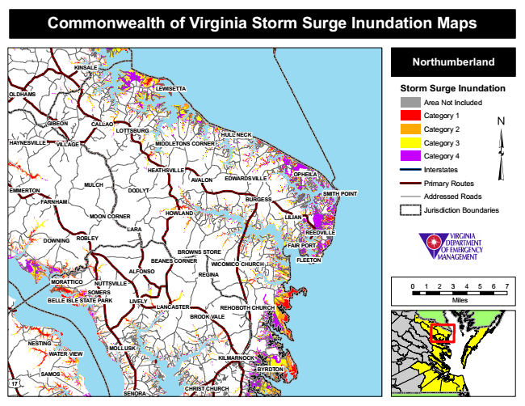

**Commonwealth of Virginia Storm Surge Inundation Maps**

**KINSALE**

**Northumberland**

**OLDHAMS**

**LEWISETTA**

**Storm Surge Inundation**

Area Not Included

Category 1 GIBEON

**CALLAO**

**LOTTSBURG**

**HULL NECK**

Category 2

**HAYNESVILLE**

**VILLAGE**

**MIDDLETONS CORNER**

Category 3

Category 4

**MULCH**

**HEATHSVILLE**

**AVALON**

**EDWARDSVILLE**

**OPHEILA**

Interstates

Primary Routes EMMERTON

**DODLYT**

Addressed Roads

**HOWLAND**

Jurisdiction Boundaries

**REEDVILLE**

**FAIR PORT BROWNS STORE**

**FLEETON**

**MORATTICO**

**0 1 2 3 4 5 6 7 SOMERS BELLE ISLE STATE PARK**

**Miles LANCASTER**

**NESTING**

**MOLLUSK WATER VIEW**

**17**

**SENORA**

**CHRIST CHURCH**

**SMITH POINT FARNHAM**

**BURGESS**

**MOON CORNER**

**DOWNING**

**ALFONSO**

**BYRDTON**

**LILIAN**

**LARA**

**SAMOS**

**ROBLEY**

**REGINA**

**LIVELY**

**BEANES CORNER**

**WICOMICO CHURCH**

**NUTTSVILLE**

**REHOBOTH CHURCH BROOK VALE**

**KILMARNOCK**