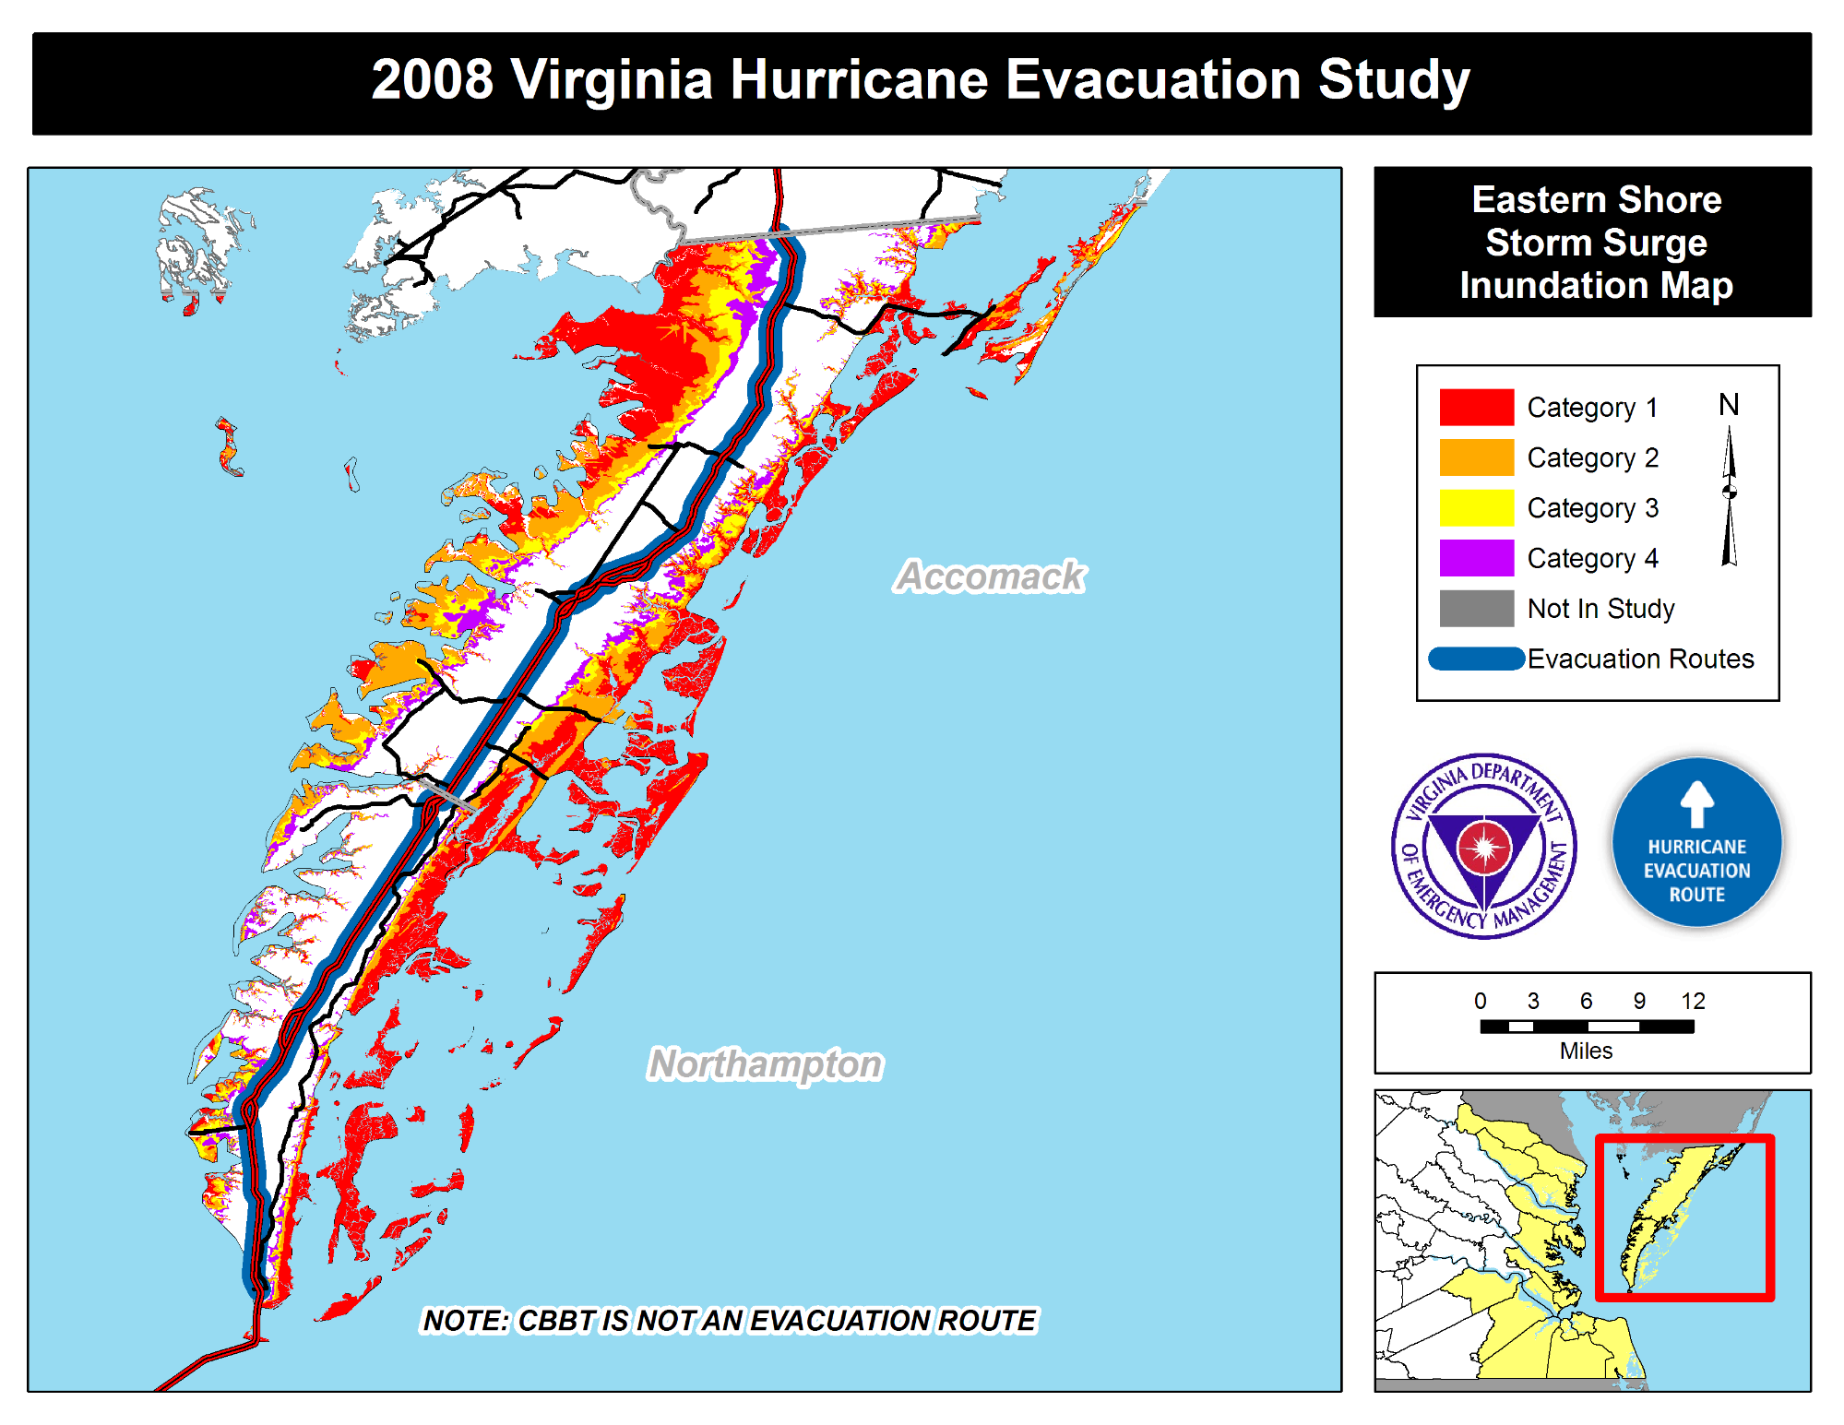

_Evacuation Routes

_ Category 1 _ Category 2 _ Category 3 _ Category 4 _ Not In Study

nunatlon 'a

HUIIIIIVI

EDI

. Hurricane Evacuation tud j