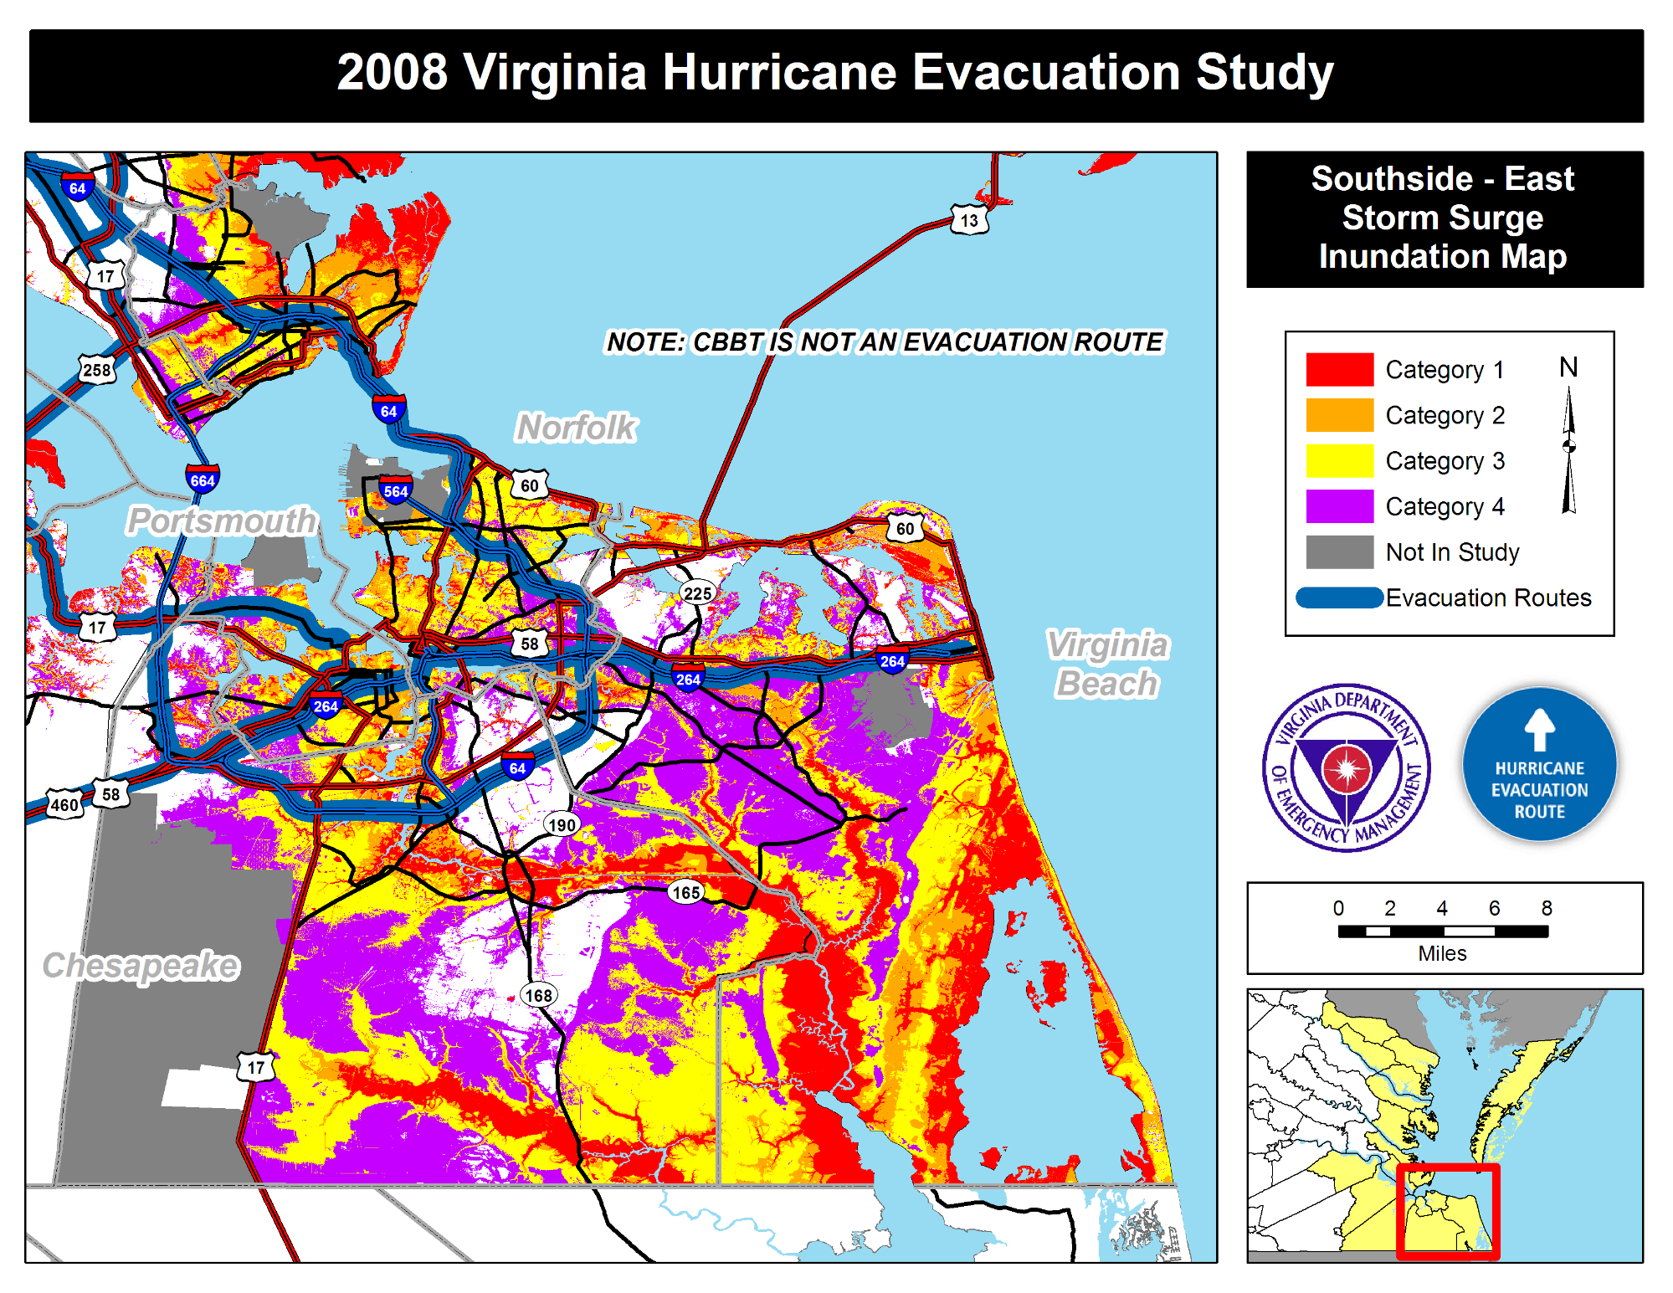

008 Vir inia Hurricane Evacuation tud

NOTE: CBBT IS NOTfAN EVA CUATION ROUTE

mi;

_ Category 1 N _ Category 2 _ Category 3 _ Category 4 _ Not In Study

_Evacuation Routes