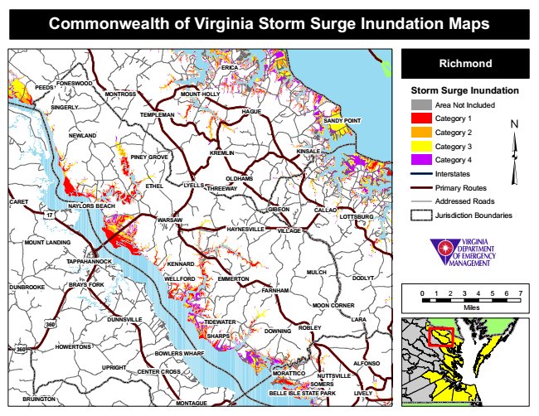

**Commonwealth of Virginia Storm Surge Inundation Maps**

**ERICA**

**Richmond**

**PEEDS**

**FONESWOOD**

**MONTROSS**

**MOUNT HOLLY**

**Storm Surge Inundation**

**SINGERLY**

**TEMPLEMAN**

**HAGUE**

Area Not Included

Category 1

Category 2

Category 3

Category 4

Interstates

**ETHEL**

Primary Routes

**CARET**

Addressed Roads

**WARSAW**

Jurisdiction Boundaries

**MULCH**

**DUNBROOKE**

0 1 2 3 4 5 6 7

**MOON CORNER**

Miles

**MORATTICO**

**SOMERS**

**BRUINGTON**

**MONTAGUE**

**SANDY POINT**

**NEWLAND**

**PINEY GROVE**

**KREMLIN**

**KINSALE**

**OLDHAMS LYELLS**

**THREEWAY**

**17**

**NAYLORS BEACH**

**GIBEON**

**CALLAO**

**LOTTSBURG**

**HAYNESVILLE**

**VILLAGE**

**MOUNT LANDING**

**TAPPAHANNOCK**

**KENNARD**

**WELLFORD**

**EMMERTON**

**DODLYT BRAYS FORK**

**FARNHAM**

**360**

**DUNNSVILLE**

**TIDEWATER**

**LARA**

**DOWNING**

**360**

**HOWERTONS**

**BOWLERS WHARF**

**UPRIGHT**

**CENTER CROSS**

**ROBLEY SHARPS**

**ALFONSO**

**NUTTSVILLE**

**BELLE ISLE STATE PARK**

**LIVELY**