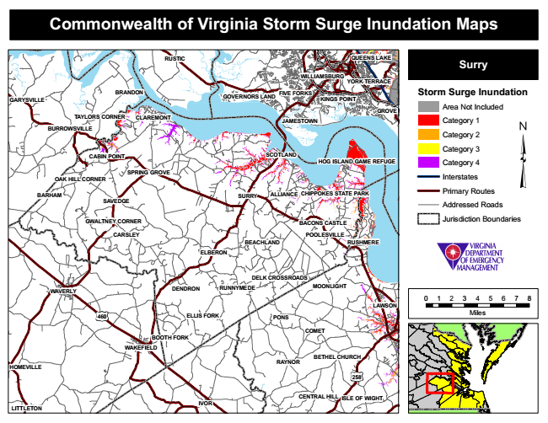

**Commonwealth of Virginia Storm Surge Inundation Maps**

**RUSTIC**

**QUEENS LAKE**

**Surry**

**Storm Surge Inundation**

Area Not Included

Category 1

Category 2

Category 3

Category 4

Interstates

Primary Routes

Addressed Roads

Jurisdiction Boundaries

**POOLESVILLE**

0 1 2 3 4 5 6 7 8

Miles

**RAYNOR**

**WILLIAMSBURG**

**SPRING GROVE**

**CENTRAL HILL**

**YORK TERRACE**

**BRANDON**

**FIVE FORKS**

**SCOTLAND**

**RUSHMERE**

**ELLIS FORK**

**BOOTH FORK**

**GOVERNORS LAND**

**OAK HILL CORNER**

**GWALTNEY CORNER**

**DELK CROSSROADS**

**KINGS POINT**

**CABIN POINT**

**GARYSVILLE**

**GROVE TAYLORS CORNER**

**CLAREMONT**

**JAMESTOWN**

**BEACHLAND**

**COMET**

**HOMEVILLE**

**BURROWSVILLE**

**HOG ISLAND GAME REFUGE**

**BARHAM**

**SAVEDGE**

**SURRY**

**ALLIANCE**

**CHIPPOKES STATE PARK**

**BACONS CASTLE**

**CARSLEY**

**ELBERON**

**WAVERLY**

**DENDRON**

**MOONLIGHT**

**WAKEFIELD**

**258**

**ISLE OF WIGHT**

**LITTLETON**

**RUNNYMEDE**

**LAWSON**

**460**

**PONS**

**IVOR**

**BETHEL CHURCH**