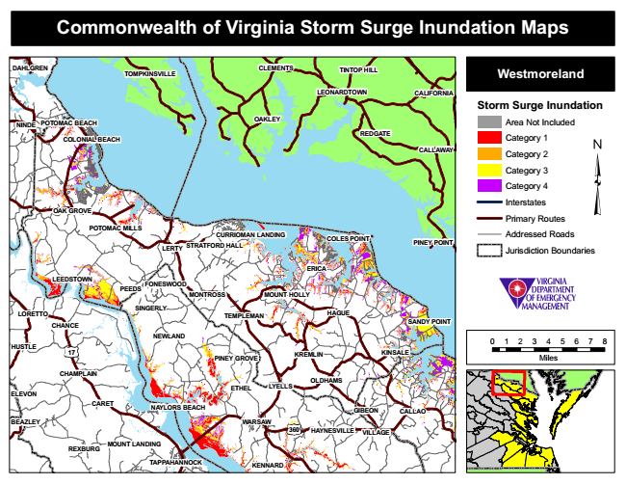

**Commonwealth of Virginia Storm Surge Inundation Maps**

**DAHLGREN**

**TOMPKINSVILLE**

**CLEMENTS**

**TINTOP HILL**

**Westmoreland**

**LEONARDTOWN**

**CALIFORNIA**

**Storm Surge Inundation**

**NINDE**

**POTOMAC BEACH**

**OAKLEY**

Area Not Included

Category 1

**CALLAWAY**

Category 2

Category 3

Category 4

Interstates

Primary Routes POTOMAC MILLS

Addressed Roads

**LERTY**

**PINEY POINT**

Jurisdiction Boundaries

**SINGERLY**

**TEMPLEMAN**

**HAGUE**

**SANDY POINT**

0 1 2 3 4 5 6 7 8

**PINEY GROVE**

Miles

**ETHEL**

**NAYLORS BEACH**

**WARSAW**

**MOUNT LANDING**

**REDGATE COLONIAL BEACH**

**OAK GROVE**

**CURRIOMAN LANDING**

**LEEDSTOWN**

**FONESWOOD**

**17**

**CHAMPLAIN**

**360**

**VILLAGE**

**REXBURG**

**COLES POINT STRATFORD HALL**

**TAPPAHANNOCK**

**ERICA**

**CARET**

**PEEDS**

**MONTROSS**

**MOUNT HOLLY**

**LORETTO**

**CHANCE**

**NEWLAND HUSTLE**

**KREMLIN**

**GIBEON**

**CALLAO**

**HAYNESVILLE**

**KINSALE**

**KENNARD**

**OLDHAMS LYELLS ELEVON**

**BEAZLEY**