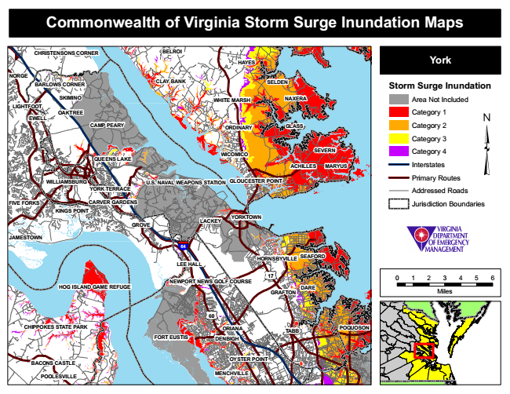

**Commonwealth of Virginia Storm Surge Inundation Maps**

**CHRISTENSONS CORNER**

**BELROI**

**HAYES**

**York**

**NORGE**

**BARLOWS CORNER**

**CLAY BANK**

**SELDEN**

**Storm Surge Inundation**

**SKIMINO**

**WHITE MARSH**

**NAXERA**

Area Not Included LIGHTFOOT

**OAKTREE EWELL**

Category 1

**CAMP PEARY**

**ORDINARY**

**GLASS**

Category 2

Category 3

**QUEENS LAKE**

**WICOMICO**

**SEVERN**

Category 4

**ACHILLES**

**MARYUS**

Interstates

**WILLIAMSBURG**

**U.S. NAVAL WEAPONS STATION**

**GLOUCESTER POINT**

Primary Routes

**YORK TERRACE**

Addressed Roads

**FIVE FORKS**

**CARVER GARDENS**

Jurisdiction Boundaries KINGS POINT

**GROVE**

**LACKEY**

**JAMESTOWN**

**64**

**SEAFORD LEE HALL**

**17**

0 1 2 3 4 5 6

**GRAFTON**

Miles

**60**

**CHIPPOKES STATE PARK**

**ORIANA**

**POQUOSON**

**FORT EUSTIS**

**DENBIGH**

**OYSTER POINT**

**POOLESVILLE**

**MENCHVILLE**

**HORNSBYVILLE**

**BACONS CASTLE**

**YORKTOWN**

**NEWPORT NEWS GOLF COURSE HOG ISLAND GAME REFUGE**

**DARE**

**TABB**