**Vergleich**

EA Magic Draw

**Element**

1. from diagram deleted element stay in Ordnung

In the model and xml

2. merge,decision no difference merge hat just one outgoins

3 just fork fork and join, join hat just one outgoing

Import from EA all are uml:fork

4 object node and buffered just buffered

5 guard body 1 attribute, 2 node from edge

6 action just callbehavior

Import from MD all are callbehavior action

7 activity no activity

**Simulation:**

1 tool inklusiv tool download

2object supported object not supported, but action mit pin,pout

3 just control flow action1 mit pout to action2 mit pin

4 action1 to action2 or action3 action1 to action2 and action3

**Stereotype**

Just tags, but not showed in diagram stereotype mit property, be showed in diagram

**Test-version**

30 days 3-4 months

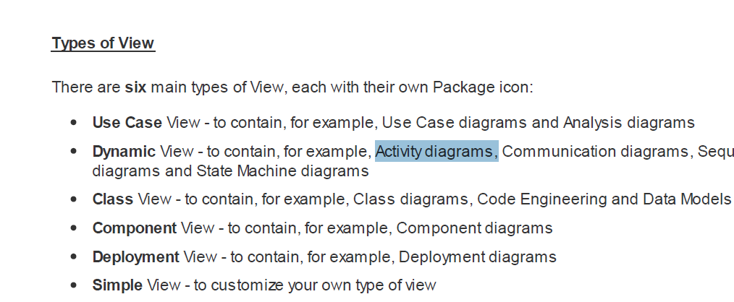

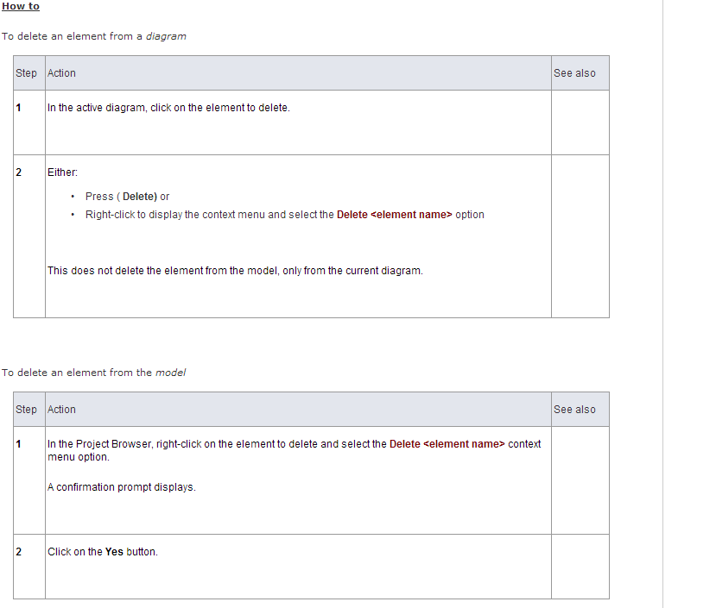

<http://www.sparxsystems.com/enterprise_architect_user_guide/10/modeling_basics/deletingobjects.html>

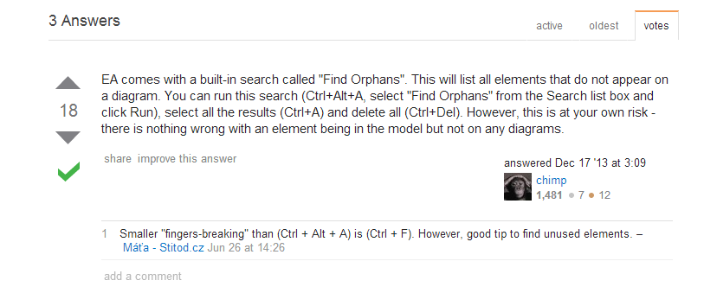

1 the possibility

20s, 25s

2 data flow graph

3 Schnittstelle Errorpro

Unit-test

Pylint—8.5

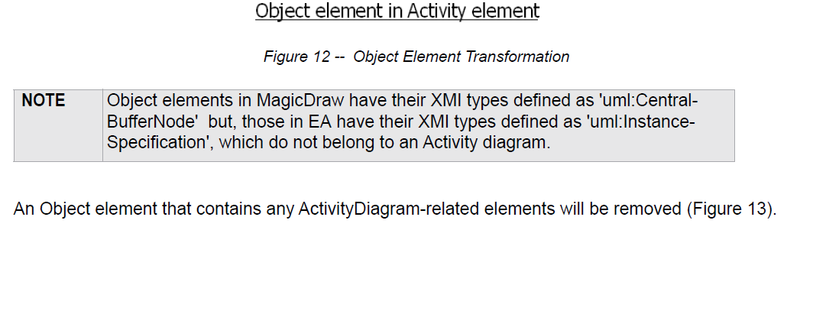

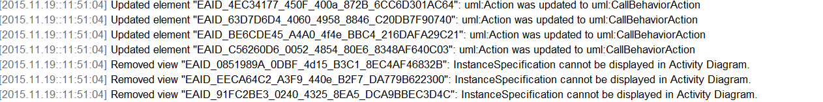



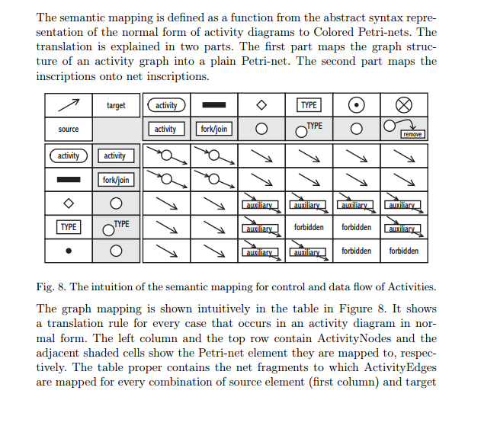

EA und magic draw , merge decision,fork,join --- Object flow

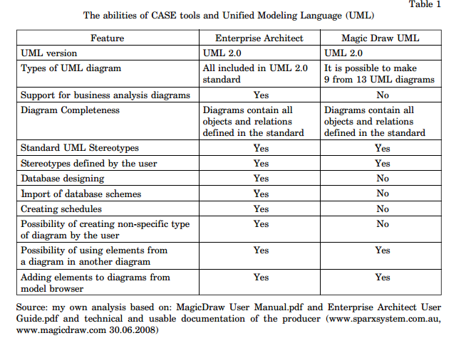

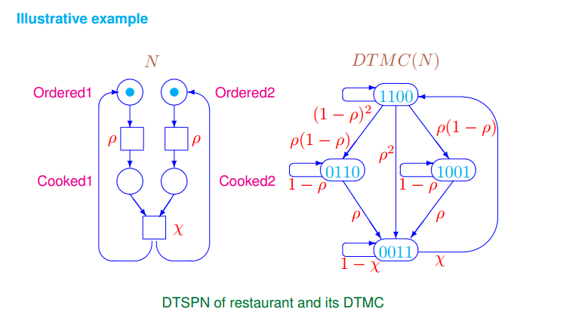

G.add_edge(*"p1"*, *"t2"*,label =*"x"*,strict=False)

G.add_edge(*"p1"*, *"t2"*,label =*"y"*,strict=False)

G.add_edge(*"p3"*, *"p3"*,label=*"aa"*)

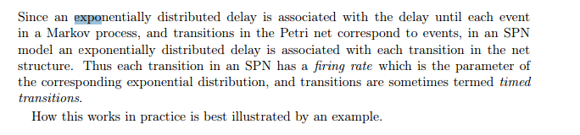



（Memoryless Property，

s,t>0,

P(T>t+s|T>t)=P(T>s)。

<http://download.csdn.net/detail/rxl2008/1370827>

