1 See github .com example/payOrder

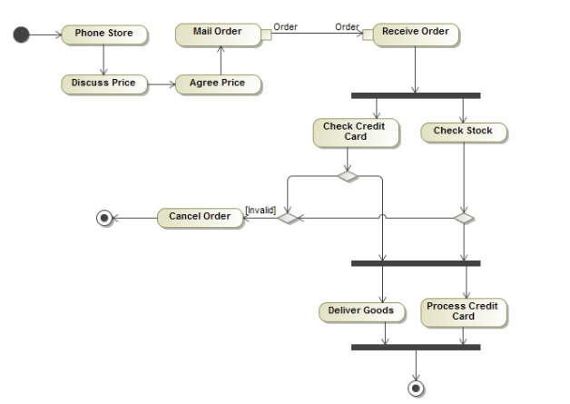

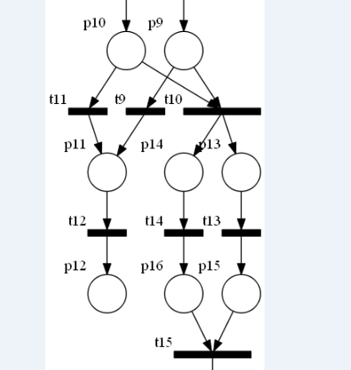

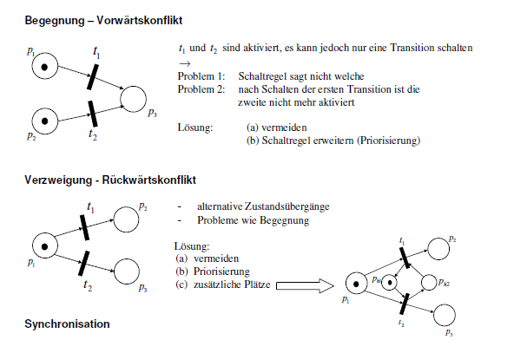

EDS1 petri netz

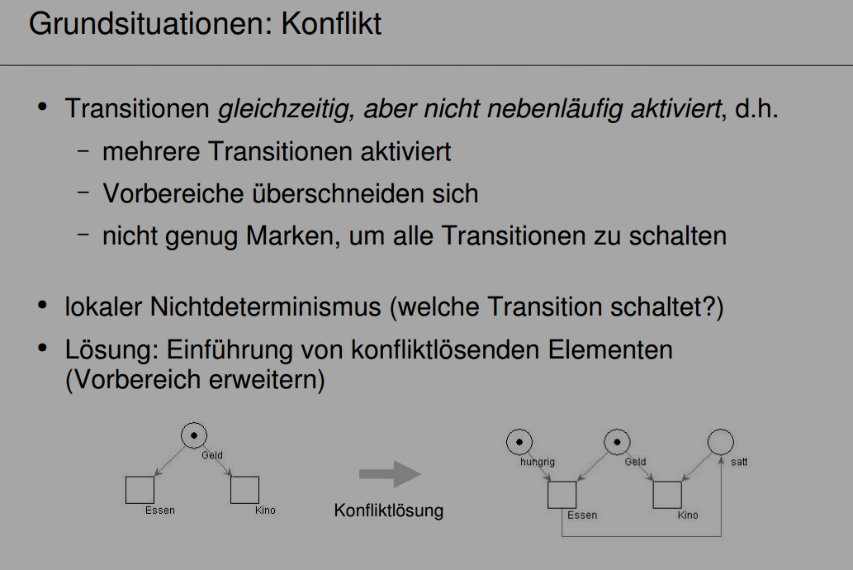

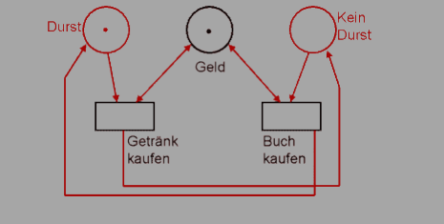

2.

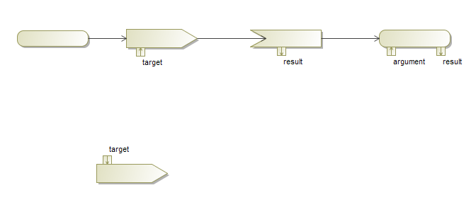



3. Time:50ms

<<Time>>

<<Time:50ms>>

action{time:50ms}

4. See github .com example/flowfinal

Cf: example/resolve

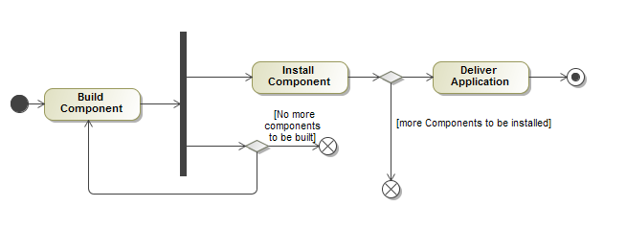

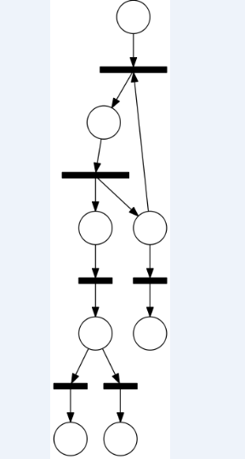

5. See github .com example/document

Object Node

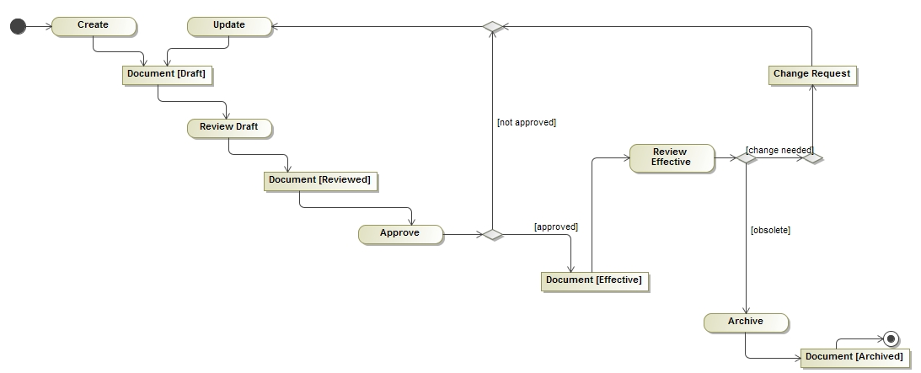

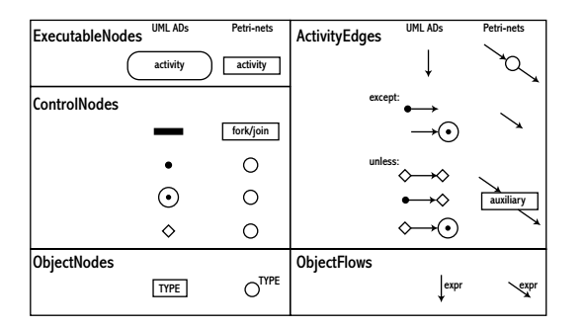

1 right click Data - create Element – stereotyp

Name with Time

2 right click stereotyp Time - create Element – property

Name with time

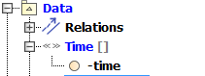

3 double left click action

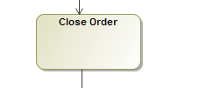

4 choose the “Tags” - <<Time>> time

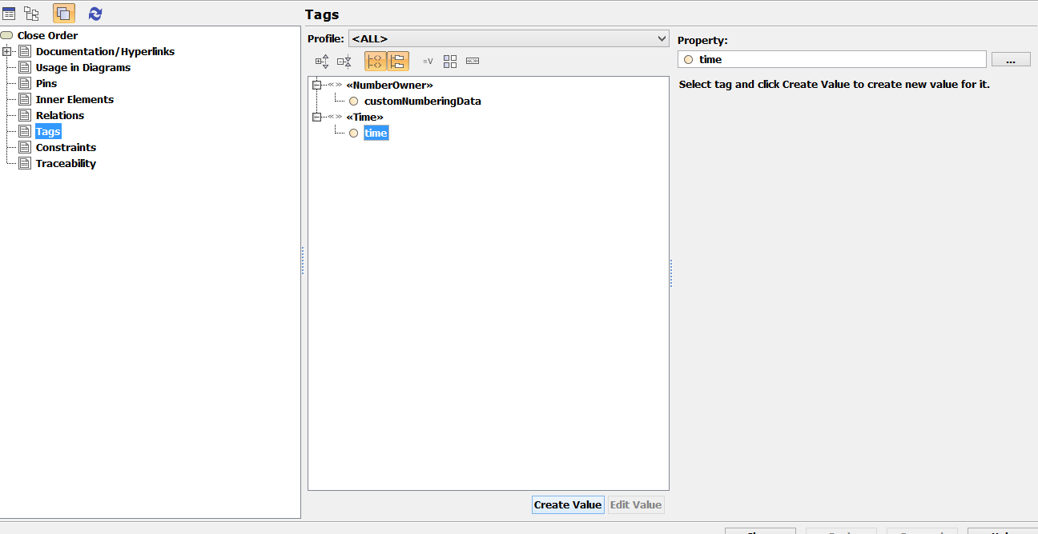

Create value

Tipp the value 40ms

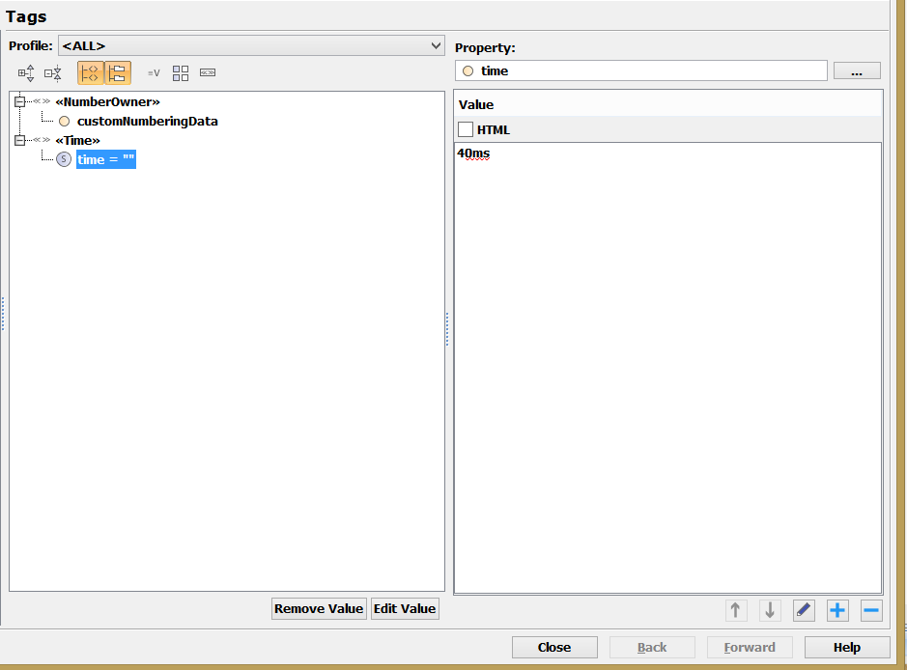

Close

5 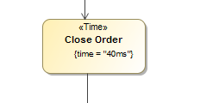

Over

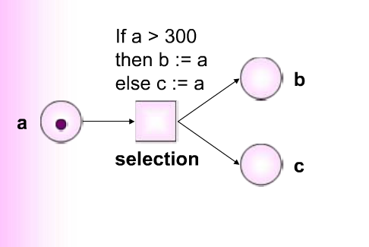

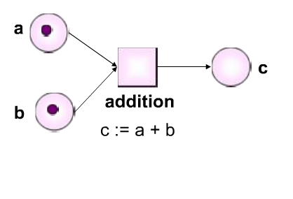

<http://people.dsv.su.se/~petia/WorkflowTutorial/player.html>

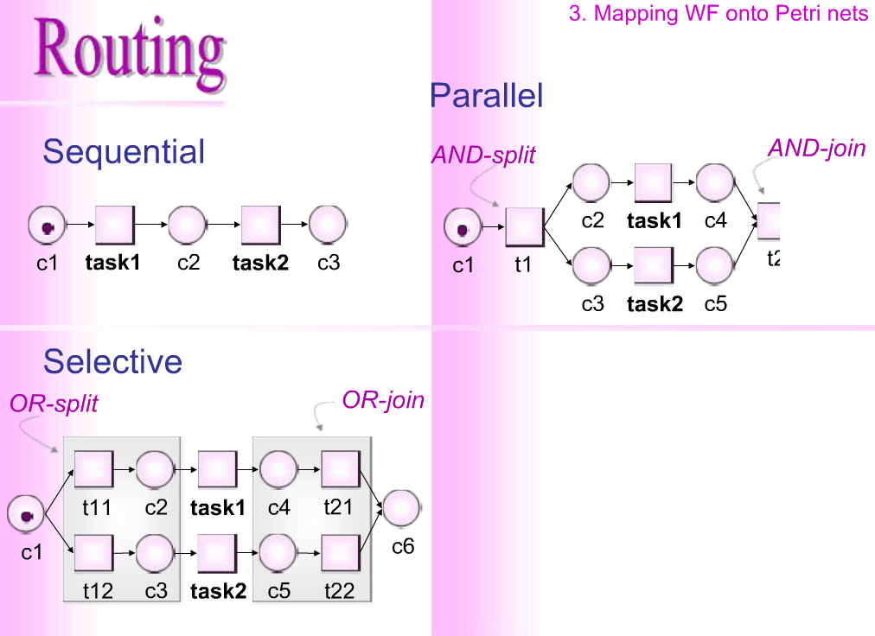

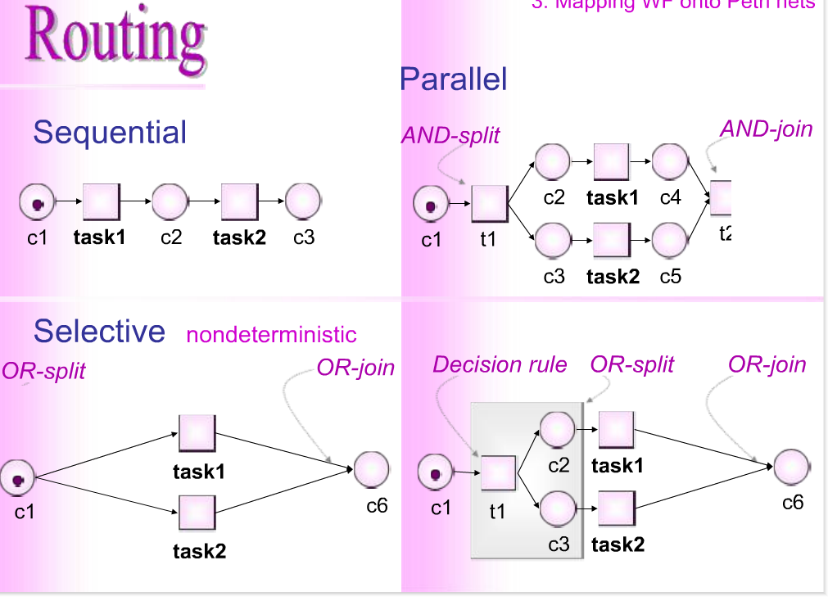

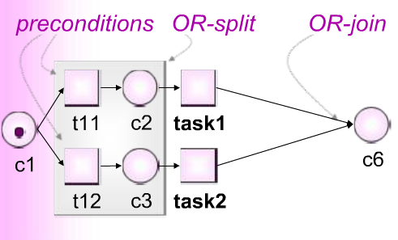

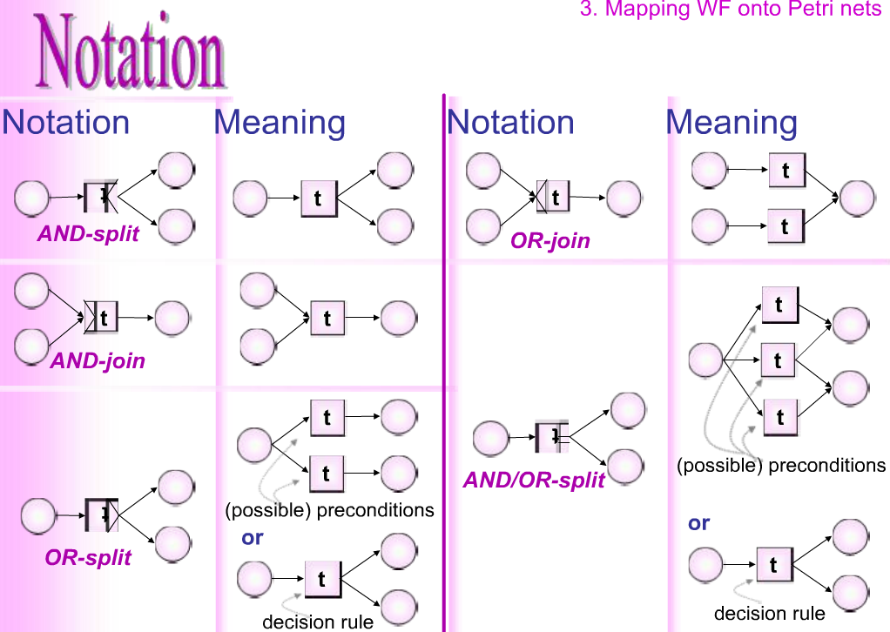

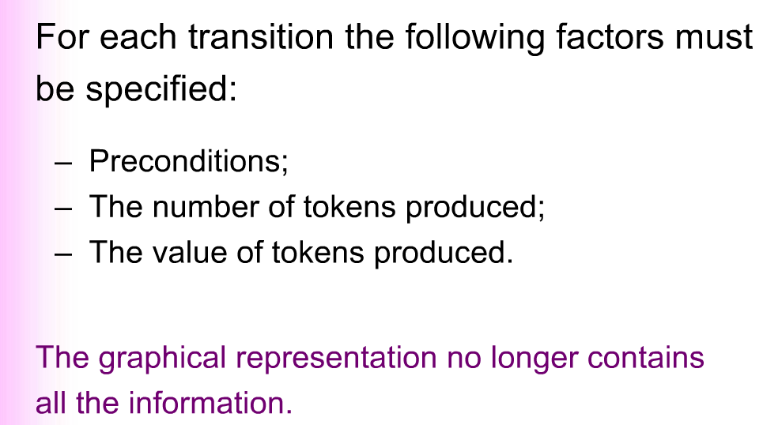

Action with automatic behavior

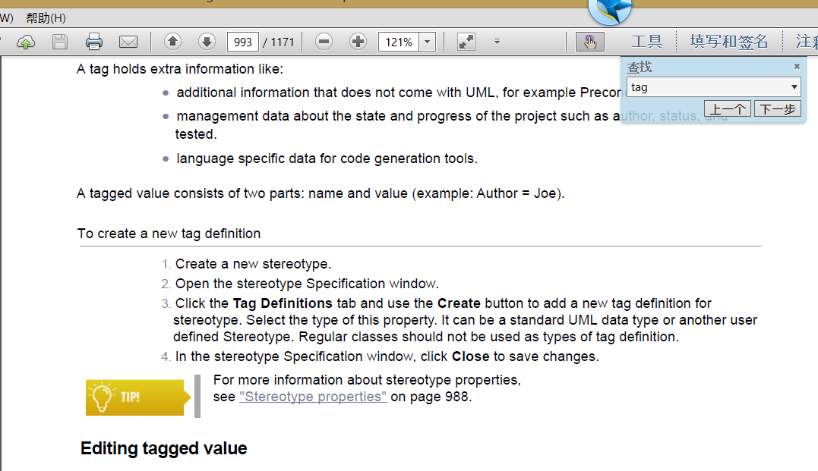

http://www.informatik.uni-hamburg.de/TGI/PetriNets/classification/level2/fcext-intro.html

* [Free Choice (FC)](http://www.informatik.uni-hamburg.de/TGI/PetriNets/classification/level2/FC.html) structure: if two transitions share a common input place then they have no other input places;

If two places share a common transition then they have no other transition

# FREE CHOICE (FC) SYSTEMS

A Free Choice Net is an ordinary Petri Net such that every arc from a place is either a unique outgoing arc or a unique incoming arc to a transition.

## Definition

(according to [[bes87]](http://www.informatik.uni-hamburg.de/TGI/PetriNets/classification/biblio.html#bes87))  
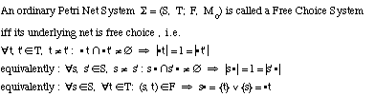   
  
The **Transition Rule**is given according to [(ordinary) Petri Nets](http://www.informatik.uni-hamburg.de/TGI/PetriNets/classification/level2/PN.html).

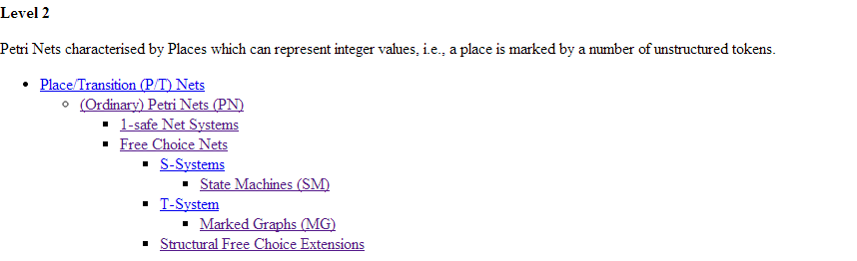

**MARKED GRAPH**

**Definition**

A Marked Graph is a pure (ordinary) Petri Net system where every place has only one input transition and one output transition:   
http://www.informatik.uni-hamburg.de/TGI/PetriNets/classification/level2/img/mg-def.gif

# STATE MACHINE

## Definition

(according to [[hac72]](http://www.informatik.uni-hamburg.de/TGI/PetriNets/classification/biblio.html#hac72))

A State Machine is a Petri Net where every transition has only one input place and one output place:   
http://www.informatik.uni-hamburg.de/TGI/PetriNets/classification/level1/img/sm-def.gif