1 add_edge(a,a)

2. multiedge

3 png without „_“,pdf with

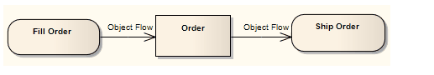

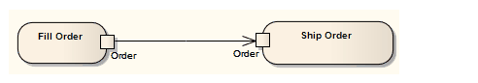

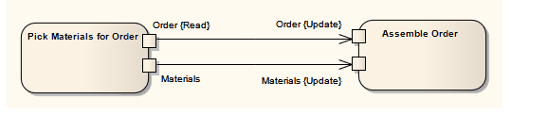

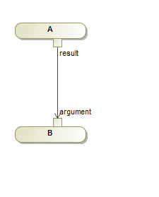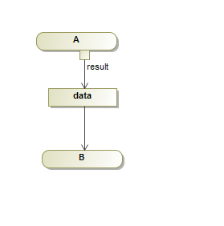

2 data have the same name

*"Data flow from a data to a data is forbidden"*

*/ und *

*Osx64*

Software install in windows, run window

Prism in windows

Data flow from activity