# Ogg技术文档总结

技术文章见附录

## 1.环境准备：

source端：  
操作系统版本：Centos6.4  
hostname:dg1

数据库版本：oracle11g

ogg版本：fbo_ggs_Linux_x64_shiphome.zip  
rac数据库名：ORACLE

IP:192.168.40.21  
  
target端：

操作系统版本：Centos6.4  
hostname:dg1

数据库版本：oracle11g

ogg版本：fbo_ggs_Linux_x64_shiphome.zip  
rac数据库名：ORACLE

IP:192.168.40.22

## 2.安装OGG软件(source和target同样操作)

[root@oracle02 oracle]# pwd

/home/oracle

[root@oracle02 oracle]# ll

总用量 40

-rw-rw-r--. 1 oracle oracle 1503 7月 22 2015 out.txt

-rw-rw-r--. 1 oracle oracle 29 7月 22 2015 sql.txt

drwxr-xr-x. 2 oracle oracle 4096 7月 18 2015 公共的

drwxr-xr-x. 2 oracle oracle 4096 7月 18 2015 模板

drwxr-xr-x. 2 oracle oracle 4096 7月 18 2015 视频

drwxr-xr-x. 2 oracle oracle 4096 7月 18 2015 图片

drwxr-xr-x. 2 oracle oracle 4096 7月 18 2015 文档

drwxr-xr-x. 2 oracle oracle 4096 7月 18 2015 下载

drwxr-xr-x. 2 oracle oracle 4096 7月 18 2015 音乐

drwxr-xr-x. 2 oracle oracle 4096 7月 18 2015 桌面

[root@oracle02 oracle]# mkdir gg_install

[root@oracle02 oracle]# pwd

/home/oracle

[root@oracle02 oracle]# cd gg_install/

[root@oracle02 gg_install]# pwd

/home/oracle/gg_install

拷贝软件

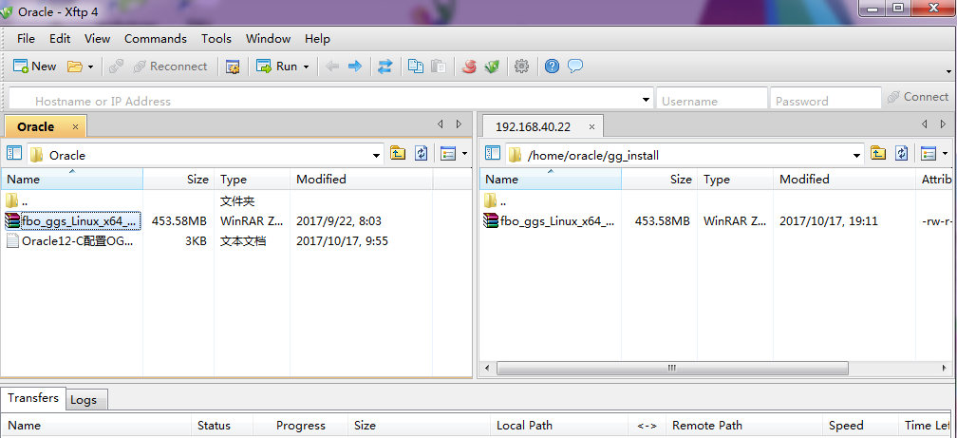

[root@oracle02 gg_install]# ll

总用量 464472

-rw-r--r--. 1 root root 475611228 10月 17 19:11 fbo_ggs_Linux_x64_shiphome.zip

[root@oracle02 gg_install]# cd ..

[root@oracle02 oracle]# chown -R oracle:oinstall gg_install/

[root@oracle02 oracle]#xhost +

[root@oracle02 oracle]# su - oracle

[oracle@oracle02 ~]$ cd gg_install/

[oracle@oracle02 gg_install]$ ll

总用量 464472

-rw-r--r--. 1 oracle oinstall 475611228 10月 17 19:11 fbo_ggs_Linux_x64_shiphome.zip

[oracle@oracle02 gg_install]$ unzip fbo_ggs_Linux_x64_shiphome.zip

[oracle@oracle02 gg_install]$ cd fbo_ggs_Linux_x64_shiphome

[oracle@oracle02 fbo_ggs_Linux_x64_shiphome]$ cd Disk1/

[oracle@oracle02 Disk1]$ ll

总用量 16

drwxr-xr-x. 4 oracle oracle 4096 12月 12 2015 install

drwxrwxr-x. 2 oracle oracle 4096 12月 12 2015 response

-rwxr-xr-x. 1 oracle oracle 918 12月 12 2015 runInstaller

drwxr-xr-x. 11 oracle oracle 4096 12月 12 2015 stage

[oracle@oracle02 Disk1]$ pwd

/home/oracle/gg_install/fbo_ggs_Linux_x64_shiphome/Disk1

[oracle@oracle02 Disk1]$ export DISPLAY=192.168.40.1:0.0

[oracle@oracle02 Disk1]$ ./runInstaller

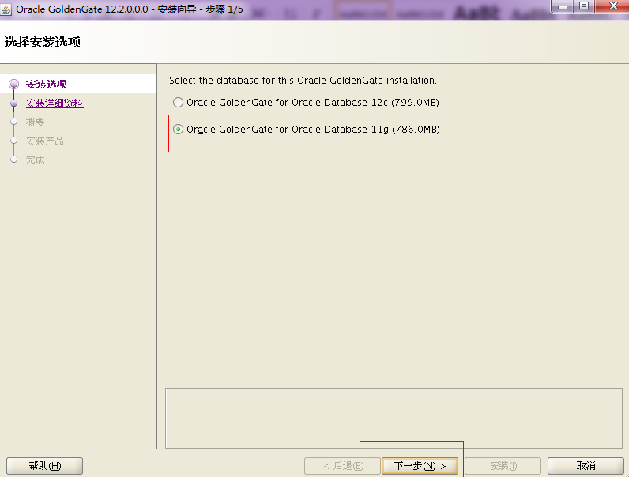

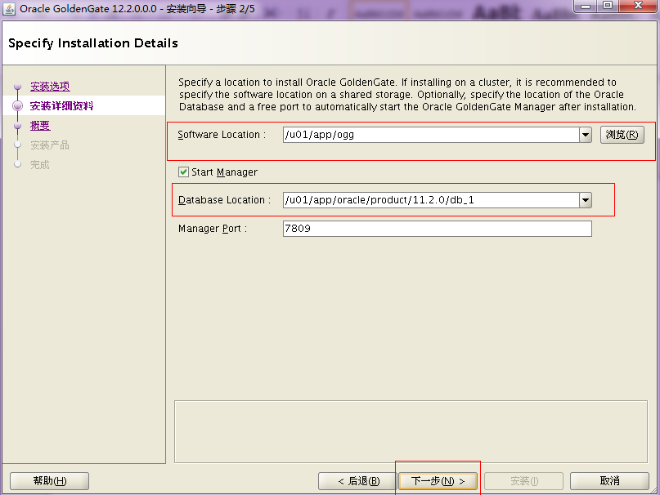

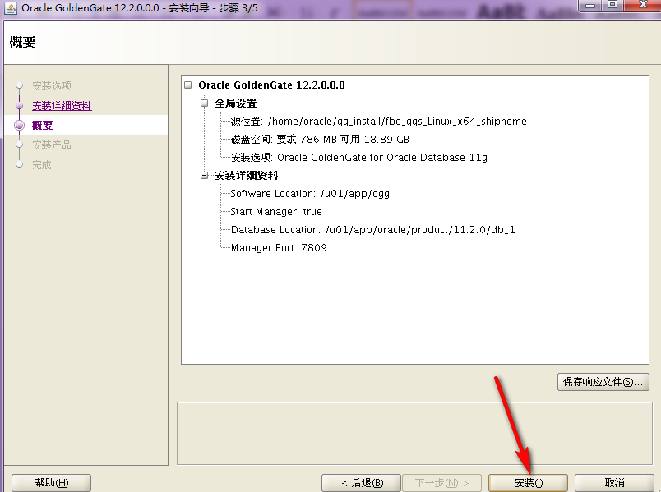

## 3配置

Linux系统变量配置

[oracle@oracle02 Disk1]$ cd /home/oracle/

[oracle@oracle02 ~]$ vim .bash_profile

# .bash_profile

# Get the aliases and functions

if [ -f ~/.bashrc ]; then

. ~/.bashrc

fi

~~# .bash_profile~~

~~# Get the aliases and functions~~

~~if [ -f ~/.bashrc ]; then~~

~~. ~/.bashrc~~

~~fi~~

# User specific environment and startup programs

ORACLE_BASE=/u01/app/oracle

ORACLE_HOME=$ORACLE_BASE/product/11.2.0/db_1

ORACLE_SID=orcl

GGS_HOME=/u01/app/ogg

export ORACLE_BASE ORACLE_HOME ORACLE_SID GGS_HOME

PATH=$ORACLE_HOME/bin:$PATH

PATH=$PATH:$HOME/bin

PATH=$PATH:$GGS_HOME

export PATH

LD_LIBRARY_PATH=$ORACLE_HOME/lib:/lib:/usr/lib

CLASSPATH=$ORACLE_HOME/JRE:$ORACLE_HOME/jlib:$ORACLE_HOME/rdbms/jlib

export LD_LIBRARY_PATH CLASSPATH

if [ $USER = "oracle" ]; then

if [ $SHELL = "/bin/ksh" ]; then

ulimit -p 16384

ulimit -n 65536

else

ulimit -u 16384 -n 65536

fi

fi

umask 022

~~ORACLE_BASE=/u01/app/oracle~~

~~ORACLE_HOME=$ORACLE_BASE/product/12.1.0.2/db_1~~

~~ORACLE_SID=ORCL~~

~~GGS_HOME=/u01/app/ogg~~

~~export ORACLE_BASE ORACLE_HOME ORACLE_SID GGS_HOME~~

~~PATH=$ORACLE_HOME/bin:$HOME/bin:$PATH:$GGS_HOME~~

~~export PATH~~

~~LD_LIBRARY_PATH=$ORACLE_HOME/lib:/lib:/usr/lib~~

~~CLASSPATH=$ORACLE_HOME/JRE:$ORACLE_HOME/jlib:$ORACLE_HOME/rdbms/jlib~~

~~export LD_LIBRARY_PATH CLASSPATH~~

~~if [ $USER = "oracle" ]; then~~

~~if [ $SHELL = "/bin/ksh" ]; then~~

~~ulimit -p 16384~~

~~ulimit -n 65536~~

~~else~~

~~ulimit -u 16384 -n 65536~~

~~fi~~

~~fi~~

~~umask 022~~

[oracle@oracle02 ~]$ source .bash_profile

ogg初始化

[oracle@oracle02 ~]$ cd /u01/app/ogg/

[oracle@oracle02 ogg]$ ggsci

Oracle GoldenGate Command Interpreter for Oracle

Version 12.2.0.1.1 OGGCORE_12.2.0.1.0_PLATFORMS_151211.1401_FBO

Linux, x64, 64bit (optimized), Oracle 11g on Dec 12 2015 00:54:38

Operating system character set identified as UTF-8.

Copyright (C) 1995, 2015, Oracle and/or its affiliates. All rights reserved.

GGSCI (oracle02) 1> create subdirs

Creating subdirectories under current directory /u01/app/ogg

Parameter files /u01/app/ogg/dirprm: already exists

Report files /u01/app/ogg/dirrpt: already exists

Checkpoint files /u01/app/ogg/dirchk: already exists

Process status files /u01/app/ogg/dirpcs: already exists

SQL script files /u01/app/ogg/dirsql: already exists

Database definitions files /u01/app/ogg/dirdef: already exists

Extract data files /u01/app/ogg/dirdat: already exists

Temporary files /u01/app/ogg/dirtmp: already exists

Credential store files /u01/app/ogg/dircrd: already exists

Masterkey wallet files /u01/app/ogg/dirwlt: already exists

Dump files /u01/app/ogg/dirdmp: already exists

GGSCI (oracle02) 1>exit

创建OGG用户并测试用户并创建测试表(source和target同样操作)

[oracle@oracle02 ogg]$ sqlplus / as sysdba

SQL*Plus: Release 11.2.0.1.0 Production on Tue Oct 17 19:37:13 2017

Copyright (c) 1982, 2009, Oracle. All rights reserved.

Connected to an idle instance.

SQL> startup;

ORACLE instance started.

Total System Global Area 521936896 bytes

Fixed Size 2214936 bytes

Variable Size 314573800 bytes

Database Buffers 201326592 bytes

Redo Buffers 3821568 bytes

Database mounted.

Database opened.

SQL> select name from v$datafile;

NAME

--------------------------------------------------------------------------------

/u01/app/oracle/oradata/orcl/system01.dbf

/u01/app/oracle/oradata/orcl/sysaux01.dbf

/u01/app/oracle/oradata/orcl/undotbs01.dbf

/u01/app/oracle/oradata/orcl/users01.dbf

SQL> exit

Disconnected from Oracle Database 11g Enterprise Edition Release 11.2.0.1.0 - 64bit Production

With the Partitioning, OLAP, Data Mining and Real Application Testing options

[oracle@oracle02 ogg]$ cd /u01/app/oracle/oradata/

[oracle@oracle02 oradata]$ ll

总用量 4

drwxr-xr-x. 2 oracle oinstall 4096 7月 7 2015 orcl

[oracle@oracle02 oradata]$ mkdir ogg

[oracle@oracle02 oradata]$ sqlplus / as sysdba

SQL*Plus: Release 11.2.0.1.0 Production on Tue Oct 17 19:39:25 2017

Copyright (c) 1982, 2009, Oracle. All rights reserved.

Connected to:

Oracle Database 11g Enterprise Edition Release 11.2.0.1.0 - 64bit Production

With the Partitioning, OLAP, Data Mining and Real Application Testing options

SQL> create tablespace ogg datafile '/u01/app/oracle/oradata/ogg/ogg01.dbf' size 1024m;

Tablespace created.

SQL> create user ogg identified by ogg default tablespace ogg;

User created.

SQL> grant connect,resource,dba to ogg;

Grant succeeded.

SQL> archive log list;

Database log mode No Archive Mode

Automatic archival Disabled

Archive destination USE_DB_RECOVERY_FILE_DEST

Oldest online log sequence 17

Current log sequence 19

//发现是没有在 Archive模式下,执行如下进入Archive模式

SQL> shutdown immediate;

Database closed.

Database dismounted.

ORACLE instance shut down.

SQL> startup mount;

ORACLE instance started.

Total System Global Area 521936896 bytes

Fixed Size 2214936 bytes

Variable Size 314573800 bytes

Database Buffers 201326592 bytes

Redo Buffers 3821568 bytes

Database mounted.

SQL> alter database archivelog;

Database altered.

SQL> archive log list;

Database log mode Archive Mode

Automatic archival Enabled

Archive destination USE_DB_RECOVERY_FILE_DEST

Oldest online log sequence 17

Next log sequence to archive 19

Current log sequence 19

//检查数据库是否开启附加日志:

SQL> SELECT supplemental_log_data_min, force_logging FROM v$database;

SUPPLEME FOR

-------- ---

NO NO

//开启数据库级别的附加日志:

SQL> alter database add supplemental log data;

Database altered.

SQL> ALTER DATABASE FORCE LOGGING;

Database altered.

SQL> SELECT supplemental_log_data_min, force_logging FROM v$database;

SUPPLEME FOR

-------- ---

YES YES

**ORACLE 12C版本下还要执行如下操作：**

SQL> show parameter enable_goldengate;

NAME TYPE VALUE

------------------------------------ ----------- ------------------------------

enable_goldengate_replication boolean FALSE

SQL> alter system set enable_goldengate_replication=true;

System altered.

SQL> show parameter enable_goldengate

NAME TYPE VALUE

------------------------------------ ----------- ------------------------------

enable_goldengate_replication boolean TRUE

SQL>

启动数据库

SQL> alter database open;

//源数据库需要同步的表空间（创建主要是用于测试同步）

SQL> create tablespace GFGXDB datafile '/u01/app/oracle/oradata/orcl/GFGXDB01.dbf' size 1m autoextend on next 1m maxsize 5m;

Tablespace created.

SQL> select name from v$datafile;

NAME

--------------------------------------------------------------------------------

/u01/app/oracle/oradata/orcl/system01.dbf

/u01/app/oracle/oradata/orcl/sysaux01.dbf

/u01/app/oracle/oradata/orcl/undotbs01.dbf

/u01/app/oracle/oradata/orcl/users01.dbf

/u01/app/oracle/oradata/ogg/ogg01.dbf

/u01/app/oracle/oradata/orcl/GFGXDB01.dbf

6 rows selected.

SQL> create user GFGXDB identified by GFGXDB default tablespace GFGXDB temporary tablespace temp;

User created.

SQL> grant connect,resource,dba to GFGXDB;

Grant succeeded.

SQL> alter profile default limit password_life_time unlimited;

Profile altered.

SQL> conn GFGXDB/GFGXDB;

Connected.

SQL> create table t1(id number,name varchar2(10));

Table created.

SQL> select * from t1;

no rows selected

三、source和target端配置manager进程：

[oracle@oracle02 oradata]$ cd /u01/app/ogg/

[oracle@oracle02 ogg]$ ./ggsci

GGSCI (oracle02) 1> create subdirs

GGSCI (oracle02) 3> edit params mgr

PORT 7809

GGSCI (oracle02) 4> start mgr

MGR is already running.

GGSCI (oracle02) 5> info mgr

Manager is running (IP port oracle02.7809, Process ID 2849).

GGSCI (oracle02) 6> info all

Program Status Group Lag at Chkpt Time Since Chkpt

MANAGER RUNNING

源端配置（192.168.40.21）

[oracle@oracle02 oradata]$ cd /u01/app/ogg/

[oracle@oracle02 ogg]$ ./ggsci

GGSCI (oracle01 as ogg@orcl) 8>dblogin userid ogg,password ogg

GGSCI (oracle01 as ogg@orcl) 8>add trandata GFGXDB.t1

GGSCI (oracle01 as ogg@orcl) 8>add ext EXT12,tranlog,begin now //配置抽取进程

GGSCI (oracle01 as ogg@orcl) 8>add exttrail /u01/app/ogg/dirdat/ab,ext EXT12,MEGABYTES 200

GGSCI (oracle01 as ogg@orcl) 8>add extract DP12,exttrailsource /u01/app/ogg/dirdat/ab //配置PUMP进程

GGSCI (oracle01 as ogg@orcl) 8>add rmttrail /u01/app/ogg/dirdat/ab,ext DP12,MEGABYTES 200

GGSCI (oracle01 as ogg@orcl) 8>edit params EXT12

#文本内容开始EXT12

EXTRACT EXT12

tranlogoptions excludeuser ogg(防止死循环的)

setenv (NLS_LANG = 'AMERICAN_AMERICA.AL32UTF8')

setenv (ORACLE_SID = orcl)

USERID ogg, PASSWORD ogg

EXTTRAIL /u01/app/ogg/dirdat/ab

table GFGXDB.t1;

#文本内容结束EXT12

GGSCI (oracle01 as ogg@orcl) 8>start EXT12

GGSCI (oracle01 as ogg@orcl) 8>edit params DP12

#文本内容开始DP12

EXTRACT DP12

setenv (NLS_LANG = 'AMERICAN_AMERICA.AL32UTF8')

passthru

rmthost 192.168.40.22, mgrport 7809, compress

rmttrail /u01/app/ogg/dirdat/ab

table GFGXDB.t1;

#文本内容结束DP12

GGSCI (oracle01 as ogg@orcl) 8>start DP12

注：查看该线程的日志

GGSCI (oracle02 as ogg@orcl) 48> view report DP12

配置接收端（192.168.40.22）：

GGSCI (oracle02 as ogg@orcl) 11> edit params globals

ggschema ogg

checkpointtable ogg.checkpiont

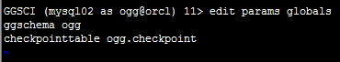

GGSCI (oracle02 as ogg@orcl) 12> dblogin userid ogg,password ogg

Successfully logged into database.

GGSCI (oracle02 as ogg@orcl) 13> add checkpointtable ogg.checkpoint

Successfully created checkpoint table ogg.checkpoint.

创建接收进程:

GGSCI (oracle02 as ogg@orcl) 14> add replicat REP12,exttrail /u01/app/ogg/dirdat/ab,checkpointtable ogg.checkpoint

REPLICAT added.

GGSCI (oracle01 as ogg@orcl) 8>edit params REP12

#文本内容开始REP12

replicat REP12

setenv (NLS_LANG = 'AMERICAN_AMERICA.AL32UTF8')

setenv (ORACLE_SID = ORCL)

userid ogg, password ogg

reperror default,abend

discardfile /u01/app/ogg/dirrpt/repa.dsc, append, megabytes 100

assumetargetdefs

dynamicresolution

map GFGXDB.t1, target GFGXDB.t1;

#文本内容结束REP12

start REP12

反向配置

1)源端配置（192.168.40.22）

GGSCI (oracle02 as ogg@orcl) 26> dblogin userid ogg,password ogg

Successfully logged into database.

GGSCI (oracle02 as ogg@orcl) 27> add trandata GFGXDB.t1

GGSCI (oracle02 as ogg@orcl) 28> add ext EXT12,tranlog,begin now

EXTRACT added.

GGSCI (oracle02 as ogg@orcl) 29> add exttrail **/u01/app/ogg/dirdat/aa**,ext EXT12,MEGABYTES 200

EXTTRAIL added.

GGSCI (oracle02 as ogg@orcl) 30> add extract DP12,exttrailsource **/u01/app/ogg/dirdat/aa**

EXTRACT added.

GGSCI (oracle02 as ogg@orcl) 31> add rmttrail **/u01/app/ogg/dirdat/aa**,ext DP12,MEGABYTES 200

RMTTRAIL added.

GGSCI (oracle02 as ogg@orcl) 32> edit params EXT12

EXTRACT EXT12

tranlogoptions excludeuser ogg

setenv (NLS_LANG = 'AMERICAN_AMERICA.AL32UTF8')

setenv (ORACLE_SID = orcl)

USERID ogg, PASSWORD ogg

EXTTRAIL /u01/app/ogg/dirdat/aa

table GFGXDB.t1;

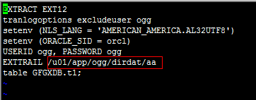

GGSCI (oracle02 as ogg@orcl) 33> start EXT12

Sending START request to MANAGER ...

EXTRACT EXT12 starting

GGSCI (oracle02 as ogg@orcl) 35> info all

Program Status Group Lag at Chkpt Time Since Chkpt

MANAGER RUNNING

EXTRACT STOPPED DP12 00:00:00 00:01:57

EXTRACT RUNNING EXT12 00:00:00 00:03:19

REPLICAT RUNNING REP12 00:00:00 00:00:09

GGSCI (oracle02 as ogg@orcl) 36> edit params DP12

EXTRACT DP12

setenv (NLS_LANG = 'AMERICAN_AMERICA.AL32UTF8')

passthru

rmthost 192.168.40.11, mgrport 7809, compress

rmttrail /u01/app/ogg/dirdat/aa

table GFGXDB.t1;

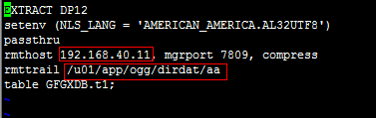

GGSCI (oracle02 as ogg@orcl) 37> start DP12

GGSCI (oracle02 as ogg@orcl) 45> info all

Program Status Group Lag at Chkpt Time Since Chkpt

MANAGER RUNNING

EXTRACT RUNNING DP12 00:00:00 00:00:07

EXTRACT RUNNING EXT12 00:00:00 00:00:08

REPLICAT RUNNING REP12 00:00:00 00:00:08

2)目的端（192.168.40.21）

GGSCI (oracle01) 32> edit params globals

ggschema ogg

checkpointtable ogg.checkpoint



GGSCI (oracle01) 33> dblogin userid ogg,password ogg

Successfully logged into database.

GGSCI (oracle01 as ogg@orcl) 34> add checkpointtable ogg.checkpoint

Successfully created checkpoint table ogg.checkpoint.

GGSCI (oracle01 as ogg@orcl) 35> info all

Program Status Group Lag at Chkpt Time Since Chkpt

MANAGER RUNNING

EXTRACT RUNNING DP12 00:00:00 00:00:01

EXTRACT RUNNING EXT12 00:00:00 00:00:08

GGSCI (oracle01 as ogg@orcl) 36> add replicat REP12,exttrail **/u01/app/ogg/dirdat/aa**,checkpointtable ogg.checkpoint

REPLICAT added.

GGSCI (oracle01 as ogg@orcl) 37> edit params REP12

replicat REP12

setenv (NLS_LANG = 'AMERICAN_AMERICA.AL32UTF8')

setenv (ORACLE_SID = orcl)

userid ogg, password ogg

reperror default,abend

discardfile /u01/app/ogg/dirrpt/repa.dsc, append, megabytes 100

assumetargetdefs

dynamicresolution

map GFGXDB.t1, target GFGXDB.t1;

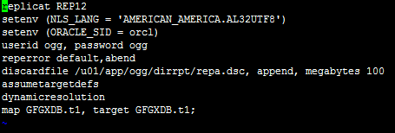

**注:ORACLE_SID = orcl一定要和系统变量ORACLE_SID保持一致（大小写）**



GGSCI (oracle01 as ogg@orcl) 38> start REP12

Sending START request to MANAGER ...

REPLICAT REP12 starting

GGSCI (oracle01 as ogg@orcl) 45> info all

Program Status Group Lag at Chkpt Time Since Chkpt

MANAGER RUNNING

EXTRACT RUNNING DP12 00:00:00 00:00:09

EXTRACT RUNNING EXT12 00:00:00 00:00:09

REPLICAT RUNNING REP12 00:00:00 00:00:06

## 4测试：

源端（192.168.40.21）

[oracle@oracle01 ~]$ sqlplus / as sysdba

SQL*Plus: Release 11.2.0.1.0 Production on Tue Oct 17 22:02:37 2017

Copyright (c) 1982, 2009, Oracle. All rights reserved.

Connected to:

Oracle Database 11g Enterprise Edition Release 11.2.0.1.0 - 64bit Production

With the Partitioning, OLAP, Data Mining and Real Application Testing options

SQL> conn GFGXDB/GFGXDB;

Connected.

SQL> insert into t1(id, name) values(100,'uuuuuu');

1 row created.

SQL> COMMIT;

Commit complete.

目的端（192.168.40.22）

[oracle@oracle02 ~]$ sqlplus / as sysdba

SQL*Plus: Release 11.2.0.1.0 Production on Wed Oct 18 00:52:33 2017

Copyright (c) 1982, 2009, Oracle. All rights reserved.

Connected to:

Oracle Database 11g Enterprise Edition Release 11.2.0.1.0 - 64bit Production

With the Partitioning, OLAP, Data Mining and Real Application Testing options

SQL> conn GFGXDB/GFGXDB;

Connected.

SQL> select * from T1;

ID NAME

---------- ----------

11 ds

100 uuuuuu

反向同步测试相同

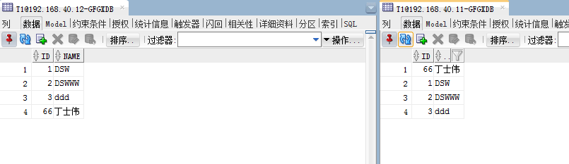

## 5附录

OGG技术介绍

一  GoldenGate简介

[Oracle](http://www.linuxidc.com/topicnews.aspx?tid=12) Golden Gate软件是一种基于日志的结构化数据复制备份软件，它通过解析源 数据库在线日志或归档日志获得数据的增量变化，再将这些变化应用到目标数据库，从而实现源数据库与目标数据库同步。Oracle Golden Gate可以在异构的IT基础结构（包括几乎 所有常用操作系统平台和数据库平台）之间实现大量数据亚秒一级的实时复制,从而在可以 在应急系统、在线报表、实时数据仓库供应、交易跟踪、数据同步、集中/分发、容灾、数 据库升级和移植、双业务中心等多个场景下应用。同时，Oracle Golden Gate 可以实现一 对一、广播(一对多)、聚合(多对一)、双向、点对点、级联等多种灵活的拓扑结构。

二、技术结构

和传统的逻辑复制一样，Oracle GoldenGate 实现原理是通过抽取源端 的redo log或者archive log，然后通过TCP/IP投递到目标端，最后解析还原应用到 目标端，使目标端实现同源端数同步。以下是OracleGoldenGate的技术架。

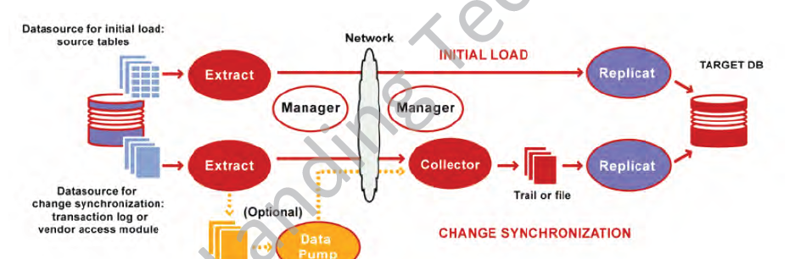

三、OGG进程

1、Manager进程

Manager进程是GoldenGate的控制进程，运行在源端和目标端上。它主要作用有以下几个方面：启动、监控、重启Goldengate的其他进程, 报告错误及事件，分配数据存储 空间，发布阀值报告等。

2、Extract进程

Extract运行在数据库源端，负责从源端数据表或者日志中捕获数据。

3、Pump进程

pump进程运行在数据库源端。

其作用是如果源端使用了本地的trail文件， 那么pump 进程就会把trail以数据块的形式通过TCP/IP协议发送到目标端，这通常也是推荐的 方式。pump进程本质是extract进程的一种特殊形式，如果不使用trails文件，那么 就是extract进程在抽取完数据以后，直接投递到目标端。

4.Trail文件

为了更有效、更安全的把数据库事务信息从源端投递到目标端。GoldenGate引进 trail文件的概念。前面提到extract抽取完数据以后Goldengate会将抽取的事务信息转化为一种GoldenGate专有格式的文件。然后pump负责把源端的trail文件投递到目标端， 所以源、目标两端都会存在这种文件。trail文件存在的目的旨在防止单点故障，将事务信 息持久化，并且使用checkpoint机制来记录其读写位置，如果故障发生，则数据可以根据 checkpoint记录的位置来重传。

5.Replicat进程

Replicat进程，通常我们也把它叫做应用进程。运行在目标端，是数据传递的最后一站，负责读取目标端trail文件中的内容，并将其解析为DML或DDL语句，然后应用到目标数据库中。

6.GGSCI

GGSCI是GoldenGate Software Command Interface 的缩写，

它提供了十分丰富的 命令来对Goldengate进行各种操作，如创建、修改、监控GoldenGate进程等等。

三、应用的拓展结构、支持平台和数据库

