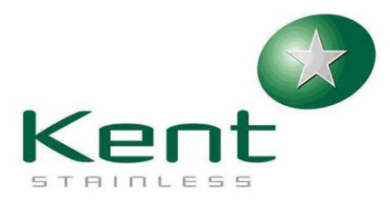

Learning Log - Toolbox Talk

Supervisor/Manager to discuss the issue/topic outlined below with the relevant people.

All attendees at the discussion must sign this document to acknowledge the issue.

This completed document is to be submitted to the quality team for closure.

|  |  |
| --- | --- |
| Target completion date | 26/01/2023 |
| Sales Order number | 168107 |
| Process Order number | 46086 |
| Learning Log number | 61 |

|  |  |
| --- | --- |
| Issue/ Topic to be discussed | **The gully side opening where the channel joins should be 137mm deep.**  **Each side opening on the gully is at different depths but they should be the same because the same size channel is joined to both openings.** |
| Corrective Action Taken |  |

|  |  |
| --- | --- |
| *Comments from Quality Department* |  |

|  |  |  |
| --- | --- | --- |
| Name (Block Capitals) | *Signature* | *Date* |
|  |  |  |
|  |  |  |
|  |  |  |
|  |  |  |
|  |  |  |

**Relevant Photos**

