Task2;

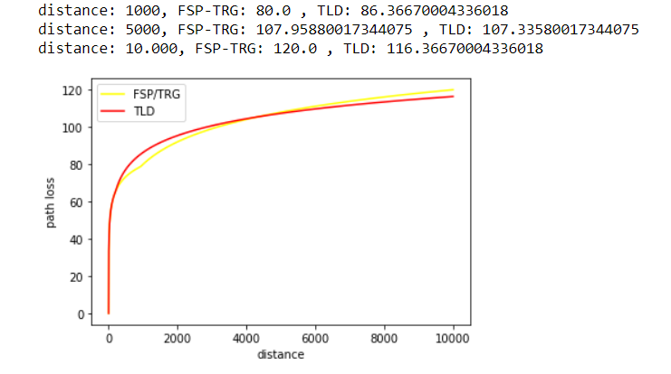

In the code, we calculated FSP and TRG from the first task and calculated TLD as given properties. Then we calculated FSP-TRG and TLD values for distances 1000, 5000, and 10.000. Path loss for TLD is a bit better than FSP-TRG values as seen in the diagram for 10.000 distance values.