**Senior Design Project**

**Healthscope**

*Project Specifications Report*

Cüneyt Erem

Doğukan Ömer Gür

Kaan Kale

Melih Sancak

Mert Gürcan

**Advisor:** A. Ercüment Çiçek

February 27, 2017

This report is submitted to the Department of Computer Engineering of Bilkent

University in partial fulfilment of the requirements of the Senior Design Project

course CS491/2

Table of Contents

1. Introduction............................................................................................................ 3

2.Current System...................................................................................................... 3

3. Proposed System................................................................................................... 4

3.1 Overview ................................................................................................... 4

3.2 Functional Requirements........................................................................... 4

3.3 Non-functional Requirements ................................................................... 5

3.4 Pseudo Requirements .............................................................................. 5

3.5 System Models.......................................................................................... 5

3.5.1 Scenarios..................................................................................... 5

Scenario 1:................................................................................. 5

Scenario 2: ................................................................................ 5

Scenario 3: ................................................................................ 6

Scenario 4: ................................................................................ 6

3.5.2 Use Case Model ......................................................................... 7

3.5.3 Object and Class Model ............................................................. 8

3.5.4 Dynamic Models ......................................................................... 9

Sequence Diagram 1................................................................. 9

Sequence Diagram 2................................................................ 10

Sequence Diagram 3................................................................ 11

Activity Diagram ...................................................................... 12

3.5.5 User interface - navigational paths and screen mock-ups ........ 13

Signin Screen........................................................................... 13

Signup Screen.......................................................................... 14

Bar-code Home Screen ........................................................... 15

Content of the Product Screen………………………………….. 16

Profile Settings Screen…………………………………………... 17

4. References .......................................................................................................... 18

**1. Introduction**

Recently, health is one of the topic that mainly took into the consideration by people. Increasing life expectancy rates is a clear main cause of human effort for making their lives more healthier. People give importance to do sports, to sleep well, care their hygiene and specially to eating healthy foods. In this century, although finding healthy food is easier than before, having a lot of unhealthy products in markets attracts people’s attention to buy more of these unhealthy products.

Healthscope is java based project, running on the Android platform, aims to make people more aware of impact of the products on their health. When customer do shopping, Healthscope identifies the product that customer like and tell him/her whether it is a healthy choice or not according to the customers’ health status which is reflected as codes in our app. As a result, this project would help customers to fill their shopping carts with more healthy foods that improve their medical conditions.

**2. Current System**

Our “Healthscope” application helps user to shop on supermarkets with aware of their medical conditions. Users create their own profile on this application. There are fields for their age, physical appearances (height, weight), diseases and allergies. And our “Healthscope” doctor evaluate every food and their ingredients in the supermarket for our users. There are five levels for every ingredients agreeableness (white, yellow, orange brown, red). It is very easy to use because users just read the barcodes of each food they want to buy with their androids, ingredients and agreeableness will appear on their screen and they can see appropriateness respect to their medical conditions.

**3. Proposed System**

**3.1 Overview**

Healtscope aims to help users to be aware of what will they eat recording to their medical conditions when they are shopping in markets. Our main purpose to have more conscious human beings and healthier bodies. To use this app user must just download it and create their own profiles, while creating they must enter their gender, age, height, weight, diseases and allergies for proper usage.Users will see each food ingredient and levels of recommendation on their screen by reading the barcodes of goods. For our users we agreed with doctors. There are five levels for every ingredients agreeableness (white, yellow, orange brown, red) and doctors scale every food ingredient for each disease and allergies.

**3.2 Functional Requirements**

* Application will allow the user to create a profile including username and password.
* All users must be login to the system before using it.
* Profile of a user will not be seen by other users.
* The user will be asked to enter some specific properties. (age, weight, etc.)
* If the user has any illness, the user can specify them in his/her profile.
* When user shows the phone camera to the product after clicking on the app, the application will identify the barcode and present the specifications of the product and suggestion. (whether the product is usable)
* App will keep thousands of product properties in database to show product details.
* App suggestions to the users. (which product should not be used for who have specific illness)

**3.3 Non-functional Requirements**

* App will support Android 4.4 and above.
* App will not work without internet connection.
* App will be user-friendly and will be very easy to use.
* App keep many product information will be updated in the database and become sustainable.
* App will be high secure to keep user information in safe.
* Our servers will be running 7/24.

**3.4 Pseudo Requirements**

* Android Platform will be used for the application.
* A version control tool, GitHub, will be used.

**3.5 System Models**

**3.5.1 Scenarios**

**Scenario 1: Register to the system**

User opens Healthscope via his mobile phone. If user doesn’t have an account, he should create an account to use our application. User can register as patient. After the user fill all the necessary fields (physical attributes, diseases, birth date) and the e-mail doesn’t match with any existing e-mail, registration will be completed.

**Scenario 2: Login to the system**

If user want to login the system and have an account. User should enter his e-mail and password to determined fields and if the password and e-mail match correctly user can login the application.

**Scenario 3: Scanning a Product Barcode**

After the login, user uses the camera of his/her mobile phone to scan the barcode of the product he/she wants to check in the database. After user scan the barcode and the product that scanned is in our database our application shows a popup screen with colour codes that shows the healthiness of the product for our user.

**Scenario 4: Changing the user Information**

User can change his/her weight, height, diseases or other personal information that can be changeable.

**3.5.2 Use Case Model**

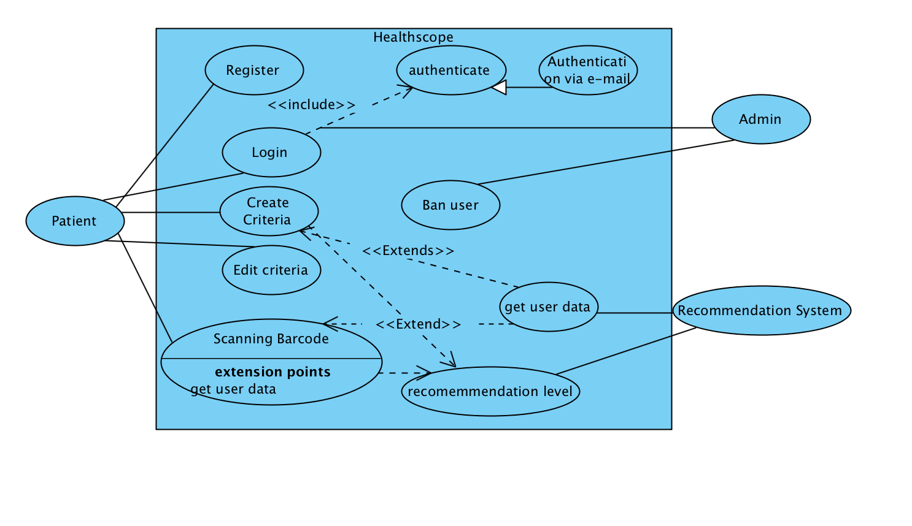

**3.5.3 Object and Class Model**

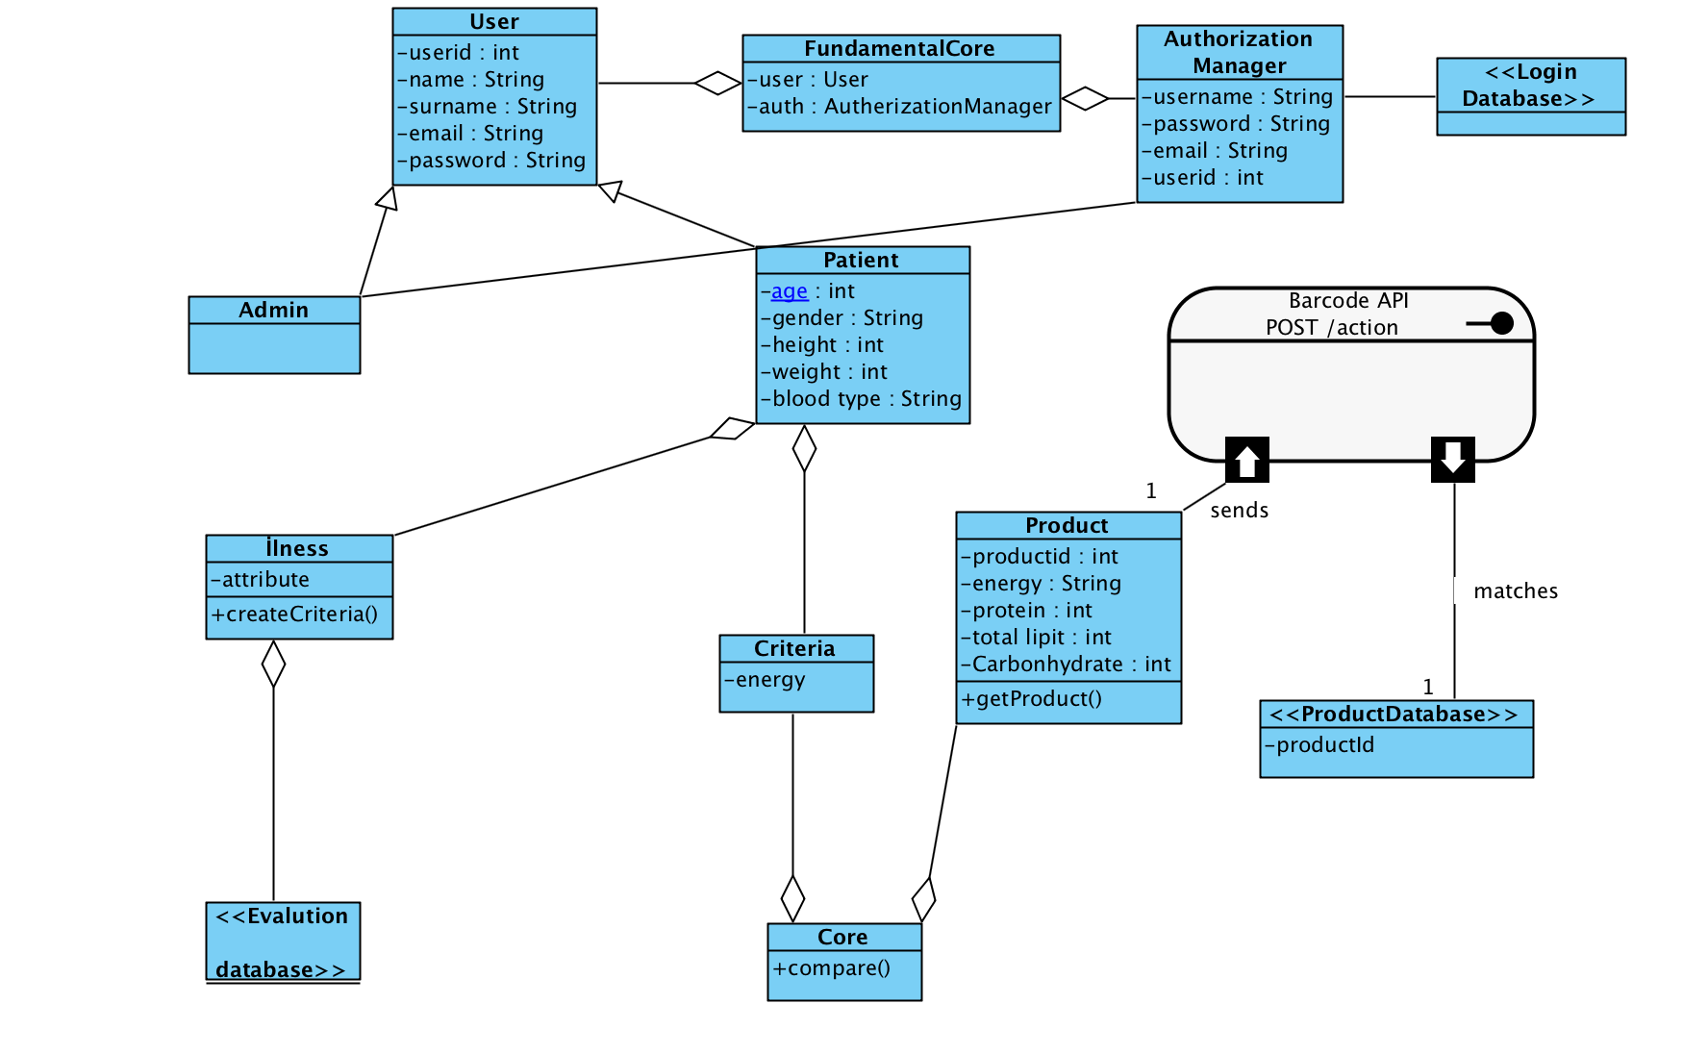

**3.5.4 Dynamic Models**

**Sequence Diagram 1**

**Actor:**User

**Entry Condition:**No precondition

**Main Flow of Event:**

1. User enter necessary information to system
2. Fundamental core passes the information which are declared to autharization manager
3. Autharization manager check informations are valid, check boundary cases such as invalid usage of letters,numbers or username and e-mail are already declared.
4. If there is no problem like those informations given to login database, and authorise new user and add information to login database.

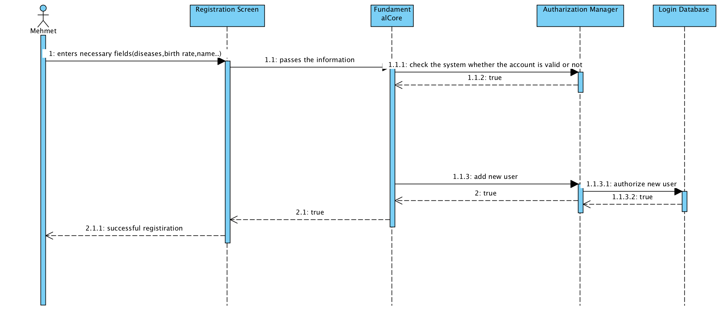

**Sequence Diagram 2**

**Actor:**User

**Entry Condition:**User should already register.

**Main Flow of Event:**

1. User enter his own e-mail and password
2. Those information goes to fundamental core
3. Check those information valid is those account are exist or not found in the system,
4. If exist login database return true and account succesfully login.

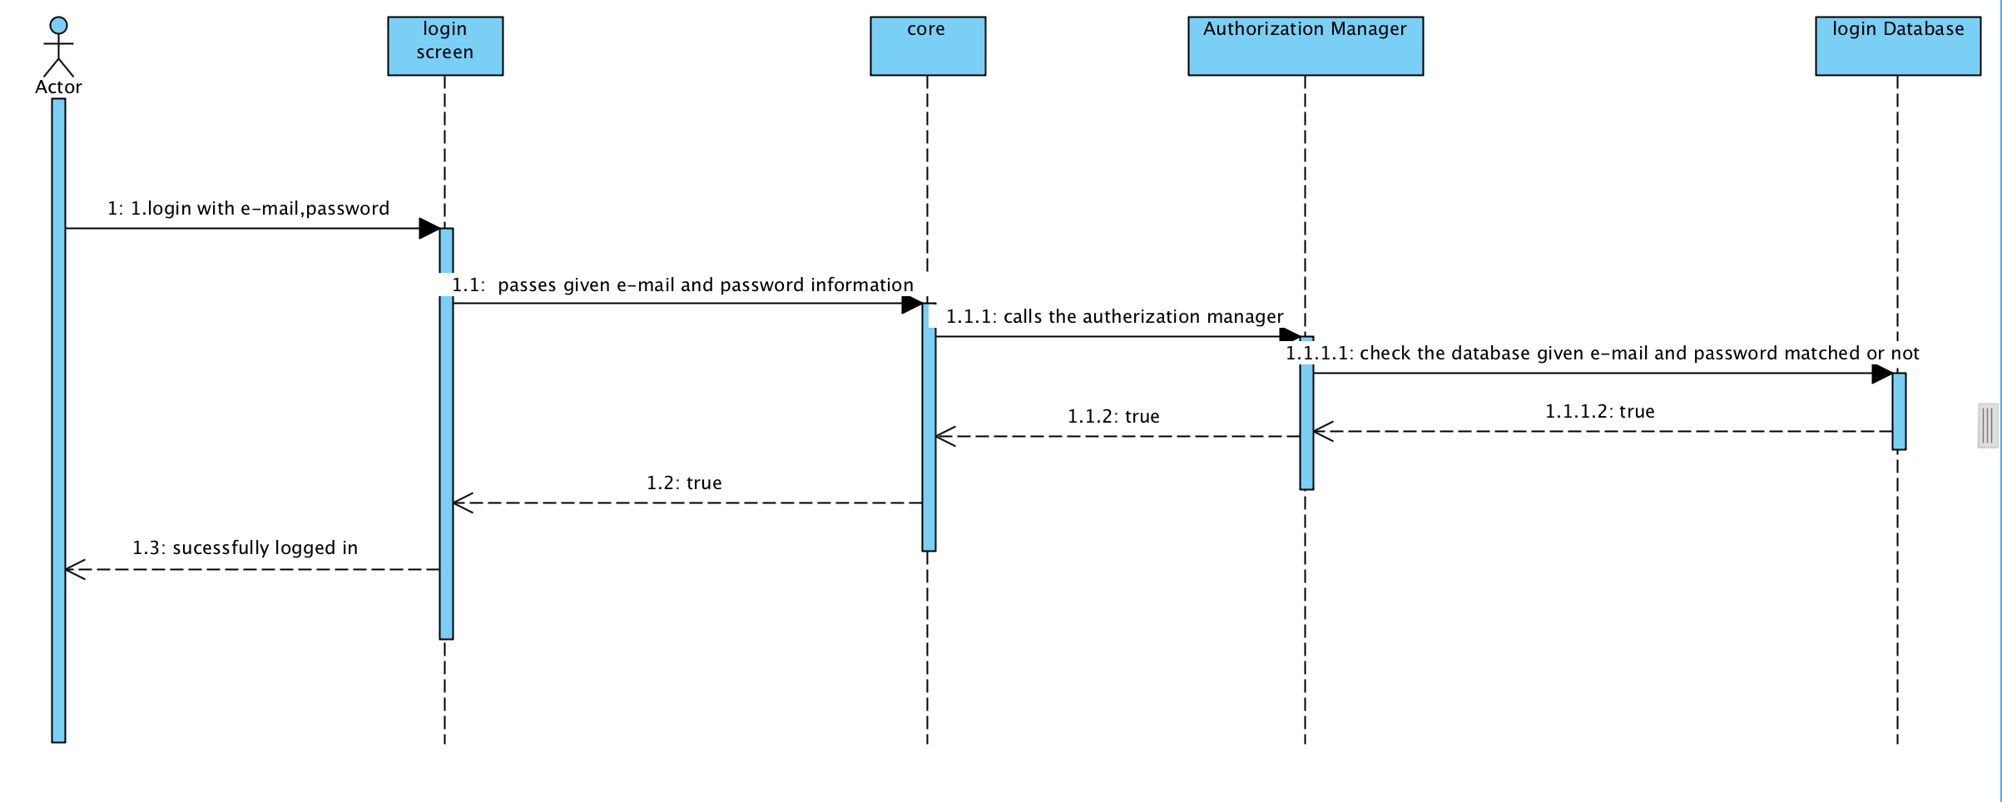

**Sequence Diagram 3:**

**Actor:**User

**Entry Condition:**User shoul already logged in to the system

**Main Flow of Event:**

1. User scan the barcode
2. Scanning barcode goes to BarcodeApı to detect which product we have
3. According to this evalution database and product criterias compared
4. Recommend system give level message such as, this product is not recommended, you should not use this product, you can buy this product and so on.

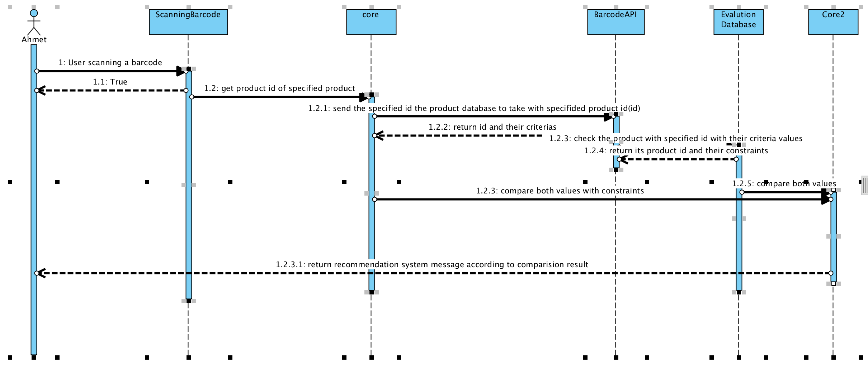

**Activity Diagram**

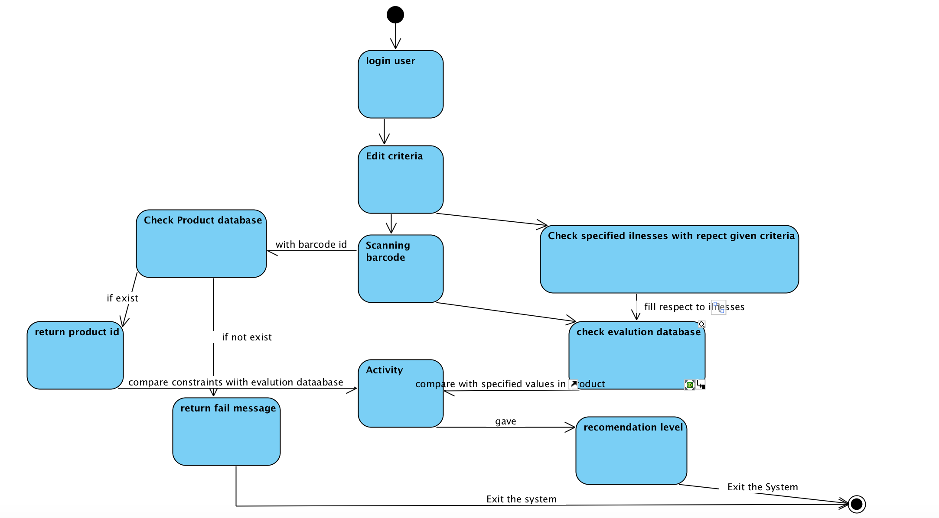

**3.5.5 User interface - navigational paths and screen mock-ups**

**Sign In Screen**

When user starts the application, entry screen will be seen. At the top of the screen, there will be a symbol of the HealthScope. If user wants to sign up, he can click on “Sign up” button. If he wants to sign in directly, he will use “e-mail address” and “password” text inputs and click on the “Sign in” button.

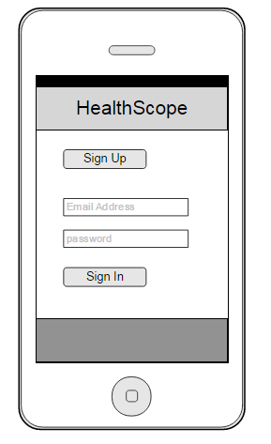

**Sign Up Screen**

When user clicks on “Sign Up” button, app goes to another screen that contains input texts such as e-mail address, password, name, surname, age, gender, height, weight. To define disease, user should select one or more disease radio buttons. Also, there is another option to determine lose/gain/maintain weight that if user wants to gain weight, then suggested screen on the bar-code screen will be shown. There is a process sliding that user can slide down the page by using his finger. After filling all necessary options, user will click on “Register” button to finish the process.

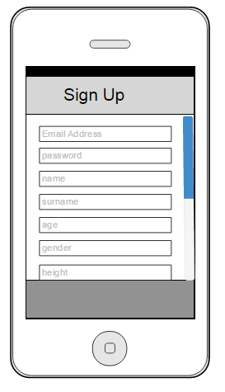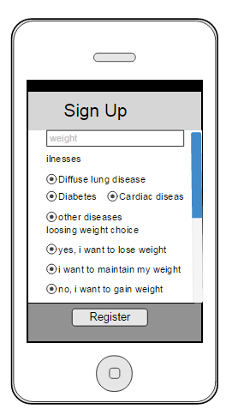

**Bar-code Home Screen**

When user successfully sign in, bar-code camera will be shown. At the bottom of the screen, there will be two options to choose bar-code screen or profile settings. At the middle of the screen, there will be focus symbol for the bar-code that after user show the bar-code of the product to the focus of the camera, new content screen will be shown automatically.

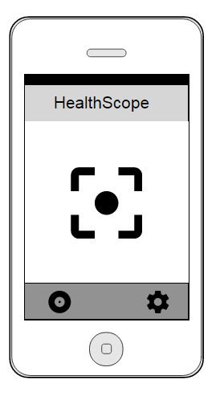

**Content of the Product Screen**

After bar-code is shown, content of the product and their percentage of the advantages/disadvantages will be shown such as protein %-10 is green color and its level is proper or cholesterol %40 in red color which is not suitable level for the user. User can decide which product he should purchase and suitable for him or not. After click on “Back” button, user will go back to the bar-code home screen.

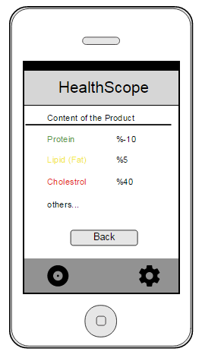

**Profile Settings Screen**

When user click on setting symbol option at the right down, he can see the profile settings. User can change all of the information in this page and update them by clicking on “Update” button.

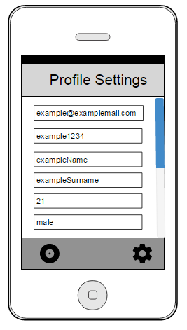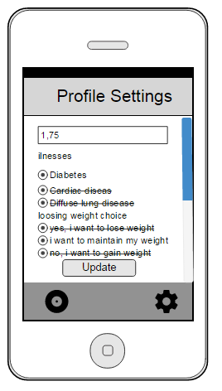

**4. REFERENCES**

[1] https://developer.android.com/studio/intro/index.html/, Online, Accessed: 25.02.2017

[2] https://dev.mysql.com/doc/, Online, Accessed: 25.02.2017

[3] https://github.com/zxing/zxing/, Online, Accessed: 25.02.2017

[4]<https://ndb.nal.usda.gov/ndb/doc/index>/, Online, Accessed: 25.02.2017

[5] https://github.com/, Online, Accessed: 25.02.2017