OpenClinica Data Importer
Software Design Document and User Guide

Document History

Version | Date | Description | Authors
1.0 | 21/05/2010 | Production version | C. Parlayan, J.A.M. Beliën

1 INTRODUCTION

1.1 Product Identification
This document contains the Software Design Specifications for the OpenClinica generic data importer.

1.2 Purpose of the Document
The purpose of this document is to provide the detailed software design and the user guide.

1.3 Scope of the Document
The scope of the body of this document is to describe the implementation of “OCDataImporter” program. Other aspects related to SPSS, MS Excel and OpenClinica can be found in SPSS, Excel and OpenClinica documents.

1.4 Intended Audience
System programmers, system operators.

1.5 References
Microsoft .NET documentation, OpenClinica documents, PostGreSQL documents.

2 GENERAL DESCRIPTION

2.1 Product Perspective
This product will make it possible to convert a study data file into an OpenClinica study.

2.2 Product Availability
The product is available in May 2010.

2.3 Principle Product Functionality
This application is based on reading a study file and converting it to a OpenClinica study.

2.4 General Constraints
This product requires Microsoft .NET Framework version 3.5 distributable Package.
It is included in Windows Vista and Windows 7.

Otherwise, it is possible to download this from the following site:
http://msdn.microsoft.com/downloads/

The program is not yet available under other operating systems.

3 USER GUIDE

This section describes how to use this application.

3.1 Installation

To install this program, create a directory, such as C:\OCDataImporter.
Copy the executable “OCDataImporter.exe” to this directory.
Open Windows explorer and double click to start the program.

You should see the following form:
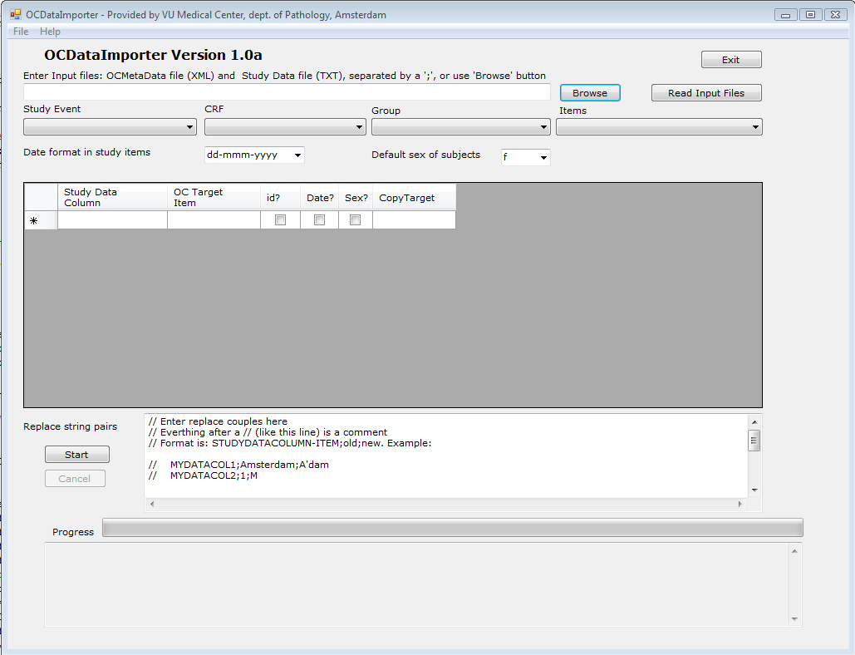

3.2 First step: Convert study to a tab delimited text file.

1- Create a directory, for example C:\MyData.

2- Start SPSS, Excel or another program to convert the study file to a tab delimited text file, named for example “POBASCAM_Data.txt.

The file should look like the following:

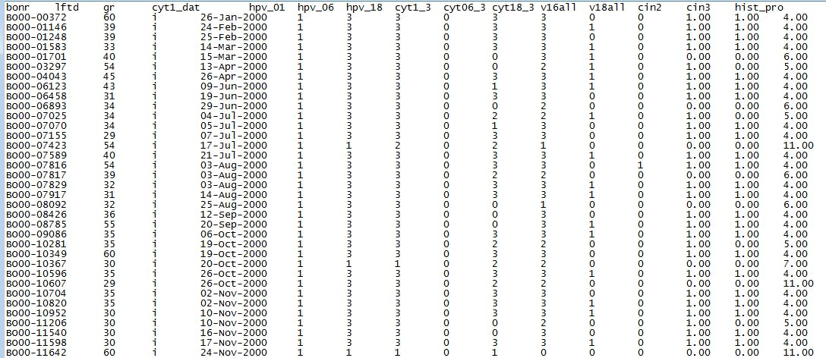

3- Copy this file to C:\MytData.

3.3 Create the Study, CRF and its Items in OpenClinica.

To do this, start OpenClinica, login as Datamanager, Create a study named for example “S_POBASCAM”, create a CRF with items which matches the items for the file generated in section 3.2. For more on using OpenClinica, refer to OpenClinica documents.

3.4 Create OpenClinica Meta Data File using OpenClinica.

Once the OpenClinica objects are created, generate the meta data file.
View the study and Click “here” of the sentence “Download all of the OID’s needed for data import and rules”. Give the file a name, for example “Pobascam_OCMeta.xml” and save the file in C:\MyData. This file is included here to give an overview on how the study and CRF and Items should be made and should look like this:

<Study OID="S_POBASCAM">
<GlobalVariables>
<StudyName>POBASCAM_demo - Test</StudyName>
<StudyDescription>
baseline round (inclusief follow-up testing op 6 en 18 maanden) van de POBASCAM studie.
De ge-includeerde vrouwen hebben abnormale cytologie op baseline en/of zijn HPV-positief. - Voor test doeleinden
</StudyDescription>
<ProtocolName>POBASCAM_demo - Test</ProtocolName>
</GlobalVariables>
<MetaDataVersion>
<Protocol>
<StudyEventRef StudyEventOID="SE_AUTOIMPO" OrderNumber="1" Mandatory="Yes"/>
</Protocol>
<StudyEventDef OID="SE_AUTOIMPO" Name="AutoImport" Repeating="No" Type="Common">
<FormRef FormOID="F_POBA_V10" Mandatory="Yes"/>
</StudyEventDef>
<FormDef OID="F_POBA_V10" Name="POBASCAM - v1.0" Repeating="No">
<ItemGroupRef ItemGroupOID="IG_POBA_UNGROUPED-F_POBA_V10" Mandatory="No"/>
</FormDef>
<ItemGroupDef OID="IG_POBA_UNGROUPED-F_POBA_V10" Name="F_POBA_V10-Ungrouped" Repeating="No" SASDatasetName="UNGROUPE">
<ItemRef ItemOID="I_POBA_BONR" OrderNumber="1" Mandatory="No"/>
<ItemRef ItemOID="I_POBA_LFTD" OrderNumber="2" Mandatory="No"/>
<ItemRef ItemOID="I_POBA_GR" OrderNumber="3" Mandatory="No"/>
<ItemRef ItemOID="I_POBA_CYT1_DAT" OrderNumber="4" Mandatory="No"/>
<ItemRef ItemOID="I_POBA_HPV_01" OrderNumber="5" Mandatory="No"/>
<ItemRef ItemOID="I_POBA_HPV_06" OrderNumber="6" Mandatory="No"/>
<ItemRef ItemOID="I_POBA_HPV_18" OrderNumber="7" Mandatory="No"/>
<ItemRef ItemOID="I_POBA_CYT1_3" OrderNumber="8" Mandatory="No"/>
<ItemRef ItemOID="I_POBA_CYT06_3" OrderNumber="9" Mandatory="No"/>
<ItemRef ItemOID="I_POBA_CYT18_3" OrderNumber="10" Mandatory="No"/>
<ItemRef ItemOID="I_POBA_V16ALL" OrderNumber="11" Mandatory="No"/>
<ItemRef ItemOID="I_POBA_V18ALL" OrderNumber="12" Mandatory="No"/>
<ItemRef ItemOID="I_POBA_CIN2" OrderNumber="13" Mandatory="No"/>
<ItemRef ItemOID="I_POBA_CIN3" OrderNumber="14" Mandatory="No"/>
<ItemRef ItemOID="I_POBA_HIST_PRO" OrderNumber="15" Mandatory="No"/>
</ItemGroupDef>
<ItemDef OID="I_POBA_BONR" Name="bonr" DataType="integer" Length="10" SASFieldName="bonr" Comment="buisnummer van het uitstrijkje">
<Question>
<TranslatedText>
Study data POBASCAM imported automatically - buisnummer van het uitstrijkje
</TranslatedText>
</Question>
</ItemDef>
<ItemDef OID="I_POBA_LFTD" Name="lftd" DataType="integer" Length="10" SASFieldName="lftd" Comment="leeftijd vrouw">
<Question>
<TranslatedText>
leeftijd vrouw
</TranslatedText>
</Question>
</ItemDef>
<ItemDef OID="I_POBA_GR" Name="gr" DataType="text" Length="1" SASFieldName="gr" Comment="groepsindeling">
<Question>
<TranslatedText>
groepsindeling
</TranslatedText>
</Question>
<CodeListRef CodeListOID="CL_451"/>
</ItemDef>
<ItemDef OID="I_POBA_CYT1_DAT" Name="cyt1_dat" DataType="date" SASFieldName="cyt1_dat" Comment="datum baseline uitstrijkje">
<Question>
<TranslatedText>
datum baseline uitstrijkje
</TranslatedText>
</Question>
</ItemDef>
<ItemDef OID="I_POBA_HPV_01" Name="hpv_01" DataType="integer" Length="1" SASFieldName="hpv_01" Comment="hpv uitslag baseline">
<Question>
<TranslatedText>
hpv uitslag baseline
</TranslatedText>
</Question>
<CodeListRef CodeListOID="CL_452"/>
</ItemDef>
<ItemDef OID="I_POBA_HPV_06" Name="hpv_06" DataType="integer" Length="1" SASFieldName="hpv_06" Comment="hpv uitslag na 6 maanden">
<Question>
<TranslatedText>
hpv uitslag na 6 maanden
</TranslatedText>
</Question>
<CodeListRef CodeListOID="CL_452"/>
</ItemDef>
<ItemDef OID="I_POBA_HPV_18" Name="hpv_18" DataType="integer" Length="1" SASFieldName="hpv_18" Comment="hpv uitslag na 18 maanden">
<Question>
<TranslatedText>
hpv uitslag na 18 maanden
</TranslatedText>
</Question>
<CodeListRef CodeListOID="CL_452"/>
</ItemDef>
<ItemDef OID="I_POBA_CYT1_3" Name="cyt1_3" DataType="integer" Length="1" SASFieldName="cyt1_3" Comment="cytologie-uitslag op baseline">
<Question>
<TranslatedText>
cytologie-uitslag op baseline
</TranslatedText>
</Question>
<CodeListRef CodeListOID="CL_453"/>
</ItemDef>
<ItemDef OID="I_POBA_CYT06_3" Name="cyt06_3" DataType="integer" Length="1" SASFieldName="cyt06_3" Comment="cytologie-uitslag na 6 maanden">
<Question>
<TranslatedText>
cytologie-uitslag na 6 maanden
</TranslatedText>
</Question>
<CodeListRef CodeListOID="CL_453"/>
</ItemDef>
<ItemDef OID="I_POBA_CYT18_3" Name="cyt18_3" DataType="integer" Length="1" SASFieldName="cyt18_3" Comment="cytologie-uitslag na 18 maanden">
<Question>
<TranslatedText>
cytologie-uitslag na 18 maanden
</TranslatedText>
</Question>
<CodeListRef CodeListOID="CL_453"/>
</ItemDef>
<ItemDef OID="I_POBA_V16ALL" Name="v16all" DataType="integer" Length="1" SASFieldName="v16all" Comment="HPV16 aanwezig">
<Question>
<TranslatedText>
HPV16 aanwezig
</TranslatedText>
</Question>
<CodeListRef CodeListOID="CL_454"/>
</ItemDef>
<ItemDef OID="I_POBA_V18ALL" Name="v18all" DataType="integer" Length="1" SASFieldName="v18all" Comment="HPV18 aanwezig">
<Question>
<TranslatedText>
HPV18 aanwezig
</TranslatedText>
</Question>
<CodeListRef CodeListOID="CL_454"/>
</ItemDef>
<ItemDef OID="I_POBA_CIN2" Name="cin2" DataType="integer" Length="1" SASFieldName="cin2" Comment="minimaal CIN2 in de follow-up">
<Question>
<TranslatedText>
minimaal CIN2 in de follow-up
</TranslatedText>
</Question>
<CodeListRef CodeListOID="CL_455"/>
</ItemDef>
<ItemDef OID="I_POBA_CIN3" Name="cin3" DataType="integer" Length="1" SASFieldName="cin3" Comment="minimaal CIN3 in de follow-up">
<Question>
<TranslatedText>
minimaal CIN3 in de follow-up
</TranslatedText>
</Question>
<CodeListRef CodeListOID="CL_456"/>
</ItemDef>
<ItemDef OID="I_POBA_HIST_PRO" Name="hist_pro" DataType="integer" Length="2" SASFieldName="hist_pro" Comment="histologie-uitslag">
<Question>
<TranslatedText>
histologie-uitslag
</TranslatedText>
</Question>
<CodeListRef CodeListOID="CL_457"/>
</ItemDef>
<CodeList OID="CL_451" Name="Groepsindeling" DataType="text" SASFormatName="$GROEPSI">
<CodeListItem CodedValue="i">
<Decode>
<TranslatedText>Interventie</TranslatedText>
</Decode>
</CodeListItem>
<CodeListItem CodedValue="c">
<Decode>
<TranslatedText>Controle</TranslatedText>
</Decode>
</CodeListItem>
</CodeList>
<CodeList OID="CL_452" Name="HPVuitslag" DataType="integer" SASFormatName="HPVUITSL">
<CodeListItem CodedValue="1">
<Decode>
<TranslatedText>HPV+</TranslatedText>
</Decode>
</CodeListItem>
<CodeListItem CodedValue="2">
<Decode>
<TranslatedText>HPV-</TranslatedText>
</Decode>
</CodeListItem>
<CodeListItem CodedValue="3">
<Decode>
<TranslatedText>Missing</TranslatedText>
</Decode>
</CodeListItem>
</CodeList>
<CodeList OID="CL_453" Name="CytologieUitslag" DataType="integer" SASFormatName="CYTOLOGI">
<CodeListItem CodedValue="0">
<Decode>
<TranslatedText>&gt; pap 2/3a1</TranslatedText>
</Decode>
</CodeListItem>
<CodeListItem CodedValue="1">
<Decode>
<TranslatedText>pap 2/3a1</TranslatedText>
</Decode>
</CodeListItem>
<CodeListItem CodedValue="2">
<Decode>
<TranslatedText>pap 1</TranslatedText>
</Decode>
</CodeListItem>
<CodeListItem CodedValue="3">
<Decode>
<TranslatedText>missing</TranslatedText>
</Decode>
</CodeListItem>
</CodeList>
<CodeList OID="CL_454" Name="AanwAfw" DataType="integer" SASFormatName="AANWAFW">
<CodeListItem CodedValue="1">
<Decode>
<TranslatedText>Aanwezig</TranslatedText>
</Decode>
</CodeListItem>
<CodeListItem CodedValue="0">
<Decode>
<TranslatedText>Afwezig</TranslatedText>
</Decode>
</CodeListItem>
</CodeList>
<CodeList OID="CL_455" Name="CIN2" DataType="integer" SASFormatName="CIN2X">
<CodeListItem CodedValue="0">
<Decode>
<TranslatedText>st CIN2</TranslatedText>
</Decode>
</CodeListItem>
<CodeListItem CodedValue="1">
<Decode>
<TranslatedText>gte CIN2</TranslatedText>
</Decode>
</CodeListItem>
</CodeList>
<CodeList OID="CL_456" Name="CIN3" DataType="integer" SASFormatName="CIN3X">
<CodeListItem CodedValue="0">
<Decode>
<TranslatedText>st CIN3</TranslatedText>
</Decode>
</CodeListItem>
<CodeListItem CodedValue="1">
<Decode>
<TranslatedText>gte CIN3</TranslatedText>
</Decode>
</CodeListItem>
</CodeList>
<CodeList OID="CL_457" Name="HistPro" DataType="integer" SASFormatName="HISTPRO">
<CodeListItem CodedValue="1">
<Decode>
<TranslatedText>AdenCa</TranslatedText>
</Decode>
</CodeListItem>
<CodeListItem CodedValue="2">
<Decode>
<TranslatedText>SCC</TranslatedText>
</Decode>
</CodeListItem>
<CodeListItem CodedValue="3">
<Decode>
<TranslatedText>biopt te vroeg</TranslatedText>
</Decode>
</CodeListItem>
<CodeListItem CodedValue="4">
<Decode>
<TranslatedText>CIN3</TranslatedText>
</Decode>
</CodeListItem>
<CodeListItem CodedValue="5">
<Decode>
<TranslatedText>CIN2</TranslatedText>
</Decode>
</CodeListItem>
<CodeListItem CodedValue="6">
<Decode>
<TranslatedText>CIN1</TranslatedText>
</Decode>
</CodeListItem>
<CodeListItem CodedValue="7">
<Decode>
<TranslatedText>CIN0</TranslatedText>
</Decode>
</CodeListItem>
<CodeListItem CodedValue="8">
<Decode>
<TranslatedText>CINnos</TranslatedText>
</Decode>
</CodeListItem>
<CodeListItem CodedValue="9">
<Decode>
<TranslatedText>UE</TranslatedText>
</Decode>
</CodeListItem>
<CodeListItem CodedValue="10">
<Decode>
<TranslatedText>no histo</TranslatedText>
</Decode>
</CodeListItem>
<CodeListItem CodedValue="11">
<Decode>
<TranslatedText>no biopt</TranslatedText>
</Decode>
</CodeListItem>
<CodeListItem CodedValue="12">
<Decode>
<TranslatedText>NSR</TranslatedText>
</Decode>
</CodeListItem>
<CodeListItem CodedValue="13">
<Decode>
<TranslatedText>biopt te laat</TranslatedText>
</Decode>
</CodeListItem>
<CodeListItem CodedValue="14">
<Decode>
<TranslatedText>biopt te vroeg</TranslatedText>
</Decode>
</CodeListItem>
</CodeList>
</MetaDataVersion>
</Study>

3.5 Read the input files in “OCDataImporter”

Hit the “browse” button and select the files that are generated:

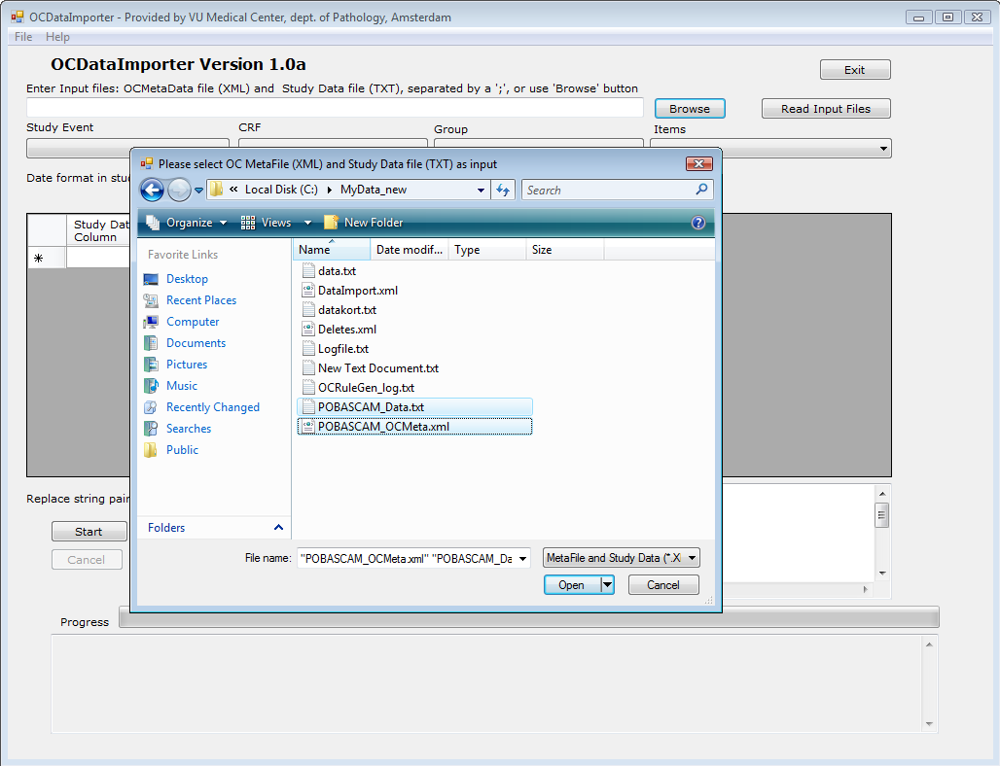

And then hit the “read input files” button.

The program will check if the number of data items in the data file matches with the items in the Meta file. If so, an automatic matching is done.

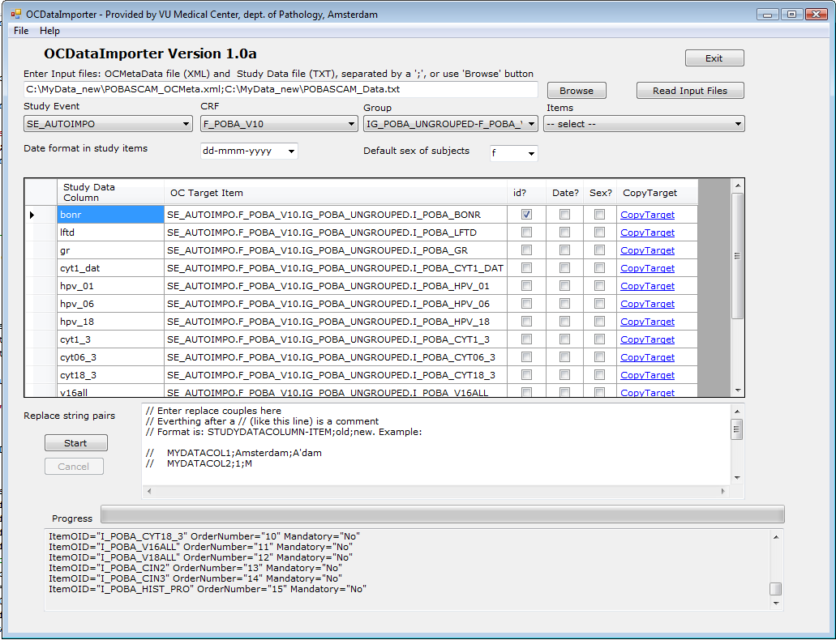

If the number of data items in the data file does not match with the items in the Meta file, the data grid of items has to be matched manually. In this case the program will display the “study data columns” of the grid, but it will leave the “OC Target Item” blank. This can be filled in by using the “CopyTarget” link. To use this link, first chose the target item using the Study event, CRF, Group and Items combo boxes, then hit the CopyTarget of the row which has to be matched with that item.

Suppose you want to match “bonnr” with SE_AUTOIMPO.F_POBA_V10.IG_POBA_UNGROUPED.I_POBA_V18ALL.

Use the combo boxes so that the above appears in the combo boxes and hit “CopyTarget” of the row of “bonnr”.

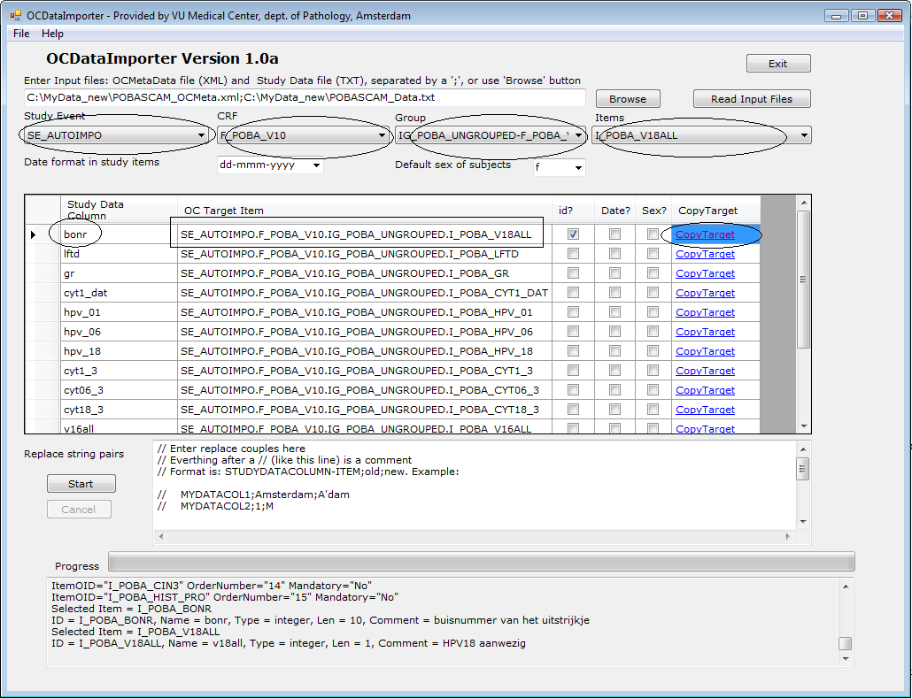

The program will copy the target item into the “OC target Item” field.
When all items of the study data column is matched with an OC target item, you can hit the “start” button. If everything goes fine, you should be able to generate the following files:

Inserts.sql
DataImport.xml

Note: You should see “Finished successfully” at the end of execution. Otherwise, if an error is issued, you should fix it and rerun the program. Possible things that can go wrong:

"Input data file format incorrect at line = 1234 Exiting..."
-> Cause: At line 1234 there are more or less items than 14. Make sure every line contains 14 items; not more, not less.

“Duplicate key at line = 1234 Exiting...”
BO value is duplicated at line 1234, remove or fix and rerun the program.

You can optionally specify the format of dates in the data file, default subject gender if this is not specified in data and replace/delete strings in data.

3.4.1 Specifying date format
You can optionally specify the format of dates in the data file by using the “Date format in study items” combo box. The dates in OC DataImport XML file must be in YYYY-MM-DD format. The program takes care of converting the dates from the format of your choice to OC format.

3.4.2 Specifying default gender of subjects
You can optionally specify the default subject gender if this is not present. Use “default sex of subjects” combo box to specify this.

3.4.3 Specifying text to replace with other text or delete
You can optionally define text to be replaced or removed, when creating OC study from data file. Use “Replace string pairs” text box for this. Format is: STUDYDATACOLUMNITEM;oldtext;newtext.

Examples:

1- Change all “Amsterdam” to “A’dam” :
City;Amsterdam;A'dam

2- In the original file gender is coded as 1 and 2, we want to create the OC study with M a and F
Gender;1;M
Gender;2;F

3- Use <null> to replace with null: We want to get rid of .00 in amount field; so 3.00 must be treated as 3
Amount;.00;<null>

4- The ‘;’ is the separator but if desired this can be changed, to change the separator, use SEPARATOR command:
SEPARATOR=$
Amount$.00$<null>

5- Use ALL to apply changes to all fields: You want to delete all (not just the field amount) .00
ALL;.00;<null>

3.5 Creating subjects, study_subjects and study_events in PostGreSQL using “Inserts.sql”.

The file “Inserts.sql” will be used to create subject, study_subject and sudy_event rows in PostGres.
It contains insert statements for those three tables for each line in the file created in section 3.2.

For example, for the first line of the study data:
“BO00-00372 60 i 26-Jan-2000 1 3 3 0 3 3 0 0 1.00 1.00 4.00”

The following will be created:

INSERT INTO subject(status_id, gender, unique_identifier, date_created, owner_id, dob_collected)
VALUES (1, 'f', 'BO00-00372', '2010-04-26', 1, '1');
INSERT INTO study_subject(label, study_id, status_id, enrollment_date, date_created, date_updated, owner_id, oc_oid, subject_id)
VALUES ('BO00-00372', (SELECT study_id FROM study WHERE oc_oid = 'S_POBASCAM'),
1, '2010-04-26', '2010-04-26', '2010-04-26', 1, 'SS_BO00-00372', (SELECT subject_id FROM subject where unique_identifier = 'BO00-00372'));
INSERT INTO study_event(study_event_definition_id, study_subject_id, location, sample_ordinal, date_start, owner_id, status_id, date_created, subject_event_status_id, start_time_flag, end_time_flag)
VALUES ((SELECT study_event_definition_id FROM study_event_definition WHERE oc_oid = 'SE_AUTOIMPO'),
(SELECT study_subject_id FROM study_subject WHERE oc_oid = 'SS_BO00-00372'),'Amsterdam', 1, '2010-04-26 12:00:00', 1, 1, '2010-04-26', 3, '0', '0');

To run this SQL file, start PGAdmin at the OpenClinica server, select the openclinica database, start Query tool from “Tools” pulldown menu, read “Inserts.sql” file and run this with “execute pgscript”. See Postgres user manuals for more information on how this is made, if necessary.

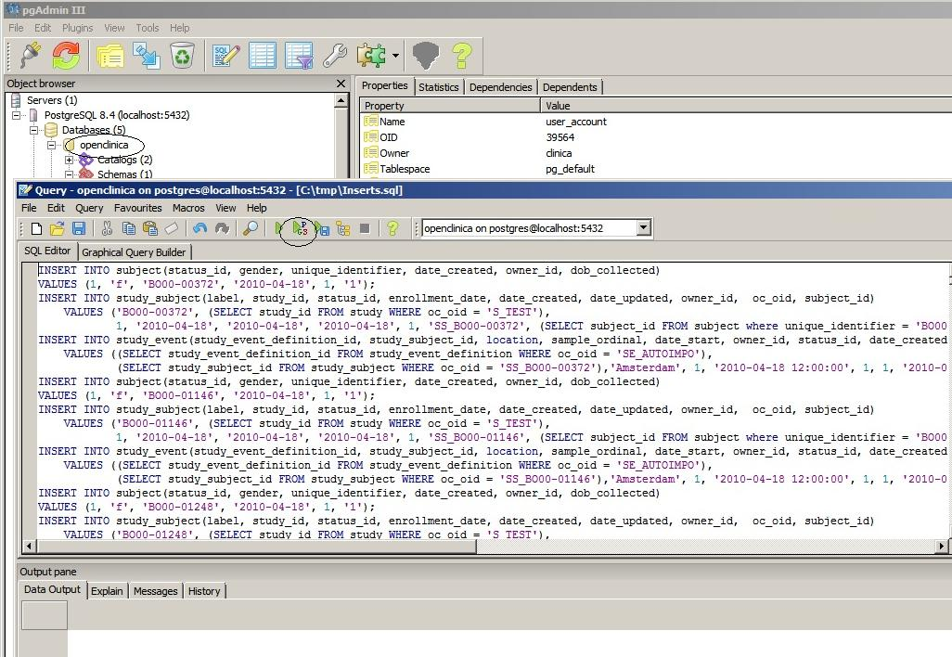

When this is done, proceed with the following section.

Importing data to OpenClinica using “DataImport.xml”.

The file DataImport.xml contains a fixed begin section + import statements for each line in the file created in section 3.2. + fixed end section.

<?xml version="1.0" encoding="UTF-8"?>
<ODM xmlns="http://www.cdisc.org/ns/odm/v1.3"
xmlns:xsi="http://www.w3.org/2001/XMLSchema-instance"
xsi:schemaLocation="http://www.cdisc.org/ns/odm/v1.3 ODM1-3.xsd"
ODMVersion="1.3" FileOID="1D20080412202420" FileType="Snapshot"
Description="First dataset for testing of ODM" CreationDateTime="2008-04-12T20:24:20" >
<ClinicalData StudyOID="S_VUMCDEPT" MetaDataVersionOID="v1.0.0">
<SubjectData SubjectKey="SS_BO00-00372">
</SubjectData>
<SubjectData SubjectKey="next…">
</SubjectData>
……….
<SubjectData SubjectKey="last">
</SubjectData>

</ClinicalData>
</ODM>

For example, for the first line of the study data:
“BO00-00372 60 i 26-Jan-2000 1 3 3 0 3 3 0 0 1.00 1.00 4.00”

The following will be created:

<?xml version="1.0" encoding="UTF-8"?>
<ODM xmlns="http://www.cdisc.org/ns/odm/v1.3"
xmlns:xsi="http://www.w3.org/2001/XMLSchema-instance"
xsi:schemaLocation="http://www.cdisc.org/ns/odm/v1.3 ODM1-3.xsd"
ODMVersion="1.3" FileOID="1D20080412202420" FileType="Snapshot"
Description="First dataset for testing of ODM" CreationDateTime="2008-04-12T20:24:20" >
<ClinicalData StudyOID="S_VUMCDEPT" MetaDataVersionOID="v1.0.0">
<SubjectData SubjectKey="SS_BO00-00372">
<StudyEventData StudyEventOID="SE_AUTOIMPO" StudyEventRepeatKey="1">
<FormData FormOID="F_POBA_V10">
<ItemGroupData ItemGroupOID="IG_POBA_UNGROUPED"
TransactionType="Insert" >
<ItemData ItemOID="I_POBA_BONR" Value="BO00-00372" />
<ItemData ItemOID="I_POBA_LFTD" Value="60" />
<ItemData ItemOID="I_POBA_GR" Value="i" />
<ItemData ItemOID="I_POBA_CYT1_DAT" Value="2000-01-26" />
<ItemData ItemOID="I_POBA_HPV_01" Value="1" />
<ItemData ItemOID="I_POBA_HPV_06" Value="3" />
<ItemData ItemOID="I_POBA_HPV_18" Value="3" />
<ItemData ItemOID="I_POBA_CYT1_3" Value="0" />
<ItemData ItemOID="I_POBA_CYT06_3" Value="3" />
<ItemData ItemOID="I_POBA_CYT18_3" Value="3" />
<ItemData ItemOID="I_POBA_V16ALL" Value="0" />
<ItemData ItemOID="I_POBA_V18ALL" Value="0" />
<ItemData ItemOID="I_POBA_CIN2" Value="1" />
<ItemData ItemOID="I_POBA_CIN3" Value="1" />
<ItemData ItemOID="I_POBA_HIST_PRO" Value="4" />
</ItemGroupData>
</FormData>
</StudyEventData>
</SubjectData>
</ClinicalData>
</ODM>

When this file is uploaded in OpenClinica, the data conversion process will be completed.
Start OpenClinica, click ok “Import Data” of the tasks menu.

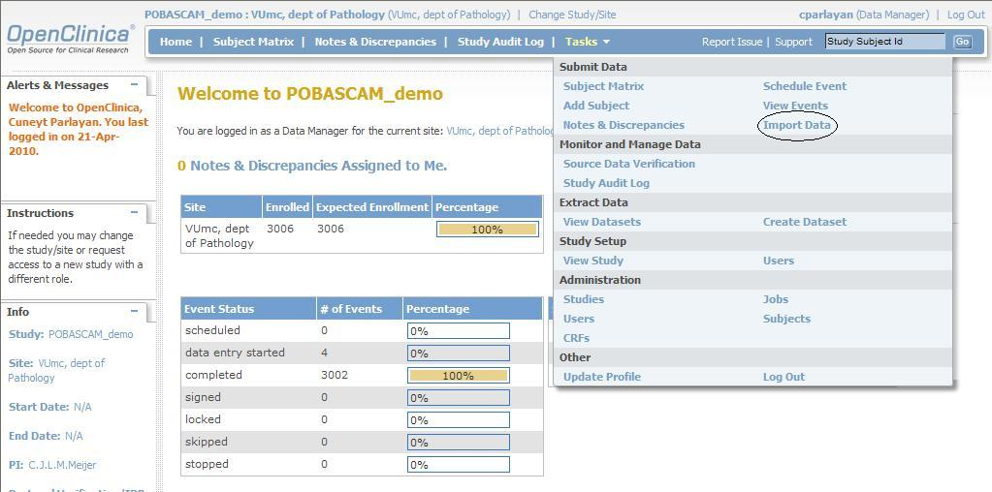

In the next screen, you can enter the path to DataImport.xml:

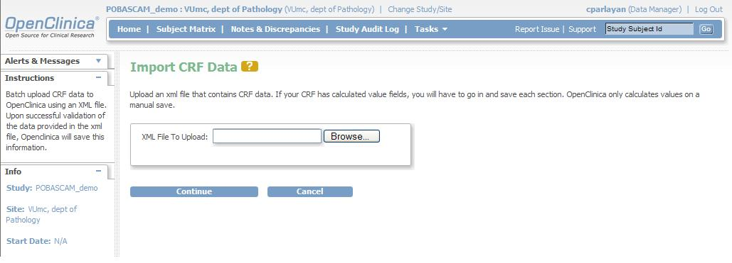

Click then “continue” to start data import.

