《Digital Design》Project Design Report
Topic | FlappyBird
Name | 刘一郴 | SID | 12112609
System Function
The bird is horizontally still. The tubes keep moving leftwards and new tubes appear from the right side.
The player controls the vertical movement of the bird using a button S4. The bird will move up a bit each time the button is pressed. Moreover, the game starts once the button is pressed, and then the bird can start to fall.
Once the bird hits any tubes or the ground, the game stops and everything on the screen becomes still.
The game score, initially zero, is added by one whenever the bird passes a tube. The game score is shown by the 7-seg display on G2 C2 C1 H1.
The game can be restarted using the global reset button (S6).

1.Display the game with 800x600.
2.Randomize the height of the tubes.
3.Implement different levels of difficulty, the speed can be adjusted by button S3 and S0 to down and up.
4.Smoothly movement with gravity.
5.Implement a well-designed and detailed game graphics with background, pipe and bird.
System Design
1.working principle
(a) The player controls the vertical movement of the bird using a button S4. The bird will move up a bit each time the button is pressed. Moreover, the game starts once the button is pressed, and then the bird can start to fall.
(b) the speed of pipes can be adjusted by button S3 and S0 to down and up.
(c) The game can be restarted using the global reset button (S6).

2. system work flow chart
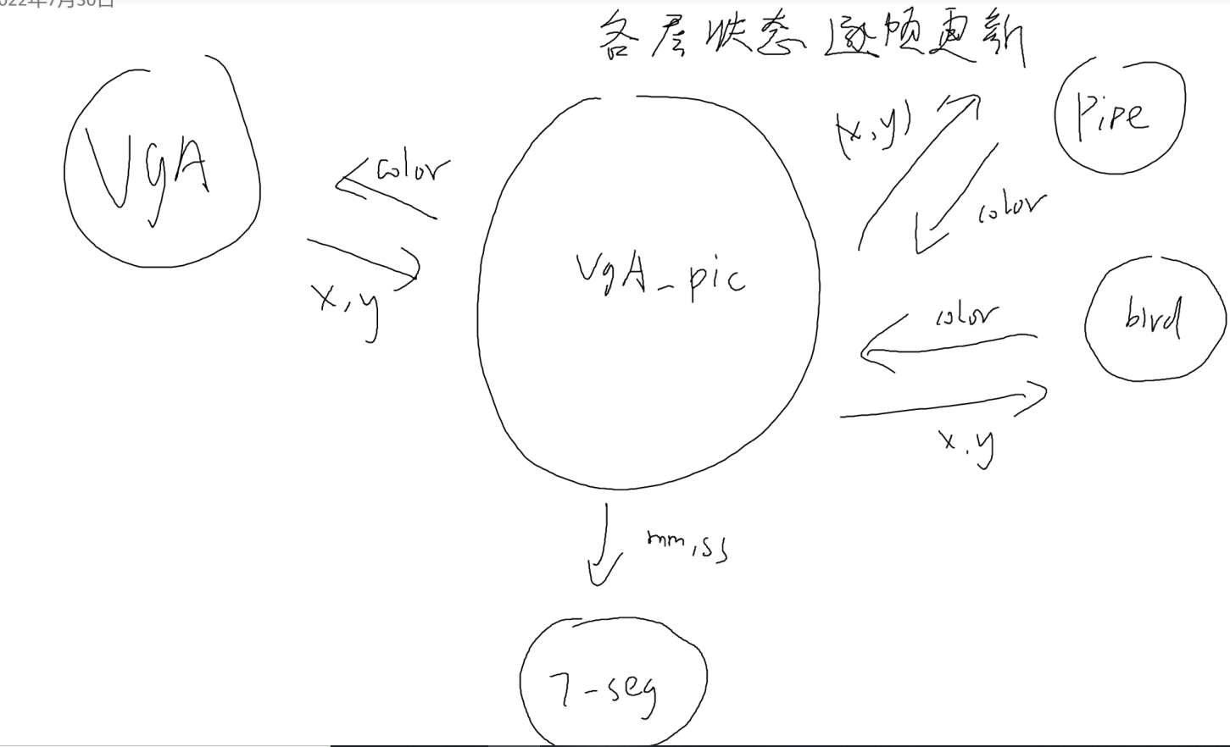

3. system frame diagram
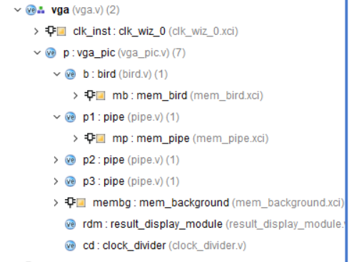
4. port logic function description
Port | Direction | Width(bit) | Function Description
clk_100M | input | 1 | clock signal
rst | input | 1 | reset signal
leap | input | 1 | leap signal
upspeed | input | 1 | upspeed signal
downspeed | input | 1 | downspeed signal
red | output | 4 | red signal
green | output | 4 | green signal
blue | output | 4 | blue signal
hsync | output | 1 | hsync signal
vsync | output | 1 | vsync signal
seg_en | output | 4 | seg_en to control led
seg_out | output | 8 | seg_out to control led

5.Sub-module design
The system is divided into 9 sub-modules, they are clk_wiz_0, vga_pic, bird, mem_bird, pipe, mem_pipe, mem_background, result_display_module, clock_divider.
(a) clk_wiz_0
This module turns the 100MHz signal into the 40MHz signal.
(b)vga_pic
This module can return the color in provided position (x, y) and can return the seg_en and seg_out signal to control the led to show the scores.
(c)bird
This module can return the color of bird if there is bird in provided (x, y).
(d)mem_bird
The rom of bird picture.
(e)pipe
This module can return the color of pipe if there is a pipe in provided (x, y).
(f)mem_pipe
The rom of pipe picture.
(g)mem_background
The rom of background picture.
(h)result_display_module
This module can let led show the scores.
(i)clock_divider
This module can divide the given signal in to signals in given periods.
Problems encountered in the process of experiment and solutions
Question 1: how to load a picture?
Reason: I need to beatify the bird pipe and background.
Solution: using COE document and ROM.
Summary & experience
Learned how to manipulate each pixel point
using only one clock would be helpful

