Homework 3

1. Convolutional Networks
2. Fully connected Autoencoder
3. Restricted Boltzmann Machine
4. Tic Tac Toe
5. Appendices (code)
   1. Convolutional Networks
   2. Fully connected Autoencoder
   3. Restricted Boltzmann Machine
   4. Tic Tac Toe
6. Convolutional networks (2020)

The below tables were calculated from a confusion matrix of each dataset.

**Network 1**

|  |  |  |  |
| --- | --- | --- | --- |
| **Digit** | **Train % Error** | **Validation % Error** | **Test % Error** |
| 0 | 0.06% | 0.14% | 0.11% |
| 1 | 0.09% | 0.14% | 0.11% |
| 2 | 0.10% | 0.12% | 0.13% |
| 3 | 0.12% | 0.30% | 0.09% |
| 4 | 0.08% | 0.15% | 0.08% |
| 5 | 0.12% | 0.20% | 0.14% |
| 6 | 0.05% | 0.14% | 0.19% |
| 7 | 0.11% | 0.11% | 0.18% |
| 8 | 0.15% | 0.29% | 0.23% |
| 9 | 0.16% | 0.28% | 0.25% |
| **Total** | **1.04%** | **1.87%** | **1.51%** |

The hardest digits for this network to classify are 8 and 9, together accounting for almost a third of the errors across all datasets. The easiest are 0 and 4, together accounting for only 14%.

**Network 2**

|  |  |  |  |
| --- | --- | --- | --- |
| **Digit** | **Train % Error** | **Validation % Error** | **Test % Error** |
| 0 | 0.06% | 0.09% | 0.03% |
| 1 | 0.08% | 0.11% | 0.04% |
| 2 | 0.12% | 0.16% | 0.12% |
| 3 | 0.13% | 0.15% | 0.15% |
| 4 | 0.11% | 0.12% | 0.08% |
| 5 | 0.08% | 0.10% | 0.12% |
| 6 | 0.05% | 0.12% | 0.18% |
| 7 | 0.10% | 0.12% | 0.16% |
| 8 | 0.13% | 0.22% | 0.10% |
| 9 | 0.13% | 0.20% | 0.24% |
| **Total** | **0.99%** | **1.39%** | **1.22%** |

The hardest digits for this network to classify are 8 and 9 again, together accounting for 28% of the total errors. The easiest are 0 and 1, together accounting for only 11%.

This network beats the previous network in all datasets, and didn’t take any longer to train. This suggests that additional layers can compensate for fewer epochs in regards to classification accuracy and training time.

1. 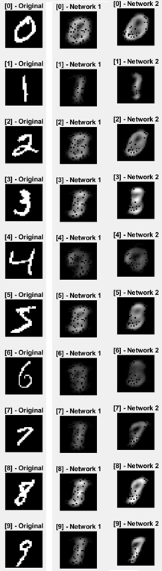Fully connected Autoencoder

Network 1 reproduces about two of them convincingly (0 and 1, the easiest) and Network 2 reproduces about four convincingly (0, 1, 3, and 7).

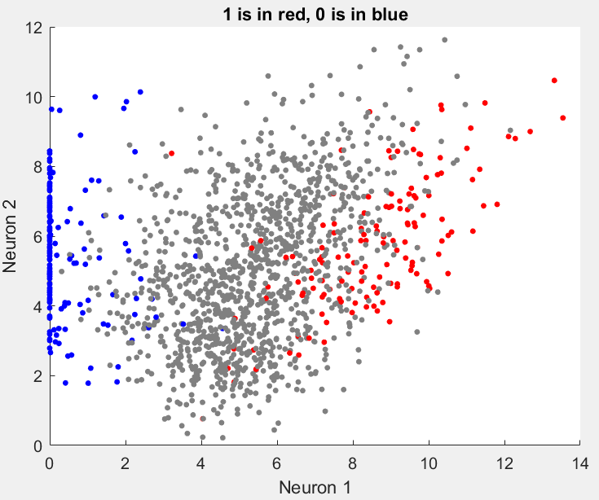Yes! There is a pattern. It separates them linearly. I could use SVM to get a y=mx+b line that discriminates the two.

I chose three random points from each cluster on the scatter plot and fed them into the decoder. They were all reproduced correctly.

For autoencoder 2, one neuron lights up more for each convincingly reproduced digit. That is to say, one neuron will have a significantly higher value than the others and which neuron that is dictates what the decoder will reproduce. The other digits will have random values with no one neuron dominating. Examples are shown below.

|  |  |  |  |  |
| --- | --- | --- | --- | --- |
| Digit | Neuron 1 | Neuron 2 | Neuron 3 | Neuron 4 |
| 0 | **22.2246** | 13.4539 | 16.5791 | 9.5972 |
| 1 | 4.7702 | **29.407** | 3.3738 | 2.6155 |
| 3 | 10.6605 | 3.2841 | **19.6941** | 2.6546 |
| 7 | 4.9645 | 5.3134 | 2.9449 | **14.935** |

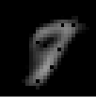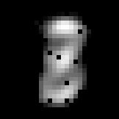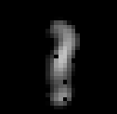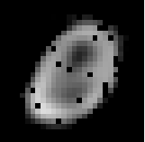

1. Restricted Boltzmann machine

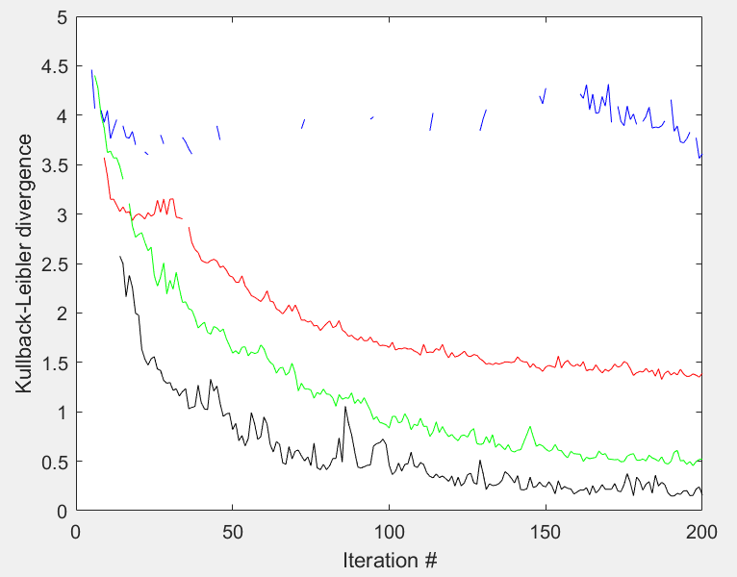The figure to the right shows the KL-divergence for the **two**, **four**, **eight**, and **sixteen** hidden neuron cases.

To estimate the Boltzmann distributions, I sampled 20k randomly generated patterns.

For a sample pattern, where the 2nd column is -1 and the other values are 0, the first 10 iterations are shown below. The network converges to a stored pattern in the 1st iteration, but made an error in the 3rd iteration which was not corrected until the 5th. I tried a few other ones that all converged after the 1st iteration, but this one was interesting.

|  |  |  |  |  |  |  |  |  |  |  |  |  |  |  |  |  |  |  |
| --- | --- | --- | --- | --- | --- | --- | --- | --- | --- | --- | --- | --- | --- | --- | --- | --- | --- | --- |
|  |  |  |  |  |  |  |  |  |  |  |  |  |  |  |  |  |  |  |
|  |  |  |  |  |  |  |  |  |  |  |  |  |  |  |  |  |  |  |
|  |  |  |  |  |  |  |  |  |  |  |  |  |  |  |  |  |  |  |
|  |  |  |  |  |  |  |  |  |  |  |  |  |  |  |  |  |  |  |
|  |  |  |  |  |  |  |  |  |  |  |  |  |  |  |  |  |  |  |
|  |  |  |  |  |  |  |  |  |  |  |  |  |  |  |  |  |  |  |
|  |  |  |  |  |  |  |  |  |  |  |  |  |  |  |  |  |  |  |

1. Tic tac toe (2020)

I wasn’t able to finish this one by the deadline. What is done:

* CheckForWin.m
  + Check if a player won
* AddToQTable.m
  + Append if a state is new
* InitializeRewardTable.m
  + Optimistic initialization
* Pseudo code of the main script
* MakeMove.m is 80% done
  + Choose random with probability = epsilon, otherwise choose best from Q Table

What is left to be done:

* UpdateQTable.m
  + According to 11.19

What is done is shown starting on page 14.

1. Appendices

**5.1 Code for Convolutional Networks**

Network 1

[xTrain, tTrain, xValid, tValid, xTest, tTest] = LoadMNIST(3);

momentum = .9;

maxEpochs = 60;

miniBatchSize = 8192;

initialLearningRate = 0.001;

validationPatience = 5;

validationFrequency = 30;

options = trainingOptions('sgdm','Momentum',momentum,'MaxEpochs',maxEpochs,...

'MiniBatchSize',miniBatchSize,'InitialLearnRate',initialLearningRate,...

'ValidationPatience',validationPatience,'ValidationFrequency',validationFrequency,...

'Shuffle','every-epoch','ValidationData',{xValid,tValid});

layers = [

imageInputLayer([28 28 1],"Name","imageinput")

convolution2dLayer([5 5],20,"Name","conv","Padding",1,"WeightsInitializer","narrow-normal")

reluLayer("Name","relu_1")

maxPooling2dLayer([2 2],"Name","maxpool","Stride",1,"padding",0)

fullyConnectedLayer(100,"Name","fc_1","WeightsInitializer","narrow-normal")

reluLayer("Name","relu_2")

fullyConnectedLayer(10,"Name","fc_2","WeightsInitializer","narrow-normal")

softmaxLayer("Name","softmax")

classificationLayer("Name","classoutput")];

net = trainNetwork(xTrain,tTrain,layers,options);

tTrainPred = classify(net,xTrain);

tValPred = classify(net,xValid);

tTestPred = classify(net,xTest);

trainConfusion = confusionmat(tTrain,tTrainPred);

validConfusion = confusionmat(tValid,tValPred);

testConfusion = confusionmat(tTest,tTestPred);

diagTrain = diag(trainConfusion);

diagValid = diag(validConfusion);

diagTest = diag(testConfusion);

for i = 1:10

iTrainError(i) = (sum(trainConfusion(i,:)) - diagTrain(i)) / sum(trainConfusion(:));

iValidError(i) = (sum(validConfusion(i,:)) - diagValid(i)) / sum(validConfusion(:));

iTestError(i) = (sum(testConfusion(i,:)) - diagTest(i)) / sum(testConfusion(:));

end

trainError = 1 - sum(tTrain==tTrainPred) / length(tTrain);

validError = 1 - sum(tValid==tValPred) / length(tValid);

testError = 1 - sum(tTest==tTestPred) / length(tTest);

Network 2

[xTrain, tTrain, xValid, tValid, xTest, tTest] = LoadMNIST(3);

momentum = .9;

maxEpochs = 30;

miniBatchSize = 8192;

initialLearningRate = 0.01;

validationPatience = 5;

validationFrequency = 30;

options = trainingOptions('sgdm','Momentum',momentum,'MaxEpochs',maxEpochs,...

'MiniBatchSize',miniBatchSize,'InitialLearnRate',initialLearningRate,...

'ValidationPatience',validationPatience,'ValidationFrequency',validationFrequency,...

'Shuffle','every-epoch','ValidationData',{xValid,tValid});

layers = [

imageInputLayer([28 28 1],"Name","imageinput")

convolution2dLayer([3 3],20,"Name","conv_1","Padding",1,"Stride",1,"WeightsInitializer","narrow-normal")

batchNormalizationLayer("Name","batchnorm_1")

reluLayer("Name","relu_1")

maxPooling2dLayer([2 2],"Name","maxpool_1","Stride",2,"Padding",0)

convolution2dLayer([3 3],30,"Name","conv_2","Padding",1,"Stride",1,"WeightsInitializer","narrow-normal")

batchNormalizationLayer("Name","batchnorm_2")

reluLayer("Name","relu_2")

maxPooling2dLayer([2 2],"Name","maxpool_2","Stride",2,"Padding",0)

convolution2dLayer([3 3],50,"Name","conv_3","Padding",1,"Stride",1,"WeightsInitializer","narrow-normal")

batchNormalizationLayer("Name","batchnorm_3")

reluLayer("Name","relu_3")

fullyConnectedLayer(10,"Name","fc","WeightsInitializer","narrow-normal")

softmaxLayer("Name","softmax")

classificationLayer("Name","classoutput")];

net = trainNetwork(xTrain,tTrain,layers,options);

tTrainPred = classify(net,xTrain);

tValPred = classify(net,xValid);

tTestPred = classify(net,xTest);

trainConfusion = confusionmat(tTrain,tTrainPred);

validConfusion = confusionmat(tValid,tValPred);

testConfusion = confusionmat(tTest,tTestPred);

diagTrain = diag(trainConfusion);

diagValid = diag(validConfusion);

diagTest = diag(testConfusion);

for i = 1:10

iTrainError(i) = (sum(trainConfusion(i,:)) - diagTrain(i)) / sum(trainConfusion(:));

iValidError(i) = (sum(validConfusion(i,:)) - diagValid(i)) / sum(validConfusion(:));

iTestError(i) = (sum(testConfusion(i,:)) - diagTest(i)) / sum(testConfusion(:));

end

trainError = 1 - sum(tTrain==tTrainPred) / length(tTrain);

validError = 1 - sum(tValid==tValPred) / length(tValid);

testError = 1 - sum(tTest==tTestPred) / length(tTest);

**5.2 Code for Fully Connected Autoencoder**

[xTrain, tTrain, xValid, tValid, xTest, tTest] = LoadMNIST(3);

xTrainAdj = reshape(xTrain,784,[]) / 255;

xValidAdj = reshape(xValid,784,[]) / 255;

xTestAdj = reshape(xTest,784,[]) / 255;

miniBatchSize = 8192;

initialLearningRate = 0.001;

shuffle = 'every-epoch';

maxEpochs = 800;

executionEnvironment = 'gpu';

options = trainingOptions('adam','MaxEpochs',maxEpochs,...

'MiniBatchSize',miniBatchSize,'InitialLearnRate',initialLearningRate,...

'Shuffle',shuffle,'ValidationData',{xValidAdj,xValidAdj},'ExecutionEnvironment',executionEnvironment);

layers1 = [

sequenceInputLayer(784,"Name","sequence","Normalization","rescale-zero-one")

fullyConnectedLayer(50,"Name","fc_1","WeightsInitializer","glorot")

reluLayer("Name","relu_1")

fullyConnectedLayer(2,"Name","fc_2","WeightsInitializer","glorot")

reluLayer("Name","relu_2")

fullyConnectedLayer(784,"Name","fc_3","WeightsInitializer","glorot")

reluLayer("Name","relu_3")

regressionLayer("Name","regressionoutput")];

layers2 = [

sequenceInputLayer(784,"Name","sequence","Normalization","rescale-zero-one")

fullyConnectedLayer(50,"Name","fc_1","WeightsInitializer","glorot")

reluLayer("Name","relu_1")

fullyConnectedLayer(4,"Name","fc_2","WeightsInitializer","glorot")

reluLayer("Name","relu_2")

fullyConnectedLayer(784,"Name","fc_3","WeightsInitializer","glorot")

reluLayer("Name","relu_3")

regressionLayer("Name","regressionoutput")];

net1 = trainNetwork(xTrainAdj,xTrainAdj,layers1,options);

save net1

net2 = trainNetwork(xTrainAdj,xTrainAdj,layers2,options);

save net2

foundTen = 0;

found = cell(10,1);

i=1;

while foundTen ~= 10

digit = tTrain(i);

if isempty(found{digit})

found{digit} = xTrainAdj(:,i);

foundTen = foundTen + 1;

end

i = i + 1;

end

digits = found;

net1output = cell(10,1);

net2output = cell(10,1);

digi = 0;

for i=1:3:30

net1output{digi+1} = reshape(predict(net1,digits{digi+1}),28,28);

net2output{digi+1} = reshape(predict(net2,digits{digi+1}),28,28);

subplot(10,3,i)

h = imshow(mat2gray(reshape(digits{digi+1},28,28)),'border','tight');

title(strcat('[',num2str(digi),'] - Original'));

subplot(10,3,i+1)

h = imshow(net1output{digi+1},'border','tight');

title(strcat('[',num2str(digi),'] - Network 1'));

subplot(10,3,i+2)

h = imshow(net2output{digi+1},'border','tight');

title(strcat('[',num2str(digi),'] - Network 2'));

digi = digi + 1;

end

layers_encode1(1) = net1.Layers(1);

layers_encode1(2) = net1.Layers(2);

layers_encode1(3) = net1.Layers(3);

layers_encode1(4) = net1.Layers(4);

layers_encode1(5) = net1.Layers(5);

layers_encode1(6) = regressionLayer("Name","regressionoutput");

net1_encode = assembleNetwork(layers_encode1);

layers_decode1(1) = sequenceInputLayer(2);

layers_decode1(2) = net1.Layers(6);

layers_decode1(3) = net1.Layers(7);

layers_decode1(4) = net1.Layers(8);

net1_decode = assembleNetwork(layers_decode1);

layers_encode2(1) = net2.Layers(1);

layers_encode2(2) = net2.Layers(2);

layers_encode2(3) = net2.Layers(3);

layers_encode2(4) = net2.Layers(4);

layers_encode2(5) = net2.Layers(5);

layers_encode2(6) = regressionLayer("Name","regressionoutput");

net2_encode = assembleNetwork(layers_encode2);

layers_decode2(1) = sequenceInputLayer(4);

layers_decode2(2) = net2.Layers(6);

layers_decode2(3) = net2.Layers(7);

layers_decode2(4) = net2.Layers(8);

net2_decode = assembleNetwork(layers_decode2);

scat = [];

colorMap = [];

predictEncode1 = predict(net1_encode,xTrainAdj(:,:));

for i = 1:1500

scat = [scat; double(tTrain(i))-1 double(predictEncode1(:,i))'];

if ismember(double(tTrain(i)), [1 2])

if double(tTrain(i)) == 1

colorMap = [colorMap; [1 0 0]];

else

colorMap = [colorMap; [0 0 1]];

end

else

colorMap = [colorMap; [.5 .5 .5]];

end

end

scatter(scat(:,2),scat(:,3),24* ones(2, 1),colorMap,'filled')

xlabel('Neuron 1')

ylabel('Neuron 2')

title('1 is in red, 0 is in blue')

zeros = [[10,6];[8,4];[11,9]];

ones = [[1,4];[.5,8];[3,9]];

tmp = 0;

for i = 1:2:6

tmp = tmp + 1;

subplot(6,2,i)

imshow(reshape(predict(net1_decode,zeros(tmp,:)'),28,28));

subplot(6,2,i+1)

imshow(reshape(predict(net1_decode,ones(tmp,:)'),28,28));

end

zero = [22.2246,13.4539,16.5791,9.5972];

one = [4.7702,29.407,3.3738,2.6155];

three = [10.6605,3.2841,19.6941,2.6536];

seven = [4.9645,5.3134,2.9499,14.935];

subplot(3,2,1)

imshow(reshape(predict(net2_decode,zero),28,28))

imshow(reshape(predict(net2_decode,one),28,28))

imshow(reshape(predict(net2_decode,three),28,28))

imshow(reshape(predict(net2_decode,seven),28,28))

**5.3 Code for Restricted Boltzmann Machine**

function DKL = CalculateDKL(PB)

DKL = 0;

for mu = 1:14

DKL = DKL + (1/14)*log((1/14)/PB(mu));

end

end

function PB = EstimateBoltzmannDistn(W,biasV,biasH,dat)

PB = zeros(1,14);

numHiddenNeurons = size(W,1);

numVisibleNeurons = size(W,2);

for T=1:20000

randPattern = randi([0 1],9,1);

randPattern(randPattern==0) = -1;

[v0, vK, bH0, bHK] = IterateDynamics(randPattern,W,biasV,biasH,12);

for mu = 1:14

if isequal(dat(mu,:),vK')

PB(mu) = PB(mu) + 1;

end

end

end

PB = PB / 20000;

end

function p = GetProbabilityFromB(b)

p = 1/(1+exp(-2*b));

end

function biasH = InitializeBiases(numNeurons)

biasH = -1 + 2*rand(1,numNeurons);

end

function theta = InitializeThresholds(numHidden)

theta = -1 + 2*rand(1,numHidden);

end

function W = InitializeWeights(numVisible,numHidden)

W = zeros(numVisible,numHidden);

for i=1:numVisible

for j=1:numHidden

W(i,j) = -1 + 2*rand;

end

end

W = W';

end

function [v0, vK, bH0, bHK] = IterateDynamics(pattern,W,biasV,biasH,K)

numHiddenNeurons = size(W,1);

numVisibleNeurons = size(W,2);

v = pattern;

v=[0 -1 0 0 -1 0 0 -1 0 ]';

v0 = v;

bH = W * v - biasH';

bH0 = bH;

h = [];

for i = 1:numHiddenNeurons

if rand < GetProbabilityFromB(bH(i))

h(i) = 1;

else

h(i) = -1;

end

end

h = h';

vPrint=[];

for t = 1:K

bV = (h' * W - biasV)';

vPrint = [vPrint v];

for j = 1:numVisibleNeurons

if rand < GetProbabilityFromB(bV(j))

v(j) = 1;

else

v(j) = -1;

end

end

bH = W * v - biasH';

for i = 1:numHiddenNeurons

if rand < GetProbabilityFromB(bH(i))

h(i) = 1;

else

h(i) = -1;

end

end

end

bHK = bH;

vK = v;

end

clear all

dat = LoadData();

numVisibleNeurons = 9;

numPatterns = 14;

learningRate = .01;

K = 100;

numIterations = 200;

DKL = zeros(4,numIterations);

iHiddenNeuron = 1;

for numHiddenNeurons=[2 4 8 16]

W = InitializeWeights(numVisibleNeurons,numHiddenNeurons);

biasH = InitializeBiases(numHiddenNeurons);

biasV = InitializeBiases(numVisibleNeurons);

for T = 1:numIterations

tmp = randperm(numPatterns);

p0 = randi(numPatterns);

p0 = tmp(1:p0);

for mu = p0

pattern = dat(mu,:)';

[v0, vK, bH0, bHK] = IterateDynamics(pattern,W,biasV,biasH,K);

tmp1 = tanh(bH0) * v0';

tmp2 = tanh(bHK) * vK';

deltaW{mu} = learningRate * (tmp1 - tmp2);

deltaBiasH{mu} = -learningRate * (tanh(bH0)-tanh(bHK))';

deltaBiasV{mu} = -learningRate * (v0 - vK);

end

for mu = p0

W = W + deltaW{mu};

biasH = biasH + deltaBiasH{mu};

biasV = biasV + deltaBiasV{mu};

end

PB = EstimateBoltzmannDistn(W,biasV,biasH,dat);

DKL(iHiddenNeuron,T) = CalculateDKL(PB);

plot(1:numIterations,DKL(1,:),'b',1:numIterations,DKL(2,:),'r',1:numIterations,DKL(3,:),'g',1:numIterations,DKL(4,:),'k');

disp(strcat(num2str(iHiddenNeuron),'-',num2str(T),'---',num2str(DKL(iHiddenNeuron,T))));

end

iHiddenNeuron = iHiddenNeuron + 1;

end

**5.4 Code for Tic Tac Toe**

function qTable = AddToQTable(qTable,boardState,initialEstimatedVal)

append = true;

for i = 1:size(qTable,2)

if isequal(qTable{1,i} , boardState)

append = false;

break;

end

end

if append == true

qTable{1,size(qTable,2) + 1} = boardState;

qTable{2,size(qTable,2)} = InitializeRewardTable(boardState,initialEstimatedVal);

end

end

function win = CheckForWin(boardState,player)

win = 0;

if boardState(1:3) == player

win = 1;

elseif boardState(4:6) == player

win = 1;

elseif boardState(7:9) == player

win = 1;

elseif boardState(1) == player && boardState(4) == player && boardState(7) == player

win = 1;

elseif boardState(2) == player && boardState(5) == player && boardState(8) == player

win = 1;

elseif boardState(3) == player && boardState(6) == player && boardState(9) == player

win = 1;

elseif boardState(1) == player && boardState(5) == player && boardState(9) == player

win = 1;

elseif boardState(3) == player && boardState(5) == player && boardState(7) == player

win = 1;

end

end

function rewardTable = InitializeRewardTable(boardState,initialEstimatedVal)

rewardTable = ones(1,9) * initialEstimatedVal;

for i = 1:9

if boardState(i) ~= 0

rewardTable(i) = NaN;

end

end

end

function [boardState, iQTable] = MakeMove(qTable,iQTable,boardState,player,epsilon)

tmpTable = qTable{2,iQTable};

if rand < epsilon

validChoice = 0;

while validChoice == 0

choice = randi(length(tmpTable));

if ~isnan(tmpTable(choice))

boardState(choice) = player;

break

end

end

else

[maxVal, choice] = max(tmpTable);

boardState(choice) = player;

end

end

clear all

initialBoardState = [0,0,0,0,0,0,0,0,0];

epsilon0 = .5;

epsilonFin = .02;

playerO = 1;

playerX = -1;

initialEstimatedVal = .7;

playerOWins = 0;

playerXWins = 0;

draws = 0;

qTableX = cell(2,1); % first row is board, 2nd is expected values\

qTableO = cell(2,1);

boardState = initialBoardState;

qTableX{1,1} = initialBoardState;

qTableX{2,1} = initialEstimatedVal * ones(1,9);

qTableO{1,1} = initialBoardState;

qTableO{2,1} = initialEstimatedVal * ones(1,9);

for iGame = 1:100000

% initialize game

gameOnGoing = 1;

boardState = initialBoardState;

iQTableO = 1; iQTableX = 1;

while gameOnGoing == 1

[boardState iQTableO] = MakeMove(qTableO,iQTableO,boardState,playerO);

gameOnGoing = CheckForWin(boardState,playerO);

if gameOnGoing == 0

qTableO = UpdateQTable(qTableO);

qTableX = UpdateQTable(qTableX);

else

boardState = MakeMove(boardState,playerX);

gameOnGoing = CheckForWin(boardState,playerX);

if gameOnGoing == 0

qTableO = UPdateQTable(qTableO);

qTableX = UpdateQTable(qTableX);

end

end

end

end