Q1

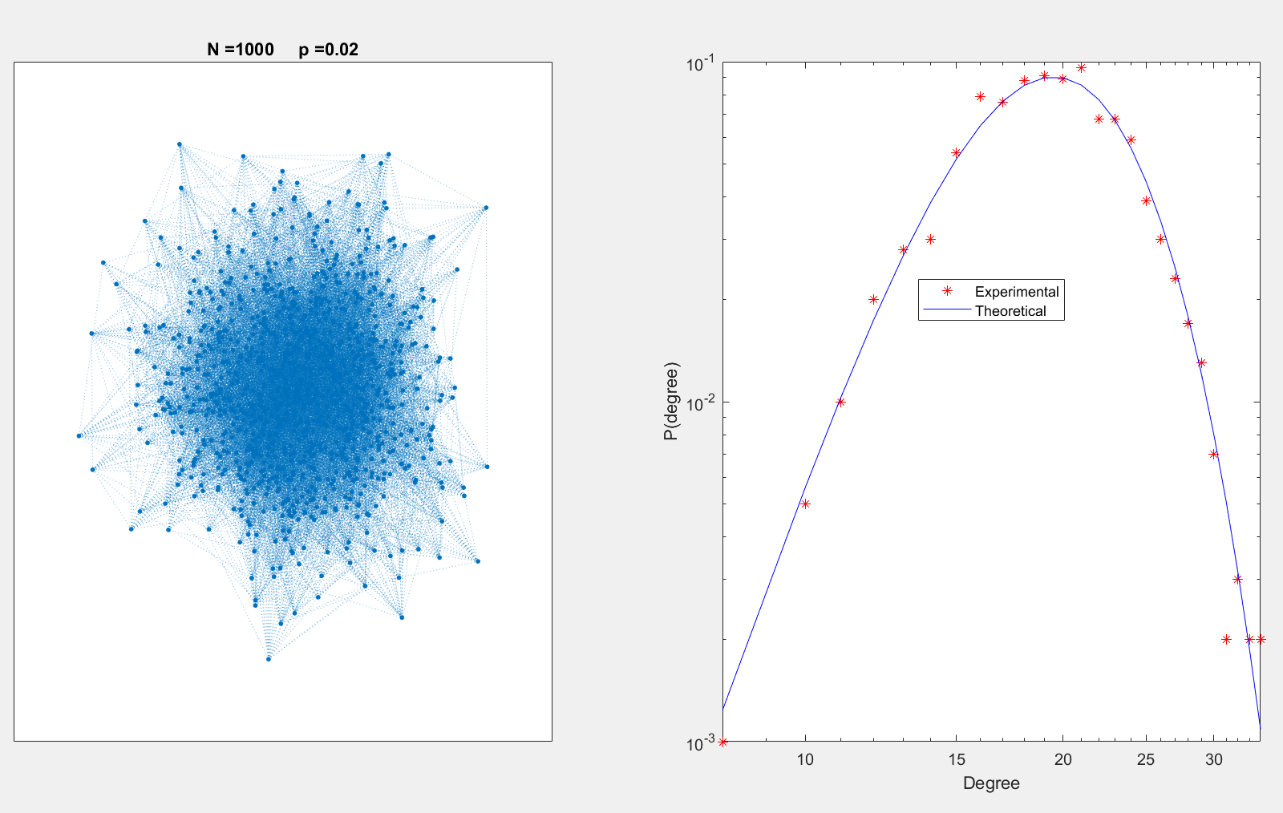

Q2

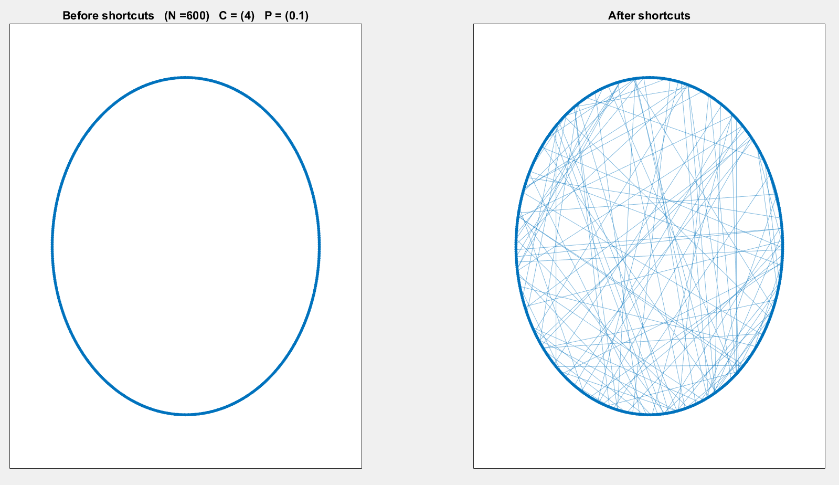

Q3

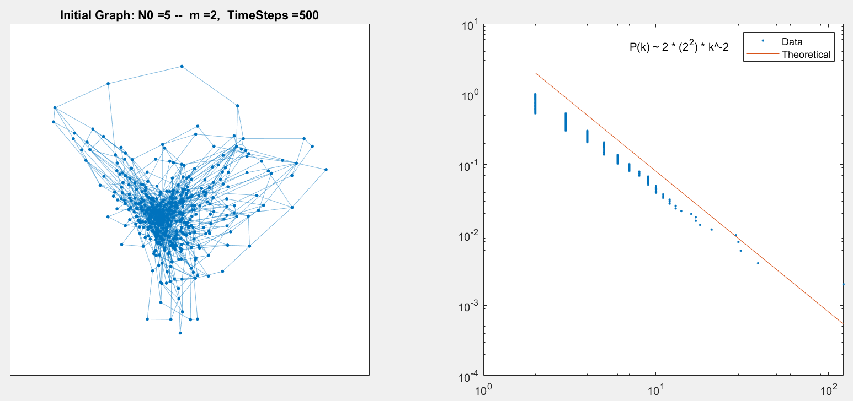

Q4

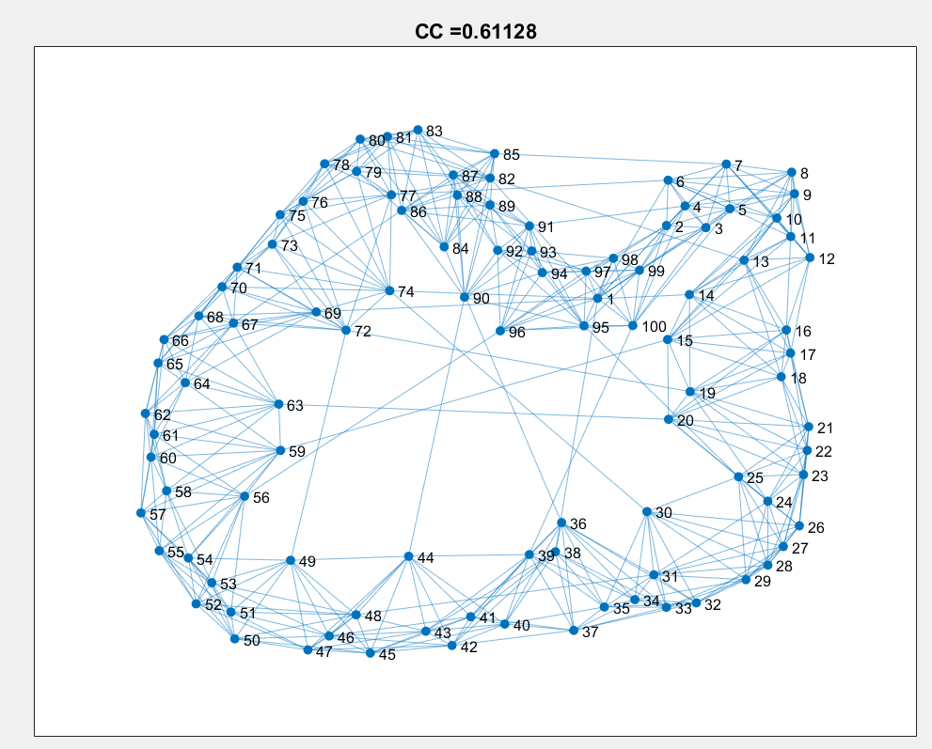

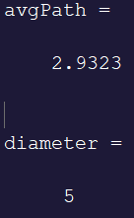Q5

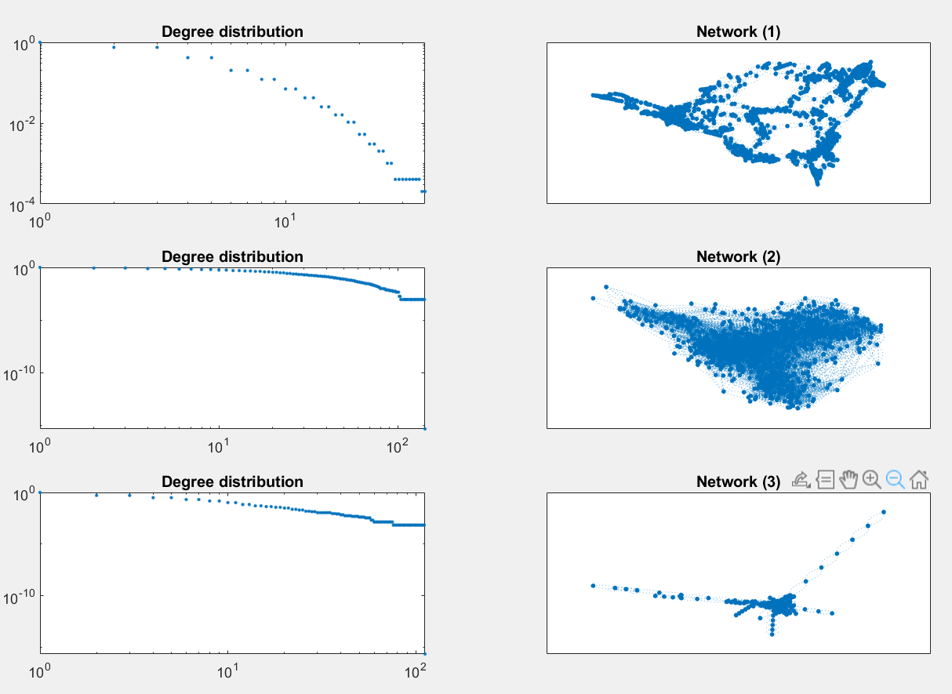Q6

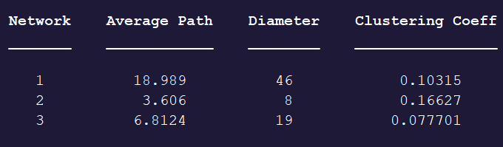

Network 2 is the email exchange due to very low diameter and path.

Network 3 is the protein network due to its scale-free-ness, which I’m guessing is a result of incremental building upon the existing structure.

Network 1 is the power grid partly by process of elimination and partly because I know robustness is huge in power grids and this network as a much lower average betweenness centrality. Net1 has BC~3.3e-4, Net2 is ~0.0011 and Net3 is ~0.0019.