中国海关水运供退物料报文结构定义

一、XML报文实例
<?xml version="1.0" encoding="UTF-8"?>
<Message xmlns="urn:Declaration:datamodel:standard:CN:CSM102:1" xmlns:xsi="http://www.w3.org/2001/XMLSchema-instance">
<MessageHead>
<MessageID/>
<FunctionCode/>
<MessageType/>
<SenderID/>
<ReceiverID/>
<SendTime/>
<Version/>
</MessageHead>
<MessageBody>
<Declaration>
<Material>
<Header>
<IMO/>
<Voyage/>
<Customs_Code/>
<Pre_Input_No/>
<Agent_Code/>
<Supply_Flag/>
<Tran_Type/>
<Pop_No/>
<Accept_Company/>
<Berth/>
<Stay_Place/>
<Quantity/>
<Cubage/>
<Pack_Type/>
<Gross_Weight/>
<Net_Weight/>
<Manage_Company/>
<Bill_Num/>
<Bill_Type/>
<Other/>
</Header>
<Item>
<SeqNo/>
<MaterielCode/>
<MaterielName/>
<DeclareQty/>
<RealQty/>
<Unit/>
<Price/>
<Total/>
<Curr/>
<Weight/>
<OriginCountry/>
<Memo/>
</Item>
</Material>
</Declaration>
</MessageBody>
</Message>

二、报文结构
1______Message
1 |______MessageHead
1 | |______MessageID
1 | |______FunctionCode
1 | |______MessageType
1 | |______SenderID
1 | |______ReceiverID
1 | |______SendTime
1 | |______Version
1 |______MessageBody
1 | |______Declaration
1 | | |______Material
1 | | | |______Header
1 | | | | |______IMO
1 | | | | |______Voyage
1 | | | | |______Customs_Code
1 | | | | |______Pre_Input_No
1 | | | | |______Agent_Code
1 | | | | |______Supply_Flag
1 | | | | |______Tran_Type
1 | | | | |______Pop_No
1 | | | | |______Accept_Company
1 | | | | |______Berth
1 | | | | |______Stay_Place
1 | | | | |______Quantity
1 | | | | |______Cubage
1 | | | | |______Pack_Type
1 | | | | |______Gross_Weight
1 | | | | |______Net_Weight
1 | | | | |______Manage_Company
1 | | | | |______Bill_Num
1 | | | | |______Bill_Type
1 | | | | |______Other
10000 | | | |______Item
1 | | | | |______SeqNo
1 | | | | |______MaterielCode
1 | | | | |______MaterielName
1 | | | | |______DeclareQty
1 | | | | |______RealQty
1 | | | | |______Unit
1 | | | | |______Price
1 | | | | |______Total
1 | | | | |______Curr
1 | | | | |______Weight
1 | | | | |______OriginCountry
1 | | | | |______Memo

三、报文节点详细说明

element Message
diagram | 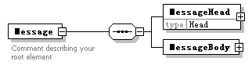
properties
  content | complex
children | MessageHead MessageBody
annotation
  documentation
  Comment describing your root element

element Message/MessageHead
diagram | 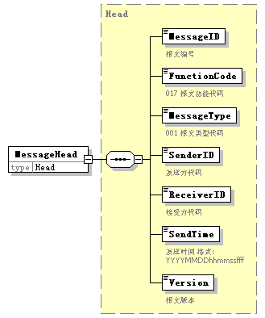
type | Head
properties
  isRef | 0
  content | complex
children | MessageID FunctionCode MessageType SenderID ReceiverID SendTime Version

element Message/MessageBody
diagram | 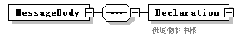
properties
  isRef | 0
  content | complex
children | Declaration

element Message/MessageBody/Declaration
diagram | 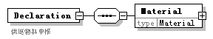
properties
  isRef | 0
  content | complex
children | Material
annotation
  documentation
  供退物料申报

element Message/MessageBody/Declaration/Material
diagram | 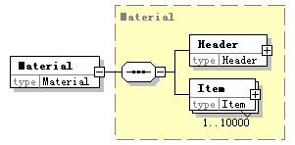
type | Material
properties
  isRef | 0
  content | complex
children | Header Item

complexType AdditionalInformation
diagram | 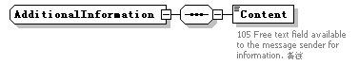
children | Content

element AdditionalInformation/Content
diagram | 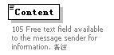
properties
  isRef | 0
annotation
  documentation
  105 Free text field available to the message sender for information. 备注

complexType ArrivalConveyanceFacility
diagram | 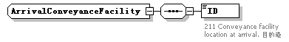
children | ID

element ArrivalConveyanceFacility/ID
diagram | 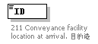
properties
  isRef | 0
annotation
  documentation
  211 Conveyance facility location at arrival. 目的港

complexType Contact
diagram | 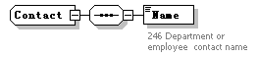
children | Name

element Contact/Name
diagram | 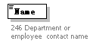
properties
  isRef | 0
annotation
  documentation
  246 Department or employee contact name

complexType DepartureConveyanceFacility
diagram | 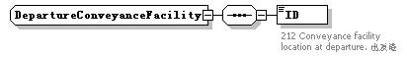
children | ID

element DepartureConveyanceFacility/ID
diagram | 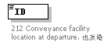
properties
  isRef | 0
annotation
  documentation
  212 Conveyance facility location at departure. 出发港

complexType Head
diagram | 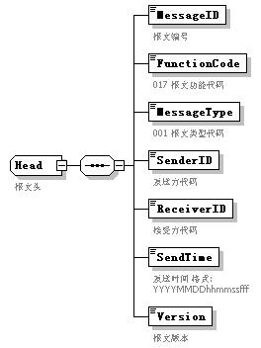
children | MessageID FunctionCode MessageType SenderID ReceiverID SendTime Version
used by
  element | Message/MessageHead
annotation
  documentation
  报文头

element Head/MessageID
diagram | 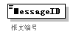
properties
  isRef | 0
annotation
  documentation
  报文编号

element Head/FunctionCode
diagram | 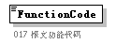
properties
  isRef | 0
annotation
  documentation
  017 报文功能代码

element Head/MessageType
diagram | 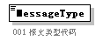
properties
  isRef | 0
annotation
  documentation
  001 报文类型代码

element Head/SenderID
diagram | 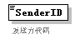
properties
  isRef | 0
annotation
  documentation
  发送方代码

element Head/ReceiverID
diagram | 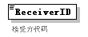
properties
  isRef | 0
annotation
  documentation
  接受方代码

element Head/SendTime
diagram | 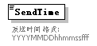
properties
  isRef | 0
annotation
  documentation
  发送时间 格式:YYYYMMDDhhmmssfff

element Head/Version
diagram | 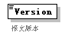
properties
  isRef | 0
annotation
  documentation
  报文版本

complexType Header
diagram | 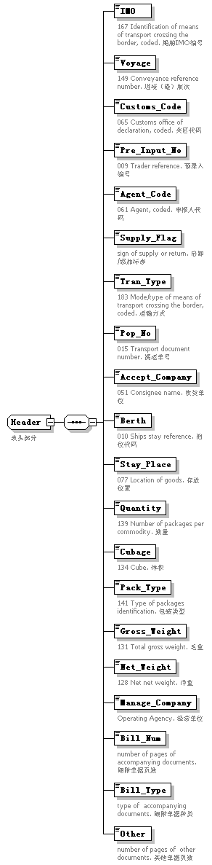
children | IMO Voyage Customs_Code Pre_Input_No Agent_Code Supply_Flag Tran_Type Pop_No Accept_Company Berth Stay_Place Quantity Cubage Pack_Type Gross_Weight Net_Weight Manage_Company Bill_Num Bill_Type Other
used by
  element | Material/Header
annotation
  documentation
  表头部分

element Header/IMO
diagram | 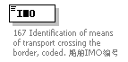
properties
  isRef | 0
annotation
  documentation
  167 Identification of means of transport crossing the border, coded. 船舶IMO编号

element Header/Voyage
diagram | 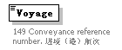
properties
  isRef | 0
annotation
  documentation
  149 Conveyance reference number. 进境（港）航次

element Header/Customs_Code
diagram | 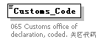
properties
  isRef | 0
annotation
  documentation
  065 Customs office of declaration, coded. 关区代码

element Header/Pre_Input_No
diagram | 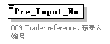
properties
  isRef | 0
annotation
  documentation
  009 Trader reference. 预录入编号

element Header/Agent_Code
diagram | 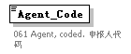
properties
  isRef | 0
annotation
  documentation
  061 Agent, coded. 申报人代码

element Header/Supply_Flag
diagram | 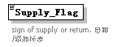
properties
  isRef | 0
annotation
  documentation
  sign of supply or return. 启卸/添加标志

element Header/Tran_Type
diagram | 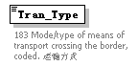
properties
  isRef | 0
annotation
  documentation
  183 Mode/type of means of transport crossing the border, coded. 运输方式

element Header/Pop_No
diagram | 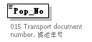
properties
  isRef | 0
annotation
  documentation
  015 Transport document number. 提运单号

element Header/Accept_Company
diagram | 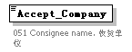
properties
  isRef | 0
annotation
  documentation
  051 Consignee name. 收货单位

element Header/Berth
diagram | 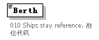
properties
  isRef | 0
annotation
  documentation
  010 Ships stay reference. 泊位代码

element Header/Stay_Place
diagram | 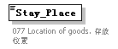
properties
  isRef | 0
annotation
  documentation
  077 Location of goods. 存放位置

element Header/Quantity
diagram | 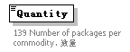
properties
  isRef | 0
annotation
  documentation
  139 Number of packages per commodity. 数量

element Header/Cubage
diagram | 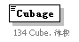
properties
  isRef | 0
annotation
  documentation
  134 Cube. 体积

element Header/Pack_Type
diagram | 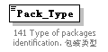
properties
  isRef | 0
annotation
  documentation
  141 Type of packages identification. 包装类型

element Header/Gross_Weight
diagram | 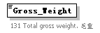
properties
  isRef | 0
annotation
  documentation
  131 Total gross weight. 毛重

element Header/Net_Weight
diagram | 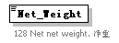
properties
  isRef | 0
annotation
  documentation
  128 Net net weight. 净重

element Header/Manage_Company
diagram | 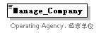
properties
  isRef | 0
annotation
  documentation
  Operating Agency. 经营单位

element Header/Bill_Num
diagram | 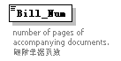
properties
  isRef | 0
annotation
  documentation
  number of pages of accompanying documents. 随附单据页数

element Header/Bill_Type
diagram | 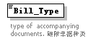
properties
  isRef | 0
annotation
  documentation
  type of accompanying documents. 随附单据种类

element Header/Other
diagram | 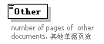
properties
  isRef | 0
annotation
  documentation
  number of pages of other documents. 其他单据页数

complexType Item
diagram | 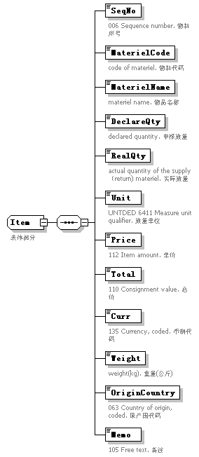
children | SeqNo MaterielCode MaterielName DeclareQty RealQty Unit Price Total Curr Weight OriginCountry Memo
used by
  element | Material/Item
annotation
  documentation
  表体部分

element Item/SeqNo
diagram | 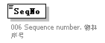
properties
  isRef | 0
annotation
  documentation
  006 Sequence number. 物料序号

element Item/MaterielCode
diagram | 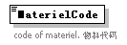
properties
  isRef | 0
annotation
  documentation
  code of materiel. 物料代码

element Item/MaterielName
diagram | 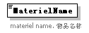
properties
  isRef | 0
annotation
  documentation
  materiel name. 物品名称

element Item/DeclareQty
diagram | 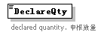
properties
  isRef | 0
annotation
  documentation
  declared quantity. 申报数量

element Item/RealQty
diagram | 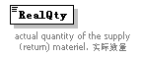
properties
  isRef | 0
annotation
  documentation
  actual quantity of the supply（return) materiel. 实际数量

element Item/Unit
diagram | 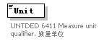
properties
  isRef | 0
annotation
  documentation
  UNTDED 6411 Measure unit qualifier. 数量单位

element Item/Price
diagram | 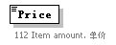
properties
  isRef | 0
annotation
  documentation
  112 Item amount. 单价

element Item/Total
diagram | 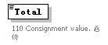
properties
  isRef | 0
annotation
  documentation
  110 Consignment value. 总价

element Item/Curr
diagram | 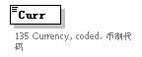
properties
  isRef | 0
annotation
  documentation
  135 Currency, coded. 币制代码

element Item/Weight
diagram | 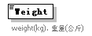
properties
  isRef | 0
annotation
  documentation
  weight(kg). 重量(公斤)

element Item/OriginCountry
diagram | 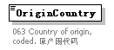
properties
  isRef | 0
annotation
  documentation
  063 Country of origin, coded. 原产国代码

element Item/Memo
diagram | 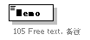
properties
  isRef | 0
annotation
  documentation
  105 Free text. 备注

complexType Material
diagram | 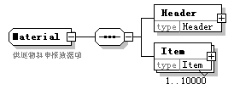
children | Header Item
used by
  element | Message/MessageBody/Declaration/Material
annotation
  documentation
  供退物料申报数据项

element Material/Header
diagram | 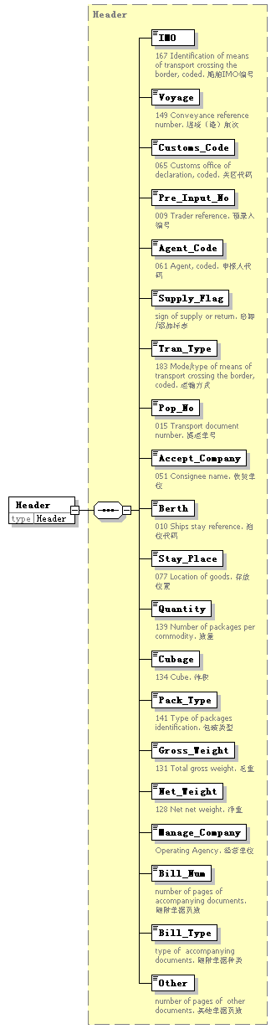
type | Header
properties
  isRef | 0
  content | complex
children | IMO Voyage Customs_Code Pre_Input_No Agent_Code Supply_Flag Tran_Type Pop_No Accept_Company Berth Stay_Place Quantity Cubage Pack_Type Gross_Weight Net_Weight Manage_Company Bill_Num Bill_Type Other

element Material/Item
diagram | 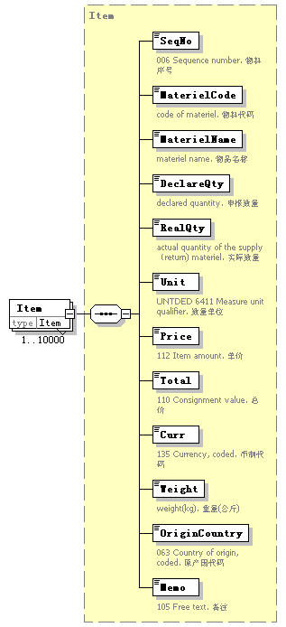
type | Item
properties
  isRef | 0
  minOcc | 1
  maxOcc | 10000
  content | complex
children | SeqNo MaterielCode MaterielName DeclareQty RealQty Unit Price Total Curr Weight OriginCountry Memo

complexType TradeTerm
diagram | 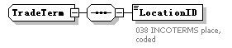
children | LocationID

element TradeTerm/LocationID
diagram | 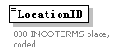
properties
  isRef | 0
annotation
  documentation
  038 INCOTERMS place, coded

complexType UnloadingLocation
diagram | 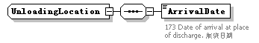
children | ArrivalDate

element UnloadingLocation/ArrivalDate
diagram | 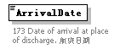
properties
  isRef | 0
annotation
  documentation
  173 Date of arrival at place of discharge. 航班日期

