中国海关空运供退物料报文结构定义

一、XML报文实例
<?xml version="1.0" encoding="UTF-8"?>
<Message xmlns="urn:Declaration:datamodel:standard:CN:CAM101:1" xmlns:xsi="http://www.w3.org/2001/XMLSchema-instance" >
<MessageHead>
<MessageID>String</MessageID>
<FunctionCode>String</FunctionCode>
<MessageType>CAM001</MessageType>
<SenderID>String</SenderID>
<ReceiverID>String</ReceiverID>
<SendTime>10000101000000+00</SendTime>
<Version>1.0</Version>
</MessageHead>
<MessageBody>
<Declaration>
<GTWL>
<HEADER>
<ENTERPRISE_CODE>String</ENTERPRISE_CODE>
<AIRCRAFT_NO>String</AIRCRAFT_NO>
<FLIGHT_NO>String</FLIGHT_NO>
<FLIGHT_DATE>10000101</FLIGHT_DATE>
<AIRPORT>String</AIRPORT>
<PRE_INPUT_NO>String</PRE_INPUT_NO>
<I_O_FLAG>S</I_O_FLAG>
<DECLARE_NAME>String</DECLARE_NAME>
<MEMO>String</MEMO>
<DECLARE_TIME>10000101</DECLARE_TIME>
</HEADER>
<ITEM>
<SERIAL_NO>0</SERIAL_NO>
<MATERIEL_CODE>String</MATERIEL_CODE>
<MATERIEL_NAME>String</MATERIEL_NAME>
<DECLARE_NUM>3.1415926535897932384626433832795</DECLARE_NUM>
<METRIC_UNIT>String</METRIC_UNIT>
<MEMO>String</MEMO>
</ITEM>
</GTWL>
</Declaration>
</MessageBody>
</Message>

二、报文结构
1______Message
1 |______MessageHead
1 | |______MessageID
1 | |______FunctionCode
1 | |______MessageType
1 | |______SenderID
1 | |______ReceiverID
1 | |______SendTime
1 | |______Version
1 |______MessageBody
1 | |______Declaration
1 | | |______GTWL
1 | | | |______HEADER
1 | | | | |______ENTERPRISE_CODE
1 | | | | |______AIRCRAFT_NO
1 | | | | |______FLIGHT_NO
1 | | | | |______FLIGHT_DATE
1 | | | | |______AIRPORT
1 | | | | |______PRE_INPUT_NO
1 | | | | |______I_O_FLAG
1 | | | | |______DECLARE_NAME
1 | | | | |______MEMO
1 | | | | |______DECLARE_TIME
99999 | | | |______ITEM
1 | | | | |______SERIAL_NO
1 | | | | |______MATERIEL_CODE
1 | | | | |______MATERIEL_NAME
1 | | | | |______DECLARE_NUM
1 | | | | |______METRIC_UNIT
1 | | | | |______MEMO

三、报文节点详细说明
element Message
diagram | 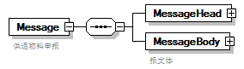
properties
  content | complex
children | MessageHead MessageBody
annotation
  documentation
  供退物料申报

element Message/MessageHead
diagram | 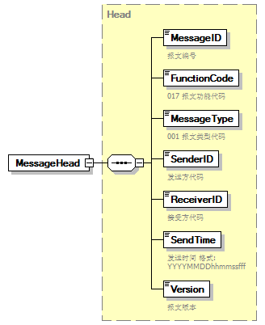
type | Head
properties
  isRef | 0
  content | complex
children | MessageID FunctionCode MessageType SenderID ReceiverID SendTime Version

element Message/MessageBody
diagram | 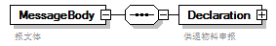
properties
  isRef | 0
  content | complex
children | Declaration
annotation
  documentation
  报文体

element Message/MessageBody/Declaration
diagram | 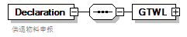
properties
  isRef | 0
  content | complex
children | GTWL
annotation
  documentation
  供退物料申报

element Message/MessageBody/Declaration/GTWL
diagram | 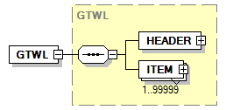
type | GTWL
properties
  isRef | 0
  content | complex
children | HEADER ITEM

complexType AdditionalInformation
diagram | 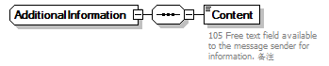
children | Content

element AdditionalInformation/Content
diagram | 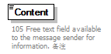
properties
  isRef | 0
annotation
  documentation
  105 Free text field available to the message sender for information. 备注

complexType ArrivalConveyanceFacility
diagram | 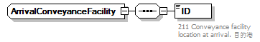
children | ID

element ArrivalConveyanceFacility/ID
diagram | 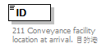
properties
  isRef | 0
annotation
  documentation
  211 Conveyance facility location at arrival. 目的港

complexType Contact
diagram | 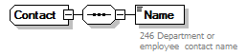
children | Name

element Contact/Name
diagram | 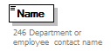
properties
  isRef | 0
annotation
  documentation
  246 Department or employee contact name

complexType DepartureConveyanceFacility
diagram | 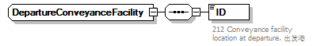
children | ID

element DepartureConveyanceFacility/ID
diagram | 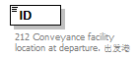
properties
  isRef | 0
annotation
  documentation
  212 Conveyance facility location at departure. 出发港

complexType GTWL
diagram | 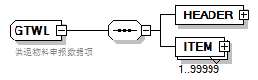
children | HEADER ITEM
used by
  element | Message/MessageBody/Declaration/GTWL
annotation
  documentation
  供退物料申报数据项

element GTWL/HEADER
diagram | 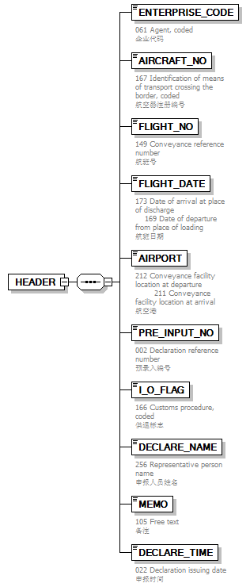
properties
  isRef | 0
  content | complex
children | ENTERPRISE_CODE AIRCRAFT_NO FLIGHT_NO FLIGHT_DATE AIRPORT PRE_INPUT_NO I_O_FLAG DECLARE_NAME MEMO DECLARE_TIME

element GTWL/HEADER/ENTERPRISE_CODE
diagram | 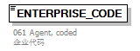
properties
  isRef | 0
annotation
  documentation
  061 Agent, coded
  企业代码

element GTWL/HEADER/AIRCRAFT_NO
diagram | 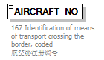
properties
  isRef | 0
annotation
  documentation
  167 Identification of means of transport crossing the border, coded
  航空器注册编号

element GTWL/HEADER/FLIGHT_NO
diagram | 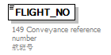
properties
  isRef | 0
annotation
  documentation
  149 Conveyance reference number
  航班号

element GTWL/HEADER/FLIGHT_DATE
diagram | 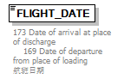
properties
  isRef | 0
annotation
  documentation
  173 Date of arrival at place of discharge 169 Date of departure from place of loading
  航班日期

element GTWL/HEADER/AIRPORT
diagram | 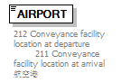
properties
  isRef | 0
annotation
  documentation
  212 Conveyance facility location at departure 211 Conveyance facility location at arrival
  航空港

element GTWL/HEADER/PRE_INPUT_NO
diagram | 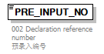
properties
  isRef | 0
annotation
  documentation
  002 Declaration reference number
  预录入编号

element GTWL/HEADER/I_O_FLAG
diagram | 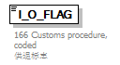
properties
  isRef | 0
annotation
  documentation
  166 Customs procedure, coded
  供退标志

element GTWL/HEADER/DECLARE_NAME
diagram | 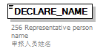
properties
  isRef | 0
annotation
  documentation
  256 Representative person name
  申报人员姓名

element GTWL/HEADER/MEMO
diagram | 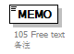
properties
  isRef | 0
annotation
  documentation
  105 Free text
  备注

element GTWL/HEADER/DECLARE_TIME
diagram | 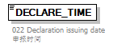
properties
  isRef | 0
annotation
  documentation
  022 Declaration issuing date
  申报时间

element GTWL/ITEM
diagram | 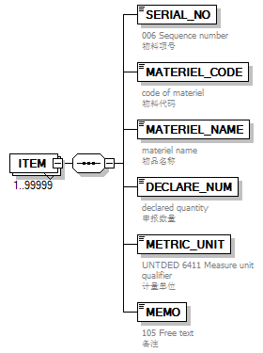
properties
  isRef | 0
  minOcc | 1
  maxOcc | 99999
  content | complex
children | SERIAL_NO MATERIEL_CODE MATERIEL_NAME DECLARE_NUM METRIC_UNIT MEMO

element GTWL/ITEM/SERIAL_NO
diagram | 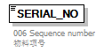
properties
  isRef | 0
annotation
  documentation
  006 Sequence number
  物料项号

element GTWL/ITEM/MATERIEL_CODE
diagram | 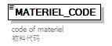
properties
  isRef | 0
annotation
  documentation
  code of materiel
  物料代码

element GTWL/ITEM/MATERIEL_NAME
diagram | 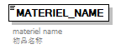
properties
  isRef | 0
annotation
  documentation
  materiel name
  物品名称

element GTWL/ITEM/DECLARE_NUM
diagram | 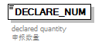
properties
  isRef | 0
annotation
  documentation
  declared quantity
  申报数量

element GTWL/ITEM/METRIC_UNIT
diagram | 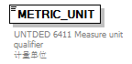
properties
  isRef | 0
annotation
  documentation
  UNTDED 6411 Measure unit qualifier
  计量单位

element GTWL/ITEM/MEMO
diagram
properties
  isRef | 0
annotation
  documentation
  105 Free text
  备注

complexType Head
diagram | 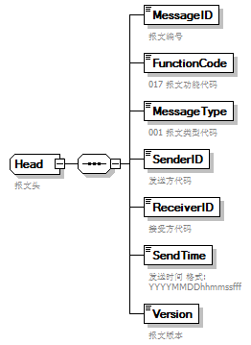
children | MessageID FunctionCode MessageType SenderID ReceiverID SendTime Version
used by
  element | Message/MessageHead
annotation
  documentation
  报文头

element Head/MessageID
diagram | 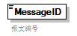
properties
  isRef | 0
annotation
  documentation
  报文编号

element Head/FunctionCode
diagram | 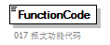
properties
  isRef | 0
annotation
  documentation
  017 报文功能代码

element Head/MessageType
diagram | 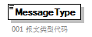
properties
  isRef | 0
annotation
  documentation
  001 报文类型代码

element Head/SenderID
diagram | 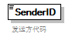
properties
  isRef | 0
annotation
  documentation
  发送方代码

element Head/ReceiverID
diagram | 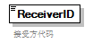
properties
  isRef | 0
annotation
  documentation
  接受方代码

element Head/SendTime
diagram | 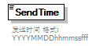
properties
  isRef | 0
annotation
  documentation
  发送时间 格式:YYYYMMDDhhmmssfff

element Head/Version
diagram | 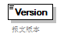
properties
  isRef | 0
annotation
  documentation
  报文版本

complexType TradeTerm
diagram | 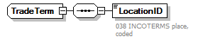
children | LocationID

element TradeTerm/LocationID
diagram | 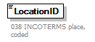
properties
  isRef | 0
annotation
  documentation
  038 INCOTERMS place, coded

complexType UnloadingLocation
diagram | 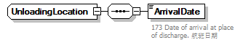
children | ArrivalDate

element UnloadingLocation/ArrivalDate
diagram | 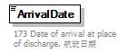
properties
  isRef | 0
annotation
  documentation
  173 Date of arrival at place of discharge. 航班日期

