中国海关空运回执报文结构定义

一、XML报文实例
<?xml version="1.0" encoding="UTF-8"?>
<Message xmlns="urn:Declaration:datamodel:standard:CN:CAM301:1" xmlns:xsi="http://www.w3.org/2001/XMLSchema-instance" >
<MessageHead>
<MessageID/>
<FunctionCode/>
<MessageType/>
<SenderID/>
<ReceiverID/>
<SendTime/>
<Version/>
</MessageHead>
<MessageBody>
<Declaration>
<REC>
<MSG_ID/>
<AIRCRAFT_NO/>
<FLIGHT_NO/>
<FLIGHT_DATE/>
<RECEIPT_TYPE/>
<RECEIPT_CONTENT/>
<PortCode/>
<CustomName/>
<SendTime/>
</REC>
</Declaration>
</MessageBody>
</Message>

二、报文结构
1______Message
1 |______MessageHead
1 | |______MessageID
1 | |______FunctionCode
1 | |______MessageType
1 | |______SenderID
1 | |______ReceiverID
1 | |______SendTime
1 | |______Version
1 |______MessageBody
1 | |______Declaration
1 | | |______REC
1 | | | |______MSG_ID
1 | | | |______AIRCRAFT_NO
1 | | | |______FLIGHT_NO
1 | | | |______FLIGHT_DATE
1 | | | |______RECEIPT_TYPE
1 | | | |______RECEIPT_CONTENT
1 | | | |______PortCode
1 | | | |______CustomName
1 | | | |______SendTime

三、报文节点详细说明

element Message
diagram | 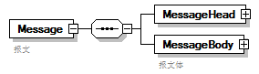
properties
  content | complex
children | MessageHead MessageBody
annotation
  documentation
  报文

element Message/MessageHead
diagram | 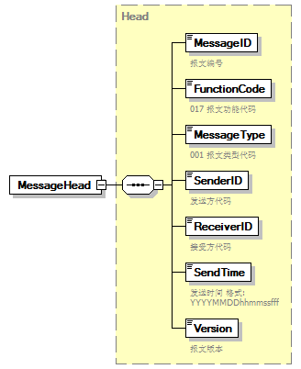
type | Head
properties
  isRef | 0
  content | complex
children | MessageID FunctionCode MessageType SenderID ReceiverID SendTime Version

element Message/MessageBody
diagram | 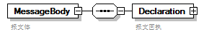
properties
  isRef | 0
  content | complex
children | Declaration
annotation
  documentation
  报文体

element Message/MessageBody/Declaration
diagram | 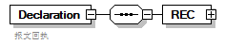
properties
  isRef | 0
  content | complex
children | REC
annotation
  documentation
  报文回执

element Message/MessageBody/Declaration/REC
diagram | 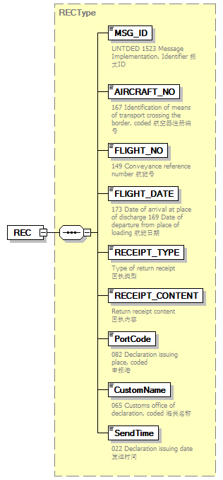
type | RECType
properties
  isRef | 0
  content | complex
children | MSG_ID AIRCRAFT_NO FLIGHT_NO FLIGHT_DATE RECEIPT_TYPE RECEIPT_CONTENT PortCode CustomName SendTime

complexType AdditionalInformation
diagram | 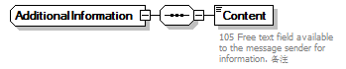
children | Content

element AdditionalInformation/Content
diagram | 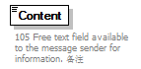
properties
  isRef | 0
annotation
  documentation
  105 Free text field available to the message sender for information. 备注

complexType ArrivalConveyanceFacility
diagram | 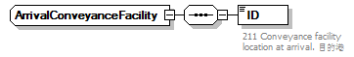
children | ID

element ArrivalConveyanceFacility/ID
diagram | 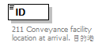
properties
  isRef | 0
annotation
  documentation
  211 Conveyance facility location at arrival. 目的港

complexType Contact
diagram | 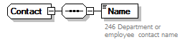
children | Name

element Contact/Name
diagram | 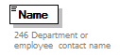
properties
  isRef | 0
annotation
  documentation
  246 Department or employee contact name

complexType DepartureConveyanceFacility
diagram | 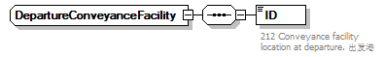
children | ID

element DepartureConveyanceFacility/ID
diagram | 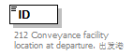
properties
  isRef | 0
annotation
  documentation
  212 Conveyance facility location at departure. 出发港

complexType Head
diagram | 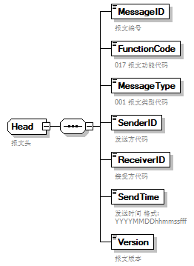
children | MessageID FunctionCode MessageType SenderID ReceiverID SendTime Version
used by
  element | Message/MessageHead
annotation
  documentation
  报文头

element Head/MessageID
diagram | 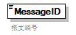
properties
  isRef | 0
annotation
  documentation
  报文编号

element Head/FunctionCode
diagram | 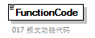
properties
  isRef | 0
annotation
  documentation
  017 报文功能代码

element Head/MessageType
diagram | 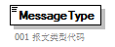
properties
  isRef | 0
annotation
  documentation
  001 报文类型代码

element Head/SenderID
diagram | 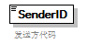
properties
  isRef | 0
annotation
  documentation
  发送方代码

element Head/ReceiverID
diagram | 
properties
  isRef | 0
annotation
  documentation
  接受方代码

element Head/SendTime
diagram | 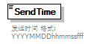
properties
  isRef | 0
annotation
  documentation
  发送时间 格式:YYYYMMDDhhmmssfff

element Head/Version
diagram | 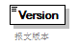
properties
  isRef | 0
annotation
  documentation
  报文版本

complexType RECType
diagram | 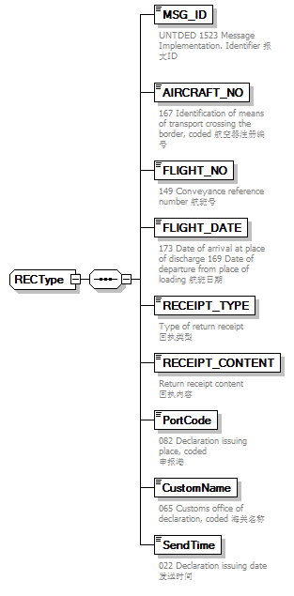
children | MSG_ID AIRCRAFT_NO FLIGHT_NO FLIGHT_DATE RECEIPT_TYPE RECEIPT_CONTENT PortCode CustomName SendTime
used by
  element | Message/MessageBody/Declaration/REC

element RECType/MSG_ID
diagram | 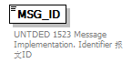
properties
  isRef | 0
annotation
  documentation
  UNTDED 1523 Message Implementation. Identifier 报文ID

element RECType/AIRCRAFT_NO
diagram | 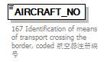
properties
  isRef | 0
annotation
  documentation
  167 Identification of means of transport crossing the border, coded 航空器注册编号

element RECType/FLIGHT_NO
diagram | 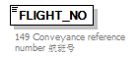
properties
  isRef | 0
annotation
  documentation
  149 Conveyance reference number 航班号

element RECType/FLIGHT_DATE
diagram | 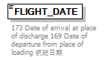
properties
  isRef | 0
annotation
  documentation
  173 Date of arrival at place of discharge 169 Date of departure from place of loading 航班日期

element RECType/RECEIPT_TYPE
diagram | 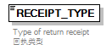
properties
  isRef | 0
annotation
  documentation
  Type of return receipt
  回执类型

element RECType/RECEIPT_CONTENT
diagram | 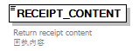
properties
  isRef | 0
annotation
  documentation
  Return receipt content
  回执内容

element RECType/PortCode
diagram | 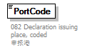
properties
  isRef | 0
annotation
  documentation
  082 Declaration issuing place, coded
  申报港

element RECType/CustomName
diagram | 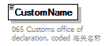
properties
  isRef | 0
annotation
  documentation
  065 Customs office of declaration, coded 海关名称

element RECType/SendTime
diagram | 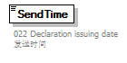
properties
  isRef | 0
annotation
  documentation
  022 Declaration issuing date
  发送时间

complexType TradeTerm
diagram | 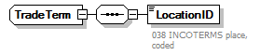
children | LocationID

element TradeTerm/LocationID
diagram | 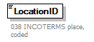
properties
  isRef | 0
annotation
  documentation
  038 INCOTERMS place, coded

complexType UnloadingLocation
diagram | 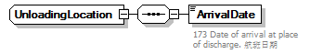
children | ArrivalDate

element UnloadingLocation/ArrivalDate
diagram | 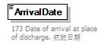
properties
  isRef | 0
annotation
  documentation
  173 Date of arrival at place of discharge. 航班日期

