中国海关空运离境航班取消报文结构定义

一、XML报文实例
<?xml version="1.0" encoding="UTF-8"?>
<Message xmlns="urn:Declaration:datamodel:standard:CN:CAM014:1" xmlns:xsi="http://www.w3.org/2001/XMLSchema-instance" >
<MessageHead>
<MessageID/>
<FunctionCode/>
<MessageType/>
<SenderID/>
<ReceiverID/>
<SendTime/>
<Version/>
</MessageHead>
<MessageBody>
<Declaration>
<BorderTransPortMeans>
<JourneyID/>
<Itinerary>
<ID/>
</Itinerary>
</BorderTransPortMeans>
<LoadingLocation>
<DepartureDate/>
</LoadingLocation>
<AdditionalInformation>
<Content/>
</AdditionalInformation>
<IssueDate/>
</Declaration>
</MessageBody>
</Message>

二、报文结构
1______Message
1 |______MessageHead
1 | |______MessageID
1 | |______FunctionCode
1 | |______MessageType
1 | |______SenderID
1 | |______ReceiverID
1 | |______SendTime
1 | |______Version
1 |______MessageBody
1 | |______Declaration
1 | | |______BorderTransPortMeans
1 | | | |______JourneyID
1 | | | |______Itinerary
1 | | | | |______ID
1 | | |______LoadingLocation
1 | | | |______DepartureDate
1 | | |______AdditionalInformation
1 | | | |______Content
1 | | |______IssueDate

三、报文节点详细说明

element Message
diagram | 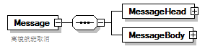
properties
  content | complex
children | MessageHead MessageBody
annotation
  documentation
  离境航班取消

element Message/MessageHead
diagram | 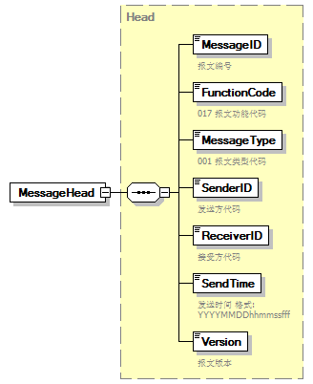
type | Head
properties
  isRef | 0
  content | complex
children | MessageID FunctionCode MessageType SenderID ReceiverID SendTime Version

element Message/MessageBody
diagram | 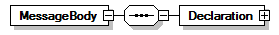
properties
  isRef | 0
  content | complex
children | Declaration

element Message/MessageBody/Declaration
diagram | 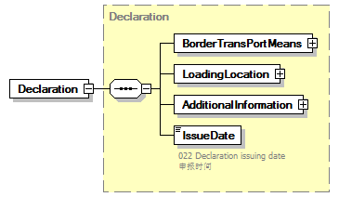
type | Declaration
properties
  isRef | 0
  content | complex
children | BorderTransPortMeans LoadingLocation AdditionalInformation IssueDate

complexType AdditionalInformation
diagram | 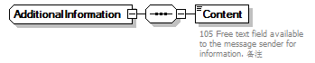
children | Content
used by
  element | Declaration/AdditionalInformation

element AdditionalInformation/Content
diagram | 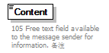
properties
  isRef | 0
annotation
  documentation
  105 Free text field available to the message sender for information. 备注

complexType ArrivalConveyanceFacility
diagram | 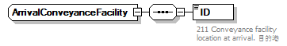
children | ID

element ArrivalConveyanceFacility/ID
diagram | 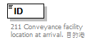
properties
  isRef | 0
annotation
  documentation
  211 Conveyance facility location at arrival. 目的港

complexType BorderTransportMeans
diagram | 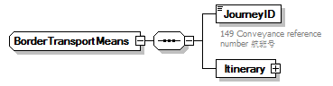
children | JourneyID Itinerary
used by
  element | Declaration/BorderTransPortMeans

element BorderTransportMeans/JourneyID
diagram | 
properties
  isRef | 0
annotation
  documentation
  149 Conveyance reference number 航班号

element BorderTransportMeans/Itinerary
diagram | 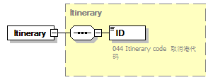
type | Itinerary
properties
  isRef | 0
  content | complex
children | ID

complexType Contact
diagram | 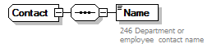
children | Name

element Contact/Name
diagram | 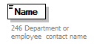
properties
  isRef | 0
annotation
  documentation
  246 Department or employee contact name

complexType Declaration
diagram | 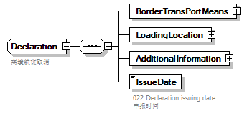
children | BorderTransPortMeans LoadingLocation AdditionalInformation IssueDate
used by
  element | Message/MessageBody/Declaration
annotation
  documentation
  离境航班取消

element Declaration/BorderTransPortMeans
diagram | 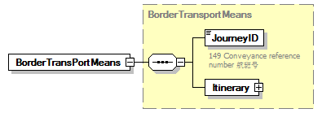
type | BorderTransportMeans
properties
  isRef | 0
  content | complex
children | JourneyID Itinerary

element Declaration/LoadingLocation
diagram | 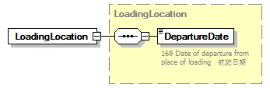
type | LoadingLocation
properties
  isRef | 0
  content | complex
children | DepartureDate

element Declaration/AdditionalInformation
diagram | 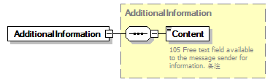
type | AdditionalInformation
properties
  isRef | 0
  content | complex
children | Content

element Declaration/IssueDate
diagram | 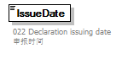
properties
  isRef | 0
annotation
  documentation
  022 Declaration issuing date 申报时间

complexType DepartureConveyanceFacility
diagram | 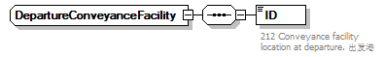
children | ID

element DepartureConveyanceFacility/ID
diagram | 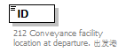
properties
  isRef | 0
annotation
  documentation
  212 Conveyance facility location at departure. 出发港

complexType Head
diagram | 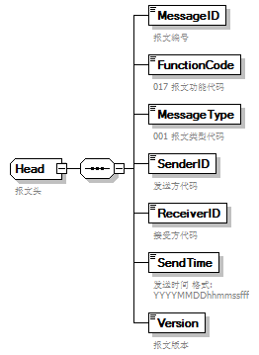
children | MessageID FunctionCode MessageType SenderID ReceiverID SendTime Version
used by
  element | Message/MessageHead
annotation
  documentation
  报文头

element Head/MessageID
diagram | 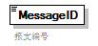
properties
  isRef | 0
annotation
  documentation
  报文编号

element Head/FunctionCode
diagram | 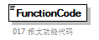
properties
  isRef | 0
annotation
  documentation
  017 报文功能代码

element Head/MessageType
diagram | 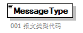
properties
  isRef | 0
annotation
  documentation
  001 报文类型代码

element Head/SenderID
diagram | 
properties
  isRef | 0
annotation
  documentation
  发送方代码

element Head/ReceiverID
diagram | 
properties
  isRef | 0
annotation
  documentation
  接受方代码

element Head/SendTime
diagram | 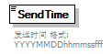
properties
  isRef | 0
annotation
  documentation
  发送时间 格式:YYYYMMDDhhmmssfff

element Head/Version
diagram | 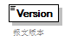
properties
  isRef | 0
annotation
  documentation
  报文版本

complexType Itinerary
diagram | 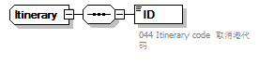
children | ID
used by
  element | BorderTransportMeans/Itinerary

element Itinerary/ID
diagram | 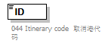
properties
  isRef | 0
annotation
  documentation
  044 Itinerary code 取消港代码

complexType LoadingLocation
diagram | 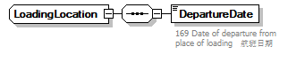
children | DepartureDate
used by
  element | Declaration/LoadingLocation

element LoadingLocation/DepartureDate
diagram | 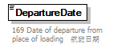
properties
  isRef | 0
annotation
  documentation
  169 Date of departure from place of loading 航班日期

complexType TradeTerm
diagram | 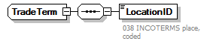
children | LocationID

element TradeTerm/LocationID
diagram | 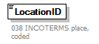
properties
  isRef | 0
annotation
  documentation
  038 INCOTERMS place, coded

complexType UnloadingLocation
diagram | 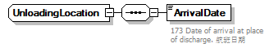
children | ArrivalDate

element UnloadingLocation/ArrivalDate
diagram | 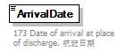
properties
  isRef | 0
annotation
  documentation
  173 Date of arrival at place of discharge. 航班日期

