中国海关航空器备案报文结构定义

一、XML报文实例
<?xml version="1.0" encoding="UTF-8"?>
<Message xmlns="urn:Declaration:datamodel:standard:CN:CAM001:1" xmlns:xsi="http://www.w3.org/2001/XMLSchema-instance" >
<MessageHead>
<MessageID/>
<FunctionCode/>
<MessageType/>
<SenderID/>
<ReceiverID/>
<SendTime/>
<Version/>
</MessageHead>
<MessageBody>
<Declaration>
<airCraftRecord>
<AIRWAYS_CODE/>
<AIRWAYS_NAME_EN/>
<AIRWAYS_NAME_CN/>
<AIRCRAFT_NO/>
<AERO_MODEL/>
<AERO_TYPE/>
<AERO_NATIONALITY/>
<CERT_NO/>
<GROSS_WEIGHT/>
<PASSENGER_LIMIT/>
<USE_RELATION/>
<DELIVER_DATE/>
<MEMO/>
<DECLARE_TIME/>
</airCraftRecord>
</Declaration>
</MessageBody>
</Message>

二、报文结构
1______Message
1 |______MessageHead
1 | |______MessageID
1 | |______FunctionCode
1 | |______MessageType
1 | |______SenderID
1 | |______ReceiverID
1 | |______SendTime
1 | |______Version
1 |______MessageBody
1 | |______Declaration
1 | | |______airCraftRecord
1 | | | |______AIRWAYS_CODE
1 | | | |______AIRWAYS_NAME_EN
1 | | | |______AIRWAYS_NAME_CN
1 | | | |______AIRCRAFT_NO
1 | | | |______AERO_MODEL
1 | | | |______AERO_TYPE
1 | | | |______AERO_NATIONALITY
1 | | | |______CERT_NO
1 | | | |______GROSS_WEIGHT
1 | | | |______PASSENGER_LIMIT
1 | | | |______USE_RELATION
1 | | | |______DELIVER_DATE
1 | | | |______MEMO
1 | | | |______DECLARE_TIME

三、报文节点详细说明
element Message
diagram | 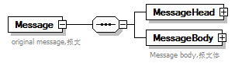
properties
  content | complex
children | MessageHead MessageBody
annotation
  documentation
  original message,报文

element Message/MessageHead
diagram | 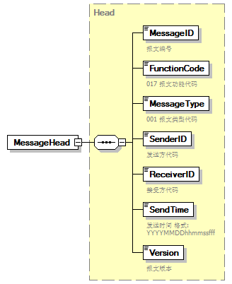
type | Head
properties
  isRef | 0
  content | complex
children | MessageID FunctionCode MessageType SenderID ReceiverID SendTime Version

element Message/MessageBody
diagram | 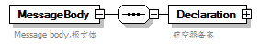
properties
  isRef | 0
  content | complex
children | Declaration
annotation
  documentation
  Message body,报文体

element Message/MessageBody/Declaration
diagram | 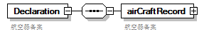
properties
  isRef | 0
  content | complex
children | airCraftRecord
annotation
  documentation
  航空器备案

element Message/MessageBody/Declaration/airCraftRecord
diagram | 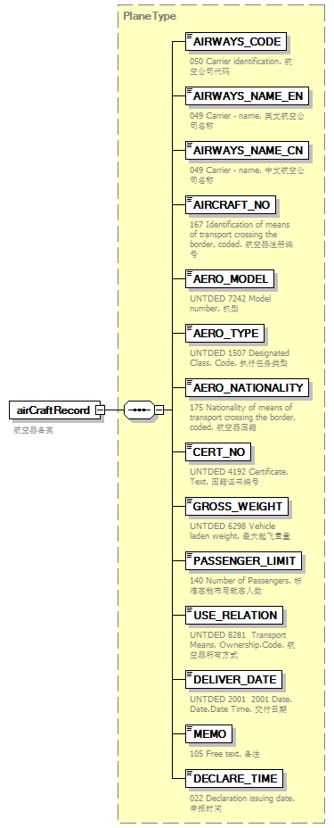
type | PlaneType
properties
  isRef | 0
  content | complex
children | AIRWAYS_CODE AIRWAYS_NAME_EN AIRWAYS_NAME_CN AIRCRAFT_NO AERO_MODEL AERO_TYPE AERO_NATIONALITY CERT_NO GROSS_WEIGHT PASSENGER_LIMIT USE_RELATION DELIVER_DATE MEMO DECLARE_TIME
annotation
  documentation
  航空器备案

complexType AdditionalInformation
diagram | 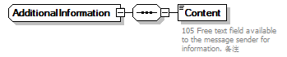
children | Content

element AdditionalInformation/Content
diagram | 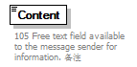
properties
  isRef | 0
annotation
  documentation
  105 Free text field available to the message sender for information. 备注

complexType ArrivalConveyanceFacility
diagram | 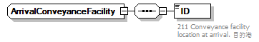
children | ID

element ArrivalConveyanceFacility/ID
diagram | 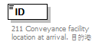
properties
  isRef | 0
annotation
  documentation
  211 Conveyance facility location at arrival. 目的港

complexType Contact
diagram | 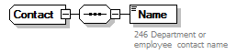
children | Name

element Contact/Name
diagram | 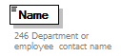
properties
  isRef | 0
annotation
  documentation
  246 Department or employee contact name

complexType DepartureConveyanceFacility
diagram | 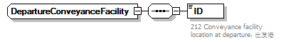
children | ID

element DepartureConveyanceFacility/ID
diagram | 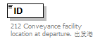
properties
  isRef | 0
annotation
  documentation
  212 Conveyance facility location at departure. 出发港

complexType Head
diagram | 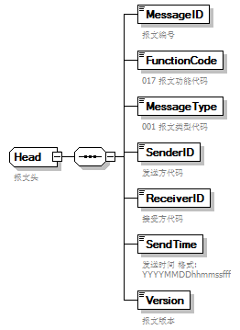
children | MessageID FunctionCode MessageType SenderID ReceiverID SendTime Version
used by
  element | Message/MessageHead
annotation
  documentation
  报文头

element Head/MessageID
diagram | 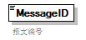
properties
  isRef | 0
annotation
  documentation
  报文编号

element Head/FunctionCode
diagram | 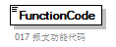
properties
  isRef | 0
annotation
  documentation
  017 报文功能代码

element Head/MessageType
diagram | 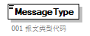
properties
  isRef | 0
annotation
  documentation
  001 报文类型代码

element Head/SenderID
diagram | 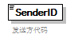
properties
  isRef | 0
annotation
  documentation
  发送方代码

element Head/ReceiverID
diagram | 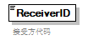
properties
  isRef | 0
annotation
  documentation
  接受方代码

element Head/SendTime
diagram | 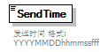
properties
  isRef | 0
annotation
  documentation
  发送时间 格式:YYYYMMDDhhmmssfff

element Head/Version
diagram | 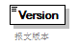
properties
  isRef | 0
annotation
  documentation
  报文版本

complexType PlaneType
diagram | 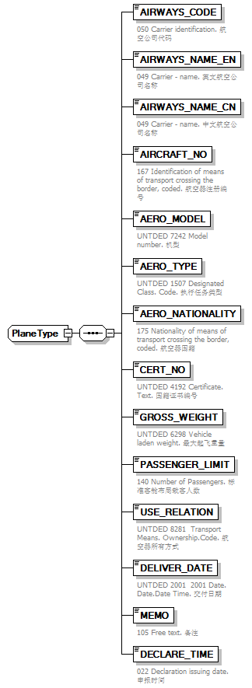
children | AIRWAYS_CODE AIRWAYS_NAME_EN AIRWAYS_NAME_CN AIRCRAFT_NO AERO_MODEL AERO_TYPE AERO_NATIONALITY CERT_NO GROSS_WEIGHT PASSENGER_LIMIT USE_RELATION DELIVER_DATE MEMO DECLARE_TIME
used by
  element | Message/MessageBody/Declaration/airCraftRecord

element PlaneType/AIRWAYS_CODE
diagram | 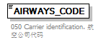
properties
  isRef | 0
annotation
  documentation
  050 Carrier identification. 航空公司代码

element PlaneType/AIRWAYS_NAME_EN
diagram | 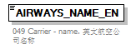
properties
  isRef | 0
annotation
  documentation
  049 Carrier - name. 英文航空公司名称

element PlaneType/AIRWAYS_NAME_CN
diagram | 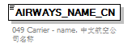
properties
  isRef | 0
annotation
  documentation
  049 Carrier - name. 中文航空公司名称

element PlaneType/AIRCRAFT_NO
diagram | 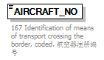
properties
  isRef | 0
annotation
  documentation
  167 Identification of means of transport crossing the border, coded. 航空器注册编号

element PlaneType/AERO_MODEL
diagram | 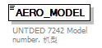
properties
  isRef | 0
annotation
  documentation
  UNTDED 7242 Model number. 机型

element PlaneType/AERO_TYPE
diagram | 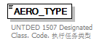
properties
  isRef | 0
annotation
  documentation
  UNTDED 1507 Designated Class. Code. 执行任务类型

element PlaneType/AERO_NATIONALITY
diagram | 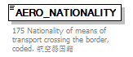
properties
  isRef | 0
annotation
  documentation
  175 Nationality of means of transport crossing the border, coded. 航空器国籍

element PlaneType/CERT_NO
diagram | 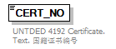
properties
  isRef | 0
annotation
  documentation
  UNTDED 4192 Certificate. Text. 国籍证书编号

element PlaneType/GROSS_WEIGHT
diagram | 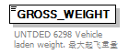
properties
  isRef | 0
annotation
  documentation
  UNTDED 6298 Vehicle laden weight. 最大起飞重量

element PlaneType/PASSENGER_LIMIT
diagram | 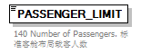
properties
  isRef | 0
annotation
  documentation
  140 Number of Passengers. 标准客舱布局载客人数

element PlaneType/USE_RELATION
diagram | 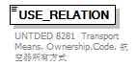
properties
  isRef | 0
annotation
  documentation
  UNTDED 8281 Transport Means. Ownership.Code. 航空器所有方式

element PlaneType/DELIVER_DATE
diagram | 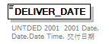
properties
  isRef | 0
annotation
  documentation
  UNTDED 2001 2001 Date. Date.Date Time. 交付日期

element PlaneType/MEMO
diagram | 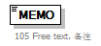
properties
  isRef | 0
annotation
  documentation
  105 Free text. 备注

element PlaneType/DECLARE_TIME
diagram | 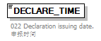
properties
  isRef | 0
annotation
  documentation
  022 Declaration issuing date. 申报时间

complexType TradeTerm
diagram | 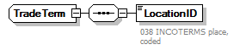
children | LocationID

element TradeTerm/LocationID
diagram | 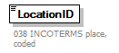
properties
  isRef | 0
annotation
  documentation
  038 INCOTERMS place, coded

complexType UnloadingLocation
diagram | 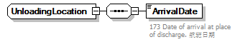
children | ArrivalDate

element UnloadingLocation/ArrivalDate
diagram | 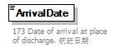
properties
  isRef | 0
annotation
  documentation
  173 Date of arrival at place of discharge. 航班日期

