中国海关水运出境确报报文结构定义

一、XML报文实例
<?xml version="1.0" encoding="UTF-8"?>
<Message xmlns="urn:Declaration:datamodel:standard:CN:CSM007:1" xmlns:xsi="http://www.w3.org/2001/XMLSchema-instance">
<MessageHead>
<MessageID/>
<FunctionCode/>
<MessageType/>
<SenderID/>
<ReceiverID/>
<SendTime/>
<Version/>
</MessageHead>
<MessageBody>
<Declaration>
<BorderTransPortMeans>
<ID/>
<Name/>
<JourneyID/>
<JourneyID/>
<Itinerary>
<ArrivalDateTime/>
<DepartureDateTime/>
</Itinerary>
<StayID/>
<DepartureConveyanceFacility>
<ID/>
</DepartureConveyanceFacility>
<ArrivalConveyanceFacility>
<ID/>
</ArrivalConveyanceFacility>
</BorderTransPortMeans>
<Agent>
<ID/>
<Contact>
<Name/>
</Contact>
</Agent>
<IssueDate/>
<AdditionalInformation>
<Content/>
</AdditionalInformation>
</Declaration>
</MessageBody>
</Message>

二、报文结构
1______Message
1 |______MessageHead
1 | |______MessageID
1 | |______FunctionCode
1 | |______MessageType
1 | |______SenderID
1 | |______ReceiverID
1 | |______SendTime
1 | |______Version
1 |______MessageBody
1 | |______Declaration
1 | | |______BorderTransPortMeans
1 | | | |______ID
1 | | | |______Name
1 | | | |______JourneyID
1 | | | |______JourneyID
1 | | | |______Itinerary
1 | | | | |______ArrivalDateTime
1 | | | | |______DepartureDateTime
1 | | | |______StayID
1 | | | |______DepartureConveyanceFacility
1 | | | | |______ID
1 | | | |______ArrivalConveyanceFacility
1 | | | | |______ID
1 | | |______Agent
1 | | | |______ID
1 | | | |______Contact
1 | | | | |______Name
1 | | |______IssueDate
1 | | |______AdditionalInformation
1 | | | |______Content

三、报文节点详细说明

element Message
diagram | 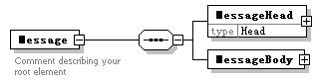
properties
  content | complex
children | MessageHead MessageBody
annotation
  documentation
  Comment describing your root element

element Message/MessageHead
diagram | 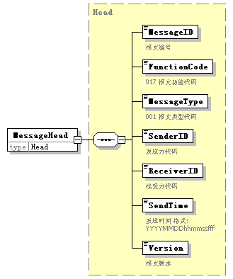
type | Head
properties
  isRef | 0
  content | complex
children | MessageID FunctionCode MessageType SenderID ReceiverID SendTime Version

element Message/MessageBody
diagram | 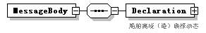
properties
  isRef | 0
  content | complex
children | Declaration

element Message/MessageBody/Declaration
diagram | 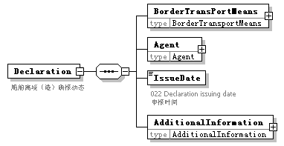
properties
  isRef | 0
  content | complex
children | BorderTransPortMeans Agent IssueDate AdditionalInformation
annotation
  documentation
  船舶离境（港）确报动态

element Message/MessageBody/Declaration/BorderTransPortMeans
diagram | 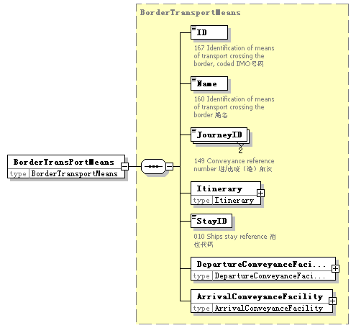
type | BorderTransportMeans
properties
  isRef | 0
  content | complex
children | ID Name JourneyID Itinerary StayID DepartureConveyanceFacility ArrivalConveyanceFacility

element Message/MessageBody/Declaration/Agent
diagram | 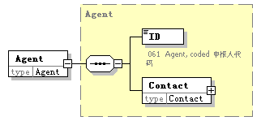
type | Agent
properties
  isRef | 0
  content | complex
children | ID Contact

element Message/MessageBody/Declaration/IssueDate
diagram | 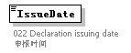
properties
  isRef | 0
annotation
  documentation
  022 Declaration issuing date 申报时间

element Message/MessageBody/Declaration/AdditionalInformation
diagram | 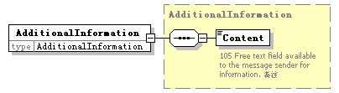
type | AdditionalInformation
properties
  isRef | 0
  content | complex
children | Content

complexType AdditionalInformation
diagram | 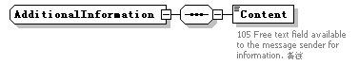
children | Content
used by
  element | Message/MessageBody/Declaration/AdditionalInformation

element AdditionalInformation/Content
diagram | 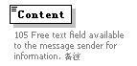
properties
  isRef | 0
annotation
  documentation
  105 Free text field available to the message sender for information. 备注

complexType Agent
diagram | 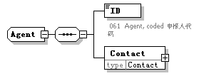
children | ID Contact
used by
  element | Message/MessageBody/Declaration/Agent

element Agent/ID
diagram | 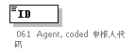
properties
  isRef | 0
annotation
  documentation
  061 Agent, coded 申报人代码

element Agent/Contact
diagram | 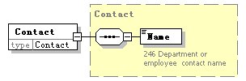
type | Contact
properties
  isRef | 0
  content | complex
children | Name

complexType ArrivalConveyanceFacility
diagram | 
children | ID
used by
  element | BorderTransportMeans/ArrivalConveyanceFacility

element ArrivalConveyanceFacility/ID
diagram | 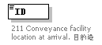
properties
  isRef | 0
annotation
  documentation
  211 Conveyance facility location at arrival. 目的港

complexType BorderTransportMeans
diagram | 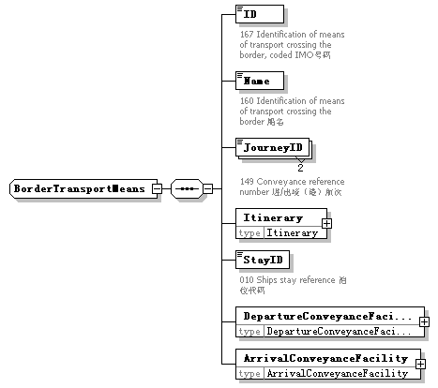
children | ID Name JourneyID Itinerary StayID DepartureConveyanceFacility ArrivalConveyanceFacility
used by
  element | Message/MessageBody/Declaration/BorderTransPortMeans

element BorderTransportMeans/ID
diagram | 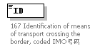
properties
  isRef | 0
annotation
  documentation
  167 Identification of means of transport crossing the border, coded IMO号码

element BorderTransportMeans/Name
diagram | 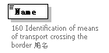
properties
  isRef | 0
annotation
  documentation
  160 Identification of means of transport crossing the border 船名

element BorderTransportMeans/JourneyID
diagram | 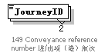
properties
  isRef | 0
  minOcc | 2
  maxOcc | 2
annotation
  documentation
  149 Conveyance reference number 进/出境（港）航次

element BorderTransportMeans/Itinerary
diagram | 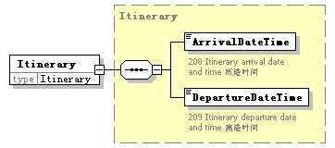
type | Itinerary
properties
  isRef | 0
  content | complex
children | ArrivalDateTime DepartureDateTime

element BorderTransportMeans/StayID
diagram | 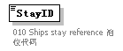
properties
  isRef | 0
annotation
  documentation
  010 Ships stay reference 泊位代码

element BorderTransportMeans/DepartureConveyanceFacility
diagram | 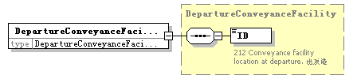
type | DepartureConveyanceFacility
properties
  isRef | 0
  content | complex
children | ID

element BorderTransportMeans/ArrivalConveyanceFacility
diagram | 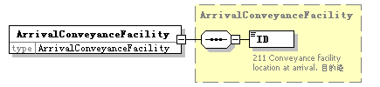
type | ArrivalConveyanceFacility
properties
  isRef | 0
  content | complex
children | ID

complexType Contact
diagram | 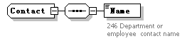
children | Name
used by
  element | Agent/Contact

element Contact/Name
diagram | 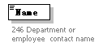
properties
  isRef | 0
annotation
  documentation
  246 Department or employee contact name

complexType DepartureConveyanceFacility
diagram | 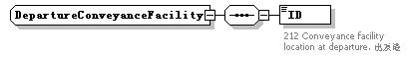
children | ID
used by
  element | BorderTransportMeans/DepartureConveyanceFacility

element DepartureConveyanceFacility/ID
diagram | 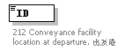
properties
  isRef | 0
annotation
  documentation
  212 Conveyance facility location at departure. 出发港

complexType Head
diagram | 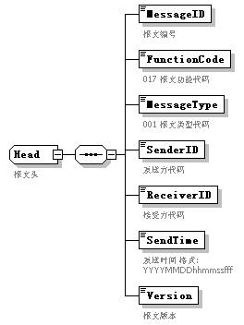
children | MessageID FunctionCode MessageType SenderID ReceiverID SendTime Version
used by
  element | Message/MessageHead
annotation
  documentation
  报文头

element Head/MessageID
diagram | 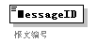
properties
  isRef | 0
annotation
  documentation
  报文编号

element Head/FunctionCode
diagram | 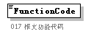
properties
  isRef | 0
annotation
  documentation
  017 报文功能代码

element Head/MessageType
diagram | 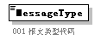
properties
  isRef | 0
annotation
  documentation
  001 报文类型代码

element Head/SenderID
diagram | 
properties
  isRef | 0
annotation
  documentation
  发送方代码

element Head/ReceiverID
diagram | 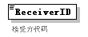
properties
  isRef | 0
annotation
  documentation
  接受方代码

element Head/SendTime
diagram | 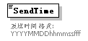
properties
  isRef | 0
annotation
  documentation
  发送时间 格式:YYYYMMDDhhmmssfff

element Head/Version
diagram | 
properties
  isRef | 0
annotation
  documentation
  报文版本

complexType Itinerary
diagram | 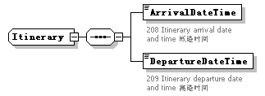
children | ArrivalDateTime DepartureDateTime
used by
  element | BorderTransportMeans/Itinerary

element Itinerary/ArrivalDateTime
diagram | 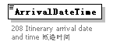
properties
  isRef | 0
annotation
  documentation
  208 Itinerary arrival date and time 抵港时间

element Itinerary/DepartureDateTime
diagram | 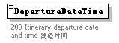
properties
  isRef | 0
annotation
  documentation
  209 Itinerary departure date and time 离港时间

complexType TradeTerm
diagram | 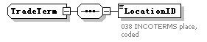
children | LocationID

element TradeTerm/LocationID
diagram | 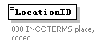
properties
  isRef | 0
annotation
  documentation
  038 INCOTERMS place, coded

complexType UnloadingLocation
diagram | 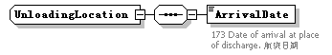
children | ArrivalDate

element UnloadingLocation/ArrivalDate
diagram | 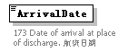
properties
  isRef | 0
annotation
  documentation
  173 Date of arrival at place of discharge. 航班日期

