中国海关水运删改申请报文结构定义

一、XML报文实例
<?xml version="1.0" encoding="UTF-8"?>
<Message xmlns="urn:Declaration:datamodel:standard:CN:CSM201:1" xmlns:xsi="http://www.w3.org/2001/XMLSchema-instance">
<MessageHead>
<MessageID/>
<FunctionCode/>
<MessageType/>
<SenderID/>
<ReceiverID/>
<SendTime/>
<Version/>
</MessageHead>
<MessageBody>
<Declaration>
<Modification>
<ChangeType/>
<ChangeItem/>
<IMO/>
<Voyage/>
<ApplyCorp/>
<I_E_Flag/>
<CustomsCode/>
<Title/>
<Reason/>
<Content/>
<ApplyEr/>
<ApplyDateTime/>
<Memo/>
</Modification>
</Declaration>
</MessageBody>
</Message>

二、报文结构
1______Message
1 |______MessageHead
1 | |______MessageID
1 | |______FunctionCode
1 | |______MessageType
1 | |______SenderID
1 | |______ReceiverID
1 | |______SendTime
1 | |______Version
1 |______MessageBody
1 | |______Declaration
1 | | |______Modification
1 | | | |______ChangeType
1 | | | |______ChangeItem
1 | | | |______IMO
1 | | | |______Voyage
1 | | | |______ApplyCorp
1 | | | |______I_E_Flag
1 | | | |______CustomsCode
1 | | | |______Title
1 | | | |______Reason
1 | | | |______Content
1 | | | |______ApplyEr
1 | | | |______ApplyDateTime
1 | | | |______Memo

三、报文节点详细说明

element Message
diagram | 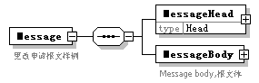
properties
  content | complex
children | MessageHead MessageBody
annotation
  documentation
  更改申请报文样例

element Message/MessageHead
diagram | 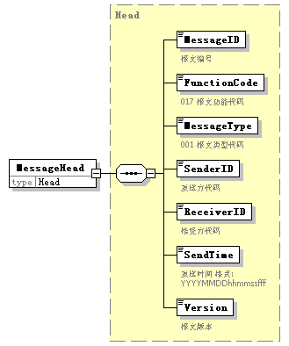
type | Head
properties
  isRef | 0
  content | complex
children | MessageID FunctionCode MessageType SenderID ReceiverID SendTime Version

element Message/MessageBody
diagram | 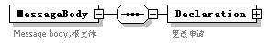
properties
  isRef | 0
  content | complex
children | Declaration
annotation
  documentation
  Message body,报文体

element Message/MessageBody/Declaration
diagram | 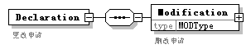
properties
  isRef | 0
  content | complex
children | Modification
annotation
  documentation
  更改申请

element Message/MessageBody/Declaration/Modification
diagram | 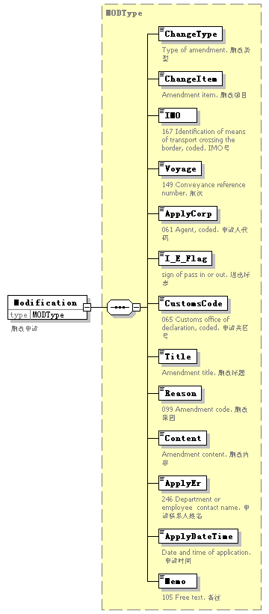
type | MODType
properties
  isRef | 0
  content | complex
children | ChangeType ChangeItem IMO Voyage ApplyCorp I_E_Flag CustomsCode Title Reason Content ApplyEr ApplyDateTime Memo
annotation
  documentation
  删改申请

complexType AdditionalInformation
diagram | 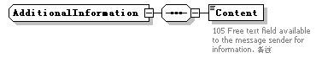
children | Content

element AdditionalInformation/Content
diagram | 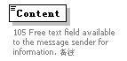
properties
  isRef | 0
annotation
  documentation
  105 Free text field available to the message sender for information. 备注

complexType ArrivalConveyanceFacility
diagram | 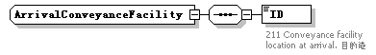
children | ID

element ArrivalConveyanceFacility/ID
diagram | 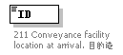
properties
  isRef | 0
annotation
  documentation
  211 Conveyance facility location at arrival. 目的港

complexType Contact
diagram | 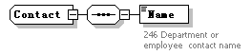
children | Name

element Contact/Name
diagram | 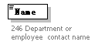
properties
  isRef | 0
annotation
  documentation
  246 Department or employee contact name

complexType DepartureConveyanceFacility
diagram | 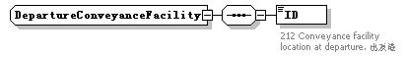
children | ID

element DepartureConveyanceFacility/ID
diagram | 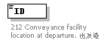
properties
  isRef | 0
annotation
  documentation
  212 Conveyance facility location at departure. 出发港

complexType Head
diagram | 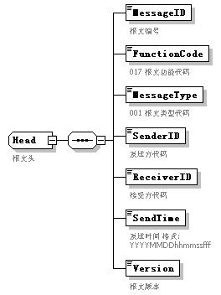
children | MessageID FunctionCode MessageType SenderID ReceiverID SendTime Version
used by
  element | Message/MessageHead
annotation
  documentation
  报文头

element Head/MessageID
diagram | 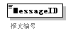
properties
  isRef | 0
annotation
  documentation
  报文编号

element Head/FunctionCode
diagram | 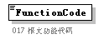
properties
  isRef | 0
annotation
  documentation
  017 报文功能代码

element Head/MessageType
diagram | 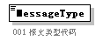
properties
  isRef | 0
annotation
  documentation
  001 报文类型代码

element Head/SenderID
diagram | 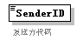
properties
  isRef | 0
annotation
  documentation
  发送方代码

element Head/ReceiverID
diagram | 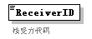
properties
  isRef | 0
annotation
  documentation
  接受方代码

element Head/SendTime
diagram | 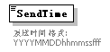
properties
  isRef | 0
annotation
  documentation
  发送时间 格式:YYYYMMDDhhmmssfff

element Head/Version
diagram | 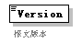
properties
  isRef | 0
annotation
  documentation
  报文版本

complexType MODType
diagram | 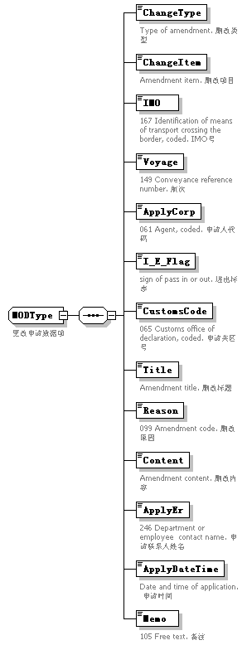
children | ChangeType ChangeItem IMO Voyage ApplyCorp I_E_Flag CustomsCode Title Reason Content ApplyEr ApplyDateTime Memo
used by
  element | Message/MessageBody/Declaration/Modification
annotation
  documentation
  更改申请数据项

element MODType/ChangeType
diagram | 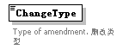
properties
  isRef | 0
annotation
  documentation
  Type of amendment. 删改类型

element MODType/ChangeItem
diagram | 
properties
  isRef | 0
annotation
  documentation
  Amendment item. 删改项目

element MODType/IMO
diagram | 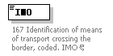
properties
  isRef | 0
annotation
  documentation
  167 Identification of means of transport crossing the border, coded. IMO号

element MODType/Voyage
diagram | 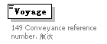
properties
  isRef | 0
annotation
  documentation
  149 Conveyance reference number. 航次

element MODType/ApplyCorp
diagram | 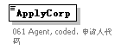
properties
  isRef | 0
annotation
  documentation
  061 Agent, coded. 申请人代码

element MODType/I_E_Flag
diagram | 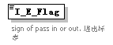
properties
  isRef | 0
annotation
  documentation
  sign of pass in or out. 进出标志

element MODType/CustomsCode
diagram | 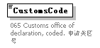
properties
  isRef | 0
annotation
  documentation
  065 Customs office of declaration, coded. 申请关区号

element MODType/Title
diagram | 
properties
  isRef | 0
annotation
  documentation
  Amendment title. 删改标题

element MODType/Reason
diagram | 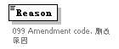
properties
  isRef | 0
annotation
  documentation
  099 Amendment code. 删改原因

element MODType/Content
diagram | 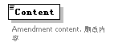
properties
  isRef | 0
annotation
  documentation
  Amendment content. 删改内容

element MODType/ApplyEr
diagram | 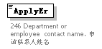
properties
  isRef | 0
annotation
  documentation
  246 Department or employee contact name. 申请联系人姓名

element MODType/ApplyDateTime
diagram | 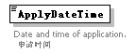
properties
  isRef | 0
annotation
  documentation
  Date and time of application. 申请时间

element MODType/Memo
diagram | 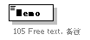
properties
  isRef | 0
annotation
  documentation
  105 Free text. 备注

complexType TradeTerm
diagram | 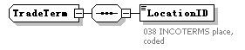
children | LocationID

element TradeTerm/LocationID
diagram | 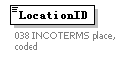
properties
  isRef | 0
annotation
  documentation
  038 INCOTERMS place, coded

complexType UnloadingLocation
diagram | 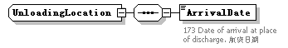
children | ArrivalDate

element UnloadingLocation/ArrivalDate
diagram | 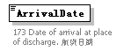
properties
  isRef | 0
annotation
  documentation
  173 Date of arrival at place of discharge. 航班日期

