中国海关船舶备案报文结构定义

一、XML报文实例
<?xml version="1.0" encoding="UTF-8"?>
<Message xmlns="urn:Declaration:datamodel:standard:CN:CSM001:1" xmlns:xsi="http://www.w3.org/2001/XMLSchema-instance">
<MessageHead>
<MessageID/>
<FunctionCode/>
<MessageType/>
<SenderID/>
<ReceiverID/>
<SendTime/>
<Version/>
</MessageHead>
<MessageBody>
<Declaration>
<Archive>
<VesselNameEn/>
<VesselNameCn/>
<IMO/>
<CallSign/>
<Nationality/>
<CertificateNo/>
<CertificateDate/>
<BuildDate/>
<HailingPort/>
<VesselSort/>
<LineType/>
<CommunicationID/>
<CommunicationType/>
<GrossTonnage/>
<NetTonnage/>
<DeadWeightTonnage/>
<VesselLength/>
<VesselBreadth/>
<VesselDeapth/>
<ControlType/>
<CoCode/>
<VesselCorpNameEn/>
<VesselCorpNameCn/>
<RecordDateTime/>
<ClassLetter/>
<ClassificationNo/>
<VesselColor/>
<FunnelColor/>
<Email/>
<SatellitePhone/>
<HorsePower/>
<Speed/>
<TPI_TPC/>
<DeepDraft/>
<LightDraft/>
<CarbinWindowNum/>
<CargoDear/>
<BaleCapacity/>
<GrainCapacity/>
<CeilingTEU/>
<DeckTEU/>
<CrewLimit/>
<PassengerLimit/>
<Memo/>
</Archive>
</Declaration>
</MessageBody>
</Message>

二、报文结构
1______Message
1 |______MessageHead
1 | |______MessageID
1 | |______FunctionCode
1 | |______MessageType
1 | |______SenderID
1 | |______ReceiverID
1 | |______SendTime
1 | |______Version
1 |______MessageBody
1 | |______Declaration
1 | | |______Archive
1 | | | |______VesselNameEn
1 | | | |______VesselNameCn
1 | | | |______IMO
1 | | | |______CallSign
1 | | | |______Nationality
1 | | | |______CertificateNo
1 | | | |______CertificateDate
1 | | | |______BuildDate
1 | | | |______HailingPort
1 | | | |______VesselSort
1 | | | |______LineType
1 | | | |______CommunicationID
1 | | | |______CommunicationType
1 | | | |______GrossTonnage
1 | | | |______NetTonnage
1 | | | |______DeadWeightTonnage
1 | | | |______VesselLength
1 | | | |______VesselBreadth
1 | | | |______VesselDeapth
1 | | | |______ControlType
1 | | | |______CoCode
1 | | | |______VesselCorpNameEn
1 | | | |______VesselCorpNameCn
1 | | | |______RecordDateTime
1 | | | |______ClassLetter
1 | | | |______ClassificationNo
1 | | | |______VesselColor
1 | | | |______FunnelColor
1 | | | |______Email
1 | | | |______SatellitePhone
1 | | | |______HorsePower
1 | | | |______Speed
1 | | | |______TPI_TPC
1 | | | |______DeepDraft
1 | | | |______LightDraft
1 | | | |______CarbinWindowNum
1 | | | |______CargoDear
1 | | | |______BaleCapacity
1 | | | |______GrainCapacity
1 | | | |______CeilingTEU
1 | | | |______DeckTEU
1 | | | |______CrewLimit
1 | | | |______PassengerLimit
1 | | | |______Memo

三、报文节点详细说明
element Message
diagram | 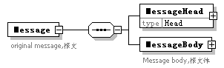
properties
  content | complex
children | MessageHead MessageBody
annotation
  documentation
  original message,报文

element Message/MessageHead
diagram | 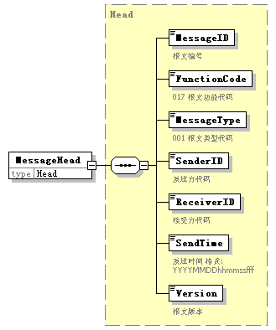
type | Head
properties
  isRef | 0
  content | complex
children | MessageID FunctionCode MessageType SenderID ReceiverID SendTime Version

element Message/MessageBody
diagram | 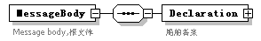
properties
  isRef | 0
  content | complex
children | Declaration
annotation
  documentation
  Message body,报文体

element Message/MessageBody/Declaration
diagram | 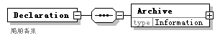
properties
  isRef | 0
  content | complex
children | Archive
annotation
  documentation
  船舶备案

element Message/MessageBody/Declaration/Archive
diagram | 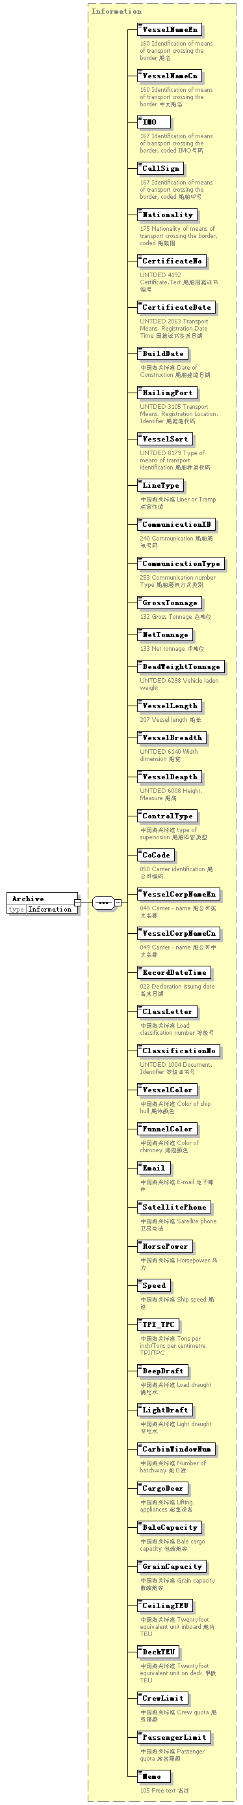
type | Information
properties
  isRef | 0
  content | complex
children | VesselNameEn VesselNameCn IMO CallSign Nationality CertificateNo CertificateDate BuildDate HailingPort VesselSort LineType CommunicationID CommunicationType GrossTonnage NetTonnage DeadWeightTonnage VesselLength VesselBreadth VesselDeapth ControlType CoCode VesselCorpNameEn VesselCorpNameCn RecordDateTime ClassLetter ClassificationNo VesselColor FunnelColor Email SatellitePhone HorsePower Speed TPI_TPC DeepDraft LightDraft CarbinWindowNum CargoDear BaleCapacity GrainCapacity CeilingTEU DeckTEU CrewLimit PassengerLimit Memo

complexType AdditionalInformation
diagram | 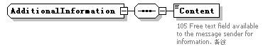
children | Content

element AdditionalInformation/Content
diagram | 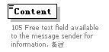
properties
  isRef | 0
annotation
  documentation
  105 Free text field available to the message sender for information. 备注

complexType ArrivalConveyanceFacility
diagram | 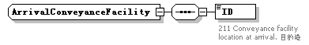
children | ID

element ArrivalConveyanceFacility/ID
diagram | 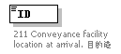
properties
  isRef | 0
annotation
  documentation
  211 Conveyance facility location at arrival. 目的港

complexType Contact
diagram | 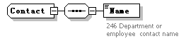
children | Name

element Contact/Name
diagram | 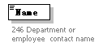
properties
  isRef | 0
annotation
  documentation
  246 Department or employee contact name

complexType DepartureConveyanceFacility
diagram | 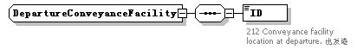
children | ID

element DepartureConveyanceFacility/ID
diagram | 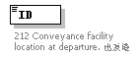
properties
  isRef | 0
annotation
  documentation
  212 Conveyance facility location at departure. 出发港

complexType Head
diagram | 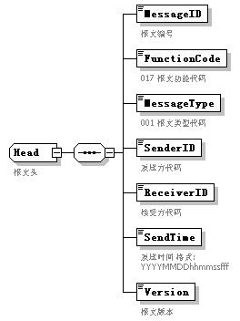
children | MessageID FunctionCode MessageType SenderID ReceiverID SendTime Version
used by
  element | Message/MessageHead
annotation
  documentation
  报文头

element Head/MessageID
diagram | 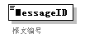
properties
  isRef | 0
annotation
  documentation
  报文编号

element Head/FunctionCode
diagram | 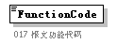
properties
  isRef | 0
annotation
  documentation
  017 报文功能代码

element Head/MessageType
diagram | 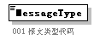
properties
  isRef | 0
annotation
  documentation
  001 报文类型代码

element Head/SenderID
diagram | 
properties
  isRef | 0
annotation
  documentation
  发送方代码

element Head/ReceiverID
diagram | 
properties
  isRef | 0
annotation
  documentation
  接受方代码

element Head/SendTime
diagram | 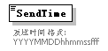
properties
  isRef | 0
annotation
  documentation
  发送时间 格式:YYYYMMDDhhmmssfff

element Head/Version
diagram | 
properties
  isRef | 0
annotation
  documentation
  报文版本

complexType Information
diagram | 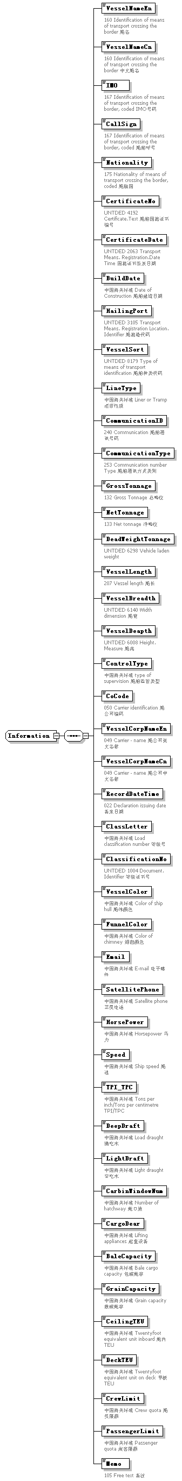
children | VesselNameEn VesselNameCn IMO CallSign Nationality CertificateNo CertificateDate BuildDate HailingPort VesselSort LineType CommunicationID CommunicationType GrossTonnage NetTonnage DeadWeightTonnage VesselLength VesselBreadth VesselDeapth ControlType CoCode VesselCorpNameEn VesselCorpNameCn RecordDateTime ClassLetter ClassificationNo VesselColor FunnelColor Email SatellitePhone HorsePower Speed TPI_TPC DeepDraft LightDraft CarbinWindowNum CargoDear BaleCapacity GrainCapacity CeilingTEU DeckTEU CrewLimit PassengerLimit Memo
used by
  element | Message/MessageBody/Declaration/Archive

element Information/VesselNameEn
diagram | 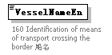
properties
  isRef | 0
annotation
  documentation
  160 Identification of means of transport crossing the border 船名

element Information/VesselNameCn
diagram | 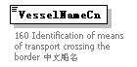
properties
  isRef | 0
annotation
  documentation
  160 Identification of means of transport crossing the border 中文船名

element Information/IMO
diagram | 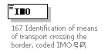
properties
  isRef | 0
annotation
  documentation
  167 Identification of means of transport crossing the border, coded IMO号码

element Information/CallSign
diagram | 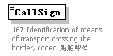
properties
  isRef | 0
annotation
  documentation
  167 Identification of means of transport crossing the border, coded 船舶呼号

element Information/Nationality
diagram | 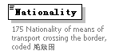
properties
  isRef | 0
annotation
  documentation
  175 Nationality of means of transport crossing the border, coded 船旗国

element Information/CertificateNo
diagram | 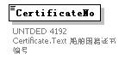
properties
  isRef | 0
annotation
  documentation
  UNTDED 4192 Certificate.Text 船舶国籍证书编号

element Information/CertificateDate
diagram | 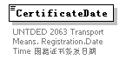
properties
  isRef | 0
annotation
  documentation
  UNTDED 2063 Transport Means. Registration.Date Time 国籍证书签发日期

element Information/BuildDate
diagram | 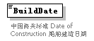
properties
  isRef | 0
annotation
  documentation
  中国海关标准 Date of Construction 船舶建造日期

element Information/HailingPort
diagram | 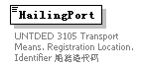
properties
  isRef | 0
annotation
  documentation
  UNTDED 3105 Transport Means. Registration Location. Identifier 船籍港代码

element Information/VesselSort
diagram | 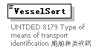
properties
  isRef | 0
annotation
  documentation
  UNTDED 8179 Type of means of transport identification 船舶种类代码

element Information/LineType
diagram | 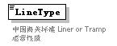
properties
  isRef | 0
annotation
  documentation
  中国海关标准 Liner or Tramp 运营性质

element Information/CommunicationID
diagram | 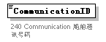
properties
  isRef | 0
annotation
  documentation
  240 Communication 船舶通讯号码

element Information/CommunicationType
diagram | 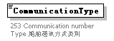
properties
  isRef | 0
annotation
  documentation
  253 Communication number Type 船舶通讯方式类别

element Information/GrossTonnage
diagram | 
properties
  isRef | 0
annotation
  documentation
  132 Gross Tonnage 总吨位

element Information/NetTonnage
diagram | 
properties
  isRef | 0
annotation
  documentation
  133 Net tonnage 净吨位

element Information/DeadWeightTonnage
diagram | 
properties
  isRef | 0
annotation
  documentation
  UNTDED 6298 Vehicle laden weight

element Information/VesselLength
diagram | 
properties
  isRef | 0
annotation
  documentation
  207 Vessel length 船长

element Information/VesselBreadth
diagram | 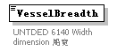
properties
  isRef | 0
annotation
  documentation
  UNTDED 6140 Width dimension 船宽

element Information/VesselDeapth
diagram | 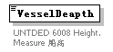
properties
  isRef | 0
annotation
  documentation
  UNTDED 6008 Height. Measure 船高

element Information/ControlType
diagram | 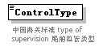
properties
  isRef | 0
annotation
  documentation
  中国海关标准 type of supervision 船舶监管类型

element Information/CoCode
diagram | 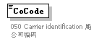
properties
  isRef | 0
annotation
  documentation
  050 Carrier identification 船公司编码

element Information/VesselCorpNameEn
diagram | 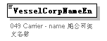
properties
  isRef | 0
annotation
  documentation
  049 Carrier - name 船公司英文名称

element Information/VesselCorpNameCn
diagram | 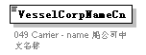
properties
  isRef | 0
annotation
  documentation
  049 Carrier - name 船公司中文名称

element Information/RecordDateTime
diagram | 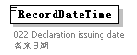
properties
  isRef | 0
annotation
  documentation
  022 Declaration issuing date 备案日期

element Information/ClassLetter
diagram | 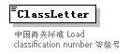
properties
  isRef | 0
annotation
  documentation
  中国海关标准 Load classification number 等级号

element Information/ClassificationNo
diagram | 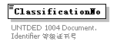
properties
  isRef | 0
annotation
  documentation
  UNTDED 1004 Document. Identifier 等级证书号

element Information/VesselColor
diagram | 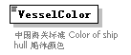
properties
  isRef | 0
annotation
  documentation
  中国海关标准 Color of ship hull 船体颜色

element Information/FunnelColor
diagram | 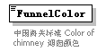
properties
  isRef | 0
annotation
  documentation
  中国海关标准 Color of chimney 烟囱颜色

element Information/Email
diagram | 
properties
  isRef | 0
annotation
  documentation
  中国海关标准 E-mail 电子邮件

element Information/SatellitePhone
diagram | 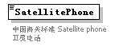
properties
  isRef | 0
annotation
  documentation
  中国海关标准 Satellite phone卫星电话

element Information/HorsePower
diagram | 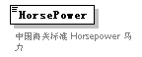
properties
  isRef | 0
annotation
  documentation
  中国海关标准 Horsepower 马力

element Information/Speed
diagram | 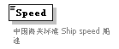
properties
  isRef | 0
annotation
  documentation
  中国海关标准 Ship speed 船速

element Information/TPI_TPC
diagram | 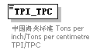
properties
  isRef | 0
annotation
  documentation
  中国海关标准 Tons per inch/Tons per centimetre TPI/TPC

element Information/DeepDraft
diagram | 
properties
  isRef | 0
annotation
  documentation
  中国海关标准 Load draught 满吃水

element Information/LightDraft
diagram | 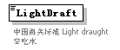
properties
  isRef | 0
annotation
  documentation
  中国海关标准 Light draught 空吃水

element Information/CarbinWindowNum
diagram | 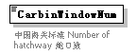
properties
  isRef | 0
annotation
  documentation
  中国海关标准 Number of hatchway 舱口数

element Information/CargoDear
diagram | 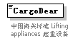
properties
  isRef | 0
annotation
  documentation
  中国海关标准 Lifting appliances 起重设备

element Information/BaleCapacity
diagram | 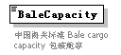
properties
  isRef | 0
annotation
  documentation
  中国海关标准 Bale cargo capacity 包装舱容

element Information/GrainCapacity
diagram | 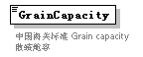
properties
  isRef | 0
annotation
  documentation
  中国海关标准 Grain capacity 散装舱容

element Information/CeilingTEU
diagram | 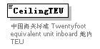
properties
  isRef | 0
annotation
  documentation
  中国海关标准 Twentyfoot equivalent unit inboard 舱内TEU

element Information/DeckTEU
diagram | 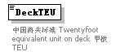
properties
  isRef | 0
annotation
  documentation
  中国海关标准 Twentyfoot equivalent unit on deck 甲板TEU

element Information/CrewLimit
diagram | 
properties
  isRef | 0
annotation
  documentation
  中国海关标准 Crew quota 船员限额

element Information/PassengerLimit
diagram | 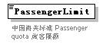
properties
  isRef | 0
annotation
  documentation
  中国海关标准 Passenger quota 旅客限额

element Information/Memo
diagram | 
properties
  isRef | 0
annotation
  documentation
  105 Free text 备注

complexType TradeTerm
diagram | 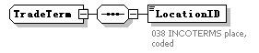
children | LocationID

element TradeTerm/LocationID
diagram | 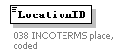
properties
  isRef | 0
annotation
  documentation
  038 INCOTERMS place, coded

complexType UnloadingLocation
diagram | 
children | ArrivalDate

element UnloadingLocation/ArrivalDate
diagram | 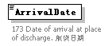
properties
  isRef | 0
annotation
  documentation
  173 Date of arrival at place of discharge. 航班日期

