中国海关水运进出单据报文结构定义

一、XML报文实例
<?xml version="1.0" encoding="UTF-8"?>
<Message xmlns="urn:Declaration:datamodel:standard:CN:CSM101:1" xmlns:xsi="http://www.w3.org/2001/XMLSchema-instance">
<MessageHead>
<MessageID/>
<FunctionCode/>
<MessageType/>
<SenderID/>
<ReceiverID/>
<SendTime/>
<Version/>
</MessageHead>
<MessageBody>
<Declaration>
<DocDeclaration>
<GeneralDeclaration>
<IMO/>
<I_E_Flag/>
<Voyage/>
<Port/>
<CrewNum/>
<PassengersNum/>
<DeadWeightDraft/>
<BussinessType/>
<PurposeOfCall/>
<LeaserCoName/>
<LeaserCoType/>
<ManageLine/>
<VesselDate/>
<AgentCorp/>
<AgentCorpAddress/>
<Declarer/>
<DeclareDate/>
<Memo/>
</GeneralDeclaration>
<CargoDeclaration>
<SeqNo/>
<LoadingPort/>
<DischagedPort/>
<SignMark/>
<CargoType/>
<ContainModal/>
<EquipmentLoadedStatus/>
<Wrap/>
<Qty/>
<FunctionDesc/>
<GrossWeight/>
<Unit/>
<Memo/>
</CargoDeclaration>
<StoresDeclaration>
<SeqNo/>
<GoodsType/>
<GoodsName/>
<GoodsQty/>
<GoodsUnit/>
<Depositary/>
<Memo/>
</StoresDeclaration>
<CrewList>
<SeqNo/>
<Name/>
<Gender/>
<Nationality/>
<DutyProfession/>
<Birthday/>
<Address/>
<CertificateType/>
<CertificateNo/>
<Memo/>
</CrewList>
<CrewsEffectsDeclaration>
<SeqNo/>
<CrewCertificateType/>
<CrewCertificateNo/>
<GoodsType/>
<GoodsName/>
<GoodsQty/>
<GoodsUnit/>
<Memo/>
</CrewsEffectsDeclaration>
<PortList>
<SeqNo/>
<Port/>
<ArrivalDateTime/>
<DepartureDateTime/>
<Memo/>
</PortList>
<EmptyCont>
<SeqNo/>
<OldImportVessel/>
<OldImportVoyage/>
<OldImportDate/>
<ContaID/>
<ContaType/>
<LoadingPort/>
<DischagedPort/>
<Memo/>
</EmptyCont>
<InternalTradeCargo>
<SeqNo/>
<BillNo/>
<ContaID/>
<ContaType/>
<ContaNum/>
<SealNo/>
<GName/>
<GrossWeight/>
<ConsigneeName/>
<ConsignorName/>
<LoadingPort/>
<DischagedPort/>
<Memo/>
</InternalTradeCargo>
<ChangeCustomsCargo>
<SeqNo/>
<FormID/>
<ContaType/>
<ContaNum/>
<LoadingPort/>
<DischangedPort/>
<Memo/>
</ChangeCustomsCargo>
<DangerDeclaration>
<SeqNo/>
<FormID/>
<SignNo/>
<QtySort/>
<TransportName/>
<Sort/>
<UnNo/>
<PackageType/>
<SecondDanger/>
<Flash/>
<InfectantSea/>
<Weight/>
<LeashUpStepNo/>
<LoadPosition/>
<Memo/>
</DangerDeclaration>
</DocDeclaration>
</Declaration>
</MessageBody>
</Message>

二、报文结构
1______Message
1 |______MessageHead
1 | |______MessageID
1 | |______FunctionCode
1 | |______MessageType
1 | |______SenderID
1 | |______ReceiverID
1 | |______SendTime
1 | |______Version
1 |______MessageBody
1 | |______Declaration
1 | | |______DocDeclaration
1 | | | |______GeneralDeclaration
1 | | | | |______IMO
1 | | | | |______I_E_Flag
1 | | | | |______Voyage
1 | | | | |______Port
1 | | | | |______CrewNum
1 | | | | |______PassengersNum
1 | | | | |______DeadWeightDraft
1 | | | | |______BussinessType
1 | | | | |______PurposeOfCall
1 | | | | |______LeaserCoName
1 | | | | |______LeaserCoType
1 | | | | |______ManageLine
1 | | | | |______VesselDate
1 | | | | |______AgentCorp
1 | | | | |______AgentCorpAddress
1 | | | | |______Declarer
1 | | | | |______DeclareDate
1 | | | | |______Memo
10000 | | | |______CargoDeclaration
1 | | | | |______SeqNo
1 | | | | |______LoadingPort
1 | | | | |______DischagedPort
1 | | | | |______SignMark
1 | | | | |______CargoType
1 | | | | |______ContainModal
1 | | | | |______EquipmentLoadedStatus
1 | | | | |______Wrap
1 | | | | |______Qty
1 | | | | |______FunctionDesc
1 | | | | |______GrossWeight
1 | | | | |______Unit
1 | | | | |______Memo
10000 | | | |______StoresDeclaration
1 | | | | |______SeqNo
1 | | | | |______GoodsType
1 | | | | |______GoodsName
1 | | | | |______GoodsQty
1 | | | | |______GoodsUnit
1 | | | | |______Depositary
1 | | | | |______Memo
10000 | | | |______CrewList
1 | | | | |______SeqNo
1 | | | | |______Name
1 | | | | |______Gender
1 | | | | |______Nationality
1 | | | | |______DutyProfession
1 | | | | |______Birthday
1 | | | | |______Address
1 | | | | |______CertificateType
1 | | | | |______CertificateNo
1 | | | | |______Memo
10000 | | | |______CrewsEffectsDeclaration
1 | | | | |______SeqNo
1 | | | | |______CrewCertificateType
1 | | | | |______CrewCertificateNo
1 | | | | |______GoodsType
1 | | | | |______GoodsName
1 | | | | |______GoodsQty
1 | | | | |______GoodsUnit
1 | | | | |______Memo
10000 | | | |______PortList
1 | | | | |______SeqNo
1 | | | | |______Port
1 | | | | |______ArrivalDateTime
1 | | | | |______DepartureDateTime
1 | | | | |______Memo
10000 | | | |______EmptyCont
1 | | | | |______SeqNo
1 | | | | |______OldImportVessel
1 | | | | |______OldImportVoyage
1 | | | | |______OldImportDate
1 | | | | |______ContaID
1 | | | | |______ContaType
1 | | | | |______LoadingPort
1 | | | | |______DischagedPort
1 | | | | |______Memo
10000 | | | |______InternalTradeCargo
1 | | | | |______SeqNo
1 | | | | |______BillNo
1 | | | | |______ContaID
1 | | | | |______ContaType
1 | | | | |______ContaNum
1 | | | | |______SealNo
1 | | | | |______GName
1 | | | | |______GrossWeight
1 | | | | |______ConsigneeName
1 | | | | |______ConsignorName
1 | | | | |______LoadingPort
1 | | | | |______DischagedPort
1 | | | | |______Memo
10000 | | | |______ChangeCustomsCargo
1 | | | | |______SeqNo
1 | | | | |______FormID
1 | | | | |______ContaType
1 | | | | |______ContaNum
1 | | | | |______LoadingPort
1 | | | | |______DischangedPort
1 | | | | |______Memo
10000 | | | |______DangerDeclaration
1 | | | | |______SeqNo
1 | | | | |______FormID
1 | | | | |______SignNo
1 | | | | |______QtySort
1 | | | | |______TransportName
1 | | | | |______Sort
1 | | | | |______UnNo
1 | | | | |______PackageType
1 | | | | |______SecondDanger
1 | | | | |______Flash
1 | | | | |______InfectantSea
1 | | | | |______Weight
1 | | | | |______LeashUpStepNo
1 | | | | |______LoadPosition
1 | | | | |______Memo

三、报文节点详细说明

element Message
diagram | 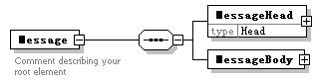
properties
  content | complex
children | MessageHead MessageBody
annotation
  documentation
  Comment describing your root element

element Message/MessageHead
diagram | 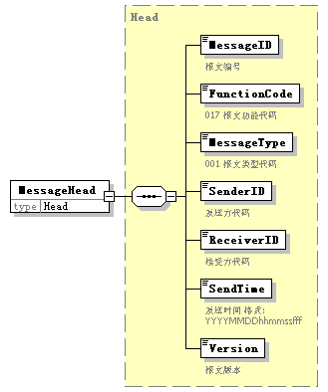
type | Head
properties
  isRef | 0
  content | complex
children | MessageID FunctionCode MessageType SenderID ReceiverID SendTime Version

element Message/MessageBody
diagram | 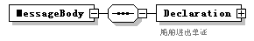
properties
  isRef | 0
  content | complex
children | Declaration

element Message/MessageBody/Declaration
diagram | 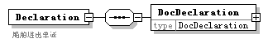
properties
  isRef | 0
  content | complex
children | DocDeclaration
annotation
  documentation
  船舶进出单证

element Message/MessageBody/Declaration/DocDeclaration
diagram | 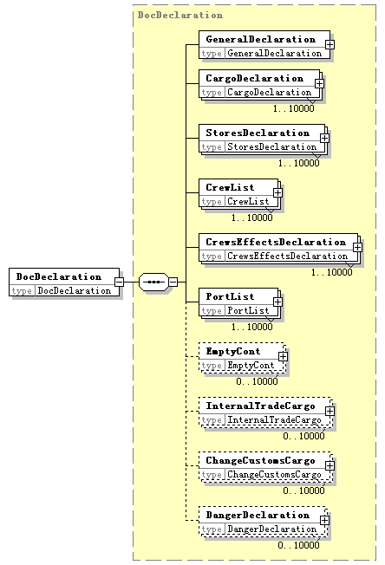
type | DocDeclaration
properties
  isRef | 0
  content | complex
children | GeneralDeclaration CargoDeclaration StoresDeclaration CrewList CrewsEffectsDeclaration PortList EmptyCont InternalTradeCargo ChangeCustomsCargo DangerDeclaration

complexType AdditionalInformation
diagram | 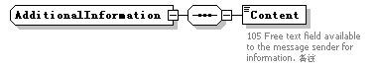
children | Content

element AdditionalInformation/Content
diagram | 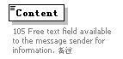
properties
  isRef | 0
annotation
  documentation
  105 Free text field available to the message sender for information. 备注

complexType ArrivalConveyanceFacility
diagram | 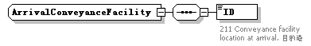
children | ID

element ArrivalConveyanceFacility/ID
diagram | 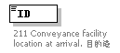
properties
  isRef | 0
annotation
  documentation
  211 Conveyance facility location at arrival. 目的港

complexType CargoDeclaration
diagram | 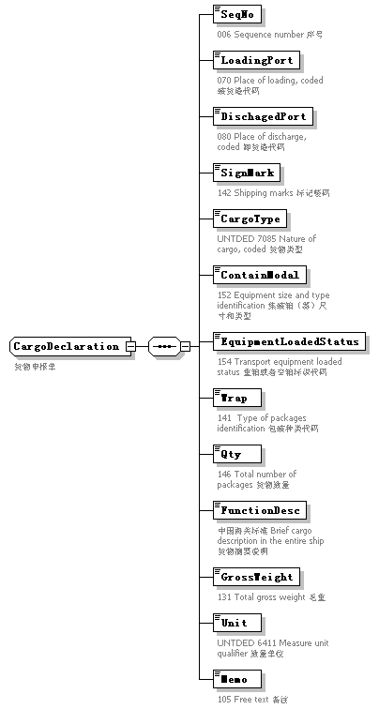
children | SeqNo LoadingPort DischagedPort SignMark CargoType ContainModal EquipmentLoadedStatus Wrap Qty FunctionDesc GrossWeight Unit Memo
used by
  element | DocDeclaration/CargoDeclaration
annotation
  documentation
  货物申报单

element CargoDeclaration/SeqNo
diagram | 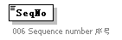
properties
  isRef | 0
annotation
  documentation
  006 Sequence number 序号

element CargoDeclaration/LoadingPort
diagram | 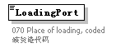
properties
  isRef | 0
annotation
  documentation
  070 Place of loading, coded 装货港代码

element CargoDeclaration/DischagedPort
diagram | 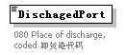
properties
  isRef | 0
annotation
  documentation
  080 Place of discharge, coded 卸货港代码

element CargoDeclaration/SignMark
diagram | 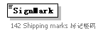
properties
  isRef | 0
annotation
  documentation
  142 Shipping marks 标记唛码

element CargoDeclaration/CargoType
diagram | 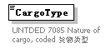
properties
  isRef | 0
annotation
  documentation
  UNTDED 7085 Nature of cargo, coded 货物类型

element CargoDeclaration/ContainModal
diagram | 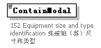
properties
  isRef | 0
annotation
  documentation
  152 Equipment size and type identification 集装箱（器）尺寸和类型

element CargoDeclaration/EquipmentLoadedStatus
diagram | 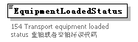
properties
  isRef | 0
annotation
  documentation
  154 Transport equipment loaded status 重箱或者空箱标识代码

element CargoDeclaration/Wrap
diagram | 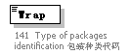
properties
  isRef | 0
annotation
  documentation
  141 Type of packages identification 包装种类代码

element CargoDeclaration/Qty
diagram | 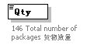
properties
  isRef | 0
annotation
  documentation
  146 Total number of packages 货物数量

element CargoDeclaration/FunctionDesc
diagram | 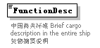
properties
  isRef | 0
annotation
  documentation
  中国海关标准 Brief cargo description in the entire ship 货物摘要说明

element CargoDeclaration/GrossWeight
diagram | 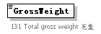
properties
  isRef | 0
annotation
  documentation
  131 Total gross weight 毛重

element CargoDeclaration/Unit
diagram | 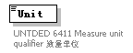
properties
  isRef | 0
annotation
  documentation
  UNTDED 6411 Measure unit qualifier 数量单位

element CargoDeclaration/Memo
diagram | 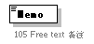
properties
  isRef | 0
annotation
  documentation
  105 Free text 备注

complexType ChangeCustomsCargo
diagram | 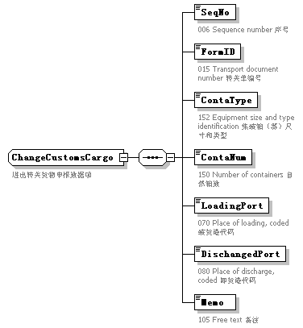
children | SeqNo FormID ContaType ContaNum LoadingPort DischangedPort Memo
used by
  element | DocDeclaration/ChangeCustomsCargo
annotation
  documentation
  进出转关货物申报数据项

element ChangeCustomsCargo/SeqNo
diagram | 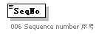
properties
  isRef | 0
annotation
  documentation
  006 Sequence number 序号

element ChangeCustomsCargo/FormID
diagram | 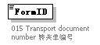
properties
  isRef | 0
annotation
  documentation
  015 Transport document number 转关单编号

element ChangeCustomsCargo/ContaType
diagram | 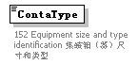
properties
  isRef | 0
annotation
  documentation
  152 Equipment size and type identification 集装箱（器）尺寸和类型

element ChangeCustomsCargo/ContaNum
diagram | 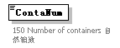
properties
  isRef | 0
annotation
  documentation
  150 Number of containers 自然箱数

element ChangeCustomsCargo/LoadingPort
diagram
properties
  isRef | 0
annotation
  documentation
  070 Place of loading, coded 装货港代码

element ChangeCustomsCargo/DischangedPort
diagram | 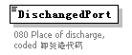
properties
  isRef | 0
annotation
  documentation
  080 Place of discharge, coded 卸货港代码

element ChangeCustomsCargo/Memo
diagram
properties
  isRef | 0
annotation
  documentation
  105 Free text 备注

complexType Contact
diagram | 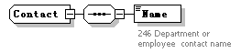
children | Name

element Contact/Name
diagram | 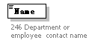
properties
  isRef | 0
annotation
  documentation
  246 Department or employee contact name

complexType CrewList
diagram | 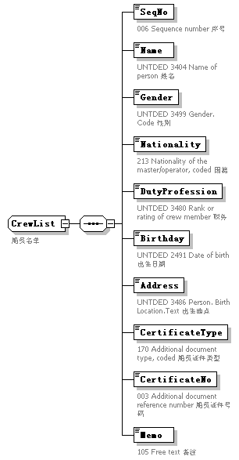
children | SeqNo Name Gender Nationality DutyProfession Birthday Address CertificateType CertificateNo Memo
used by
  element | DocDeclaration/CrewList
annotation
  documentation
  船员名单

element CrewList/SeqNo
diagram
properties
  isRef | 0
annotation
  documentation
  006 Sequence number 序号

element CrewList/Name
diagram | 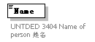
properties
  isRef | 0
annotation
  documentation
  UNTDED 3404 Name of person 姓名

element CrewList/Gender
diagram | 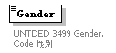
properties
  isRef | 0
annotation
  documentation
  UNTDED 3499 Gender. Code 性别

element CrewList/Nationality
diagram | 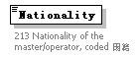
properties
  isRef | 0
annotation
  documentation
  213 Nationality of the master/operator, coded 国籍

element CrewList/DutyProfession
diagram | 
properties
  isRef | 0
annotation
  documentation
  UNTDED 3480 Rank or rating of crew member 职务

element CrewList/Birthday
diagram | 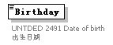
properties
  isRef | 0
annotation
  documentation
  UNTDED 2491 Date of birth 出生日期

element CrewList/Address
diagram | 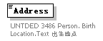
properties
  isRef | 0
annotation
  documentation
  UNTDED 3486 Person. Birth Location.Text 出生地点

element CrewList/CertificateType
diagram | 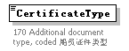
properties
  isRef | 0
annotation
  documentation
  170 Additional document type, coded 船员证件类型

element CrewList/CertificateNo
diagram | 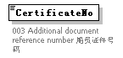
properties
  isRef | 0
annotation
  documentation
  003 Additional document reference number 船员证件号码

element CrewList/Memo
diagram
properties
  isRef | 0
annotation
  documentation
  105 Free text 备注

complexType CrewsEffectsDeclaration
diagram | 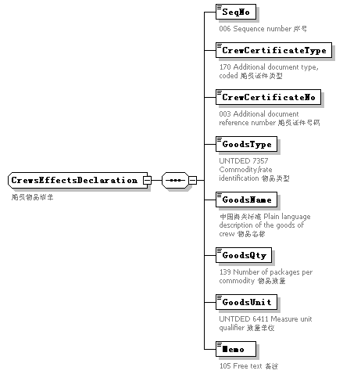
children | SeqNo CrewCertificateType CrewCertificateNo GoodsType GoodsName GoodsQty GoodsUnit Memo
used by
  element | DocDeclaration/CrewsEffectsDeclaration
annotation
  documentation
  船员物品清单

element CrewsEffectsDeclaration/SeqNo
diagram
properties
  isRef | 0
annotation
  documentation
  006 Sequence number 序号

element CrewsEffectsDeclaration/CrewCertificateType
diagram | 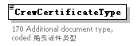
properties
  isRef | 0
annotation
  documentation
  170 Additional document type, coded 船员证件类型

element CrewsEffectsDeclaration/CrewCertificateNo
diagram | 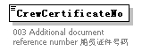
properties
  isRef | 0
annotation
  documentation
  003 Additional document reference number 船员证件号码

element CrewsEffectsDeclaration/GoodsType
diagram | 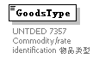
properties
  isRef | 0
annotation
  documentation
  UNTDED 7357 Commodity/rate identification 物品类型

element CrewsEffectsDeclaration/GoodsName
diagram | 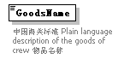
properties
  isRef | 0
annotation
  documentation
  中国海关标准 Plain language description of the goods of crew 物品名称

element CrewsEffectsDeclaration/GoodsQty
diagram | 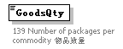
properties
  isRef | 0
annotation
  documentation
  139 Number of packages per commodity 物品数量

element CrewsEffectsDeclaration/GoodsUnit
diagram | 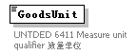
properties
  isRef | 0
annotation
  documentation
  UNTDED 6411 Measure unit qualifier 数量单位

element CrewsEffectsDeclaration/Memo
diagram
properties
  isRef | 0
annotation
  documentation
  105 Free text 备注

complexType DangerDeclaration
diagram | 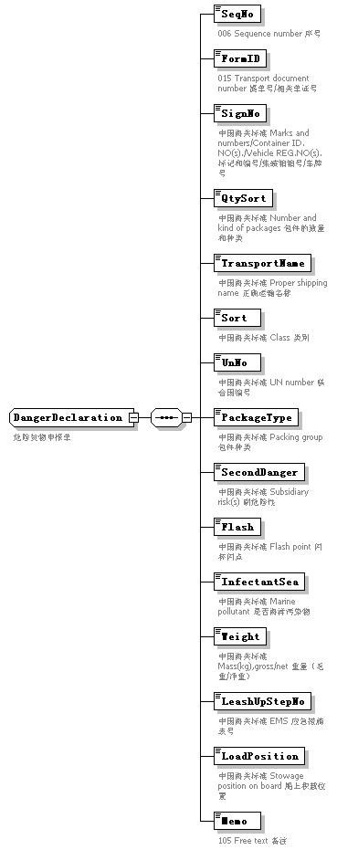
children | SeqNo FormID SignNo QtySort TransportName Sort UnNo PackageType SecondDanger Flash InfectantSea Weight LeashUpStepNo LoadPosition Memo
used by
  element | DocDeclaration/DangerDeclaration
annotation
  documentation
  危险货物申报单

element DangerDeclaration/SeqNo
diagram
properties
  isRef | 0
annotation
  documentation
  006 Sequence number 序号

element DangerDeclaration/FormID
diagram | 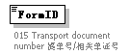
properties
  isRef | 0
annotation
  documentation
  015 Transport document number 提单号/相关单证号

element DangerDeclaration/SignNo
diagram | 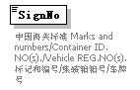
properties
  isRef | 0
annotation
  documentation
  中国海关标准 Marks and numbers/Container ID. NO(s)./Vehicle REG.NO(s). 标记和编号/集装箱箱号/车牌号

element DangerDeclaration/QtySort
diagram | 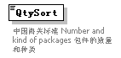
properties
  isRef | 0
annotation
  documentation
  中国海关标准 Number and kind of packages 包件的数量和种类

element DangerDeclaration/TransportName
diagram | 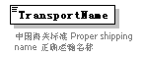
properties
  isRef | 0
annotation
  documentation
  中国海关标准 Proper shipping name 正确运输名称

element DangerDeclaration/Sort
diagram | 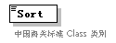
properties
  isRef | 0
annotation
  documentation
  中国海关标准 Class 类别

element DangerDeclaration/UnNo
diagram | 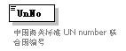
properties
  isRef | 0
annotation
  documentation
  中国海关标准 UN number 联合国编号

element DangerDeclaration/PackageType
diagram | 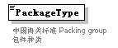
properties
  isRef | 0
annotation
  documentation
  中国海关标准 Packing group 包件种类

element DangerDeclaration/SecondDanger
diagram | 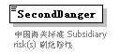
properties
  isRef | 0
annotation
  documentation
  中国海关标准 Subsidiary risk(s) 副危险性

element DangerDeclaration/Flash
diagram | 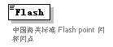
properties
  isRef | 0
annotation
  documentation
  中国海关标准 Flash point 闪杯闪点

element DangerDeclaration/InfectantSea
diagram | 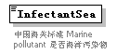
properties
  isRef | 0
annotation
  documentation
  中国海关标准 Marine pollutant 是否海洋污染物

element DangerDeclaration/Weight
diagram | 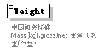
properties
  isRef | 0
annotation
  documentation
  中国海关标准 Mass(kg),gross/net 重量（毛重/净重）

element DangerDeclaration/LeashUpStepNo
diagram | 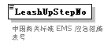
properties
  isRef | 0
annotation
  documentation
  中国海关标准 EMS 应急措施表号

element DangerDeclaration/LoadPosition
diagram | 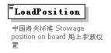
properties
  isRef | 0
annotation
  documentation
  中国海关标准 Stowage position on board 船上积栽位置

element DangerDeclaration/Memo
diagram
properties
  isRef | 0
annotation
  documentation
  105 Free text 备注

complexType DepartureConveyanceFacility
diagram | 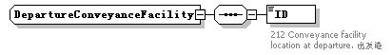
children | ID

element DepartureConveyanceFacility/ID
diagram | 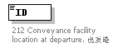
properties
  isRef | 0
annotation
  documentation
  212 Conveyance facility location at departure. 出发港

complexType DocDeclaration
diagram | 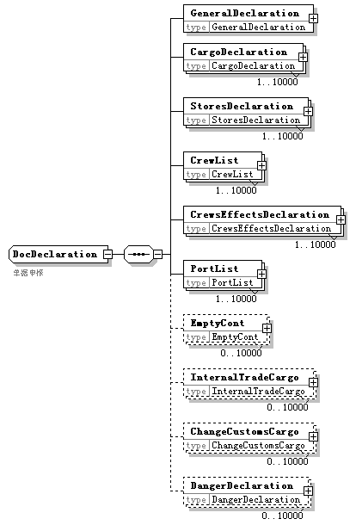
children | GeneralDeclaration CargoDeclaration StoresDeclaration CrewList CrewsEffectsDeclaration PortList EmptyCont InternalTradeCargo ChangeCustomsCargo DangerDeclaration
used by
  element | Message/MessageBody/Declaration/DocDeclaration
annotation
  documentation
  单据申报

element DocDeclaration/GeneralDeclaration
diagram | 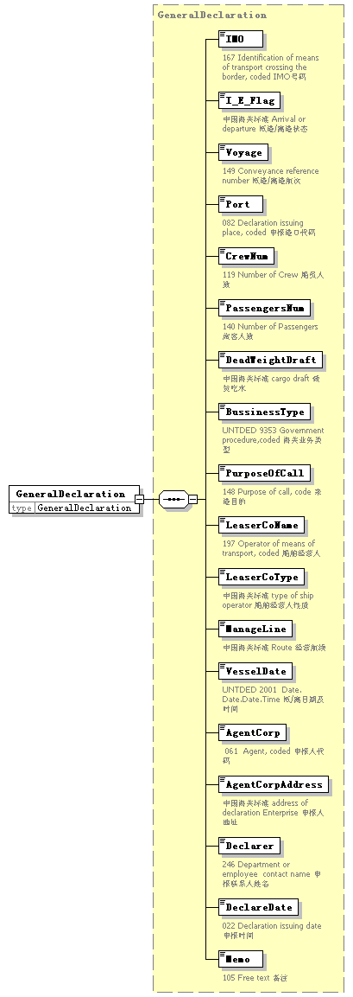
type | GeneralDeclaration
properties
  isRef | 0
  content | complex
children | IMO I_E_Flag Voyage Port CrewNum PassengersNum DeadWeightDraft BussinessType PurposeOfCall LeaserCoName LeaserCoType ManageLine VesselDate AgentCorp AgentCorpAddress Declarer DeclareDate Memo

element DocDeclaration/CargoDeclaration
diagram | 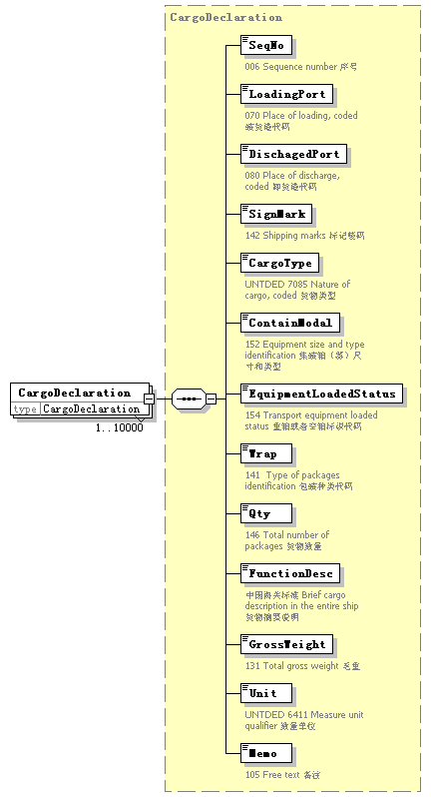
type | CargoDeclaration
properties
  isRef | 0
  minOcc | 1
  maxOcc | 10000
  content | complex
children | SeqNo LoadingPort DischagedPort SignMark CargoType ContainModal EquipmentLoadedStatus Wrap Qty FunctionDesc GrossWeight Unit Memo

element DocDeclaration/StoresDeclaration
diagram | 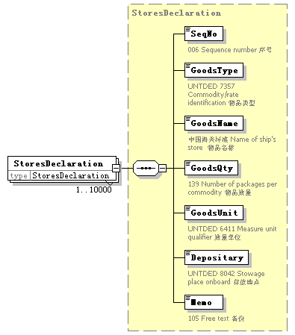
type | StoresDeclaration
properties
  isRef | 0
  minOcc | 1
  maxOcc | 10000
  content | complex
children | SeqNo GoodsType GoodsName GoodsQty GoodsUnit Depositary Memo

element DocDeclaration/CrewList
diagram | 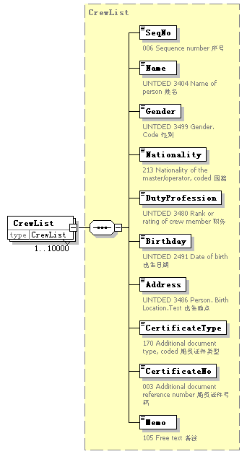
type | CrewList
properties
  isRef | 0
  minOcc | 1
  maxOcc | 10000
  content | complex
children | SeqNo Name Gender Nationality DutyProfession Birthday Address CertificateType CertificateNo Memo

element DocDeclaration/CrewsEffectsDeclaration
diagram | 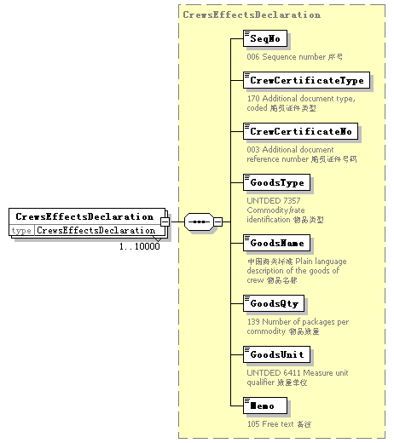
type | CrewsEffectsDeclaration
properties
  isRef | 0
  minOcc | 1
  maxOcc | 10000
  content | complex
children | SeqNo CrewCertificateType CrewCertificateNo GoodsType GoodsName GoodsQty GoodsUnit Memo

element DocDeclaration/PortList
diagram | 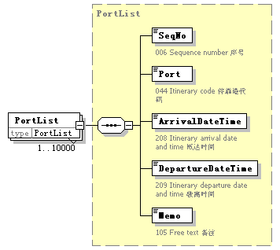
type | PortList
properties
  isRef | 0
  minOcc | 1
  maxOcc | 10000
  content | complex
children | SeqNo Port ArrivalDateTime DepartureDateTime Memo

element DocDeclaration/EmptyCont
diagram | 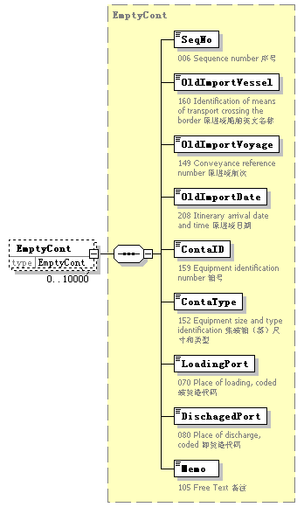
type | EmptyCont
properties
  isRef | 0
  minOcc | 0
  maxOcc | 10000
  content | complex
children | SeqNo OldImportVessel OldImportVoyage OldImportDate ContaID ContaType LoadingPort DischagedPort Memo

element DocDeclaration/InternalTradeCargo
diagram | 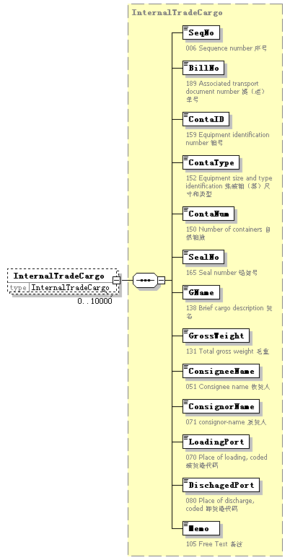
type | InternalTradeCargo
properties
  isRef | 0
  minOcc | 0
  maxOcc | 10000
  content | complex
children | SeqNo BillNo ContaID ContaType ContaNum SealNo GName GrossWeight ConsigneeName ConsignorName LoadingPort DischagedPort Memo

element DocDeclaration/ChangeCustomsCargo
diagram | 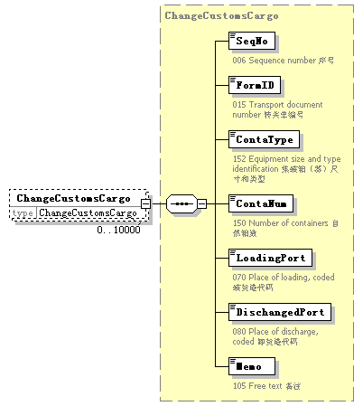
type | ChangeCustomsCargo
properties
  isRef | 0
  minOcc | 0
  maxOcc | 10000
  content | complex
children | SeqNo FormID ContaType ContaNum LoadingPort DischangedPort Memo

element DocDeclaration/DangerDeclaration
diagram | 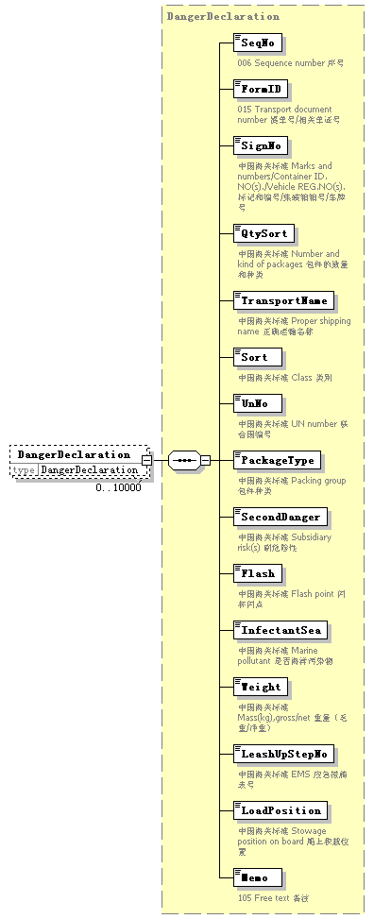
type | DangerDeclaration
properties
  isRef | 0
  minOcc | 0
  maxOcc | 10000
  content | complex
children | SeqNo FormID SignNo QtySort TransportName Sort UnNo PackageType SecondDanger Flash InfectantSea Weight LeashUpStepNo LoadPosition Memo

complexType EmptyCont
diagram | 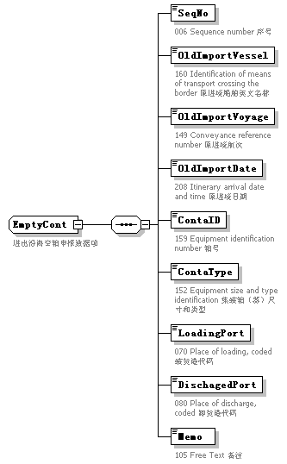
children | SeqNo OldImportVessel OldImportVoyage OldImportDate ContaID ContaType LoadingPort DischagedPort Memo
used by
  element | DocDeclaration/EmptyCont
annotation
  documentation
  进出沿海空箱申报数据项

element EmptyCont/SeqNo
diagram
properties
  isRef | 0
annotation
  documentation
  006 Sequence number 序号

element EmptyCont/OldImportVessel
diagram | 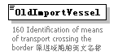
properties
  isRef | 0
annotation
  documentation
  160 Identification of means of transport crossing the border 原进境船舶英文名称

element EmptyCont/OldImportVoyage
diagram | 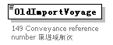
properties
  isRef | 0
annotation
  documentation
  149 Conveyance reference number 原进境航次

element EmptyCont/OldImportDate
diagram | 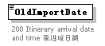
properties
  isRef | 0
annotation
  documentation
  208 Itinerary arrival date and time 原进境日期

element EmptyCont/ContaID
diagram | 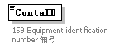
properties
  isRef | 0
annotation
  documentation
  159 Equipment identification number 箱号

element EmptyCont/ContaType
diagram
properties
  isRef | 0
annotation
  documentation
  152 Equipment size and type identification 集装箱（器）尺寸和类型

element EmptyCont/LoadingPort
diagram
properties
  isRef | 0
annotation
  documentation
  070 Place of loading, coded 装货港代码

element EmptyCont/DischagedPort
diagram
properties
  isRef | 0
annotation
  documentation
  080 Place of discharge, coded 卸货港代码

element EmptyCont/Memo
diagram | 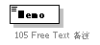
properties
  isRef | 0
annotation
  documentation
  105 Free Text 备注

complexType GeneralDeclaration
diagram | 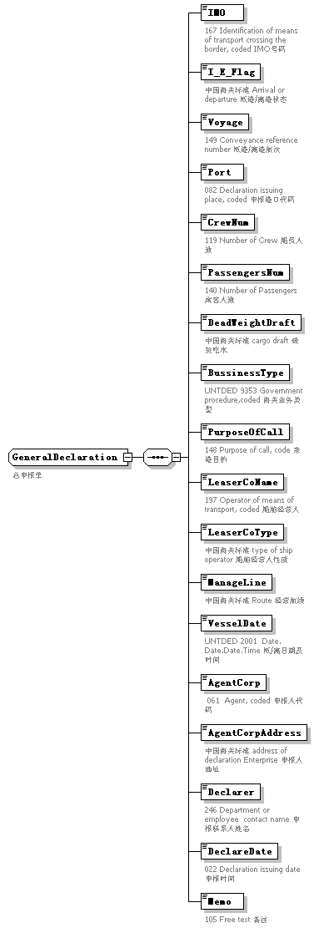
children | IMO I_E_Flag Voyage Port CrewNum PassengersNum DeadWeightDraft BussinessType PurposeOfCall LeaserCoName LeaserCoType ManageLine VesselDate AgentCorp AgentCorpAddress Declarer DeclareDate Memo
used by
  element | DocDeclaration/GeneralDeclaration
annotation
  documentation
  总申报单

element GeneralDeclaration/IMO
diagram | 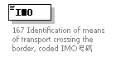
properties
  isRef | 0
annotation
  documentation
  167 Identification of means of transport crossing the border, coded IMO号码

element GeneralDeclaration/I_E_Flag
diagram | 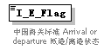
properties
  isRef | 0
annotation
  documentation
  中国海关标准 Arrival or departure 抵港/离港状态

element GeneralDeclaration/Voyage
diagram | 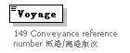
properties
  isRef | 0
annotation
  documentation
  149 Conveyance reference number 抵港/离港航次

element GeneralDeclaration/Port
diagram | 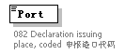
properties
  isRef | 0
annotation
  documentation
  082 Declaration issuing place, coded 申报港口代码

element GeneralDeclaration/CrewNum
diagram | 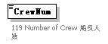
properties
  isRef | 0
annotation
  documentation
  119 Number of Crew 船员人数

element GeneralDeclaration/PassengersNum
diagram | 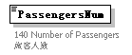
properties
  isRef | 0
annotation
  documentation
  140 Number of Passengers 旅客人数

element GeneralDeclaration/DeadWeightDraft
diagram | 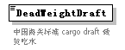
properties
  isRef | 0
annotation
  documentation
  中国海关标准 cargo draft 载货吃水

element GeneralDeclaration/BussinessType
diagram | 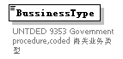
properties
  isRef | 0
annotation
  documentation
  UNTDED 9353 Government procedure,coded 海关业务类型

element GeneralDeclaration/PurposeOfCall
diagram | 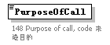
properties
  isRef | 0
annotation
  documentation
  148 Purpose of call, code 来港目的

element GeneralDeclaration/LeaserCoName
diagram | 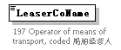
properties
  isRef | 0
annotation
  documentation
  197 Operator of means of transport, coded 船舶经营人

element GeneralDeclaration/LeaserCoType
diagram | 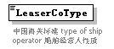
properties
  isRef | 0
annotation
  documentation
  中国海关标准 type of ship operator 船舶经营人性质

element GeneralDeclaration/ManageLine
diagram | 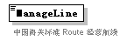
properties
  isRef | 0
annotation
  documentation
  中国海关标准 Route 经营航线

element GeneralDeclaration/VesselDate
diagram | 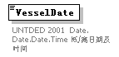
properties
  isRef | 0
annotation
  documentation
  UNTDED 2001 Date. Date.Date.Time 抵/离日期及时间

element GeneralDeclaration/AgentCorp
diagram | 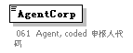
properties
  isRef | 0
annotation
  documentation
  061 Agent, coded 申报人代码

element GeneralDeclaration/AgentCorpAddress
diagram | 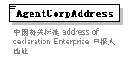
properties
  isRef | 0
annotation
  documentation
  中国海关标准 address of declaration Enterprise 申报人地址

element GeneralDeclaration/Declarer
diagram | 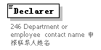
properties
  isRef | 0
annotation
  documentation
  246 Department or employee contact name 申报联系人姓名

element GeneralDeclaration/DeclareDate
diagram | 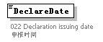
properties
  isRef | 0
annotation
  documentation
  022 Declaration issuing date 申报时间

element GeneralDeclaration/Memo
diagram | 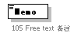
properties
  isRef | 0
annotation
  documentation
  105 Free text 备注

complexType Head
diagram | 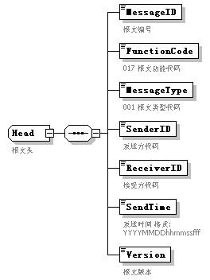
children | MessageID FunctionCode MessageType SenderID ReceiverID SendTime Version
used by
  element | Message/MessageHead
annotation
  documentation
  报文头

element Head/MessageID
diagram | 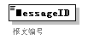
properties
  isRef | 0
annotation
  documentation
  报文编号

element Head/FunctionCode
diagram | 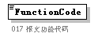
properties
  isRef | 0
annotation
  documentation
  017 报文功能代码

element Head/MessageType
diagram | 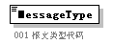
properties
  isRef | 0
annotation
  documentation
  001 报文类型代码

element Head/SenderID
diagram | 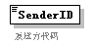
properties
  isRef | 0
annotation
  documentation
  发送方代码

element Head/ReceiverID
diagram | 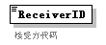
properties
  isRef | 0
annotation
  documentation
  接受方代码

element Head/SendTime
diagram | 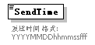
properties
  isRef | 0
annotation
  documentation
  发送时间 格式:YYYYMMDDhhmmssfff

element Head/Version
diagram | 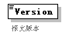
properties
  isRef | 0
annotation
  documentation
  报文版本

complexType InternalTradeCargo
diagram | 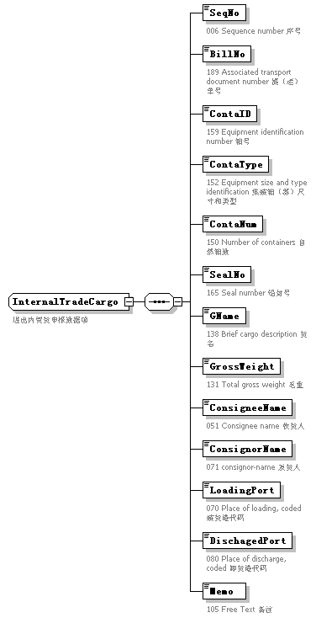
children | SeqNo BillNo ContaID ContaType ContaNum SealNo GName GrossWeight ConsigneeName ConsignorName LoadingPort DischagedPort Memo
used by
  element | DocDeclaration/InternalTradeCargo
annotation
  documentation
  进出内贸货申报数据项

element InternalTradeCargo/SeqNo
diagram
properties
  isRef | 0
annotation
  documentation
  006 Sequence number 序号

element InternalTradeCargo/BillNo
diagram | 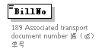
properties
  isRef | 0
annotation
  documentation
  189 Associated transport document number 提（运）单号

element InternalTradeCargo/ContaID
diagram
properties
  isRef | 0
annotation
  documentation
  159 Equipment identification number 箱号

element InternalTradeCargo/ContaType
diagram
properties
  isRef | 0
annotation
  documentation
  152 Equipment size and type identification 集装箱（器）尺寸和类型

element InternalTradeCargo/ContaNum
diagram
properties
  isRef | 0
annotation
  documentation
  150 Number of containers 自然箱数

element InternalTradeCargo/SealNo
diagram | 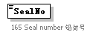
properties
  isRef | 0
annotation
  documentation
  165 Seal number 铅封号

element InternalTradeCargo/GName
diagram | 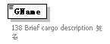
properties
  isRef | 0
annotation
  documentation
  138 Brief cargo description 货名

element InternalTradeCargo/GrossWeight
diagram | 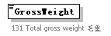
properties
  isRef | 0
annotation
  documentation
  131 Total gross weight 毛重

element InternalTradeCargo/ConsigneeName
diagram | 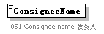
properties
  isRef | 0
annotation
  documentation
  051 Consignee name 收货人

element InternalTradeCargo/ConsignorName
diagram | 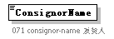
properties
  isRef | 0
annotation
  documentation
  071 consignor-name 发货人

element InternalTradeCargo/LoadingPort
diagram
properties
  isRef | 0
annotation
  documentation
  070 Place of loading, coded 装货港代码

element InternalTradeCargo/DischagedPort
diagram
properties
  isRef | 0
annotation
  documentation
  080 Place of discharge, coded 卸货港代码

element InternalTradeCargo/Memo
diagram
properties
  isRef | 0
annotation
  documentation
  105 Free Text 备注

complexType PortList
diagram | 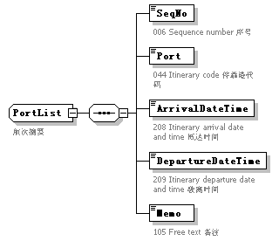
children | SeqNo Port ArrivalDateTime DepartureDateTime Memo
used by
  element | DocDeclaration/PortList
annotation
  documentation
  航次摘要

element PortList/SeqNo
diagram
properties
  isRef | 0
annotation
  documentation
  006 Sequence number 序号

element PortList/Port
diagram | 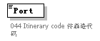
properties
  isRef | 0
annotation
  documentation
  044 Itinerary code 停靠港代码

element PortList/ArrivalDateTime
diagram | 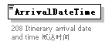
properties
  isRef | 0
annotation
  documentation
  208 Itinerary arrival date and time 抵达时间

element PortList/DepartureDateTime
diagram | 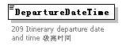
properties
  isRef | 0
annotation
  documentation
  209 Itinerary departure date and time 驶离时间

element PortList/Memo
diagram
properties
  isRef | 0
annotation
  documentation
  105 Free text 备注

complexType StoresDeclaration
diagram | 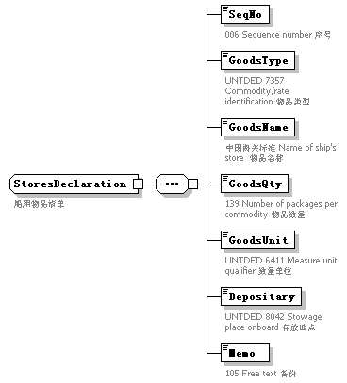
children | SeqNo GoodsType GoodsName GoodsQty GoodsUnit Depositary Memo
used by
  element | DocDeclaration/StoresDeclaration
annotation
  documentation
  船用物品清单

element StoresDeclaration/SeqNo
diagram
properties
  isRef | 0
annotation
  documentation
  006 Sequence number 序号

element StoresDeclaration/GoodsType
diagram
properties
  isRef | 0
annotation
  documentation
  UNTDED 7357 Commodity/rate identification 物品类型

element StoresDeclaration/GoodsName
diagram | 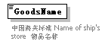
properties
  isRef | 0
annotation
  documentation
  中国海关标准 Name of ship's store 物品名称

element StoresDeclaration/GoodsQty
diagram
properties
  isRef | 0
annotation
  documentation
  139 Number of packages per commodity 物品数量

element StoresDeclaration/GoodsUnit
diagram
properties
  isRef | 0
annotation
  documentation
  UNTDED 6411 Measure unit qualifier 数量单位

element StoresDeclaration/Depositary
diagram | 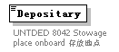
properties
  isRef | 0
annotation
  documentation
  UNTDED 8042 Stowage place onboard 存放地点

element StoresDeclaration/Memo
diagram | 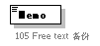
properties
  isRef | 0
annotation
  documentation
  105 Free text 备份

complexType TradeTerm
diagram | 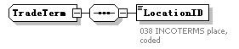
children | LocationID

element TradeTerm/LocationID
diagram | 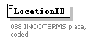
properties
  isRef | 0
annotation
  documentation
  038 INCOTERMS place, coded

complexType UnloadingLocation
diagram | 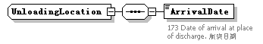
children | ArrivalDate

element UnloadingLocation/ArrivalDate
diagram | 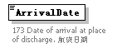
properties
  isRef | 0
annotation
  documentation
  173 Date of arrival at place of discharge. 航班日期

