中国海关搭载转关货物的国内航班离港报文结构定义

一、XML报文实例
<?xml version="1.0" encoding="UTF-8"?>
<Message xmlns="urn:Declaration:datamodel:standard:CN:CAM010:1" xmlns:xsi="http://www.w3.org/2001/XMLSchema-instance" >
<MessageHead>
<MessageID/>
<FunctionCode/>
<MessageType/>
<SenderID/>
<ReceiverID/>
<SendTime/>
<Version/>
</MessageHead>
<MessageBody>
<Declaration>
<GHLG>
<FLIGHT_NO/>
<DEPART_TIME/>
<FLIGHT_DATE/>
<FROM_PORT/>
<TO_PORT/>
<MEMO/>
<DECLARE_TIME/>
</GHLG>
</Declaration>
</MessageBody>
</Message>

二、报文结构
1______Message
1 |______MessageHead
1 | |______MessageID
1 | |______FunctionCode
1 | |______MessageType
1 | |______SenderID
1 | |______ReceiverID
1 | |______SendTime
1 | |______Version
1 |______MessageBody
1 | |______Declaration
1 | | |______GHLG
1 | | | |______FLIGHT_NO
1 | | | |______DEPART_TIME
1 | | | |______FLIGHT_DATE
1 | | | |______FROM_PORT
1 | | | |______TO_PORT
1 | | | |______MEMO
1 | | | |______DECLARE_TIME

三、报文节点详细说明
element Message
diagram | 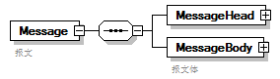
properties
  content | complex
children | MessageHead MessageBody
annotation
  documentation
  报文

element Message/MessageHead
diagram | 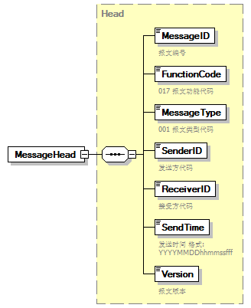
type | Head
properties
  isRef | 0
  content | complex
children | MessageID FunctionCode MessageType SenderID ReceiverID SendTime Version

element Message/MessageBody
diagram | 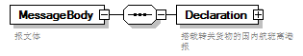
properties
  isRef | 0
  content | complex
children | Declaration
annotation
  documentation
  报文体

element Message/MessageBody/Declaration
diagram | 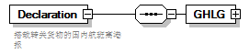
properties
  isRef | 0
  content | complex
children | GHLG
annotation
  documentation
  搭载转关货物的国内航班离港报

element Message/MessageBody/Declaration/GHLG
diagram | 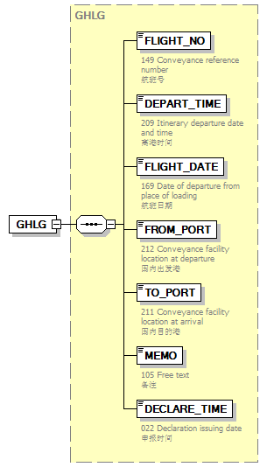
type | GHLG
properties
  isRef | 0
  content | complex
children | FLIGHT_NO DEPART_TIME FLIGHT_DATE FROM_PORT TO_PORT MEMO DECLARE_TIME

complexType AdditionalInformation
diagram | 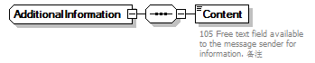
children | Content

element AdditionalInformation/Content
diagram | 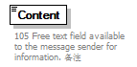
properties
  isRef | 0
annotation
  documentation
  105 Free text field available to the message sender for information. 备注

complexType ArrivalConveyanceFacility
diagram | 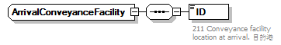
children | ID

element ArrivalConveyanceFacility/ID
diagram | 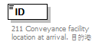
properties
  isRef | 0
annotation
  documentation
  211 Conveyance facility location at arrival. 目的港

complexType Contact
diagram | 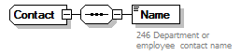
children | Name

element Contact/Name
diagram | 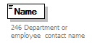
properties
  isRef | 0
annotation
  documentation
  246 Department or employee contact name

complexType DepartureConveyanceFacility
diagram | 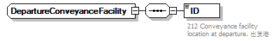
children | ID

element DepartureConveyanceFacility/ID
diagram | 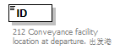
properties
  isRef | 0
annotation
  documentation
  212 Conveyance facility location at departure. 出发港

complexType GHLG
diagram | 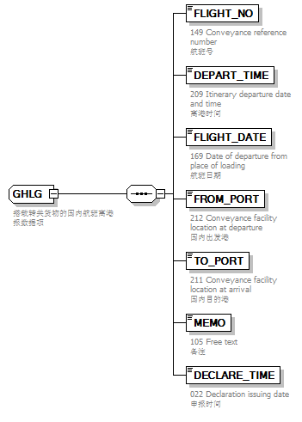
children | FLIGHT_NO DEPART_TIME FLIGHT_DATE FROM_PORT TO_PORT MEMO DECLARE_TIME
used by
  element | Message/MessageBody/Declaration/GHLG
annotation
  documentation
  搭载转关货物的国内航班离港报数据项

element GHLG/FLIGHT_NO
diagram | 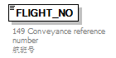
properties
  isRef | 0
annotation
  documentation
  149 Conveyance reference number
  航班号

element GHLG/DEPART_TIME
diagram | 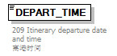
properties
  isRef | 0
annotation
  documentation
  209 Itinerary departure date and time
  离港时间

element GHLG/FLIGHT_DATE
diagram | 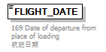
properties
  isRef | 0
annotation
  documentation
  169 Date of departure from place of loading
  航班日期

element GHLG/FROM_PORT
diagram | 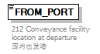
properties
  isRef | 0
annotation
  documentation
  212 Conveyance facility location at departure
  国内出发港

element GHLG/TO_PORT
diagram | 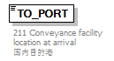
properties
  isRef | 0
annotation
  documentation
  211 Conveyance facility location at arrival
  国内目的港

element GHLG/MEMO
diagram | 
properties
  isRef | 0
annotation
  documentation
  105 Free text
  备注

element GHLG/DECLARE_TIME
diagram | 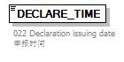
properties
  isRef | 0
annotation
  documentation
  022 Declaration issuing date
  申报时间

complexType Head
diagram | 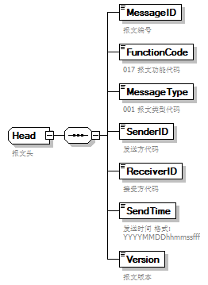
children | MessageID FunctionCode MessageType SenderID ReceiverID SendTime Version
used by
  element | Message/MessageHead
annotation
  documentation
  报文头

element Head/MessageID
diagram | 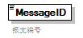
properties
  isRef | 0
annotation
  documentation
  报文编号

element Head/FunctionCode
diagram | 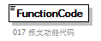
properties
  isRef | 0
annotation
  documentation
  017 报文功能代码

element Head/MessageType
diagram | 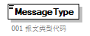
properties
  isRef | 0
annotation
  documentation
  001 报文类型代码

element Head/SenderID
diagram | 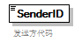
properties
  isRef | 0
annotation
  documentation
  发送方代码

element Head/ReceiverID
diagram | 
properties
  isRef | 0
annotation
  documentation
  接受方代码

element Head/SendTime
diagram | 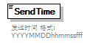
properties
  isRef | 0
annotation
  documentation
  发送时间 格式:YYYYMMDDhhmmssfff

element Head/Version
diagram | 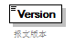
properties
  isRef | 0
annotation
  documentation
  报文版本

complexType TradeTerm
diagram | 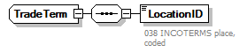
children | LocationID

element TradeTerm/LocationID
diagram | 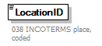
properties
  isRef | 0
annotation
  documentation
  038 INCOTERMS place, coded

complexType UnloadingLocation
diagram | 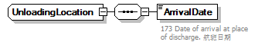
children | ArrivalDate

element UnloadingLocation/ArrivalDate
diagram | 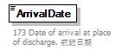
properties
  isRef | 0
annotation
  documentation
  173 Date of arrival at place of discharge. 航班日期

