中国海关航班备案报文结构定义

一、XML报文示例
<?xml version="1.0" encoding="UTF-8"?>
<Message xmlns="urn:Declaration:datamodel:standard:CN:CAM002:1" xmlns:xsi="http://www.w3.org/2001/XMLSchema-instance" >
<MessageHead>
<MessageID/>
<FunctionCode/>
<MessageType/>
<SenderID/>
<ReceiverID/>
<SendTime/>
<Version/>
</MessageHead>
<MessageBody>
<Declaration>
<FRRecord>
<AIRWAYS_NAME_EN/>
<AIRWAYS_NAME_CN/>
<AIRWAYS_CODE/>
<AIRLINE_APPROVAL/>
<FLIGHT_NO/>
<MISSION_TYPE/>
<FLIGHT_TYPE/>
<AIRLINE>
<SERIAL_NO/>
<FROM_AIRPORT/>
<TO_AIRPORT/>
<TIME_CONSUMING/>
<FLIGHT_PLAN>
<STD/>
<STA/>
<EFF_START_DATE/>
<EFF_END_DATE/>
<PLAN/>
</FLIGHT_PLAN>
</AIRLINE>
<MEMO/>
<DECLARE_TIME/>
</FRRecord>
</Declaration>
</MessageBody>
</Message>

二、报文结构

1______Message
1 |______MessageHead
1 | |______MessageID
1 | |______FunctionCode
1 | |______MessageType
1 | |______SenderID
1 | |______ReceiverID
1 | |______SendTime
1 | |______Version
1 |______MessageBody
1 | |______Declaration
1 | | |______FRRecord
1 | | | |______AIRWAYS_NAME_EN
1 | | | |______AIRWAYS_NAME_CN
1 | | | |______AIRWAYS_CODE
1 | | | |______AIRLINE_APPROVAL
1 | | | |______FLIGHT_NO
1 | | | |______MISSION_TYPE
1 | | | |______FLIGHT_TYPE
100 | | | |______AIRLINE
1 | | | | |______SERIAL_NO
1 | | | | |______FROM_AIRPORT
1 | | | | |______TO_AIRPORT
1 | | | | |______TIME_CONSUMING
1 | | | | |______FLIGHT_PLAN
1 | | | | | |______STD
1 | | | | | |______STA
1 | | | | | |______EFF_START_DATE
1 | | | | | |______EFF_END_DATE
1 | | | | | |______PLAN
1 | | | |______MEMO
1 | | | |______DECLARE_TIME

三、报文节点详细说明
element Message
diagram | 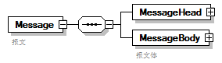
properties
  content | complex
children | MessageHead MessageBody
annotation
  documentation
  报文

element Message/MessageHead
diagram | 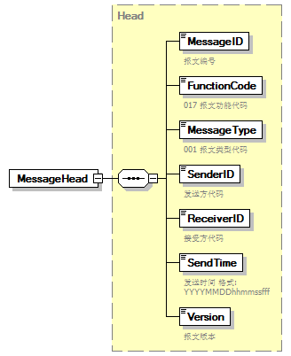
type | Head
properties
  isRef | 0
  content | complex
children | MessageID FunctionCode MessageType SenderID ReceiverID SendTime Version

element Message/MessageBody
diagram | 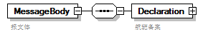
properties
  isRef | 0
  content | complex
children | Declaration
annotation
  documentation
  报文体

element Message/MessageBody/Declaration
diagram | 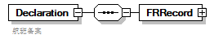
properties
  isRef | 0
  content | complex
children | FRRecord
annotation
  documentation
  航班备案

element Message/MessageBody/Declaration/FRRecord
diagram | 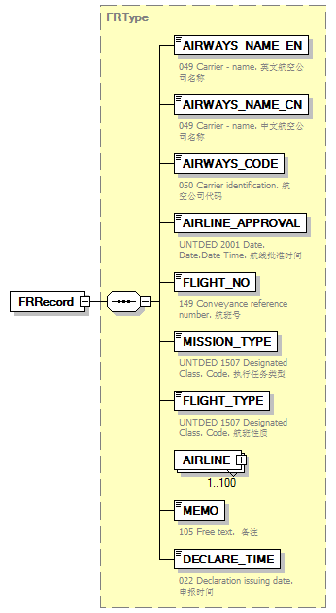
type | FRType
properties
  isRef | 0
  content | complex
children | AIRWAYS_NAME_EN AIRWAYS_NAME_CN AIRWAYS_CODE AIRLINE_APPROVAL FLIGHT_NO MISSION_TYPE FLIGHT_TYPE AIRLINE MEMO DECLARE_TIME

complexType AdditionalInformation
diagram | 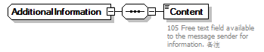
children | Content

element AdditionalInformation/Content
diagram | 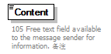
properties
  isRef | 0
annotation
  documentation
  105 Free text field available to the message sender for information. 备注

complexType ArrivalConveyanceFacility
diagram | 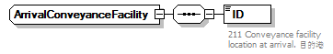
children | ID

element ArrivalConveyanceFacility/ID
diagram | 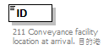
properties
  isRef | 0
annotation
  documentation
  211 Conveyance facility location at arrival. 目的港

complexType Contact
diagram | 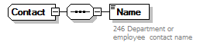
children | Name

element Contact/Name
diagram | 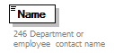
properties
  isRef | 0
annotation
  documentation
  246 Department or employee contact name

complexType DepartureConveyanceFacility
diagram | 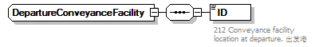
children | ID

element DepartureConveyanceFacility/ID
diagram | 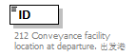
properties
  isRef | 0
annotation
  documentation
  212 Conveyance facility location at departure. 出发港

complexType FRType
diagram | 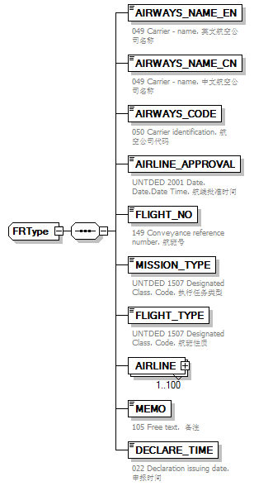
children | AIRWAYS_NAME_EN AIRWAYS_NAME_CN AIRWAYS_CODE AIRLINE_APPROVAL FLIGHT_NO MISSION_TYPE FLIGHT_TYPE AIRLINE MEMO DECLARE_TIME
used by
  element | Message/MessageBody/Declaration/FRRecord

element FRType/AIRWAYS_NAME_EN
diagram | 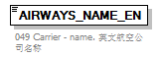
properties
  isRef | 0
annotation
  documentation
  049 Carrier - name. 英文航空公司名称

element FRType/AIRWAYS_NAME_CN
diagram | 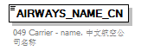
properties
  isRef | 0
annotation
  documentation
  049 Carrier - name. 中文航空公司名称

element FRType/AIRWAYS_CODE
diagram | 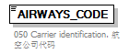
properties
  isRef | 0
annotation
  documentation
  050 Carrier identification. 航空公司代码

element FRType/AIRLINE_APPROVAL
diagram | 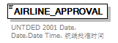
properties
  isRef | 0
annotation
  documentation
  UNTDED 2001 Date. Date.Date Time. 航线批准时间

element FRType/FLIGHT_NO
diagram | 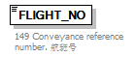
properties
  isRef | 0
annotation
  documentation
  149 Conveyance reference number. 航班号

element FRType/MISSION_TYPE
diagram | 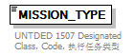
properties
  isRef | 0
annotation
  documentation
  UNTDED 1507 Designated Class. Code. 执行任务类型

element FRType/FLIGHT_TYPE
diagram | 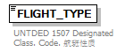
properties
  isRef | 0
annotation
  documentation
  UNTDED 1507 Designated Class. Code. 航班性质

element FRType/AIRLINE
diagram | 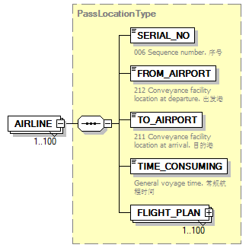
type | PassLocationType
properties
  isRef | 0
  minOcc | 1
  maxOcc | 100
  content | complex
children | SERIAL_NO FROM_AIRPORT TO_AIRPORT TIME_CONSUMING FLIGHT_PLAN

element FRType/MEMO
diagram | 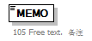
properties
  isRef | 0
annotation
  documentation
  105 Free text. 备注

element FRType/DECLARE_TIME
diagram | 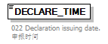
properties
  isRef | 0
annotation
  documentation
  022 Declaration issuing date. 申报时间

complexType Head
diagram | 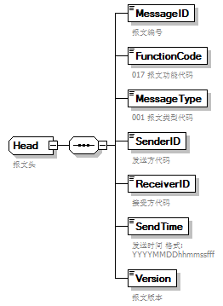
children | MessageID FunctionCode MessageType SenderID ReceiverID SendTime Version
used by
  element | Message/MessageHead
annotation
  documentation
  报文头

element Head/MessageID
diagram | 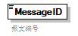
properties
  isRef | 0
annotation
  documentation
  报文编号

element Head/FunctionCode
diagram | 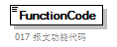
properties
  isRef | 0
annotation
  documentation
  017 报文功能代码

element Head/MessageType
diagram | 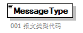
properties
  isRef | 0
annotation
  documentation
  001 报文类型代码

element Head/SenderID
diagram | 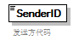
properties
  isRef | 0
annotation
  documentation
  发送方代码

element Head/ReceiverID
diagram | 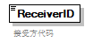
properties
  isRef | 0
annotation
  documentation
  接受方代码

element Head/SendTime
diagram | 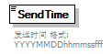
properties
  isRef | 0
annotation
  documentation
  发送时间 格式:YYYYMMDDhhmmssfff

element Head/Version
diagram | 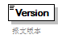
properties
  isRef | 0
annotation
  documentation
  报文版本

complexType PassLocationType
diagram | 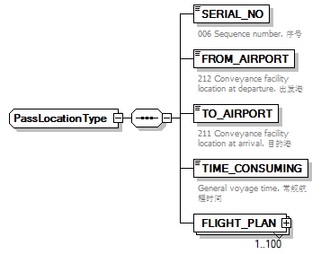
children | SERIAL_NO FROM_AIRPORT TO_AIRPORT TIME_CONSUMING FLIGHT_PLAN
used by
  element | FRType/AIRLINE

element PassLocationType/SERIAL_NO
diagram | 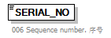
properties
  isRef | 0
annotation
  documentation
  006 Sequence number. 序号

element PassLocationType/FROM_AIRPORT
diagram | 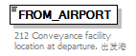
properties
  isRef | 0
annotation
  documentation
  212 Conveyance facility location at departure. 出发港

element PassLocationType/TO_AIRPORT
diagram | 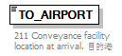
properties
  isRef | 0
annotation
  documentation
  211 Conveyance facility location at arrival. 目的港

element PassLocationType/TIME_CONSUMING
diagram | 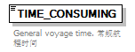
properties
  isRef | 0
annotation
  documentation
  General voyage time. 常规航程时间

element PassLocationType/FLIGHT_PLAN
diagram | 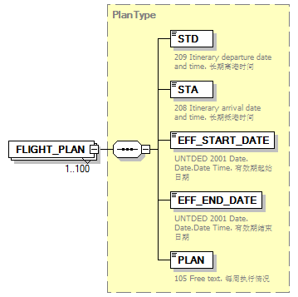
type | PlanType
properties
  isRef | 0
  minOcc | 1
  maxOcc | 100
  content | complex
children | STD STA EFF_START_DATE EFF_END_DATE PLAN

complexType PlanType
diagram | 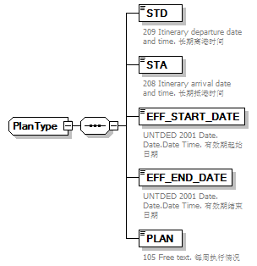
children | STD STA EFF_START_DATE EFF_END_DATE PLAN
used by
  element | PassLocationType/FLIGHT_PLAN

element PlanType/STD
diagram | 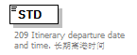
properties
  isRef | 0
annotation
  documentation
  209 Itinerary departure date and time. 长期离港时间

element PlanType/STA
diagram | 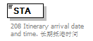
properties
  isRef | 0
annotation
  documentation
  208 Itinerary arrival date and time. 长期抵港时间

element PlanType/EFF_START_DATE
diagram | 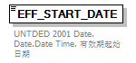
properties
  isRef | 0
annotation
  documentation
  UNTDED 2001 Date. Date.Date Time. 有效期起始日期

element PlanType/EFF_END_DATE
diagram | 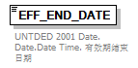
properties
  isRef | 0
annotation
  documentation
  UNTDED 2001 Date. Date.Date Time. 有效期结束日期

element PlanType/PLAN
diagram | 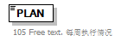
properties
  isRef | 0
annotation
  documentation
  105 Free text. 每周执行情况

complexType TradeTerm
diagram | 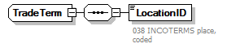
children | LocationID

element TradeTerm/LocationID
diagram | 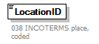
properties
  isRef | 0
annotation
  documentation
  038 INCOTERMS place, coded

complexType UnloadingLocation
diagram | 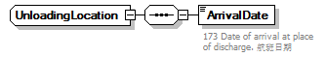
children | ArrivalDate

element UnloadingLocation/ArrivalDate
diagram | 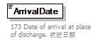
properties
  isRef | 0
annotation
  documentation
  173 Date of arrival at place of discharge. 航班日期

