中国海关空运转关信息清单报文结构定义

一、XML报文实例
<?xml version="1.0" encoding="UTF-8"?>
<Message xmlns="urn:Declaration:datamodel:standard:CN:CAM009:1">
<MessageHead>
<MessageID/>
<FunctionCode/>
<MessageType/>
<SenderID/>
<ReceiverID/>
<SendTime/>
<Version/>
</MessageHead>
<MessageBody>
<Declaration>
<ZGHW>
<HEADER>
<FLIGHT_NO/>
<AIRWAYS_CODE/>
<AIRCRAFT_AGENT/>
<FLIGHT_DATE/>
<DOMESTIC_SOURCE/>
<DOMESTIC_DESTINATION/>
<DEPART_DATE/>
<ARRIVE_DATE/>
<DECLARE_TIME/>
<MEMO/>
</HEADER>
<GOODS_LIST>
<I_E_FLIGHT/>
<BILL_NO/>
<GOODS_NUM/>
<GOODS_WEIGHT/>
<MEMO/>
</GOODS_LIST>
<PASSENGER_LIST>
<SERIAL_NO/>
<NAME/>
<GENDER/>
<NATIONALITY/>
<CERT_TYPE/>
<CERT_NO/>
</PASSENGER_LIST>
<CREW_LIST>
<SERIAL_NO/>
<NAME/>
<GENDER/>
<NATIONALITY/>
<CAREER/>
<BIRTHDAY/>
<CERT_TYPE/>
<CERT_NO/>
<MEMO/>
</CREW_LIST>
</ZGHW>
</Declaration>
</MessageBody>
</Message>

二、报文结构
1______Message
1 |______MessageHead
1 | |______MessageID
1 | |______FunctionCode
1 | |______MessageType
1 | |______SenderID
1 | |______ReceiverID
1 | |______SendTime
1 | |______Version
1 |______MessageBody
1 | |______Declaration
1 | | |______ZGHW
1 | | | |______HEADER
1 | | | | |______FLIGHT_NO
1 | | | | |______AIRWAYS_CODE
1 | | | | |______AIRCRAFT_AGENT
1 | | | | |______FLIGHT_DATE
1 | | | | |______DOMESTIC_SOURCE
1 | | | | |______DOMESTIC_DESTINATION
1 | | | | |______DEPART_DATE
1 | | | | |______ARRIVE_DATE
1 | | | | |______DECLARE_TIME
1 | | | | |______MEMO
9999 | | | |______GOODS_LIST
1 | | | | |______I_E_FLIGHT
1 | | | | |______BILL_NO
1 | | | | |______GOODS_NUM
1 | | | | |______GOODS_WEIGHT
1 | | | | |______MEMO
9999 | | | |______PASSENGER_LIST
1 | | | | |______SERIAL_NO
1 | | | | |______NAME
1 | | | | |______GENDER
1 | | | | |______NATIONALITY
1 | | | | |______CERT_TYPE
1 | | | | |______CERT_NO
9999 | | | |______CREW_LIST
1 | | | | |______SERIAL_NO
1 | | | | |______NAME
1 | | | | |______GENDER
1 | | | | |______NATIONALITY
1 | | | | |______CAREER
1 | | | | |______BIRTHDAY
1 | | | | |______CERT_TYPE
1 | | | | |______CERT_NO
1 | | | | |______MEMO

三、报文节点详细说明
element Message
diagram | 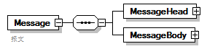
properties
  content | complex
children | MessageHead MessageBody
annotation
  documentation
  报文

element Message/MessageHead
diagram | 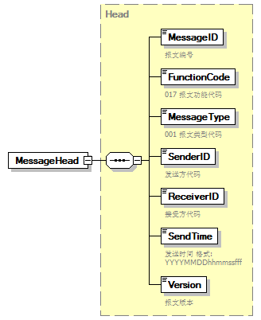
type | Head
properties
  isRef | 0
  content | complex
children | MessageID FunctionCode MessageType SenderID ReceiverID SendTime Version

element Message/MessageBody
diagram | 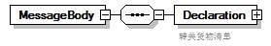
properties
  isRef | 0
  content | complex
children | Declaration

element Message/MessageBody/Declaration
diagram | 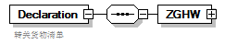
properties
  isRef | 0
  content | complex
children | ZGHW
annotation
  documentation
  转关货物清单

element Message/MessageBody/Declaration/ZGHW
diagram | 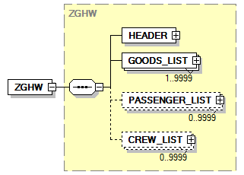
type | ZGHW
properties
  isRef | 0
  content | complex
children | HEADER GOODS_LIST PASSENGER_LIST CREW_LIST

complexType AdditionalInformation
diagram | 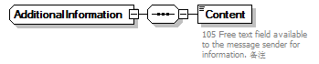
children | Content

element AdditionalInformation/Content
diagram | 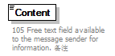
properties
  isRef | 0
annotation
  documentation
  105 Free text field available to the message sender for information. 备注

complexType ArrivalConveyanceFacility
diagram | 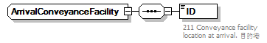
children | ID

element ArrivalConveyanceFacility/ID
diagram | 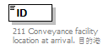
properties
  isRef | 0
annotation
  documentation
  211 Conveyance facility location at arrival. 目的港

complexType Contact
diagram | 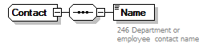
children | Name

element Contact/Name
diagram | 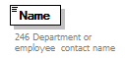
properties
  isRef | 0
annotation
  documentation
  246 Department or employee contact name

complexType DepartureConveyanceFacility
diagram | 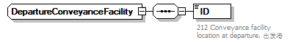
children | ID

element DepartureConveyanceFacility/ID
diagram | 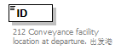
properties
  isRef | 0
annotation
  documentation
  212 Conveyance facility location at departure. 出发港

complexType Head
diagram | 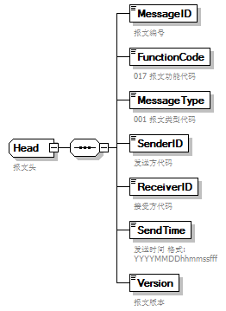
children | MessageID FunctionCode MessageType SenderID ReceiverID SendTime Version
used by
  element | Message/MessageHead
annotation
  documentation
  报文头

element Head/MessageID
diagram | 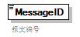
properties
  isRef | 0
annotation
  documentation
  报文编号

element Head/FunctionCode
diagram | 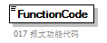
properties
  isRef | 0
annotation
  documentation
  017 报文功能代码

element Head/MessageType
diagram | 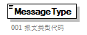
properties
  isRef | 0
annotation
  documentation
  001 报文类型代码

element Head/SenderID
diagram | 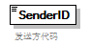
properties
  isRef | 0
annotation
  documentation
  发送方代码

element Head/ReceiverID
diagram | 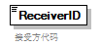
properties
  isRef | 0
annotation
  documentation
  接受方代码

element Head/SendTime
diagram | 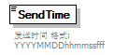
properties
  isRef | 0
annotation
  documentation
  发送时间 格式:YYYYMMDDhhmmssfff

element Head/Version
diagram | 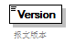
properties
  isRef | 0
annotation
  documentation
  报文版本

complexType TradeTerm
diagram | 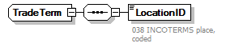
children | LocationID

element TradeTerm/LocationID
diagram | 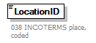
properties
  isRef | 0
annotation
  documentation
  038 INCOTERMS place, coded

complexType UnloadingLocation
diagram | 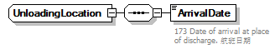
children | ArrivalDate

element UnloadingLocation/ArrivalDate
diagram | 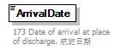
properties
  isRef | 0
annotation
  documentation
  173 Date of arrival at place of discharge. 航班日期

complexType ZGHW
diagram | 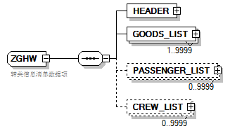
children | HEADER GOODS_LIST PASSENGER_LIST CREW_LIST
used by
  element | Message/MessageBody/Declaration/ZGHW
annotation
  documentation
  转关信息清单数据项

element ZGHW/HEADER
diagram | 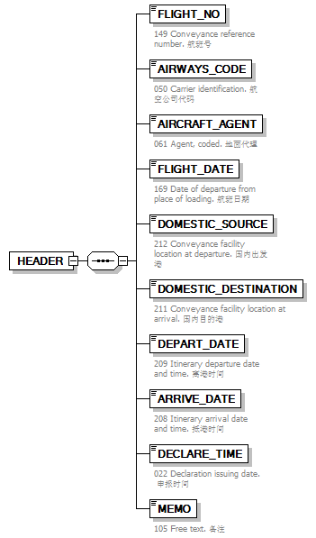
properties
  isRef | 0
  content | complex
children | FLIGHT_NO AIRWAYS_CODE AIRCRAFT_AGENT FLIGHT_DATE DOMESTIC_SOURCE DOMESTIC_DESTINATION DEPART_DATE ARRIVE_DATE DECLARE_TIME MEMO

element ZGHW/HEADER/FLIGHT_NO
diagram | 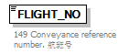
properties
  isRef | 0
annotation
  documentation
  149 Conveyance reference number. 航班号

element ZGHW/HEADER/AIRWAYS_CODE
diagram | 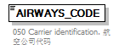
properties
  isRef | 0
annotation
  documentation
  050 Carrier identification. 航空公司代码

element ZGHW/HEADER/AIRCRAFT_AGENT
diagram | 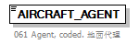
properties
  isRef | 0
annotation
  documentation
  061 Agent, coded. 地面代理

element ZGHW/HEADER/FLIGHT_DATE
diagram | 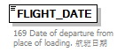
properties
  isRef | 0
annotation
  documentation
  169 Date of departure from place of loading. 航班日期

element ZGHW/HEADER/DOMESTIC_SOURCE
diagram | 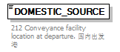
properties
  isRef | 0
annotation
  documentation
  212 Conveyance facility location at departure. 国内出发港

element ZGHW/HEADER/DOMESTIC_DESTINATION
diagram | 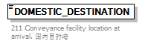
properties
  isRef | 0
annotation
  documentation
  211 Conveyance facility location at arrival. 国内目的港

element ZGHW/HEADER/DEPART_DATE
diagram | 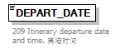
properties
  isRef | 0
annotation
  documentation
  209 Itinerary departure date and time. 离港时间

element ZGHW/HEADER/ARRIVE_DATE
diagram | 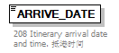
properties
  isRef | 0
annotation
  documentation
  208 Itinerary arrival date and time. 抵港时间

element ZGHW/HEADER/DECLARE_TIME
diagram | 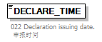
properties
  isRef | 0
annotation
  documentation
  022 Declaration issuing date. 申报时间

element ZGHW/HEADER/MEMO
diagram | 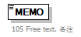
properties
  isRef | 0
annotation
  documentation
  105 Free text. 备注

element ZGHW/GOODS_LIST
diagram | 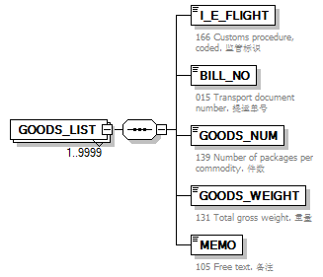
properties
  isRef | 0
  minOcc | 1
  maxOcc | 9999
  content | complex
children | I_E_FLIGHT BILL_NO GOODS_NUM GOODS_WEIGHT MEMO

element ZGHW/GOODS_LIST/I_E_FLIGHT
diagram | 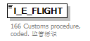
properties
  isRef | 0
annotation
  documentation
  166 Customs procedure, coded. 监管标识

element ZGHW/GOODS_LIST/BILL_NO
diagram | 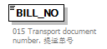
properties
  isRef | 0
annotation
  documentation
  015 Transport document number. 提运单号

element ZGHW/GOODS_LIST/GOODS_NUM
diagram | 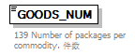
properties
  isRef | 0
annotation
  documentation
  139 Number of packages per commodity. 件数

element ZGHW/GOODS_LIST/GOODS_WEIGHT
diagram | 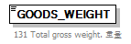
properties
  isRef | 0
annotation
  documentation
  131 Total gross weight. 重量

element ZGHW/GOODS_LIST/MEMO
diagram
properties
  isRef | 0
annotation
  documentation
  105 Free text. 备注

element ZGHW/PASSENGER_LIST
diagram | 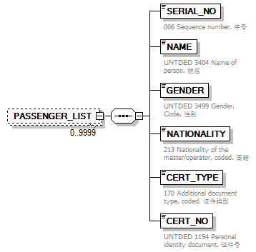
properties
  isRef | 0
  minOcc | 0
  maxOcc | 9999
  content | complex
children | SERIAL_NO NAME GENDER NATIONALITY CERT_TYPE CERT_NO

element ZGHW/PASSENGER_LIST/SERIAL_NO
diagram | 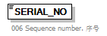
properties
  isRef | 0
annotation
  documentation
  006 Sequence number. 序号

element ZGHW/PASSENGER_LIST/NAME
diagram | 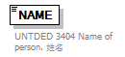
properties
  isRef | 0
annotation
  documentation
  UNTDED 3404 Name of person. 姓名

element ZGHW/PASSENGER_LIST/GENDER
diagram | 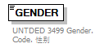
properties
  isRef | 0
annotation
  documentation
  UNTDED 3499 Gender. Code. 性别

element ZGHW/PASSENGER_LIST/NATIONALITY
diagram | 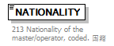
properties
  isRef | 0
annotation
  documentation
  213 Nationality of the master/operator, coded. 国籍

element ZGHW/PASSENGER_LIST/CERT_TYPE
diagram | 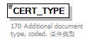
properties
  isRef | 0
annotation
  documentation
  170 Additional document type, coded. 证件类型

element ZGHW/PASSENGER_LIST/CERT_NO
diagram | 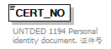
properties
  isRef | 0
annotation
  documentation
  UNTDED 1194 Personal identity document. 证件号

element ZGHW/CREW_LIST
diagram | 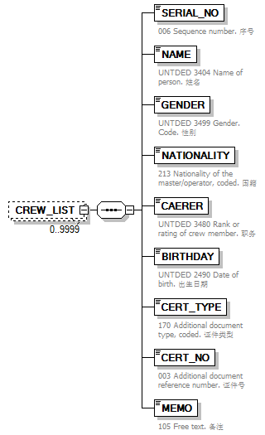
properties
  isRef | 0
  minOcc | 0
  maxOcc | 9999
  content | complex
children | SERIAL_NO NAME GENDER NATIONALITY CAREER BIRTHDAY CERT_TYPE CERT_NO MEMO

element ZGHW/CREW_LIST/SERIAL_NO
diagram
properties
  isRef | 0
annotation
  documentation
  006 Sequence number. 序号

element ZGHW/CREW_LIST/NAME
diagram
properties
  isRef | 0
annotation
  documentation
  UNTDED 3404 Name of person. 姓名

element ZGHW/CREW_LIST/GENDER
diagram
properties
  isRef | 0
annotation
  documentation
  UNTDED 3499 Gender. Code. 性别

element ZGHW/CREW_LIST/NATIONALITY
diagram
properties
  isRef | 0
annotation
  documentation
  213 Nationality of the master/operator, coded. 国籍

element ZGHW/CREW_LIST/CAREER
diagram | 
properties
  isRef | 0
annotation
  documentation
  UNTDED 3480 Rank or rating of crew member. 职务

element ZGHW/CREW_LIST/BIRTHDAY
diagram | 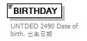
properties
  isRef | 0
annotation
  documentation
  UNTDED 2490 Date of birth. 出生日期

element ZGHW/CREW_LIST/CERT_TYPE
diagram
properties
  isRef | 0
annotation
  documentation
  170 Additional document type, coded. 证件类型

element ZGHW/CREW_LIST/CERT_NO
diagram | 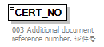
properties
  isRef | 0
annotation
  documentation
  003 Additional document reference number. 证件号

element ZGHW/CREW_LIST/MEMO
diagram
properties
  isRef | 0
annotation
  documentation
  105 Free text. 备注

