中国海关空运进出基本单据报文结构定义

一、XML报文实例
<?xml version="1.0" encoding="UTF-8"?>
<Message xmlns="urn:Declaration:datamodel:standard:CN:CAM102:1" xmlns:xsi="http://www.w3.org/2001/XMLSchema-instance" >
<MessageHead>
<MessageID>String</MessageID>
<FunctionCode>String</FunctionCode>
<MessageType>CAM001</MessageType>
<SenderID>String</SenderID>
<ReceiverID>String</ReceiverID>
<SendTime>10000101000000+00</SendTime>
<Version>1.0</Version>
</MessageHead>
<MessageBody>
<Declaration>
<Head>
<AIRCRAFT_NO>String</AIRCRAFT_NO>
<AIRCRAFT_AGENT>String</AIRCRAFT_AGENT>
<AIRCREW_LIST>
<SERIAL_NO>0</SERIAL_NO>
<NAME>String</NAME>
<GENDER>M</GENDER>
<NATIONALITY>String</NATIONALITY>
<CAREER>String</CAREER>
<BIRTHDAY>10000101</BIRTHDAY>
<CERT_TYPE>Str</CERT_TYPE>
<CERT_NO>String</CERT_NO>
<MEMO>String</MEMO>
</AIRCREW_LIST>
<FLIGHT_NO>String</FLIGHT_NO>
<FLIGHT_DATE>10000101</FLIGHT_DATE>
<I_E_FLAG>I</I_E_FLAG>
<AIRCREW_SUM>0</AIRCREW_SUM>
<INTER_PASSENGER_SUM>0</INTER_PASSENGER_SUM>
<LOCALE_PASSENGER_SUM>0</LOCALE_PASSENGER_SUM>
<INTER_BAGGAGE_NUM>2147483647</INTER_BAGGAGE_NUM>
<LOCALE_BAGGAGE_NUM>2147483647</LOCALE_BAGGAGE_NUM>
<GOODS_QUANTITY>3.1415926535897932384626433832795</GOODS_QUANTITY>
<GOODS_NUM>2147483647</GOODS_NUM>
<TAKEOFF_TIME>100001010000+00</TAKEOFF_TIME>
<AIRPORT>String</AIRPORT>
<I_E_TIME>100001010000+00</I_E_TIME>
<ARRIVAL_POSITION>String</ARRIVAL_POSITION>
<MEMO>String</MEMO>
<DECLARE_TIME>10000101</DECLARE_TIME>
</Head>
</Declaration>
</MessageBody>
</Message>

二、报文结构
1______Message
1 |______MessageHead
1 | |______MessageID
1 | |______FunctionCode
1 | |______MessageType
1 | |______SenderID
1 | |______ReceiverID
1 | |______SendTime
1 | |______Version
1 |______MessageBody
1 | |______Declaration
1 | | |______Head
1 | | | |______AIRCRAFT_NO
1 | | | |______AIRCRAFT_AGENT
9999 | | | |______AIRCREW_LIST
1 | | | | |______SERIAL_NO
1 | | | | |______NAME
1 | | | | |______GENDER
1 | | | | |______NATIONALITY
1 | | | | |______CAREER
1 | | | | |______BIRTHDAY
1 | | | | |______CERT_TYPE
1 | | | | |______CERT_NO
1 | | | | |______MEMO
1 | | | |______FLIGHT_NO
1 | | | |______FLIGHT_DATE
1 | | | |______I_E_FLAG
1 | | | |______AIRCREW_SUM
1 | | | |______INTER_PASSENGER_SUM
1 | | | |______LOCALE_PASSENGER_SUM
1 | | | |______INTER_BAGGAGE_NUM
1 | | | |______LOCALE_BAGGAGE_NUM
1 | | | |______GOODS_QUANTITY
1 | | | |______GOODS_NUM
1 | | | |______TAKEOFF_TIME
1 | | | |______AIRPORT
1 | | | |______I_E_TIME
1 | | | |______ARRIVAL_POSITION
1 | | | |______MEMO
1 | | | |______DECLARE_TIME

三、报文节点详细说明

element Message
diagram | 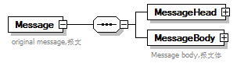
properties
  content | complex
children | MessageHead MessageBody
annotation
  documentation
  original message,报文

element Message/MessageHead
diagram | 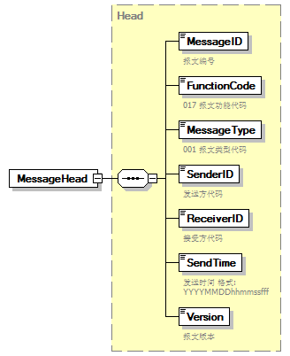
type | Head
properties
  isRef | 0
  content | complex
children | MessageID FunctionCode MessageType SenderID ReceiverID SendTime Version

element Message/MessageBody
diagram | 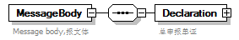
properties
  isRef | 0
  content | complex
children | Declaration
annotation
  documentation
  Message body,报文体

element Message/MessageBody/Declaration
diagram | 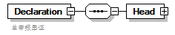
properties
  isRef | 0
  content | complex
children | Head
annotation
  documentation
  总申报单证

element Message/MessageBody/Declaration/Head
diagram | 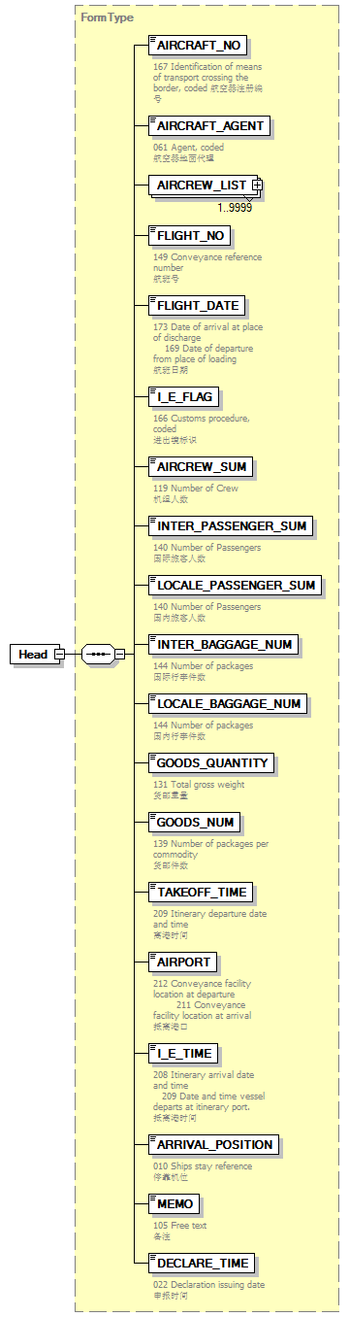
type | FormType
properties
  isRef | 0
  content | complex
children | AIRCRAFT_NO AIRCRAFT_AGENT AIRCREW_LIST FLIGHT_NO FLIGHT_DATE I_E_FLAG AIRCREW_SUM INTER_PASSENGER_SUM LOCALE_PASSENGER_SUM INTER_BAGGAGE_NUM LOCALE_BAGGAGE_NUM GOODS_QUANTITY GOODS_NUM TAKEOFF_TIME AIRPORT I_E_TIME ARRIVAL_POSITION MEMO DECLARE_TIME

complexType AdditionalInformation
diagram | 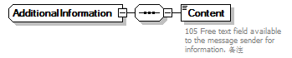
children | Content

element AdditionalInformation/Content
diagram | 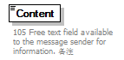
properties
  isRef | 0
annotation
  documentation
  105 Free text field available to the message sender for information. 备注

complexType AirCrewType
diagram | 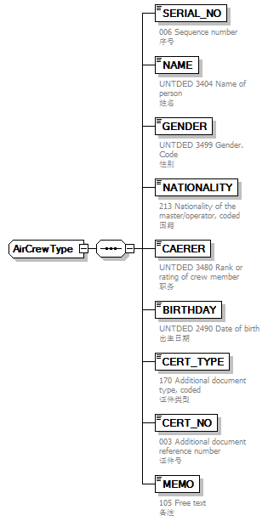
children | SERIAL_NO NAME GENDER NATIONALITY CAREER BIRTHDAY CERT_TYPE CERT_NO MEMO
used by
  element | FormType/AIRCREW_LIST

element AirCrewType/SERIAL_NO
diagram | 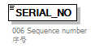
properties
  isRef | 0
annotation
  documentation
  006 Sequence number
  序号

element AirCrewType/NAME
diagram | 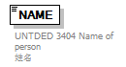
properties
  isRef | 0
annotation
  documentation
  UNTDED 3404 Name of person
  姓名

element AirCrewType/GENDER
diagram | 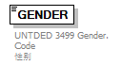
properties
  isRef | 0
annotation
  documentation
  UNTDED 3499 Gender. Code
  性别

element AirCrewType/NATIONALITY
diagram | 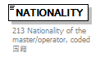
properties
  isRef | 0
annotation
  documentation
  213 Nationality of the master/operator, coded
  国籍

element AirCrewType/CAREER
diagram | 
properties
  isRef | 0
annotation
  documentation
  UNTDED 3480 Rank or rating of crew member
  职务

element AirCrewType/BIRTHDAY
diagram | 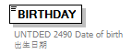
properties
  isRef | 0
annotation
  documentation
  UNTDED 2490 Date of birth
  出生日期

element AirCrewType/CERT_TYPE
diagram | 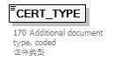
properties
  isRef | 0
annotation
  documentation
  170 Additional document type, coded
  证件类型

element AirCrewType/CERT_NO
diagram | 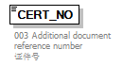
properties
  isRef | 0
annotation
  documentation
  003 Additional document reference number
  证件号

element AirCrewType/MEMO
diagram | 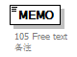
properties
  isRef | 0
annotation
  documentation
  105 Free text
  备注

complexType ArrivalConveyanceFacility
diagram | 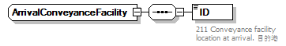
children | ID

element ArrivalConveyanceFacility/ID
diagram | 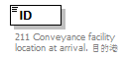
properties
  isRef | 0
annotation
  documentation
  211 Conveyance facility location at arrival. 目的港

complexType Contact
diagram | 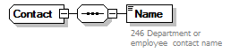
children | Name

element Contact/Name
diagram | 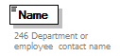
properties
  isRef | 0
annotation
  documentation
  246 Department or employee contact name

complexType DepartureConveyanceFacility
diagram | 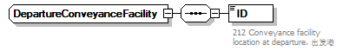
children | ID

element DepartureConveyanceFacility/ID
diagram | 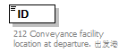
properties
  isRef | 0
annotation
  documentation
  212 Conveyance facility location at departure. 出发港

complexType FormType
diagram | 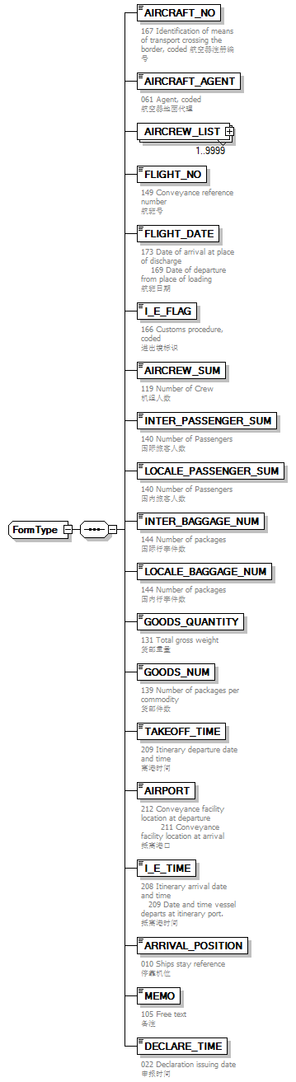
children | AIRCRAFT_NO AIRCRAFT_AGENT AIRCREW_LIST FLIGHT_NO FLIGHT_DATE I_E_FLAG AIRCREW_SUM INTER_PASSENGER_SUM LOCALE_PASSENGER_SUM INTER_BAGGAGE_NUM LOCALE_BAGGAGE_NUM GOODS_QUANTITY GOODS_NUM TAKEOFF_TIME AIRPORT I_E_TIME ARRIVAL_POSITION MEMO DECLARE_TIME
used by
  element | Message/MessageBody/Declaration/Head

element FormType/AIRCRAFT_NO
diagram | 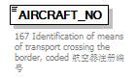
properties
  isRef | 0
annotation
  documentation
  167 Identification of means of transport crossing the border, coded 航空器注册编号

element FormType/AIRCRAFT_AGENT
diagram | 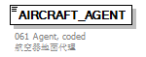
properties
  isRef | 0
annotation
  documentation
  061 Agent, coded
  航空器地面代理

element FormType/AIRCREW_LIST
diagram | 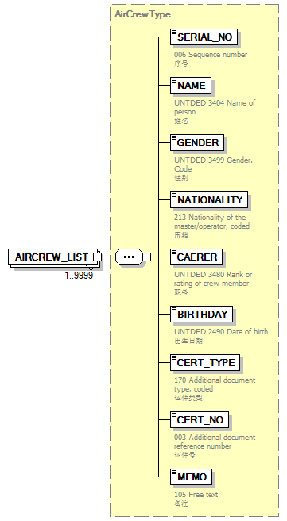
type | AirCrewType
properties
  isRef | 0
  minOcc | 1
  maxOcc | 9999
  content | complex
children | SERIAL_NO NAME GENDER NATIONALITY CAERER BIRTHDAY CERT_TYPE CERT_NO MEMO

element FormType/FLIGHT_NO
diagram | 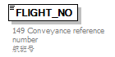
properties
  isRef | 0
annotation
  documentation
  149 Conveyance reference number
  航班号

element FormType/FLIGHT_DATE
diagram | 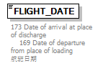
properties
  isRef | 0
annotation
  documentation
  173 Date of arrival at place of discharge 169 Date of departure from place of loading
  航班日期

element FormType/I_E_FLAG
diagram | 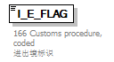
properties
  isRef | 0
annotation
  documentation
  166 Customs procedure, coded
  进出境标识

element FormType/AIRCREW_SUM
diagram | 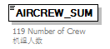
properties
  isRef | 0
annotation
  documentation
  119 Number of Crew
  机组人数

element FormType/INTER_PASSENGER_SUM
diagram | 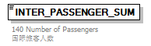
properties
  isRef | 0
annotation
  documentation
  140 Number of Passengers
  国际旅客人数

element FormType/LOCALE_PASSENGER_SUM
diagram | 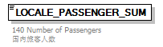
properties
  isRef | 0
annotation
  documentation
  140 Number of Passengers
  国内旅客人数

element FormType/INTER_BAGGAGE_NUM
diagram | 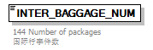
properties
  isRef | 0
annotation
  documentation
  144 Number of packages
  国际行李件数

element FormType/LOCALE_BAGGAGE_NUM
diagram | 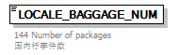
properties
  isRef | 0
annotation
  documentation
  144 Number of packages
  国内行李件数

element FormType/GOODS_QUANTITY
diagram | 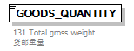
properties
  isRef | 0
annotation
  documentation
  131 Total gross weight
  货邮重量

element FormType/GOODS_NUM
diagram | 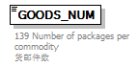
properties
  isRef | 0
annotation
  documentation
  139 Number of packages per commodity
  货邮件数

element FormType/TAKEOFF_TIME
diagram | 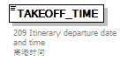
properties
  isRef | 0
annotation
  documentation
  209 Itinerary departure date and time
  离港时间

element FormType/AIRPORT
diagram | 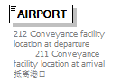
properties
  isRef | 0
annotation
  documentation
  212 Conveyance facility location at departure 211 Conveyance facility location at arrival
  抵离港口

element FormType/I_E_TIME
diagram | 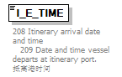
properties
  isRef | 0
annotation
  documentation
  208 Itinerary arrival date and time 209 Date and time vessel departs at itinerary port.
  抵离港时间

element FormType/ARRIVAL_POSITION
diagram | 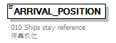
properties
  isRef | 0
annotation
  documentation
  010 Ships stay reference
  停靠机位

element FormType/MEMO
diagram
properties
  isRef | 0
annotation
  documentation
  105 Free text
  备注

element FormType/DECLARE_TIME
diagram | 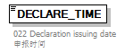
properties
  isRef | 0
annotation
  documentation
  022 Declaration issuing date
  申报时间

complexType Head
diagram | 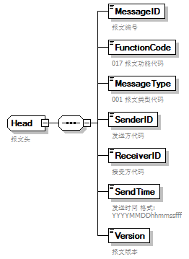
children | MessageID FunctionCode MessageType SenderID ReceiverID SendTime Version
used by
  element | Message/MessageHead
annotation
  documentation
  报文头

element Head/MessageID
diagram | 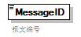
properties
  isRef | 0
annotation
  documentation
  报文编号

element Head/FunctionCode
diagram | 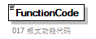
properties
  isRef | 0
annotation
  documentation
  017 报文功能代码

element Head/MessageType
diagram | 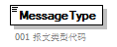
properties
  isRef | 0
annotation
  documentation
  001 报文类型代码

element Head/SenderID
diagram | 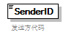
properties
  isRef | 0
annotation
  documentation
  发送方代码

element Head/ReceiverID
diagram | 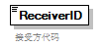
properties
  isRef | 0
annotation
  documentation
  接受方代码

element Head/SendTime
diagram | 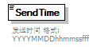
properties
  isRef | 0
annotation
  documentation
  发送时间 格式:YYYYMMDDhhmmssfff

element Head/Version
diagram | 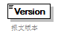
properties
  isRef | 0
annotation
  documentation
  报文版本

complexType TradeTerm
diagram | 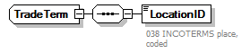
children | LocationID

element TradeTerm/LocationID
diagram | 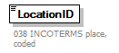
properties
  isRef | 0
annotation
  documentation
  038 INCOTERMS place, coded

complexType UnloadingLocation
diagram | 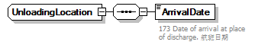
children | ArrivalDate

element UnloadingLocation/ArrivalDate
diagram | 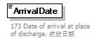
properties
  isRef | 0
annotation
  documentation
  173 Date of arrival at place of discharge. 航班日期

