中国海关飞行计划报文结构定义

一、XML报文实例
<?xml version="1.0" encoding="UTF-8"?>
<Message xmlns="urn:Declaration:datamodel:standard:CN:CAM003:1" xmlns:xsi="http://www.w3.org/2001/XMLSchema-instance" >
<MessageHead>
<MessageID/>
<FunctionCode/>
<MessageType/>
<SenderID/>
<ReceiverID/>
<SendTime/>
<Version/>
</MessageHead>
<MessageBody>
<Declaration>
<flightPlanRecord>
<FLIGHT_NO/>
<FLIGHT_DATE/>
<FROM_AIRPORT/>
<TO_AIRPORT/>
<CURRENT_TAKEOFF_TIME/>
<CURRENT_LANDING_TIME/>
<LINES_TYPE/>
<MEMO/>
<DECLARE_TIME/>
</flightPlanRecord>
</Declaration>
</MessageBody>
</Message>

二、报文结构
1______Message
1 |______MessageHead
1 | |______MessageID
1 | |______FunctionCode
1 | |______MessageType
1 | |______SenderID
1 | |______ReceiverID
1 | |______SendTime
1 | |______Version
1 |______MessageBody
1 | |______Declaration
1 | | |______flightPlanRecord
1 | | | |______FLIGHT_NO
1 | | | |______FLIGHT_DATE
1 | | | |______FROM_AIRPORT
1 | | | |______TO_AIRPORT
1 | | | |______CURRENT_TAKEOFF_TIME
1 | | | |______CURRENT_LANDING_TIME
1 | | | |______LINES_TYPE
1 | | | |______MEMO
1 | | | |______DECLARE_TIME

三、报文节点详细说明
element Message
diagram | 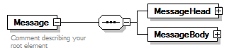
properties
  content | complex
children | MessageHead MessageBody
annotation
  documentation
  Comment describing your root element

element Message/MessageHead
diagram | 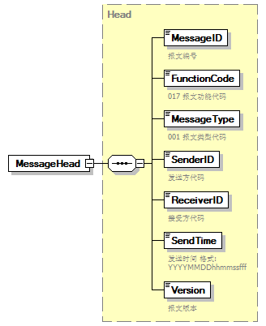
type | Head
properties
  isRef | 0
  content | complex
children | MessageID FunctionCode MessageType SenderID ReceiverID SendTime Version

element Message/MessageBody
diagram | 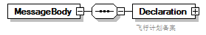
properties
  isRef | 0
  content | complex
children | Declaration

element Message/MessageBody/Declaration
diagram | 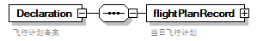
properties
  isRef | 0
  content | complex
children | flightPlanRecord
annotation
  documentation
  飞行计划备案

element Message/MessageBody/Declaration/flightPlanRecord
diagram | 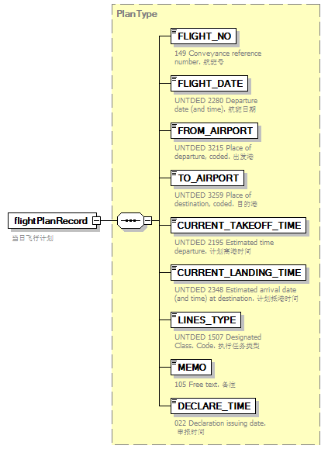
type | PlanType
properties
  isRef | 0
  content | complex
children | FLIGHT_NO FLIGHT_DATE FROM_AIRPORT TO_AIRPORT CURRENT_TAKEOFF_TIME CURRENT_LANDING_TIME LINES_TYPE MEMO DECLARE_TIME
annotation
  documentation
  当日飞行计划

complexType AdditionalInformation
diagram | 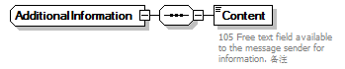
children | Content

element AdditionalInformation/Content
diagram | 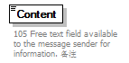
properties
  isRef | 0
annotation
  documentation
  105 Free text field available to the message sender for information. 备注

complexType ArrivalConveyanceFacility
diagram | 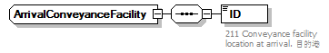
children | ID

element ArrivalConveyanceFacility/ID
diagram | 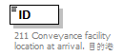
properties
  isRef | 0
annotation
  documentation
  211 Conveyance facility location at arrival. 目的港

complexType Contact
diagram | 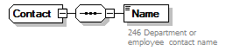
children | Name

element Contact/Name
diagram | 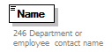
properties
  isRef | 0
annotation
  documentation
  246 Department or employee contact name

complexType DepartureConveyanceFacility
diagram | 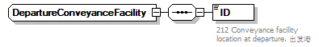
children | ID

element DepartureConveyanceFacility/ID
diagram | 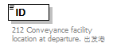
properties
  isRef | 0
annotation
  documentation
  212 Conveyance facility location at departure. 出发港

complexType Head
diagram | 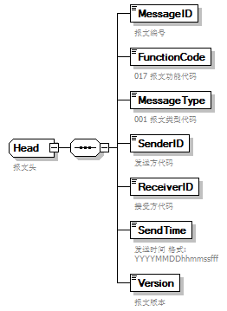
children | MessageID FunctionCode MessageType SenderID ReceiverID SendTime Version
used by
  element | Message/MessageHead
annotation
  documentation
  报文头

element Head/MessageID
diagram | 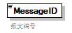
properties
  isRef | 0
annotation
  documentation
  报文编号

element Head/FunctionCode
diagram | 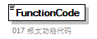
properties
  isRef | 0
annotation
  documentation
  017 报文功能代码

element Head/MessageType
diagram | 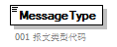
properties
  isRef | 0
annotation
  documentation
  001 报文类型代码

element Head/SenderID
diagram | 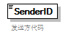
properties
  isRef | 0
annotation
  documentation
  发送方代码

element Head/ReceiverID
diagram | 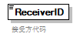
properties
  isRef | 0
annotation
  documentation
  接受方代码

element Head/SendTime
diagram | 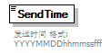
properties
  isRef | 0
annotation
  documentation
  发送时间 格式:YYYYMMDDhhmmssfff

element Head/Version
diagram | 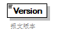
properties
  isRef | 0
annotation
  documentation
  报文版本

complexType PlanType
diagram | 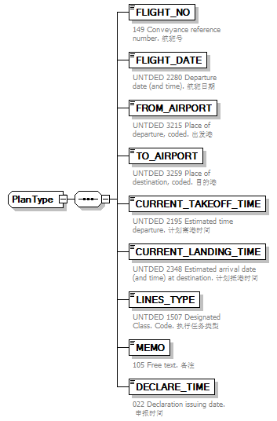
children | FLIGHT_NO FLIGHT_DATE FROM_AIRPORT TO_AIRPORT CURRENT_TAKEOFF_TIME CURRENT_LANDING_TIME LINES_TYPE MEMO DECLARE_TIME
used by
  element | Message/MessageBody/Declaration/flightPlanRecord

element PlanType/FLIGHT_NO
diagram | 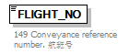
properties
  isRef | 0
annotation
  documentation
  149 Conveyance reference number. 航班号

element PlanType/FLIGHT_DATE
diagram | 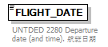
properties
  isRef | 0
annotation
  documentation
  UNTDED 2280 Departure date (and time). 航班日期

element PlanType/FROM_AIRPORT
diagram | 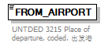
properties
  isRef | 0
annotation
  documentation
  UNTDED 3215 Place of departure, coded. 出发港

element PlanType/TO_AIRPORT
diagram | 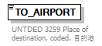
properties
  isRef | 0
annotation
  documentation
  UNTDED 3259 Place of destination, coded. 目的港

element PlanType/CURRENT_TAKEOFF_TIME
diagram | 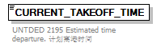
properties
  isRef | 0
annotation
  documentation
  UNTDED 2195 Estimated time departure. 计划离港时间

element PlanType/CURRENT_LANDING_TIME
diagram | 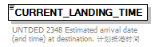
properties
  isRef | 0
annotation
  documentation
  UNTDED 2348 Estimated arrival date (and time) at destination. 计划抵港时间

element PlanType/LINES_TYPE
diagram | 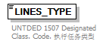
properties
  isRef | 0
annotation
  documentation
  UNTDED 1507 Designated Class. Code. 执行任务类型

element PlanType/MEMO
diagram | 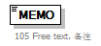
properties
  isRef | 0
annotation
  documentation
  105 Free text. 备注

element PlanType/DECLARE_TIME
diagram | 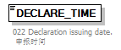
properties
  isRef | 0
annotation
  documentation
  022 Declaration issuing date. 申报时间

complexType TradeTerm
diagram | 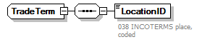
children | LocationID

element TradeTerm/LocationID
diagram | 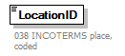
properties
  isRef | 0
annotation
  documentation
  038 INCOTERMS place, coded

complexType UnloadingLocation
diagram | 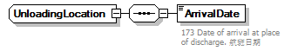
children | ArrivalDate

element UnloadingLocation/ArrivalDate
diagram | 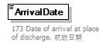
properties
  isRef | 0
annotation
  documentation
  173 Date of arrival at place of discharge. 航班日期

