Class Design

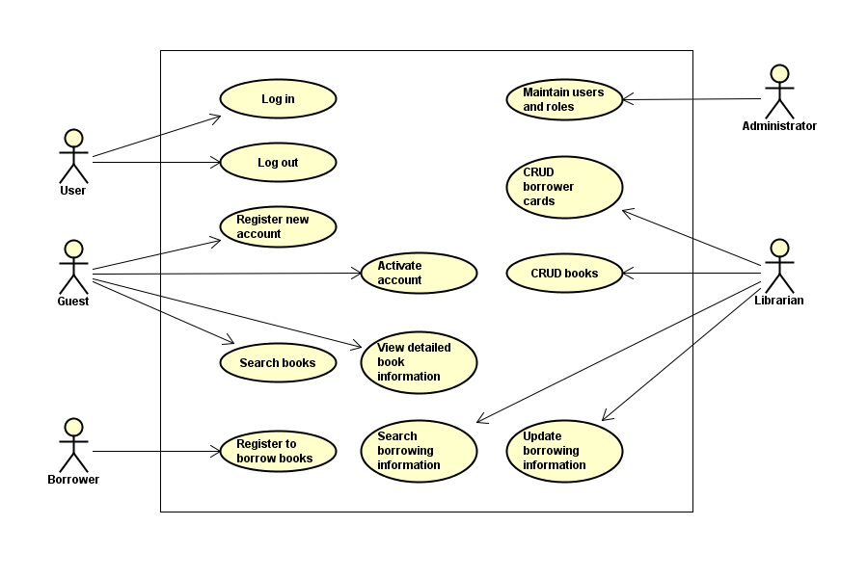1. Analize Classes from Use cases

Figure : Use case diagram for the Library System

|  |  |  |  |  |
| --- | --- | --- | --- | --- |
| Actor | Use case | Boundary classes | Control classes | Entity classes |
| User | Log in | Log in form | Client account controller | User information |
| Log out | Log out button | Client account controller |  |
| Guest | Register new account | Register account form | Client account controller | User information |
| Activate account | Activate account form | Client account controller | - User information  - Borrower card |
| Search book | - Search bar  - Result list | Client Search controller | Book information |
| View detailed book information | Book info page | Book Search controller | Book information |
| Borrower | Register to borrow books | Register to borrow form | Borrow controller | Borrow information |
| Librarian | Update borrowing infomation | Update borrow information form | Borrow controller | Borrow information |
| CRUB books | CRUD book UI | CRUD book controller | Book information |
| CRUD borrower cards | CRUD borrower cards UI | CRUD borrower cards controller | Borrower card |
| Administrator | Maintain users and roles | CRUD users/roles UI | CRUD users/roles controller | User information |

2. Class Analyzing summary

2.1. Entity classes

- User:

The class used for storing user information.

- Book:

The class used for storing book information.

- Borrower card:

The class used for storing borrower card’s number and the card owner’s borrowing information/history.

2.2. Boundary classes

- Search book UI:

The user interface where user search for books and view search result list.

- Client account UI:

The user interface where user log in, log out. Not registered user (guest) register for a new account, and activate it.

- Book information UI:

The user interface where user view detailed book information.

- Borrow UI:

The user interface where user view desired books and register to borrow them.

- Borrow information UI:

The user interface where librarian view and edit/update the borrow information of borrowers, inluding currently borrowed books, expected returned date, currently not collected books.

- CRUD book UI:

The user interface where librarian CRUB books, including register new book entry and register new book copy.

- CRUD borrower card UI:  
The user interface where librarian CRUB borrower cards.

- CRUD Users/roles UI:

The user interface where administrator manage/maintain users and roles. Including CRUD user, grant, revoke user roles.

2.3. Control classes

- Client account controller:

Control the log in, log out, register state of users.

- Client search controller:

Control the search queries from users and returned results.

- Borrow controller:

Control the borrow information.

- Book Search controller.

- CRUD book controller.

- CRUD borrower card controller.

- CRUD users/roles controller.

3. Divide Classes into packages

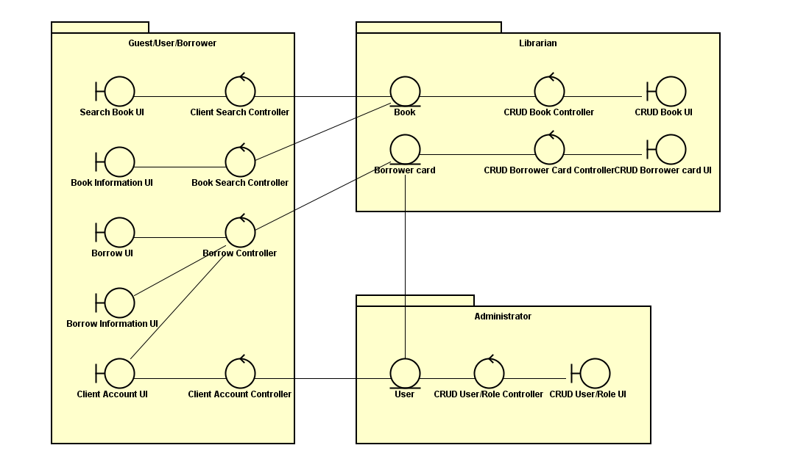

Classes are divided based on the actor who have control over them.